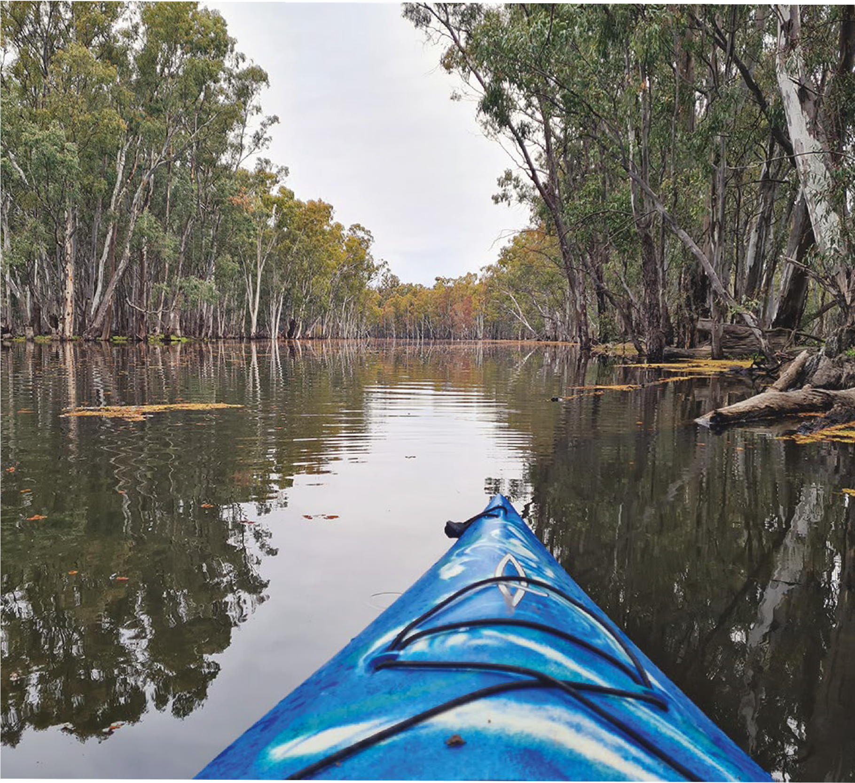
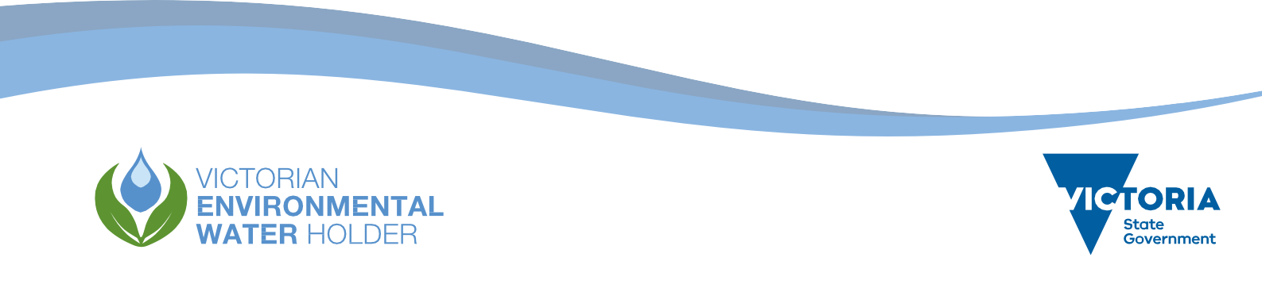
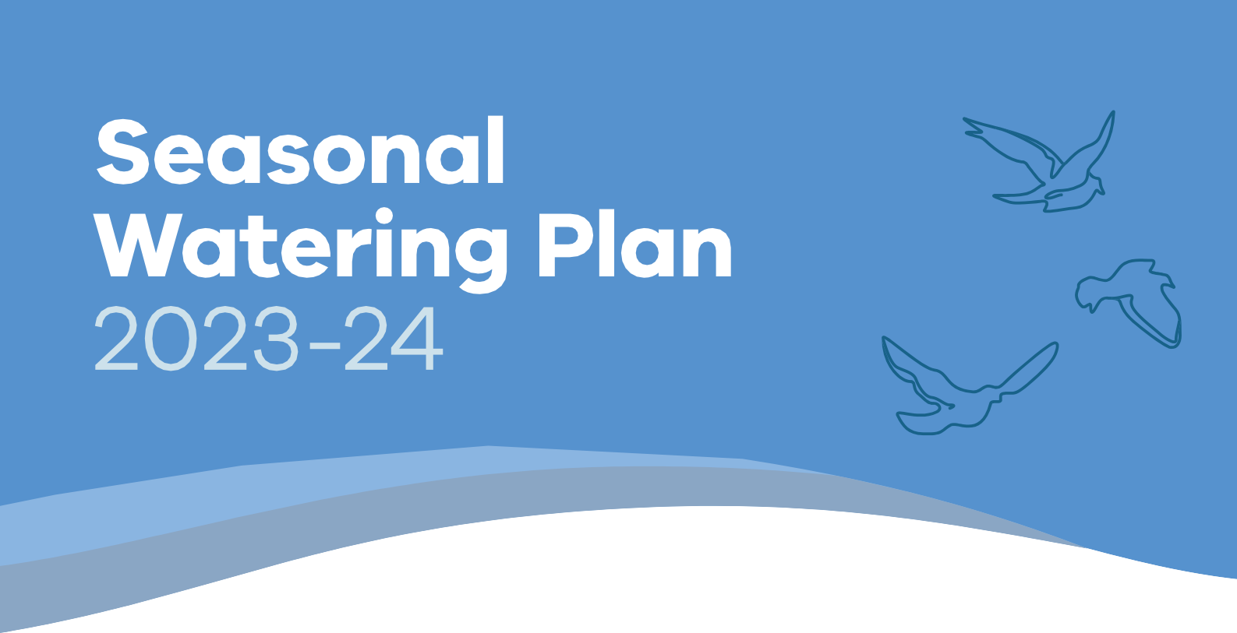

Victorian Environmental Water Holder
Seasonal Watering Plan 2023-24

Cover image:
Monitoring water for the environment via kayak in the Little Reedy Wetland Complex, Gunbower Forest during August 2022. Image by Kathryn Roosje, VEWH.

Acknowledgement of Traditional Owners
The Victorian Environmental Water Holder (VEWH) proudly acknowledges Victoria’s Traditional Owners and their rich culture and pays our respect to Elders past and present, whose knowledge and wisdom has ensured the continuation of culture and traditional practices.
We acknowledge and respect Victorian Traditional Owners as the original custodians of Victoria’s land and waters, their unique ability to care for Country and deep spiritual connection to it.
We are committed to genuinely partner and meaningfully engage, with Victoria’s Traditional Owners and Aboriginal communities to support the protection of Country, the maintenance of spiritual and cultural practices and their broader aspirations in the 21st century and beyond.
The VEWH sees the meaningful intersection between the aims of the environmental watering program — healthy waterways, healthy communities — and the deep and enduring obligations Traditional Owners have to Country and to Aboriginal people. We deeply value the ongoing contribution that Traditional Owners and Aboriginal knowledge systems are making to planning and managing water for the environment. We recognise that this contribution is largely through frameworks and processes that have not been determined by Traditional Owners, and contribution does not imply endorsement of those frameworks and processes. More can be done to increase Traditional Owners’ power and agency and enable progress towards self- determination within the environmental watering program.
Adequately recognising and strengthening the rights of Traditional Owners in water management is critical for achieving self- determination and healthy waterways into the future. The VEWH is committed to an active role in supporting and enabling this within its power and capability.

Acknowledgement of program partners
The VEWH acknowledges that the seasonal watering plan is based on the significant contributions and hard work of Victoria’s catchment management authorities and Melbourne Water in consultation with their communities.
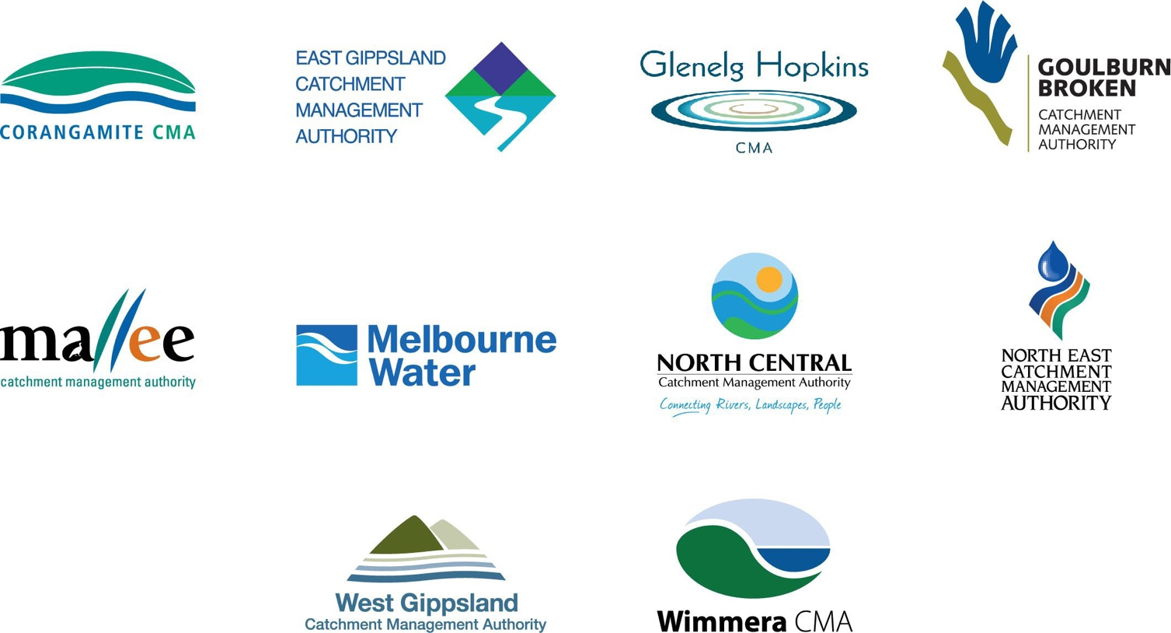

Acknowledgement of Traditional Owners 3
Acknowledgement of program partners 3
Section 1 – Introduction 6
Where can I find more information about the Victorian environmental watering program? 6
1.1 The seasonal watering plan 6
1.1.1 What ‘seasonal’ means 6
1.1.2 How the seasonal watering plan fits into planning environmental flows 6
1.1.3 Who contributes to the seasonal watering plan 6
1.1.4 Changes to the seasonal watering plan 6
1.1.5 When a formal variation to the seasonal watering plan is not required 6
1.1.1 What ‘seasonal’ means 6
1.1.2 How the seasonal watering plan fits into planning environmental flows 7
1.1.3 Who contributes to the seasonal watering plan 8
1.1.4 Changes to the seasonal watering plan 9
1.1.5 When a formal variation to the seasonal watering plan is not required 9
1.2 Implementing the seasonal watering plan 10
1.2.1 How watering decisions are made throughout the year 10
1.2.2 When the VEWH commits and authorises the use of water for the environment 10
1.2.3 How the VEWH prioritises different watering actions when there is not enough available water
for the environment 11
1.2.4 How seasonal conditions affect the use of water for the environment 13
1.2.5 How economic, recreational, social and Traditional Owner cultural values and uses are considered
in decisions to deliver water for the environment 15
1.2.6 Self-determination for Traditional Owners in the management of water for the environment 15
1.2.7 How risks are managed 16
1.2.8 How environmental watering emergencies are managed 16
1.3 How to read the seasonal watering plan 17
Section 2 – Gippsland region 21
2.1 Gippsland region overview 23
2.2 Latrobe system 27
2.2.1 Latrobe River 27
2.2.2 Lower Latrobe wetlands 33
2.3 Thomson system 40
2.4 Macalister system 48
2.5 Snowy system 55
Section 3 – Central region 58
3.1 Central region overview 60
3.2 Yarra system 66
3.3 Tarago system 74
3.4 Maribyrnong system 80
3.5 Werribee system 85
3.6 Moorabool system 92
3.7 Barwon system 98
3.7.1 Upper Barwon River 98
3.7.2 Lower Barwon wetlands 103
Section 4 – Western region 108
4.1 Western region overview 110
4.2 Glenelg system 116
4.3 Wimmera system 127
4.4 Wimmera-Mallee wetlands system 138
Section 5 – Northern region 146
5.1 Northern region overview 148
5.2 Victorian Murray system 160
5.2.1 Upper Murray wetlands 162
5.2.2 Barmah Forest subsystem 165
5.2.3 Gunbower Creek and Forest 171
5.2.4 Central Murray wetlands 180
5.2.5 Hattah Lakes 187
5.2.6 Lower Murray wetlands 192
5.2.7 Lindsay, Mulcra and Wallpolla islands 196
5.3 Ovens system 204
5.4 Goulburn system 210
5.4.1 Goulburn River 210
5.4.2 Goulburn wetlands 217
5.5 Broken system 222
5.5.1 Broken River and upper Broken Creek 222
5.5.2 Lower Broken Creek 228
5.5.3 Broken wetlands 232
5.6 Campaspe system 235
5.6.1 Campaspe River 235
5.6.2 Coliban River 241
5.7 Loddon system 245
5.7.1 Loddon River system (including Serpentine and Pyramid creeks) 245
5.7.2 Boort wetlands 256
5.7.3 Birchs Creek 259
Section 6 – Further information 262
6.1 Acronyms and abbreviations 262
6.2 Glossary 263
6.3 Contact details 268

Section 1 – Introduction
The Victorian environmental watering program is the ongoing, collaborative management of water for the environment used to improve the health of Victoria’s rivers and wetlands and of the native plants and animals that depend on them.

Where can I find more information about the Victorian environmental watering program?
Information about the Victorian environmental watering program is on the Victorian Environmental Water Holder’s (VEWH’s) website at vewh.vic.gov.au or available from the VEWH on (03) 9637 8951 or by email to general.enquiries@vewh.vic.gov.au.
This includes general information such as:
- what water for the environment is
- why water for the environment is important
- what the environmental watering program aims to achieve
- what delivery of water for the environment involves
- how we know if water for the environment is successful
- what environmental water trading is.

You can get more detailed information about water for the environment in your region by contacting your local waterway manager: the contact details are in section 6.3.

The seasonal watering plan
The seasonal watering plan is a statewide plan that guides decisions about delivering water for the environment in Victoria. It outlines how water for the environment is likely to be used across the state under different climate scenarios and therefore tells our program partners, stakeholders and communities what to expect during the water year.
In this section ...
    - What ‘seasonal’ means
    - How the seasonal watering plan fits into planning environmental flows
    - Who contributes to the seasonal watering plan
    - Changes to the seasonal watering plan
    - When a formal variation to the seasonal watering plan is not required

This plan publicly describes all the potential watering actions that could be carried out using water available under all environmental water entitlements held in Victoria. This includes water available under the VEWH’s environmental water entitlements and water held by other environmental water holders for use in Victoria.
The VEWH releases the seasonal watering plan for the upcoming water year by 30 June each year. The plan and any variations are valid for the whole water year, which runs from 1 July to 30 June, or until the next seasonal watering plan is released.
    - What ‘seasonal’ means
‘Seasonal’ refers to various climate conditions in a given year, including normal differences between summer, autumn, winter and spring and whether a year is estimated to be drier or wetter than average.

Return to start of section

Seasonal conditions can affect environmental objectives and water availability. When we plan water for the environment, it is important to consider potential conditions ranging from drought to wet and related water availability scenarios that may unfold during the year.
This scenario planning guides the VEWH and waterway managers when deciding what environmental flows to deliver
throughout the year. There is more on how seasonal conditions influence environmental flows planning in subsection 1.2.4.

Sections 2 to 5 of the seasonal watering plan have more details about potential watering actions likely to be delivered in each river and wetland system during the year under different climatic conditions.
    - How the seasonal watering plan fits into planning environmental flows
Waterway managers scope the potential actions in their seasonal watering proposals to deliver water for the environment in their regions for the coming year. These proposals draw on environmental flow studies and longer-term plans like
environmental water management plans, regional waterway strategies and regional catchment strategies. Proposals include information and advice from local communities and Traditional Owners.
The VEWH reviews the proposed watering actions in each seasonal watering proposal and works with waterway managers to identify the potential watering actions for each region and across the state. This seasonal watering plan is a collated summary of agreed actions from all the seasonal watering proposals.
The different stages of environmental flows planning are shown in Figure 1.1.1. More information about the strategies and plans in the figure (such as environmental flows studies and environmental water management plans for Victorian waterways) is available at vewh.vic.gov.au. Waterway strategies and regional catchment strategies are published on the relevant waterway manager’s website.

Return to start of section

Figure 1.1.1 Victorian environmental watering program planning framework
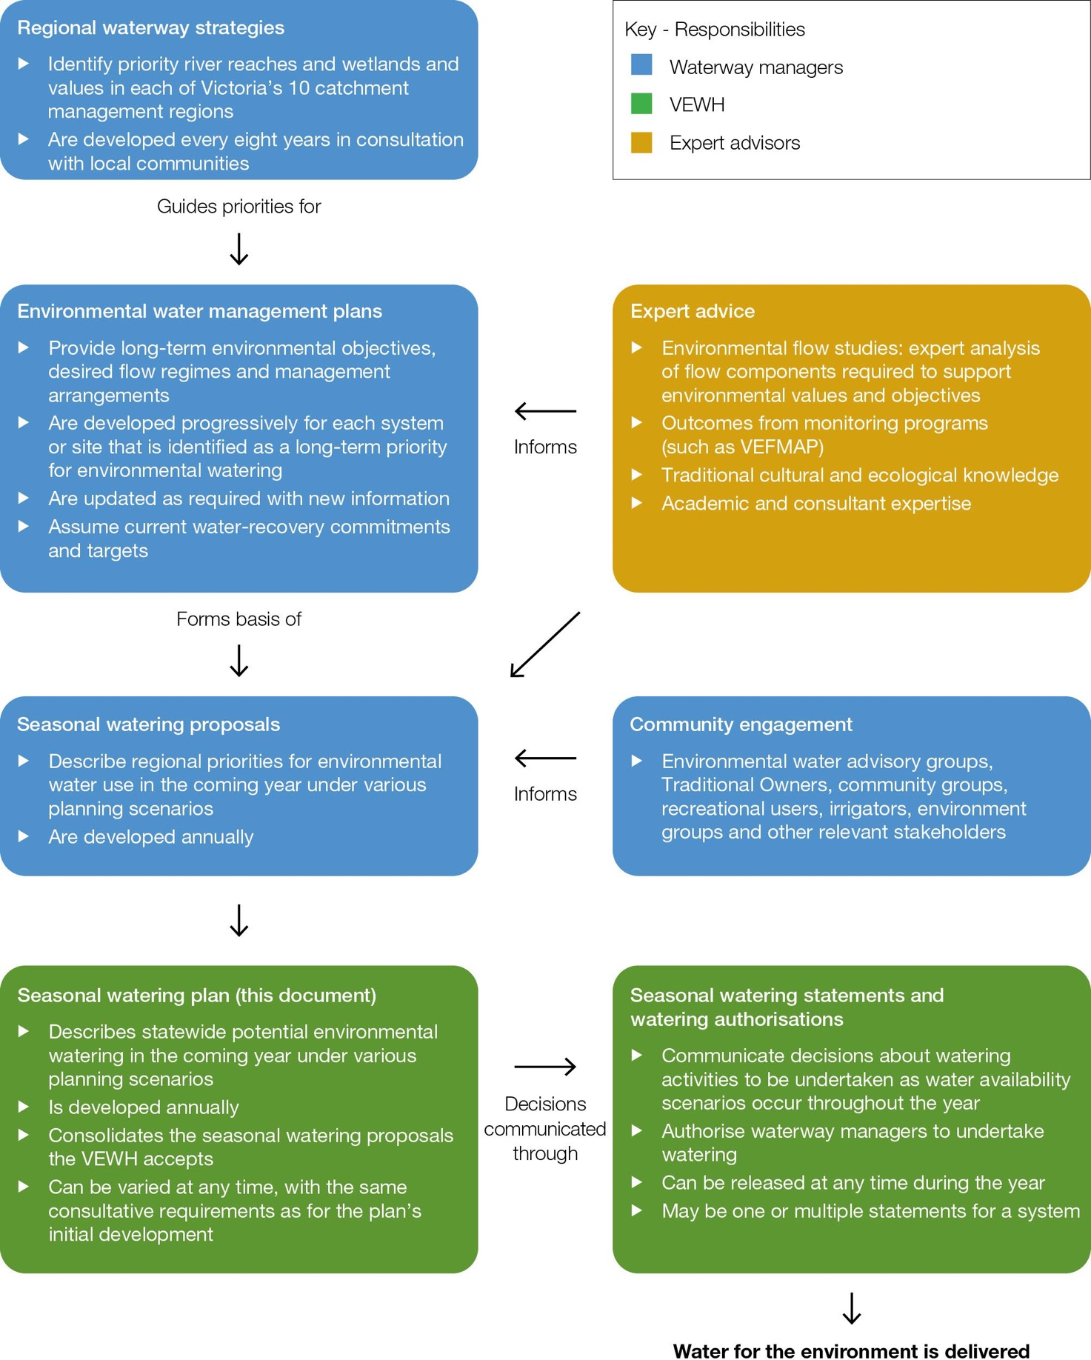

    - Who contributes to the seasonal watering plan
Partners in the environmental watering program are those with some implementation responsibility, while stakeholders are those organisations or individuals with an interest in the environmental watering program.
The VEWH’s partners include Victoria’s waterway managers (catchment management authorities and Melbourne Water), the Department of Energy, Environment and Climate Action (DEECA), other environmental water holders, storage managers and land managers. Traditional Owners also increasingly partner in the environmental watering program.
Return to start of section
Many stakeholders are engaged in discussions about potential actions to deliver water for the environment as seasonal watering proposals are being developed. Levels and methods of engagement vary, depending on different water systems, watering actions and stakeholders across Victoria and regional preferences. Traditional Owners1, irrigators, farmers, people living close to or interested in a specific waterway and members of recreational and environmental groups are among the stakeholders who get involved.
There are formal environmental watering advisory groups in some regions for waterway managers and community members to talk about potential environmental flows in their system or locality for the coming year. In other systems, there is one-on- one engagement between waterway managers and interested stakeholders. Land managers and storage managers endorse or give written support for seasonal watering proposals. This makes sure that releases of water for the environment align with land and storage management objectives, can feasibly be delivered through planned system operations, and risks can be adequately managed.
    - Changes to the seasonal watering plan
Under the Water Act 1989, the VEWH can only authorise the use of water for the environment if it is consistent with the seasonal watering plan. This makes sure there is transparency about the planning and management of environmental flows.
The Act allows the VEWH to vary any section of the seasonal watering plan to incorporate new knowledge or address circumstances that were not identified before the start of the water year. This enables flexibility to adapt to changing conditions. Any variations are publicly available at vewh.vic.gov.au as separate attachments to the current seasonal watering plan.
    - When a formal variation to the seasonal watering plan is not required
Sometimes there may be unforeseen circumstances that call for the use of water for the environment that does not require a variation to the seasonal watering plan. These include:
      - minor operational adjustments to specific water delivery actions
      - water for the environment being used for environmental emergency management purposes
      - small volumes of water for the environment being used for technical investigations or infrastructure maintenance
      - assisting the delivery of water for the environment held by other water holders for downstream, non-Victorian objectives.

The VEWH cannot anticipate these specific circumstances or include details about them in this plan. Waterway managers must consult the VEWH in all situations where releases of water for the environment do not align with the seasonal watering plan.
Minor operational adjustments
There may occasionally be minor operational adjustments to actions to deliver water for the environment. The targeted river reaches, flow rates, timings, magnitudes and durations detailed in sections 2 to 5 may need slight adjustments because of changes in predicted rainfall, other water orders, delivery infrastructure constraints, emerging ecological knowledge or the timing of specific ecological triggers (such as bird-breeding).
In all cases, actions will still aim to optimise environmental outcomes to meet the seasonal watering plan’s objectives.
Any changes to the timing, magnitude or length of a planned watering action must be approved by the VEWH CEO or Commission through a formal variation.
Environmental emergency management situations
Water for the environment may be needed for an environmental emergency management situation, like mitigating a toxic water-quality event. Section 1.2.8 describes how environmental watering emergencies are managed and authorised.
Small technical investigations and maintenance
There may be situations where a small volume of water for the environment is used for research and development or for small-scale infrastructure testing or maintenance. These are considered on a case-by-case basis and must aim to
improve knowledge and management of water for the environment. They must not compromise the potential to achieve the environmental objectives in the seasonal watering plan.
Facilitating the delivery of water held by other water holders for downstream objectives
Some water held by other water holders is stored in Victorian storages and may be required to meet downstream demands beyond the scope of this plan (such as for the Coorong, Lower Lakes and Murray Mouth area in South Australia). Sometimes this water needs to be delivered at a time and flow rate that was not scoped in the seasonal watering plan. The VEWH authorises and makes these deliveries possible as long as risks like potential harm to Victoria’s rivers, wetlands and floodplains are managed appropriately.
1 In the context of the Victorian Government commitment to self-determination for First Nations, partners in the environmental watering program are committed to strengthening the role of Traditional Owners as program partners into the future and supporting self-determination within and beyond the program.
Return to start of section

  - Implementing the seasonal watering plan
The seasonal watering plan scopes the potential delivery of water for the environment for the coming year, but many factors influence decisions about what water is committed and delivered.
In this section…
    - How watering decisions are made throughout the year
    - When the VEWH commits and authorises the use of water for the environment
    - How the VEWH prioritises different watering actions when there is not enough available water for the environment
    - How seasonal conditions affect the use of water for the environment
    - How economic, recreational, social and Traditional Owner cultural values and uses are considered in decisions to deliver water for the environment
    - Self-determination for Traditional Owners in the management of water for the environment
    - How risks are managed
    - How environmental watering emergencies are managed

Factors that influence decisions about committing and delivering water for the environment are:
      - seasonal conditions, weather forecasts and catchment conditions
      - river and system operations like unregulated flows, catchment inflows, storage levels, other water users’ needs and potential delivery constraints
      - ecological or biological factors and triggers like plant and animal responses to natural flows or temperature
      - water availability
      - risks or costs associated with an action to deliver water for the environment
      - the opportunity to deliver shared benefits, such as for Traditional Owner and recreational values.
It is important there is flexibility to respond to these different factors because they can have a big influence on the environmental outcomes and shared benefits that we can achieve.
    - How watering decisions are made throughout the year
Many of the uncertainties about seasonal conditions, water availability and the consequential impacts of system operating rules become clearer as the season unfolds. This clarity informs decisions about which environmental flows go ahead and when. Many on-ground factors do not become clear until much closer to the anticipated water delivery.
The VEWH takes a flexible and adaptive approach to decisions with relevant stakeholders, then reviews and adjusts them so that water for the environment is used efficiently for the best environmental outcomes across Victoria.
Waterway, storage and land managers advise the necessary watering actions that can be delivered in each region during the year. Environmental water holders use that information to decide which actions to authorise. All program partners have a role in identifying potential watering actions and enabling the release of water for the environment, as explained in subsection 1.2.3.
The VEWH can also ask for more scientific or community contributions if planned watering actions need to change significantly during the season to respond to unforeseen circumstances.
Updated information about current and anticipated deliveries of water for the environment is published regularly at vewh.vic.gov.au.
    - When the VEWH commits and authorises the use of water for the environment
The VEWH aims to commit as much water as realistically and as early as possible to give waterway managers certainty to go ahead with planned actions to deliver water for the environment.
The VEWH can commit its water at any point before or during the water year. It commits this water through seasonal watering statements that authorise waterway managers to release water for the environment and are published at vewh.vic.gov.au.
Depending on the nature of the system and the entitlement being used, the VEWH may make one or multiple statements for a system during the water year. Before issuing a seasonal watering statement, the VEWH must be sure the required delivery arrangements, including risk management measures, are in place and that any related costs are acceptable.
Decisions to commit water for the environment may need more thorough consideration if delivery of the water across different systems requires access to the same environmental or bulk entitlement. One river, wetland or flow component may have to be prioritised over another.
Return to start of section

The VEWH may sometimes commit water very close to the anticipated date of release. This may be necessary because of a sudden demand for water caused by environmental, operational or weather conditions. For example, a colonial waterbird
nesting event in Barmah Forest may trigger a need for water to maintain shallow flooding long enough for the birds to fledge or grow and fly from the nest.
The Commonwealth Environmental Water Office (CEWH) and the Southern Connected Basin Environmental Watering Committee (for the Living Murray program) commit water for use in Victoria, and the VEWH formally authorises that use through seasonal watering statements.
When water in Victorian accounts held by the CEWH and the Living Murray program needs to be delivered to non-Victorian sites, the VEWH enables that use through a watering authorisation. These authorisations generally include the same conditions and requirements as seasonal watering statements, but the water must be ordered and delivered by the VEWH instead of a waterway manager.
When environmental water holders and waterway managers can change their plans after a seasonal watering statement or watering authorisation has been issued
The VEWH can withdraw a seasonal watering statement or watering authorisation at any point during the year to address emerging risks or changes in operating conditions or water availability. It consults with the relevant environmental water holders, waterway manager and storage manager for that river or wetland system before withdrawing a seasonal watering statement or watering authorisation.
A waterway manager or storage manager may decide, in consultation with the VEWH, not to go ahead with delivering water for the environment after a seasonal watering statement has been issued. This could be due to environmental triggers indicating the water was no longer required, resourcing constraints or new information that the potential environmental or public risk of watering is too high.

    - How the VEWH prioritises different watering actions when there is not enough available water for the environment
The VEWH works with its program partners to decide where available water for the environment and funding are used and where water is carried over or traded to get the best possible outcomes for the health of Victoria’s rivers, wetlands, estuaries and floodplains.
It is essential to recognise the dynamic nature of delivering water for the environment when putting the program into action. Seasonal conditions can vary greatly between years, affecting the demand for water for the environment for particular sites and the supply of available water for the environment.
There can be a deficit in supply because of large, high-value demands for water for the environment or low water availability.

The VEWH may use tools like carryover and trade to avoid a deficit. If a deficit can’t be avoided, it works with waterway managers and other relevant water holders to prioritise actions to deliver water for the environment. More information about trade is provided in VEWH’s Water Allocation Trading Strategy which is published at vewh.vic.gov.au
Criteria used to guide prioritisation decisions
The VEWH considers certain criteria, which Figure 1.2.1 shows, when making trade-off decisions and prioritising specific watering actions. Waterway managers provide information in their seasonal watering proposals about how different watering actions meet these criteria and about opportunities for shared benefits.
When the VEWH decides how to use the available Water Holdings in any given year, it also considers:
- decisions by other water holders about the use of their water for the environment
- Victorian and Commonwealth Government decisions about water resource policy
- the resources, knowledge and capability of the VEWH and its program partners
- storage managers meeting their obligations to the environment as part of the right to harvest and distribute water sustainably
- complementary works and measures being undertaken
- the availability of funds to pay the costs of water delivery and/or storage
- the merit of selling available water allocation to fund works or technical investigations to improve environmental outcomes
- services associated with managing Water Holdings and delivering water for the environment.

Return to start of section

Figure 1.2.1 Criteria for prioritising actions to deliver water for the environment
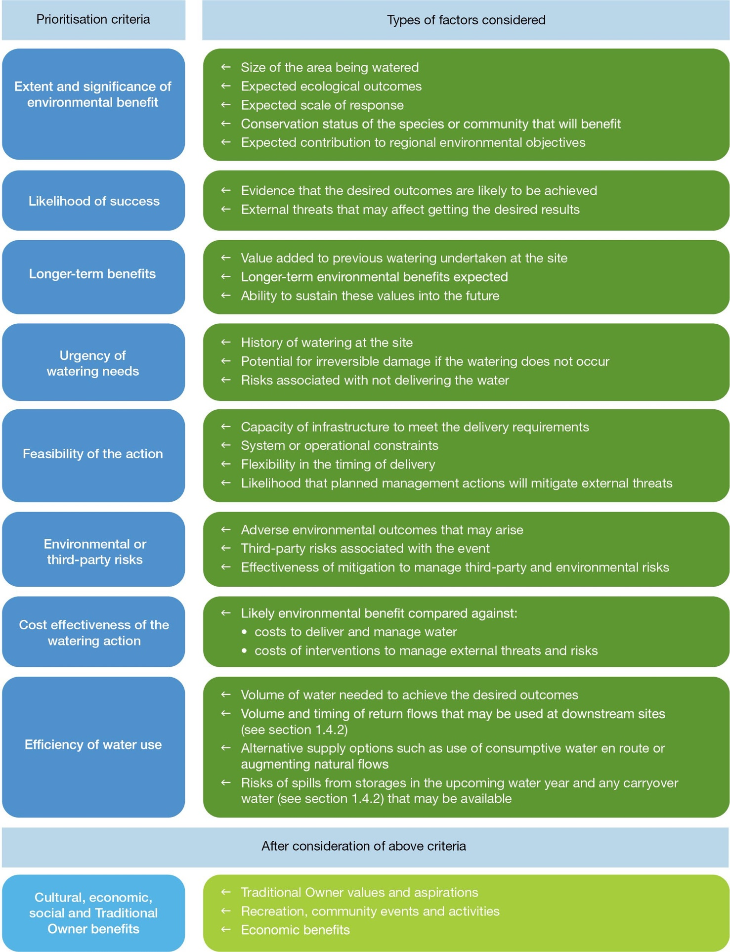

Return to start of section

Who is involved in the prioritisation process
Waterway managers, environmental water holders, storage managers, land managers, Traditional Owners, stakeholders, communities including recreational users, environmental and farming groups and interested landholders and community members all have a role in prioritising actions to deliver water for the environment, depending on the nature and scale of the decisions being made.
Waterway managers undertake stakeholder and community engagement and advise about the extent and significance of actions to deliver water for the environment and the highest priorities in their region.
The VEWH and other environmental water holders determine the highest watering priorities across regions. The VEWH collaborates with waterway managers and other program partners to decide on the best possible environmental outcomes for Victoria. Storage managers’ advice is important to help understand how practical it is to water at a particular time within potential operational constraints.
Land managers consent to the delivery of environmental flows on their land. They advise about this after considering land management activities, public access and the risks and benefits of the watering action.
Waterway managers consult with local communities each year about prioritising sites for watering. These consultations are informed by longer-term planning detailed in plans, including regional catchment strategies, regional waterway strategies and environmental water management plans. They draw on a breadth of local and specialist knowledge and, as well as seeking to achieve the environmental outcome aims, also seek to prioritise sites for watering and other river health activities that have high environmental, economic, social and Traditional Owner cultural values.

    - How seasonal conditions affect the use of water for the environment
Different climatic conditions influence how water for the environment is managed, just as rainfall patterns influence how we water our gardens or paddocks. Seasonal conditions, as explained in subsection 1.1.1, influence what water will be available during the water year and the environmental objectives to work towards. Waterway managers take seasonal conditions into account when prioritising the water for the environment needed at each site. Seasonal planning scenarios describe the range of watering actions that could occur, depending on drought to very wet conditions.
Waterway managers work with the program partners to get the best possible outcomes from water for the environment by considering:
      - environmental objectives under each climatic scenario, plus any essential needs for water for the environment
      - how rainfall, natural flooding and delivering water for operational and/or consumptive use can help to achieve environmental objectives
      - how water for the environment can be used to build on natural flows or irrigation deliveries to meet the environment’s needs
      - natural climatic cues that might help produce an ecological outcome: for instance, a drying wetland.

Planning scenarios are presented in the seasonal watering plan as a basis for adaptively managing water use as the season unfolds. They also give an early indication of how much water may be used at different sites and whether the VEWH may need to trade water during the season to meet identified environmental needs. Figure 1.2.2 shows how different planning scenarios can influence decisions about how water for the environment is managed in a year.

Return to start of section

Figure 1.2.2 Example planning scenarios under a range of climatic conditions
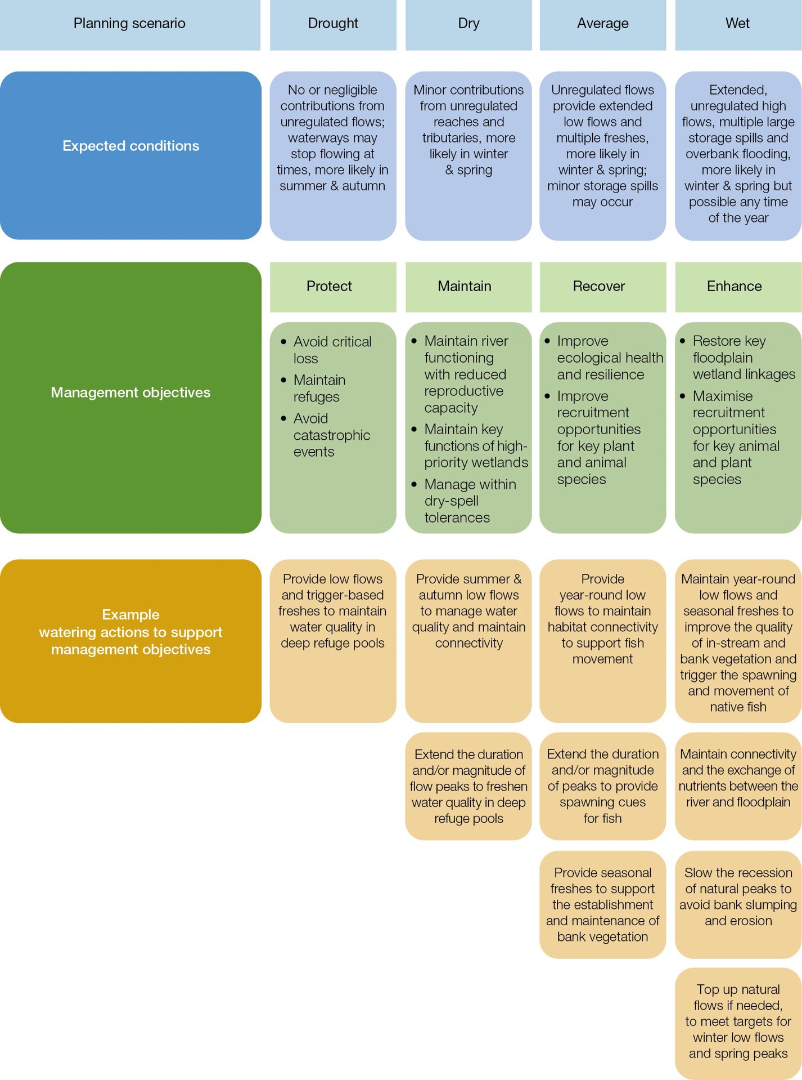

Return to start of section

    - How economic, recreational, social and Traditional Owner cultural values and uses are considered in decisions to deliver water for the environment
Water delivered for the environment provides many direct benefits to the community by improving the health of rivers, wetlands and floodplains. It benefits places where people visit to relax, play and connect with nature. Water for the environment helps
to increase populations of fish species popular with anglers, maintain healthy Country for Aboriginal communities and improve the quality of water available to irrigators.
Waterway managers engage with Traditional Owners regarding cultural values and uses of waterways and how the environmental watering program can contribute to realising cultural objectives for Country. The VEWH recognises the government frameworks and processes for managing water for the environment have not been determined by Traditional Owners. The VEWH is committed to progressing Traditional Owner self-determination in the environmental watering program and has started working with Traditional Owners and the government toward establishing Traditional Owner-led seasonal watering proposals, as subsection 1.2.6 explains.
Waterway managers work with communities to identify environmental, social, economic and recreational values and uses of waterways, including through regional catchment strategies, regional waterway strategies, environmental water management plans and seasonal watering proposals. Opportunities to support these values and uses are taken up in deliveries of water for the environment wherever possible, as long as the delivery does not compromise environmental outcomes.
Longer-term community benefits sometimes involve short-term inconvenience. For example, floodplain watering in Hattah Lakes may limit access, which can inconvenience campers in the short term, but the environmental benefits of the watering are likely to boost tourism and recreational opportunities in the longer term and enhance the experience of connecting with nature. If short-term inconveniences happen, waterway managers work closely with land managers to limit the disruption to users as much as possible.
Values and uses considered during planning for environmental flows are summarised in each system shown in sections 2 to 5. Specific watering actions planned to align with a social or recreational objective or be delivered in partnership with Traditional Owners to support Aboriginal cultural values and uses are identified by the icons shown in Figure 1.2.3.
Figure 1.2.3 Cultural, social and recreational objectives icons

Icon | Objective
 | Watering planned and/or delivered in partnership with Traditional Owners to support Aboriginal cultural values and uses
 | Watering planned to support water sports activities (e.g. canoeing, kayaking, rowing, swimming, water skiing)
 | Watering planned to support waterbird-related recreational activities
 | Watering planned to support angling activities
 | Watering planned to support peaks in visitation (e.g. camping or other public activities on long weekends or school holidays)

    - Self-determination for Traditional Owners in the management of water for the environment
The Seasonal Watering Plan 2023-24 represents existing legislative requirements to take Aboriginal cultural values into account in the formation of seasonal watering proposals, based mainly on engagement with waterway managers. However, the VEWH is committed to increasing the agency and self-determination of Traditional Owners in the Victorian environmental watering program and to supporting Traditional Owners to access and manage water on their own terms.
Early in 2022, the VEWH published its position statement outlining its commitment to progress Traditional Owner self- determination. The Victorian Government’s 2022 Water is Life: Traditional Owner Access to Water Roadmap sets out short, medium, and long-term policy actions to reform existing government frameworks and processes for the management of water on Traditional Owner Country, including water for the environment. The VEWH is working with Traditional Owners, DEECA and waterway, land and storage managers to progress these policy actions. Early work includes starting trials for Traditional Owner-led seasonal watering proposals. Additional watering actions that may result from the trials can be approved by the VEWH CEO or Commission through a variation to the seasonal watering plan.
Return to start of section

    - How risks are managed
Risk management is essential in managing water for the environment, and program partners consider risks continually during long-term and annual planning, implementation and review.
The VEWH and its program partners have developed a risk management framework that addresses interagency risk, respects each partner’s practices and documents roles and responsibilities for operating arrangements.
The seasonal watering proposals that are the basis for this seasonal watering plan identify potential risks with specific watering actions proposed for the coming water year. Partners jointly assess risks and identify and commit to mitigation actions when they develop the proposals so they can manage the shared risks of delivering water for the environment.
The main shared risks are shown in Table 1.2.1. Program partners consider and reassess these and other potential risks as the season unfolds and planned watering actions are about to start.
Some risks may only happen at the time of delivery, such as forecast heavy rain that coincides with a planned environmental flow that could increase the risk of nuisance flooding. Program partners review risks immediately before a planned environmental flow and take measures to mitigate the risks, as the partners have agreed. Watering actions will not be carried out if unacceptable risks to the public or environment cannot be mitigated.
Table 1.2.1 Main shared risks of delivering water for the environment

Type of risk | Example mitigating actions
Delivering water for the environment contributes to third-party impacts | Identify and understand the capacities of water systems and monitor water levels at key locations to inform daily water release decisions to make sure impacts do not eventuate.  Consider potential catchment run-off from forecast rainfall before deciding on the timing of releases of water for the environment.  Put a communication strategy into action that may include media releases, public notices and signage before environmental flows to make sure people are  informed about significant deliveries and can adjust their behaviour. This includes early liaison with stakeholders who may be affected.  Restrict access by closing gates and tracks.
Inability to achieve or demonstrate ecological outcomes from delivering water for the environment | Do intervention monitoring with available resources to identify the ecological response.  Do research to better understand responses to water for the environment. Communicate the outcomes of monitoring and apply learnings to future deliveries.  Consider the need for complementary works to help achieve the environmental objectives of delivering water for the environment as part of integrated catchment management.  Factor in the likely time it will take for ecological responses to be observed.
Delivering water for the environment has negative effects on the environment (like bank erosion and the spread of weeds) | Plan the timing, frequency, length and variability of environmental flows to limit negative effects.  Monitor the outcomes of deliveries of water for the environment and adapt future deliveries and/or scientific recommendations if necessary.
Even with the best risk management controls, there may be unintended effects from environmental flows or situations where those flows cannot be delivered as planned. In these situations, program partners work together to respond to incidents and then learn and adapt their risk management. The VEWH has developed an agreed approach to incident management to help program partners report, investigate and respond to risks.

    - How environmental watering emergencies are managed
An emergency watering action is where water for the environment may be necessary to prevent, mitigate or respond to an acute environmental threat.
Common threats are:
      - impacts on water quality from low oxygen levels, toxic levels of blue-green algae, high temperatures or high salinity
      - falling water levels at a refuge habitat or breeding site that are an immediate risk to native aquatic plants and animals.

Acute environmental threats are unpredictable, so potential emergency watering actions may not be specified in sections 2 to 5 of this plan. The VEWH has developed a procedure for emergency watering actions to be taken at short notice.
Return to start of section

Emergency watering procedure
Emergency actions to deliver water for the environment are usually one or other of the following scenarios:
      - the necessary watering action is not described adequately or at all in the current seasonal watering plan, but there is a valid seasonal watering statement with water available that covers other watering actions for the affected system and authorises a total volume that is enough for the proposed emergency watering action, or
      - there is no authorised seasonal watering statement for the affected system, or there is not enough water available under the seasonal watering statement to cover the proposed emergency watering action.
Under the first scenario, waterway managers can reprioritise watering actions authorised under the existing seasonal watering statement to allow the emergency watering action to be taken without impacting the overall resource.
Under the second scenario, waterway managers must ask for an emergency seasonal watering statement from the VEWH before water for the environment can be used for an emergency watering action. The VEWH has administrative processes to support emergency decisions to deliver water and to expedite requests for emergency seasonal watering statements.

How to read the seasonal watering plan
Under the Victorian Water Act 1989, the VEWH can only authorise the use of water for the environment where it is consistent with a seasonal watering plan. This is to maintain transparency about the planning and management of environmental flows.
The plan must make sure that the scope, objectives and potential watering activities for each waterway are clear and that decisions about possible water use are made effectively and transparently.
Four broad geographic areas in Victoria’s Gippsland, central, western and northern regions are represented in sections 2 to 5 of the seasonal watering plan with overviews that include:
- a description of the region
- an acknowledgement of the Traditional Owners of the area
- a description of communities and program partners engaged
- examples of integrated catchment management in the region
- a description of how risks are managed
- a seasonal outlook for the region.
Each region is divided into system sections for waterways and wetlands supplied with water for the environment from an environmental entitlement. Each section presents the system’s environmental values, environmental objectives and planned actions for the year.
The system sections include:
- a system introduction page with:
  - the names of the one or more waterway managers, storage managers and/or environmental water holders for the system
  - a pie chart showing the proportion of water entitlements in the system for environmental, urban, industry and irrigation uses, where available
- a system overview describing the system’s location, its waterways and major features
- environmental values outlining the main water-dependent species, communities, ecological processes and habitats that rely on healthy waterways and form the basis for environmental objectives
- environmental objectives in the system, which Figure 1.3.1 shows, that summarises the measurable outcomes sought for each environmental value in the system. Each objective usually relies on one or more continuing watering actions and complementary actions, like controlling invasive species or installing fishways. It may take years or several decades to achieve targeted outcomes
- Traditional Owner and recreational values considered in planning for environmental flows, along with opportunities to support these values, as long as environmental outcomes are not compromised
- the scope of deliveries of water for the environment, which Figure 1.3.2 shows, that sets out potential actions to deliver water in 2023-24, the expected physical or biological effects of the actions and the longer-term environmental objectives they support. Achieving each environmental objective relies on one or more potential actions and their expected watering effects
Return to start of section

- scenario planning, which Figure 1.3.3 shows, indicating in a table the range and priority of potential actions to deliver water for the environment in the coming year under different climate and water availability scenarios. The text with the table describes the rationale or need for the proposed combination of potential actions under each scenario. Climate scenarios considered are mostly drought, dry, average and wet, but occasionally more or fewer scenarios are used. Section 1.2.4 explains how seasonal conditions are considered in planning.
Figure 1.3.1 Example environmental objectives table
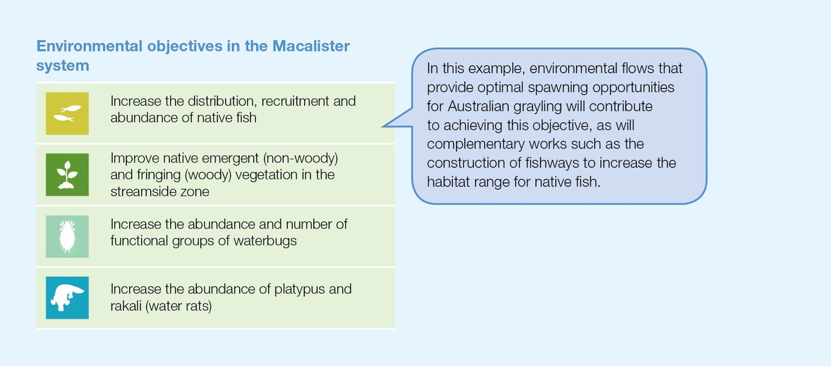

Return to start of section

Figure 1.3.2 Example potential actions to deliver water for the environment and objectives table
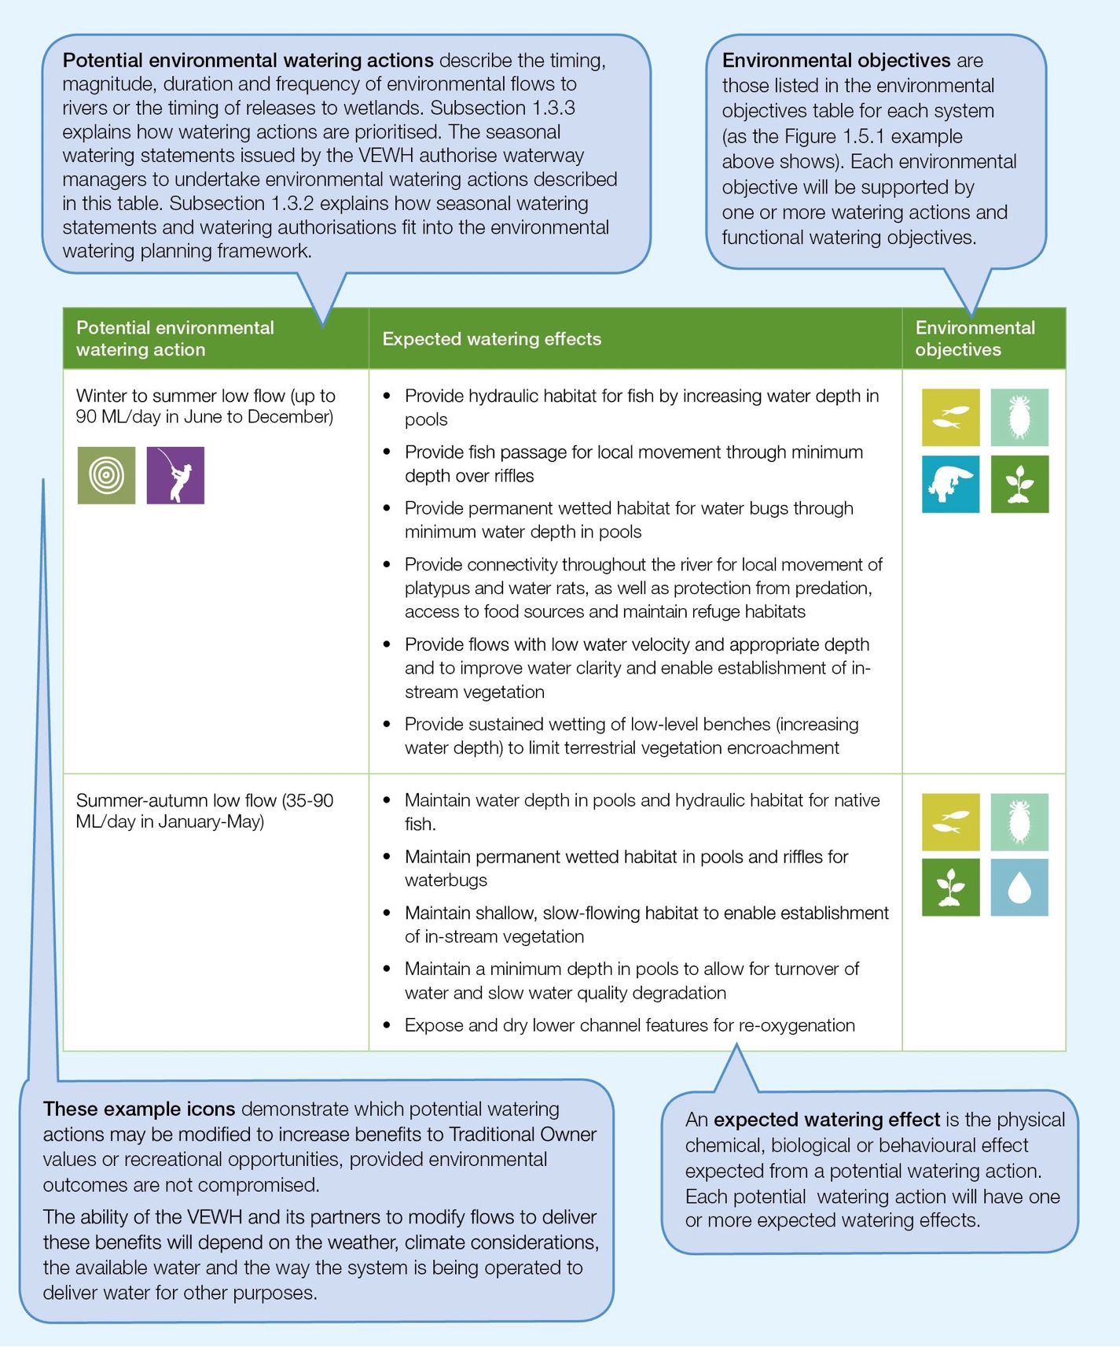

Return to start of section

Figure 1.3.3 Example scenario planning table
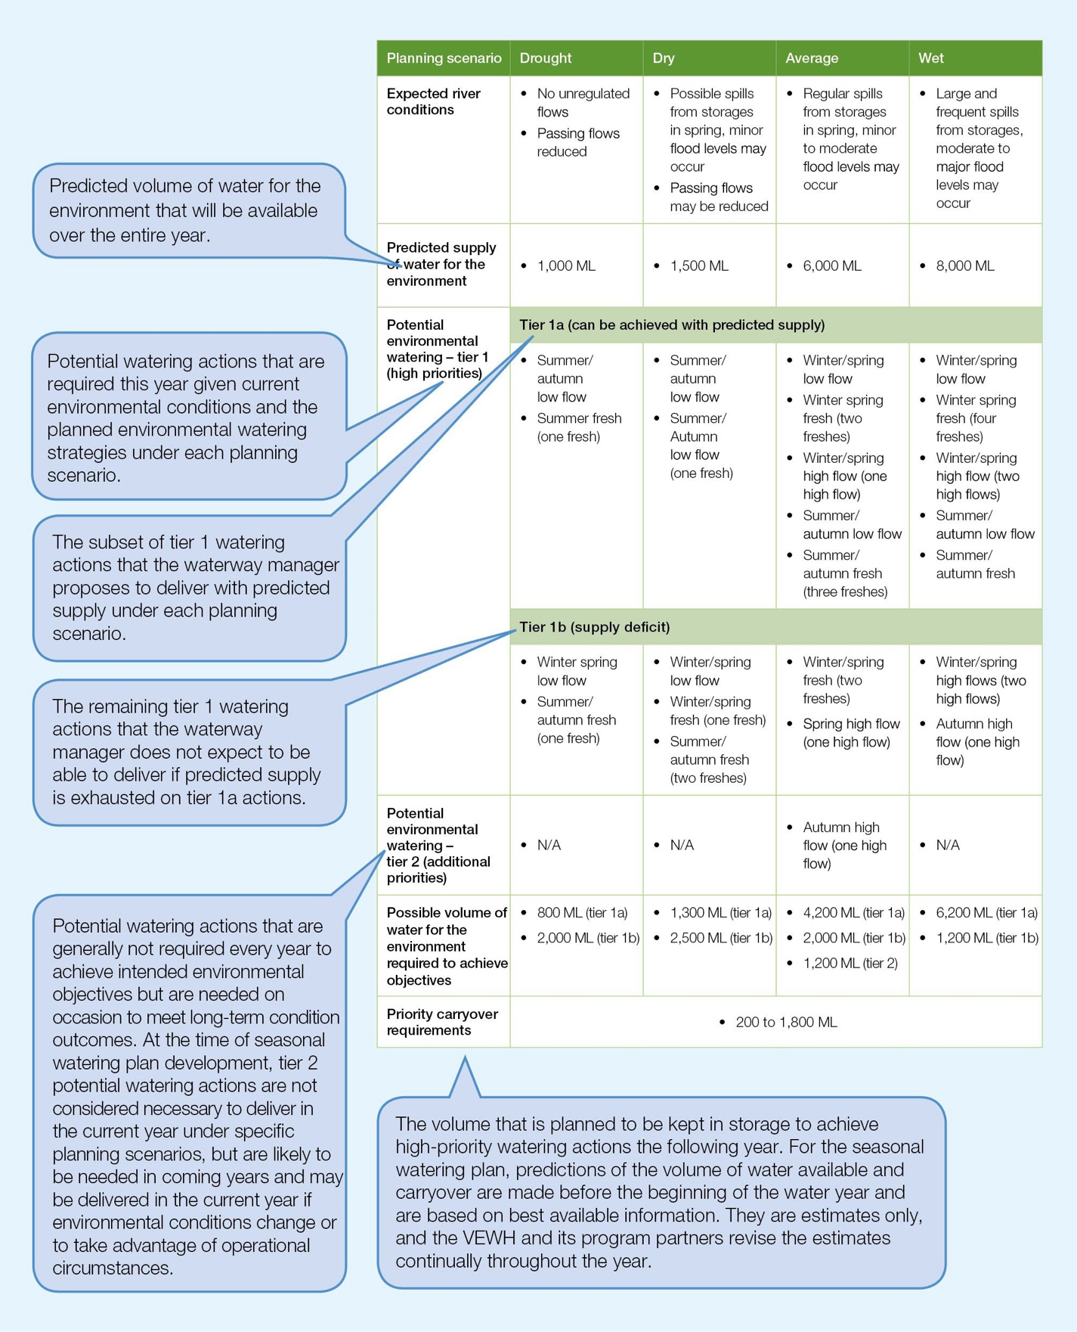

Return to start of section

Section 2
Gippsland region

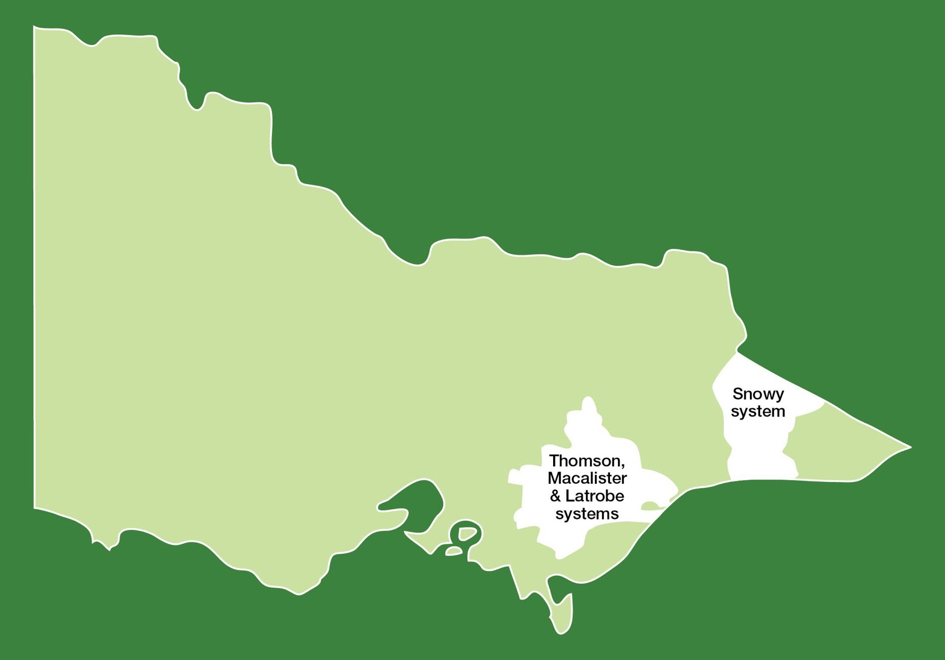

  - Gippsland region overview 23
  - Latrobe system 27
    - Latrobe River 27
    - Lower Latrobe wetlands 33
  - Thomson system 40
  - Macalister system 48
  - Snowy system 55

Gippsland region overview
The systems in the Gippsland region that can receive water from the VEWH’s environmental entitlements are Durt-Yowan (Latrobe River), lower Latrobe wetlands, Carran Carran (Thomson River), Heyfield wetlands and Wirn wirndook Yeerung (Macalister River). The Snowy River also receives environmental flows, which the New South Wales Department of Planning, Industry and Environment manages.
Environmental values, objectives, and planned actions for delivering water for the environment for each system in the Gippsland region are presented in the system sections that follow.

Traditional Owners in the Gippsland region
Traditional Owners in the Gippsland region have a deep connection to Country that has endured for tens of thousands of years. This includes inherent rights and cultural obligations to Country and community.
The Gunaikurnai Land and Waters Aboriginal Corporation (GLaWAC), on behalf of the Gunaikurnai, holds Native Title, has a recognition and settlement agreement with the Victorian Government and is a Registered Aboriginal Party (through the Commonwealth Native Title Act 1993, the Victorian Traditional Owner Settlement Act 2010 and the Victorian Aboriginal Heritage Act 2006). Gunaikurnai Country extends over an area from Warragul in the west to the Snowy River in the east and from the Great Dividing Range in the north to the coast in the south. This area includes Durt-Yowan (Latrobe River), Carran
Carran (Thomson River), Wirn wirndook Yeerung (Macalister River), the Snowy River and the lower Latrobe wetlands covered by this section of the seasonal watering plan.
Other Registered Aboriginal Parties in the Gippsland region are the Bunurong Land Council Aboriginal Corporation and Wurundjeri Woi Wurrung Cultural Heritage Aboriginal Corporation. Their boundaries do not extend to the waterways managed with water for the environment in the Gippsland region.
Traditional Owners with links to the Snowy River system include the Monero Ngarigo, Bidhawal and Gunaikurnai peoples.

The Victorian Government is committed to self-determination for Traditional Owners through Treaty negotiations, policies such as Water is Life: Traditional Owner Access to Water Roadmap 2022 and actions in the 2022 Central and Gippsland Region Sustainable Water Strategy. The VEWH and its partners are working with Traditional Owners to embed the outcomes of government policy into the Victorian environmental watering program. Program partners in the environmental watering program are aware that structural changes (such as legislative, policy and governance changes) to how water is managed may be made in the future in recognition of Aboriginal water rights. Program partners have heard that Traditional Owners want empowerment and agency in water management, and in many cases, they want to manage water on Country on their terms.

Engagement
The environmental watering program is informed by engagement with Traditional Owners, stakeholders and local communities. Program partners undertake extensive engagement at the local level to understand community priorities for the delivery of water for the environment in the coming year.
Program partners also seek to understand how cultural, social, economic and recreational values, uses and objectives may be supported by delivering environmental flows. Opportunities to support these values, uses and objectives are incorporated into watering decisions where possible, provided they do not compromise environmental outcomes. Cultural, social, economic and recreational values considered for each system in the Gippsland region are presented in the following system sections.
Engagement through other strategies, plans and processes also informs environmental flows objectives. These include regional catchment strategies, regional waterway strategies and technical studies (such as environmental flows studies and environmental water management plans). Traditional Owner cultural objectives for environmental flows may refer to cultural flows studies, Aboriginal Waterway Assessments, Traditional Owner Country Plans and other tools. These strategies, plans and technical reports collectively describe a range of environmental, economic, social and Traditional Owner perspectives and longer-term integrated catchment and waterway management objectives that influence actions and priorities for water for the environment.

Return to start of section

Table 2.1.1 Partners and stakeholders engaged by West Gippsland Catchment Management Authority in developing seasonal watering proposals for the Latrobe, lower Latrobe wetlands, Thomson and Macalister systems and other key foundation documents that have directly informed the proposals (grouped in alphabetical order)

 | Latrobe system | Lower Latrobe wetlands | Thomson system | Macalister system
Community groups and environment groups | - Birdlife Australia  - Friends of Latrobe River  - Friends of Tyers Park  - Greening Australia  - Latrobe Landcare Network  - Latrobe Valley Field Naturalist Club Inc.  - Native Fish Australia  - Trust for Nature | - Birdlife Australia  - Greening Australia  - Latrobe Valley Field Naturalist Club Inc.  - Native Fish Australia  - VR Fish  - WaterWatch Volunteers | - Birdlife Australia  - Greening Australia  - Heyfield Wetlands Committee of Management  - Maffra and District Landcare Network  - Native Fish Australia | - Birdlife Australia  - Field Naturalists  - Friends of Bellbird Corner  - Greening Australia  - Maffra and District Landcare Network  - Native Fish Australia
Government agencies | - Department of Energy,  Environment and Climate Action  - East Gippsland CMA  - Gippsland Water  - Parks Victoria  - Southern Rural Water  - Victorian Environmental Water Holder  - Victorian Fisheries Authority | - Department of Energy,  Environment and Climate Action  - East Gippsland CMA  - Gippsland Water  - Parks Victoria  - Victorian Environmental Water Holder | - Department of Energy,  Environment and Climate Action  - Gippsland Water  - Melbourne Water  - Southern Rural Water  - Victorian Environmental Water Holder  - Victorian Fisheries Authority | - Department of Energy,  Environment and Climate Action  - Gippsland Water  - Southern Rural Water  - Victorian Environmental Water Holder  - Victorian Fisheries Authority
Landholders/farmers | - Individual landholders and irrigators | - Field & Game Australia (Heart Morass)  - Individual landholders | - Individual irrigators  - Individual landholders | - Individual landholders  - Macalister Irrigation District irrigators/ diverters
Recreational users | - Field & Game Australia  - Recreational users  - VR Fish | - Field & Game Australia (Dowd Morass and Sale Common)  - Recreational users  - VR Fish | - Recreational users  - Whitehorse Canoe Club  - VR Fish | - Recreational users VR Fish
Local businesses |  | - Frog Gully Cottages  - Port of Sale Heritage River Cruises
Technical experts | - Arthur Rylah Institute |  | - Arthur Rylah Institute | - Arthur Rylah Institute
Traditional Owners | - Gunaikurnai Land and Waters Aboriginal Corporation | - Gunaikurnai Land and Waters Aboriginal Corporation | - Gunaikurnai Land and Waters Aboriginal Corporation | - Gunaikurnai Land and Waters Aboriginal Corporation

Integrated catchment management
Altered water regimes are one of many threats to the health of Victoria’s waterways. To be effective, environmental flows need to be part of an integrated approach to catchment management. Many of the environmental objectives of water for the environment in the Gippsland region will not be fully met without simultaneously addressing issues such as barriers to fish movement, high nutrient loads, loss of streambank vegetation and invasive species.
Victorian and Australian government agencies, Traditional Owner groups, community groups and private landholders collectively implement a wide range of programs that aim to protect and improve the environmental condition and function of land, soils and waterways throughout Victoria’s catchments.
Examples of complementary programs that support the outcomes of environmental flows in the Gippsland region include:
- works to protect and enhance stream banks along priority reaches of rivers and their tributaries, including fencing to exclude stock, revegetation of riverbanks, willow removal and erosion control
- work with farmers along the Thomson and Macalister rivers on grazing and soil management and on nutrient and water- use-efficiency projects that help to improve water quality and river health
- construction of a fishway on the Thomson River to improve fish passage near the heritage-listed Horseshoe Bend Tunnel, completed in August 2019. The fishway now allows Australian grayling (specifically targeted with releases of water for the environment) and other migratory fish to access over 200 km of river habitat from the upper reaches of the Aberfeldy River down to the Latrobe River. Tupong are now regularly found above the Horseshoe Bend Tunnel in surveys conducted by the Arthur Rylah Institute
- construction of a fishway on the Macalister River to allow fish passage through the Maffra Weir, which is due to commence in 2024
- a weed and willow control program in remote parts of the Snowy River catchment, which led to 200 km of the river now being willow-free. Surveys and ongoing control of willows in areas burned by the 2019-20 bushfires will be a particular focus over the next few years.
For more information about integrated catchment management programs in the Gippsland region, refer to the West Gippsland and East Gippsland regional catchment strategies and regional waterway strategies.

Risk management
During the development of the seasonal watering proposals for the Latrobe, Thomson and Macalister systems, environmental watering program partners assessed risks associated with the potential delivery of water for the environment in 2023-24
and identified appropriate mitigating strategies. Risks and mitigating actions are continually assessed by program partners throughout the year (see subsection 1.2.7).
In the Snowy system, when weather conditions increase the risk of flooding, the New South Wales Department of Planning, Industry and Environment works with the Bureau of Meteorology, the East Gippsland CMA, New South Wales State Emergency Service and the VEWH to inform the community about the management of planned releases. Releases may be cancelled or rescheduled to limit flood impacts on private land.

Seasonal outlook 2023-24
La Nina conditions in 2022-23 delivered above-average winter and spring rainfall in the northern and western parts of the Gippsland region for the third consecutive year, while rainfall in the eastern part of the catchment was close to the long-term average. Upper sections of the Latrobe River catchment received their highest total June rainfall in 24 years, and heavy rainfall in August caused minor flooding in Traralgon Creek. Thomson Dam spilled in October for the first time since 1996. Temperatures throughout the region were close to the long-term average during 2022-23.
Delivery of water for the environment in rivers and wetlands within the West Gippsland CMA region was managed in line with the wet scenario during 2022-23, and all planned watering actions were achieved. Natural flows from spilling reservoirs and local catchment run-off met most planned watering actions during the year. Water for the environment was used to supplement the winter-spring low flow in the Thomson River during July to help fish and other animals move freely between different habitats. Water for the environment was not needed in the Macalister River or the Latrobe River at all during 2022-23 because the natural flow met or exceeded flow recommendations. The three lower Latrobe wetlands (Sale Common, Dowd Morass and Heart Morass) were flushed by natural flows for the second consecutive year, and salinity levels in Lake Wellington continued to remain low.
The Snowy River received high allocations of water for the environment for the second consecutive year, and the water was used to mimic seasonal snow melt patterns to enhance the river’s ecological and physical conditions.
Return to start of section

The Bureau of Meteorology forecasts below-average rainfall and above-average temperatures for the Gippsland region during autumn and winter 2023. However, relatively high storage levels mean the risk of flooding remains for the Gippsland region in the first half of 2023-24.
High storage levels going into 2023-24 will likely result in high allocations to environmental entitlements in the Gippsland systems. Despite the loss of 23,039 ML of carryover when Thomson Dam spilled, the forecast allocations and remaining carryover volumes should be sufficient to deliver planned watering actions in all climate scenarios during 2023-24.
The approach to delivering water for the environment in the Gippsland region aims to maintain enough flow in dry times to minimise stress on existing plant and animal populations and deliver larger flows in wetter conditions to enhance the condition of and increase recruitment in those populations. Over the last three years, wet conditions have resulted in strong native fish recruitment in all the Gippsland systems that receive water for the environment. While certain flows will be delivered at a lower magnitude in the drier climate scenarios, the forecast high water availability means that delivery of water for the environment to consolidate the environmental gains of the last three years and to support additional recruitment should still be possible in all scenarios in 2023-24. Efforts to boost migratory fish populations in the Latrobe, Thomson and Macalister rivers are particularly important because the larvae and juveniles of these species spend time in the ocean and can then colonise other coastal rivers. Increasing the total number of larvae and juveniles in waters along the Gippsland coast may help recover native fish populations in river systems that were affected by the 2019-20 bushfires.
Delivery of water for the environment in the lower Latrobe wetlands in 2023-24 will aim to consolidate and, where possible, improve the environmental gains of the last three years. This will involve keeping Sale Common, Dowd Morass and Heart Morass at least partially full during winter and spring and allowing a natural partial drawdown during the warmer months in all climate scenarios.
The water year for the Snowy system starts in May and ends in April the following year, which differs from how water is managed in the other Gippsland systems. The total volume for release and daily release targets for the Snowy River from May 2023 to April 2024 were endorsed by the Snowy Advisory Committee in March 2023. The agreed daily releases will not vary unless flows increase the risk of flooding downstream or operational constraints prevent delivery.

Return to start of section

Latrobe system
Waterway manager – West Gippsland Catchment Management Authority
Storage manager – Southern Rural Water
Environmental water holder – Victorian Environmental Water Holder
Proportions of water entitlements in the Latrobe basin held by private users, water corporations and environmental water holders on 30 June 2020
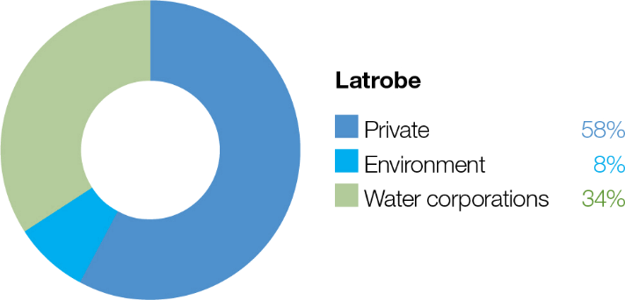

The Latrobe system includes Durt-Yowan (Latrobe River) and the lower Latrobe wetlands: Sale Common, Heart Morass and Dowd Morass.

Latrobe River
System overview
Durt-Yowan (Latrobe River) originates near the Baw Baw Plateau and passes through relatively flat to undulating plains, which have been largely cleared for agriculture, before flowing into Lake Wellington (the westernmost point of the Gippsland Lakes) (Figure 2.2.1). Notable tributaries include the Tanjil River, Narracan Creek, Morwell River, Tyers River, Traralgon Creek and Carran Carran (Thomson River).
Water for the environment is supplied to the Latrobe River from Blue Rock Reservoir on the Tanjil River. Blue Rock Reservoir also supplies water for irrigation, urban supply and electricity generation, and water for a paper mill in the Latrobe Valley.
The Latrobe River from Kilmany to the Thomson River confluence (reach 5) is a high-priority reach for delivering water for the environment because it contains endangered plant communities with good potential for rehabilitation. However, capacity constraints within reach 5 mean that some of the larger freshes required to meet environmental objectives in reaches 4, 5 and 6 cannot be delivered without flooding private land. Until this can be resolved, environmental flows will be managed to within- channel levels. Where possible, the flow in the Latrobe River is coordinated with freshes in the Thomson River to meet targets for the Latrobe River estuary.
Options to deliver water for the environment to the Latrobe River via the Tyers River may be investigated in 2023-24. These options include a physical transfer of water from Blue Rock Reservoir to Moondarra Reservoir via existing infrastructure operated by Gippsland Water or a temporary administrative transfer arrangement. Delivering water via the Tyers River would increase the proportion of the Latrobe catchment that could receive water for the environment without compromising outcomes in the main target reaches of the Latrobe River. If adopted, these options are expected to benefit native in-stream and streamside vegetation and non-migratory fish within the Tyers River.

Return to start of section

Figure 2.2.1 The Latrobe system

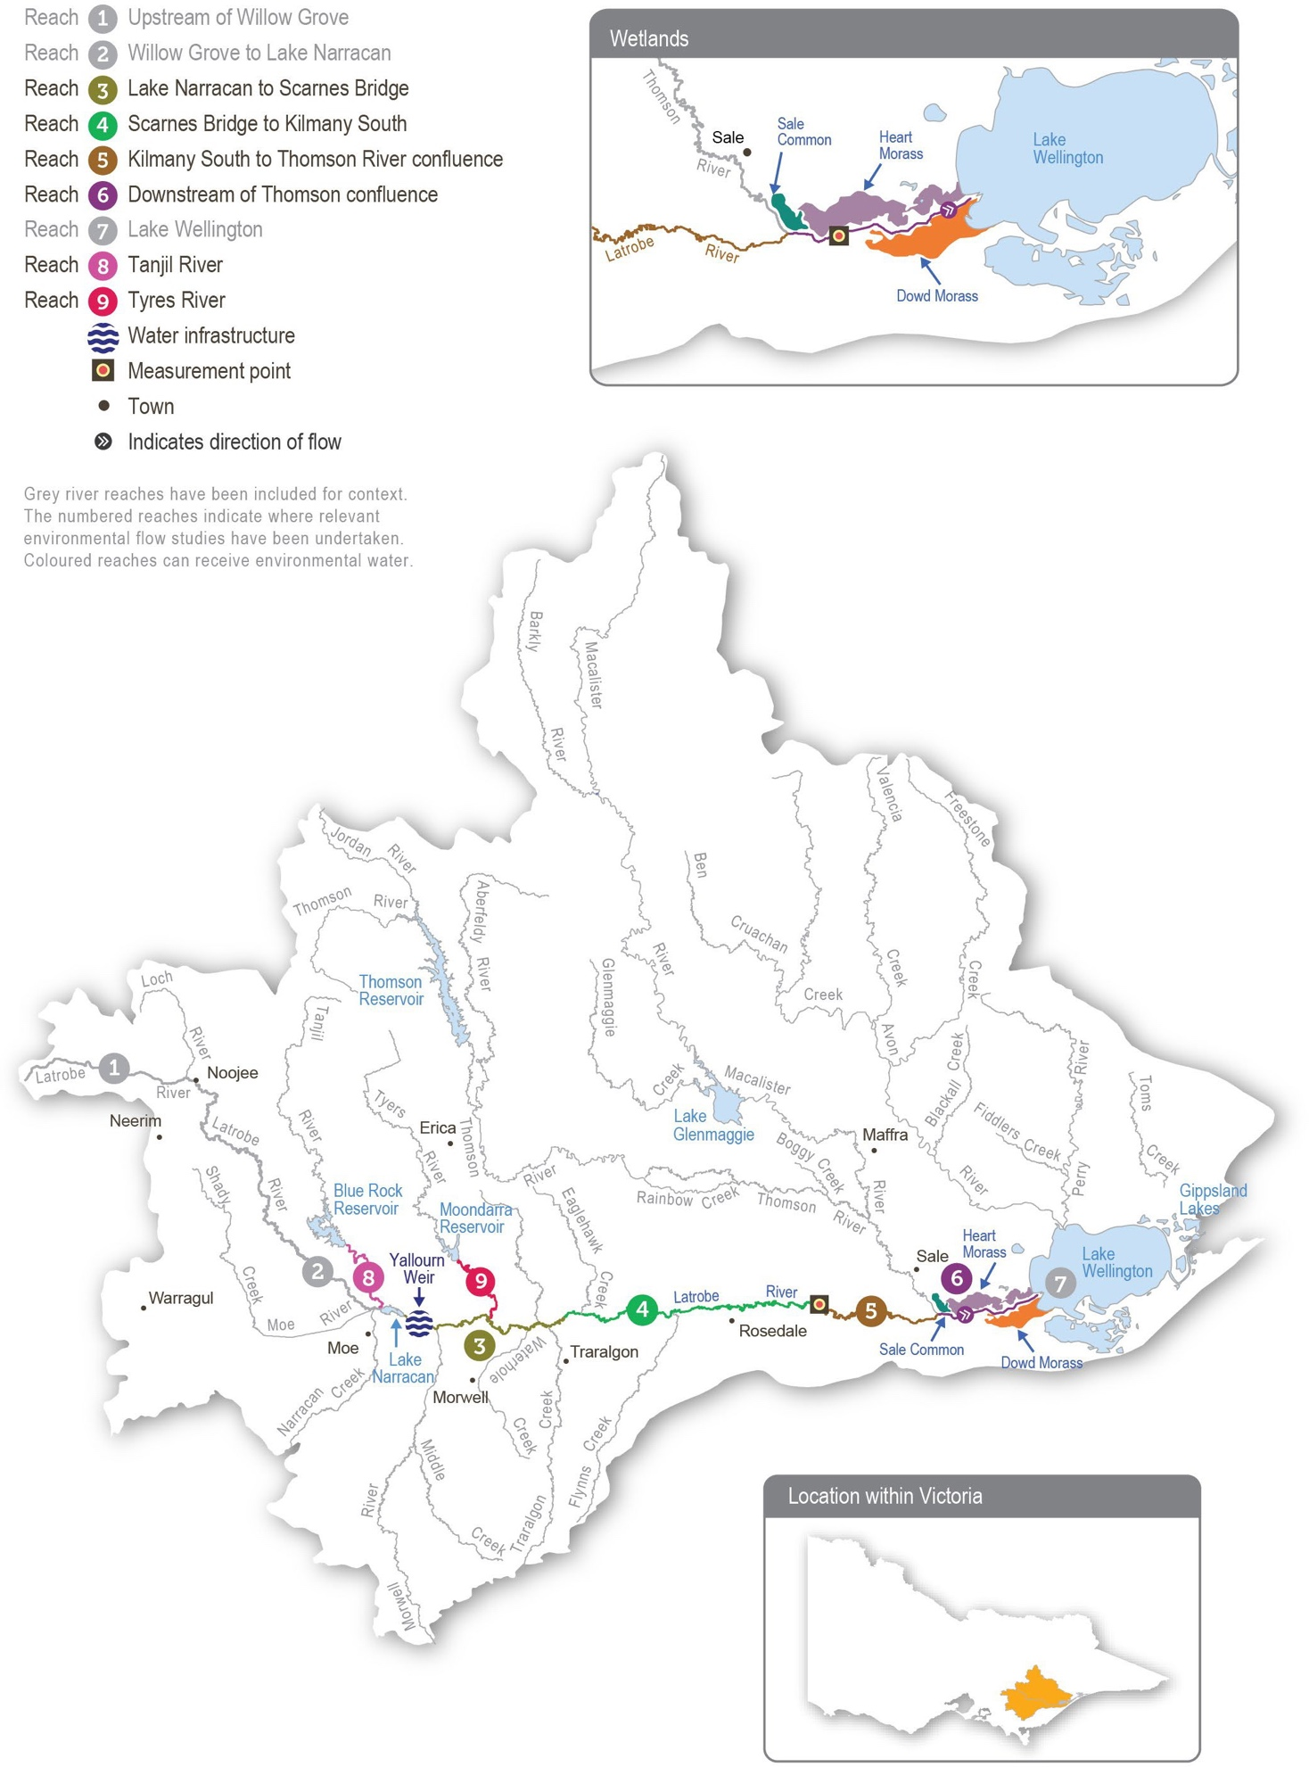
Return to start of section

Environmental values
The upper reaches of the Latrobe River flow through state forest and are relatively intact and ecologically healthy. They have continuous stands of river red gums and intact streamside vegetation, and they support native animals, including barred galaxias, river blackfish, Gippsland spiny crayfish and nankeen night herons.
Below Lake Narracan, the Latrobe River is regulated and highly degraded due to historic river management practices. Most large woody habitat has been removed from the river, and many sections have been artificially straightened. These practices have caused significant erosion and widened the channel, reducing the quality and quantity of habitat for aquatic plants and animals.
Endangered and vulnerable vegetation is found in all but the most modified sections of the Latrobe River. The banks along the lower reaches support stands of swamp scrub, characterised by swamp paperbark and tea tree. Mature river red gums grow adjacent to the lower Latrobe wetlands and provide nesting habitat for sea eagles and other birds of prey that hunt in the wetlands. The Latrobe River supports native estuarine and freshwater fish, including black bream, Australian bass, Australian grayling and short- and long-finned eel. The river also provides habitat and supports feeding and breeding conditions for platypus, rakali (water rats) and freshwater turtles.
The Latrobe River and its tributaries provide an essential source of freshwater to the Gippsland Lakes system, of which the lower Latrobe wetlands are an important component.

Environmental objectives in the Latrobe River
Increase native fish (migratory, resident and estuary) populations
Increase in-stream geomorphic diversity
Increase the extent of platypus and rakali (water rats) populations
Maintain the abundance of freshwater turtle populations
Improve the condition and increase the extent and diversity of submerged, emergent and streamside native vegetation
Reduce the extent and density of invasive plants
Increase the abundance of all macro- and micro-invertebrates
Avoid adverse water-quality conditions (such as high salinity) in the lower reaches of the Latrobe River and its estuary

Traditional Owner cultural values and uses
The Gunaikurnai have had a continued connection to Country for tens of thousands of years, including with the waterways in the Latrobe system.
For the Gunaikurnai as Traditional Owners, there are immense challenges to heal, protect and manage Country, which has been drastically altered since colonisation. “As Gunaikurnai, we see our land (Wurruk), waters (Yarnda), air (Watpootjan) and every living thing as one. All things come from Wurruk, Yarnda and Watpootjan and they are the spiritual life-giving resources, providing us with resources and forming the basis of our cultural practices. We have a cultural responsibility to ensure that all of it is looked after” (Water is Life: Traditional Owner Access to Water Roadmap 2022 - Gunaikurnai Nation Statement). This cultural landscape is dependent on culture and Aboriginal management.
Gunaikurnai Land and Waters Aboriginal Corporation (GLaWAC) is working with the West Gippsland CMA to determine how to express Gunaikurnai objectives for water in a way that contributes to seasonal watering proposals from the perspective of Traditional Owners with traditional knowledge. GLaWAC has membership of the Latrobe Environmental Water Advisory Group (EWAG).
Return to start of section

GLaWAC is working in partnership with the West Gippsland CMA to determine how cultural values and uses can be considered in planning for water for the environment. For the Latrobe system, this includes:
- undertaking Aboriginal Waterways Assessments to examine cultural values and uses and incorporating the findings of assessments into the Latrobe Environmental Water Requirements Investigation
- identifying primary objectives under the modified water regime
- supporting approaches to water management that recognise and promote healthy Country
- reinforcing the importance of the Durt-Yowan (Latrobe River) system to the Gunaikurnai creation story of Borun the pelican and Tuk the musk duck, and their water quality and habitat requirements
- implementation of cultural resource management
- waterways as meeting places, pathways and boundaries
- preliminary accommodation of the water quality and management requirements of species with cultural values and uses.

GLaWAC is sharing its knowledge with the West Gippsland CMA around plant and animal species of cultural significance in and around the waterways of the Latrobe Valley, and the importance of specific watering decisions to support them.
Watering requirements to support cultural values and uses include:
- timing the delivery of water for the environment planned in partnership with GLaWAC to support a seasonal flow regime and wet and dry periods that contribute to healthy Country
- maintaining freshwater supply to Latrobe estuary, Dowd Morass, Sale Common and Heart Morass, and associated freshwater habitats as the lower Latrobe wetlands are an important resource for the Gunaikurnai
- providing connectivity between reaches and onto floodplains to support dependent plants and animals with cultural values and uses of significance to the Gunaikurnai
- maintaining water quality to support the health of native plants and animals with cultural values and uses of significance to the Gunaikurnai.
West Gippsland CMA engaged with the GLaWAC Cultural Water Team on Durt-Yowan (Latrobe River) watering priorities for 2023-24, with engagement planned to continue in the 2023-2024 water year.

Social, recreational and economic values and uses
In planning the potential environmental watering actions in Table 2.2.1, the West Gippsland CMA considered how environmental flows could support values and uses, including:
- water-based recreation (such as fishing and water skiing)
- riverside recreation and amenity (such as birdwatching and game hunting)
- socioeconomic benefits (such as commercial fishing, tourism and improved water quality for domestic, irrigation and stock use).
If the timing or management of planned environmental flows may be modified to align with a community benefit, this is acknowledged in Table 2.2.1 with the following icon.

Watering planned to support water sports activities (e.g. water skiing)
The West Gippsland CMA plans the timing of releases of water for the environment so that they do not impact the lake’s water levels during water skiing events held between January and March.

Scope of environmental watering
The term ‘environmental watering’ refers to the active delivery of water for the environment to support particular environmental objectives by altering the flow in a river or the water level in a wetland. While other terms are also used to describe the delivery of water for the environment, ‘environmental watering’ is deliberately used here and in seasonal watering statements to ensure consistency in the legal instruments that authorise the use of water for the environment in Victoria.
Table 2.2.1 describes the potential environmental watering actions in 2023-24, their expected watering effect (that is, the intended physical or biological effects of the watering action) and the longer-term environmental objectives they support. Each environmental objective relies on one or more potential environmental watering actions and their associated physical or biological effects.

Return to start of section

Table 2.2.1 Potential environmental watering actions, expected watering effects and associated environmental objectives for the Latrobe River

Potential environmental watering action | Expected watering effects | Environmental objectives
Latrobe River (targeting reach 5)
Winter/spring low flow (620 ML/day during July to November 2023 and June 2024) | - Wet benches to maintain habitat, support the growth of emergent macrophyte vegetation and limit the encroachment of terrestrial vegetation  - Maintain oxygen levels in pools and maintain sediment (sands and silts) in suspension to prevent pools from filling and depositing on substrates, helping to maintain habitat for waterbugs, turtles, aquatic mammals and breeding substrate for river blackfish  - Maintain longitudinal connectivity to allow movement/dispersal of native fish, turtles, platypus and rakali (water rats)
Summer/autumn low flow (440 ML/day during December to May) | - Maintain an adequate depth in pool habitat to support native fish, turtles, platypus and rakali (water rats) and submerged vegetation  - Limit encroachment by terrestrial vegetation and support the growth of emergent macrophyte vegetation  - Mix pools to maintain oxygen levels suitable for aquatic animals
Summer/autumn river freshes (five to nine freshes of 980 ML/  day for one to five days during December to May) | Water-quality fresh (one-day duration):  - freshen water quality in pools to support fish, waterbug and zooplankton communities  - provide sufficient velocity to turn over and flush sediments (sands and silts) from pools, scour algae from hard surfaces and clean fine sediment from substrates, including river blackfish nesting habitats  Fish and vegetation fresh (three to five days duration):  - objectives of the one-day fresh as well as:  - wet benches to support the growth of emergent macrophyte vegetation  - provide longitudinal connectivity (including over benches for Australian grayling) for native fish, platypus and rakali (water rats)
Latrobe River (targeting reach 6)
Summer/autumn estuary fresh(es) (one to three freshes of 2,200 ML/ day for seven to 10 days during December to May)  Note: this is a combined magnitude with the Thomson River over  the equivalent period; a contribution of at least 1,220 ML/day from  the Thomson River is required | - Upper estuary: fully flush with freshwater to support submerged vegetation, provide adequate oxygen levels for aquatic animals, transport silt, wet benches, and deliver freshwater to connected wetlands  - Mid-estuary: partially/fully flush the upper layer of the water column to improve water quality, support emergent macrophytes, provide freshwater habitat and associated food sources for freshwater fish and provide breeding opportunities for estuary fish  - Lower estuary: partially flush the upper layer of the water column; a flow of this magnitude will also provide opportunities to fill the lower Latrobe wetlands
Scenario planning
Table 2.2.2 outlines potential environmental watering and expected water use in a range of planning scenarios. As seen in recent years, natural tributary inflows are likely to achieve many of the planned watering actions under the wetter planning scenarios, so all tier 1 actions proposed in the average and wet planning scenarios can be achieved with the available supply. High volumes of water carried over into 2023-24 also mean tier 1 actions proposed in the drought and dry planning scenarios can also be achieved with the available supply.
Return to start of section

Maintaining the target low flow throughout the year to provide habitat for native fish, turtles, platypus and rakali (water rats) and to support vegetation growth are high priorities in all planning scenarios. Delivering summer/autumn freshes to maintain water quality and provide specific opportunities for fish movement are also high priorities in all planning scenarios. Three consecutive wet years have meant the Latrobe River estuary and the lower Latrobe wetlands are the freshest they have been for many years, which has improved the condition and extent of streamside and wetland vegetation. Maintaining this level of freshness in the Latrobe River estuary on the back of three wet years to improve vegetation condition is a high priority in 2023-24.
Most of the recommended flows are likely to be fully achieved through a combination of natural events, operational releases, passing flows and environmental deliveries in the average and wet planning scenarios. There will be less natural inflow and lower operational releases in the drought and dry planning scenarios, and available water for the environment will be used to deliver a low flow and freshes at their lower recommended magnitude, duration and frequency to maintain rather than improve current environmental conditions in the Latrobe River. Maintaining the recommended minimum low flow during summer/ autumn will be the highest priority in the drought and dry planning scenarios to avoid poor water quality and a reduction of pool habitats that could threaten populations of native fish, platypus and turtles. It is expected that even in the drought and dry planning scenarios, passing flow and natural inflows from unregulated tributaries will provide some flow through the system during winter and spring.
Freshes with larger magnitudes and longer durations (up to 10 days) may be coordinated with the flow in the Thomson River in all planning scenarios to meet environmental flow objectives in the Latrobe River estuary (reach 6). Summer/autumn estuary freshes also achieve the objectives of river freshes in reach 5 and will likely be met naturally in the wet and possibly the average planning scenarios. In the drier planning scenarios, estuary freshes are achieved by extending the duration of summer/autumn river freshes.
There are no true carryover provisions in the Latrobe system. Rather, the VEWH maintains an ongoing share of storage capacity in Blue Rock Reservoir. In the drought and dry planning scenarios, ensuring a minimum of 5,000 ML is maintained in storage at the end of 2023-24 to help deliver critical watering actions in 2024-25 will be important. Natural inflows will likely
meet some planned watering actions in the average and wet planning scenarios in 2023-24 and result in some leftover water at the end of the year. This leftover water will help support potential environmental watering actions in 2024-25, and no specified carryover target has been set or prioritised for the wet planning scenario.
Table 2.2.2 Potential environmental watering for the Latrobe River in a range of planning scenarios

Planning scenario | Drought | Dry | Average | Wet
Expected conditions | - Small contributions to low flow from unregulated reaches and tributaries  - Passing flow likely reduced over summer/autumn | - Possible spills from storages in spring, minor flood levels may occur  - Some natural flow contributing to low flow and freshes  - Passing flow likely reduced over summer | - Regular spills from storages in spring and minor to moderate flood levels may occur  - Natural flow and/or passing flow likely to meet low-flow requirements | - Large and frequent spills from storages and moderate to major flood levels may occur  - Natural flow and/ or passing flow are likely to meet low- flow requirements
Expected availability of water for the environment | - 25,800 ML | - 28,400 ML | - 31,500 ML | - 36,200 ML
Potential environmental watering – tier 1 (high priorities) | Tier 1 (can be achieved with predicted supply)
 | - Winter/spring low flow  - Summer/autumn low flow  - Summer/autumn river freshes (four freshes of lower duration and one of mid-duration [four days])  - Summer/autumn estuary freshes (two freshes of lower duration) | - Winter/spring low flow  - Summer/autumn low flow  - Summer/autumn river freshes (five freshes of lower duration and two of mid-duration [three days])  - Summer/autumn estuary freshes (two freshes of upper duration) | - Winter/spring low flow  - Summer/autumn low flow  - Summer/autumn river fresh (six freshes of lower duration and three of mid-duration [four days])  - Summer/autumn estuary freshes (three freshes of upper duration) | - Winter/spring low flow  - Summer/autumn low flow  - Summer/autumn river fresh (six freshes of lower duration and three of upper duration [five days])  - Summer/autumn estuary freshes (three freshes of upper duration)

Planning scenario | Drought | Dry | Average | Wet
Possible volume of water for the environment required to achieve objectives | - 16,400-20,600 ML  (tier 1) | - 16,900-22,100 ML  (tier 1) | - 22,700-30,200 ML  (tier 1) | - 15,800-35,600 ML  (tier 1)
Priority carryover requirements for 2024-25 | - 5,000 ML | - 5,000 ML | - 0-3,000 ML | - 0 ML

Lower Latrobe wetlands
System overview
The lower Latrobe wetlands (Dowd Morass, Heart Morass and Sale Common) are an important component of the internationally recognised Gippsland Lakes Ramsar site and provide habitat for waterbirds of state, national and international conservation significance. The wetlands are located on the floodplain of Durt-Yowan (Latrobe River) between its confluence with Carran Carran (Thomson River), and they form part of the Gippsland Lakes system.
River regulation and water extraction from the Latrobe, Thomson and Macalister rivers have reduced the frequency of small and medium-sized floods that naturally wet the lower Latrobe wetlands. The construction of levees and drains and the filling of natural depressions have also altered water movement into and through the wetlands. The drainage and flooding regime in all three wetlands is now managed to some extent with regulators connected to the Latrobe River.
Environmental values
Sale Common is one of only two remaining freshwater wetlands in the Gippsland Lakes system. It provides sheltered feeding, breeding and resting habitat for diverse waterbirds, including the Australasian bittern.
Dowd Morass is a large, brackish wetland that regularly supports rookeries of colonial nesting waterbirds, including Australian white ibis, straw-necked ibis, little black and little pied cormorants, royal spoonbills and great egrets.
Heart Morass is also a large brackish wetland, with open expanses providing shallow feeding habitat for waterbirds, including black swans, Eurasian coots and various duck species. The lower Latrobe wetlands function as a diverse and complementary ecological system. Colonial nesting waterbirds breed among swamp paperbark trees at Dowd Morass in spring. Migratory shorebirds feed on the mudflats that are exposed as the wetlands draw down and dry over the summer. Waterfowl and fish- eating birds use open-water habitat at the wetlands year-round. The wetlands also support threatened vegetation communities, including swamp scrub, brackish herbland and aquatic herbland.

Environmental objectives in the lower Latrobe wetlands
 | Maintain the abundance of frog populations
 | Maintain the abundance of freshwater turtle populations
Maintain a variety of self-sustaining submerged and emergent aquatic vegetation types Maintain the diversity, condition and/or extent of native streamside vegetation fringing wetlands
Discourage the introduction and reduce the extent and density of undesirable/invasive plants (Sale Common)
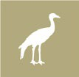 | Enhance waterbird breeding, recruitment, foraging and sheltering opportunities
Provide suitable physio-chemical conditions to support aquatic life
Avoid catastrophic water-quality conditions (such as acid sulfate soil exposure) (Heart Morass)

Traditional Owner cultural values and uses
The lower Latrobe wetlands are a place of spiritual and cultural connection for the Gunaikurnai people. Over many thousands of years, customs and lore have been passed orally between generations about the cultural values and uses of the wetlands and their importance to all Gunaikurnai people. The wetlands are on the lands of the Brayakaulung clan of the Gunaikurnai.
Return to start of section
For the Gunaikurnai, the overarching objective for the wetlands is to provide and maintain healthy Country. Healthy Country includes the importance of place and the health of the entire ecosystem, including maintaining water quality, controlling pest species and maintaining a natural, seasonal flow regime and overbank flood events.
Environmental objectives for the delivery of water for the environment for the lower Latrobe wetlands should take a cultural landscape approach.
Watering requirements to support cultural values and uses include:
- timing the delivery of water for the environment planned in partnership with the Gunaikurnai Land and Waters Aboriginal Corporation (GLaWAC) to support a seasonal flow regime and wet and dry periods that embody healthy Country
- maintaining freshwater supply to the Durt-Yowan (Latrobe River) estuary, Dowd Morass, Sale Common and Heart Morass and associated freshwater habitats
- providing connectivity between reaches and onto floodplains and maintaining water quality to support cultural values and uses of significance to the Gunaikurnai.
The lower Latrobe wetlands support many keystone species important to the Gunaikurnai. Borun (pelican) and Tuk (musk duck) are the father and mother in the Gunaikurnai creation story. If Borun and Tuk are living and breeding at the wetlands, it is a sign that Country is healthy. If they are not, flows should be provided to promote required habitat and ecosystem services.
Other birds are important for woorngan (hunting) and food, including nalbong (water hens), gidai (black swans), boyangs (eggs) and koortgan (ducks except for tuk). Gidai require submerged and softer emergent vegetation to make nest mounds, placing them on a small island or floating them in deeper water. Gidai breed in late Winter to early Spring after the water level rises. Actions that fill the large wetlands and support the growth of loombrak (water ribbon) and submerged aquatic plants will support gidai. Ensuring that the lower wetlands and floodplain depressions (for example, billabongs) receive freshwater flows in Winter/Spring will provide the conditions for submerged and emergent aquatic plants to grow and provide food and nesting materials for the waterbirds.
GLaWAC is developing a vision for the wetlands that aligns with the Gunaikurnai Whole-of-Country Plan. Key aspects of the vision include:
- healthy Country: reflecting the spiritual and cultural values of the Gunaikurnai custodians; healthy Country contributes to the wellbeing of the Gunaikurnai
- water access: access to water is crucial for many cultural values, including identity and relational values, future economic values and place values, among many others. Access to water, through ownership or management, means that water is made available to the Gunaikurnai on the Latrobe and Thomson systems to provide freshwater to the wetlands. Every effort should be made to maintain freshwater-dependent values, which in turn deliver cultural values
- cultural and economic use: returning to cultural practices and Gunaikurnai-informed management at the lower Latrobe wetlands is key to returning to a more freshwater habitat for cultural uses and cultural species. It will also provide for water- based tourism, cultural education and ecotourism (camping) experiences
- connection: GLaWAC takes its responsibility to work closely with the people it represents on management decisions concerning Country and the health of Country very seriously. Gunaikurnai cultural obligations reflect Gunaikurnai views on healthy Country and, in turn, help the Gunaikurnai continue their ongoing connection to the land and waters of Country
- climate change: the Gunaikurnai have cared for Country for thousands upon thousands of years through many cycles
of climatic change, and they understand how to manage the landscape as it too changes. When cared for using traditional knowledge, Country can be healed. Mitigation of climate change impacts affecting the lakes, rivers and other waterways of the lower Latrobe wetlands can be effective with resources and empowerment provided to the Gunaikurnai.
Increasing the involvement of Traditional Owners in environmental flows management and progressing opportunities towards self-determination in the environmental watering program is a core commitment of the VEWH and its agency partners. This is reinforced by a range of legislation and policy commitments, including the Water Act 1989, the Victorian Aboriginal Affairs Framework, the 2016 Water for Victoria, the 2022 Water is Life: Traditional Owner Access to Water Roadmap and in some cases, agreements under the Traditional Owner Settlement Act 2010.
Where Traditional Owners are more deeply involved in the planning and/or delivery of environmental flows for a particular site, their contribution is acknowledged in Table 2.2.3 with an icon. The use of this icon is not intended to indicate that these activities are meeting all the needs of Traditional Owners but is incorporated in the spirit of valuing that contribution.

Watering planned and/or delivered in partnership with Traditional Owners to support cultural values and uses
GLaWAC and West Gippsland CMA are exploring opportunities to align environmental flows with Gunaikurnai outcomes in the lower Latrobe wetlands. In 2023-24, a Gunaikurnai cultural event is planned at Dowd Morass. This event will be jointly managed with WGCMA and will coincide with delivery of water for the environment. The timing of the event will be decided by GLaWAC, after some water quality and fish monitoring.
Return to start of section
In early 2023, the West Gippsland CMA met with GLaWAC to discuss 2023-24 environmental watering priorities in the lower Latrobe wetlands, with further engagement planned in the 2023-2024 water year.
Social, recreational and economic values and uses
In planning the potential environmental watering actions in Table 2.2.3, the West Gippsland CMA considered how environmental flows could support values and uses, including:
- water-based recreation (such as canoeing and fishing)
- riverside recreation and amenity (such as birdwatching, bushwalking, camping and duck hunting)
- socioeconomic benefits (such as commercial eel and carp fishing and tourism).
Scope of environmental watering
The term ‘environmental watering’ refers to the active delivery of water for the environment to support particular environmental objectives by altering the flow in a river or the water level in a wetland. While other terms are also used to describe the delivery of water for the environment, ‘environmental watering’ is deliberately used here and in seasonal watering statements to ensure consistency in the legal instruments that authorise the use of water for the environment in Victoria.
Table 2.2.3 describes the potential environmental watering actions in 2023-24, their expected watering effect (that is, the intended physical or biological effects of the watering action) and the longer-term environmental objectives they support. Each environmental objective relies on one or more potential environmental watering actions and their associated physical or biological effects.
Table 2.2.3 Potential environmental watering actions, expected watering effects and associated environmental objectives for the lower Latrobe wetlands

Potential environmental watering action | Expected watering effects | Environmental objectives
Sale Common
Top-up (anytime, following bird breeding event if required) | - Prolong wetting of reed beds to maintain habitat and food resources for nesting waterbirds and protect chicks from predators
Partial fill (in July to August1 with top-ups as required to maintain water depth of at least  0.3 m AHD and surface coverage year-round) | - Encourage the growth and flowering of semi-aquatic plants  - Provide appropriate wetland habitat for frogs and turtles  - Provide conditions that support waterbug communities and food resources for waterbirds
Fill (with top-ups as required during August to November to maintain a water depth of 0.4 m AHD for two months) | - Wet the outer boundaries of the wetland to support the growth and flowering of streamside and fringing wetland plants, increasing foraging opportunities for waterbirds  - Encourage bird and turtle breeding by providing nesting habitat  - Provide connectivity between the river and wetlands and increase habitat and feeding opportunities for frogs and turtles
Trigger-based fill or top- up to 0.5 m AHD (during December to January)  Trigger: requirement to drown out invasive vegetation | - Wet key habitats within the wetland for a sufficient duration to discourage invasive plants, particularly the excessive spread of giant rush
Partial drawdown (during December to March) | - Oxygenate sediments to enable aquatic vegetation germination and recruitment  - Provide water level fluctuations for emergent vegetation reproduction and expansion (particularly swamp scrub and tall marsh)  - Break down organic matter and promote nutrient cycling  - Expose mudflats and create shallows to facilitate waterbird foraging

Potential environmental watering action | Expected watering effects | Environmental objectives
Dowd Morass
Top-up (any time, following bird breeding event if required) | - Prolong wetting of reed beds to maintain habitat and food resources for waterbirds and protect chicks from predators, following an observed breeding event
Fill to control salinity (anytime) | - Dilute salt concentrations within the wetland that may be caused by king tides from Lake Wellington (likely occurring between March to May) or other sources  - This watering action is likely to be triggered1 if electrical conductivity rises and reaches 7,000 µS/cm
Partial fill (with top-ups as required to maintain a water depth of 0.3 m AHD during July to December 2023 and April to June 20242) | - Provide seasonal variation in water depth throughout the wetland to support the growth and flowering of semi-aquatic plants  - Wet vegetation and soils at middle elevations within the wetland to increase the abundance of waterbugs and other food resources for frogs, turtles and waterbirds  - Provide connectivity between the river and wetlands and between wetlands, increasing available habitat for frogs and turtles  - Support bird breeding (when delivered in spring/early summer following earlier fill) by maintaining wetted habitat around reed beds
Fill (with top-ups as required to maintain a water depth of 0.6 m AHD during August to November) | - Wet reed beds and deep water next to reedbeds to provide waterbird nesting habitat and stimulate bird breeding  - Wet high-elevation banks and the streamside zone to support vegetation growth, creating nesting habitat for waterbirds  - Wet vegetation and soils at higher elevations to stimulate ecosystem productivity and increase the abundance of waterbugs and other food resources for frogs, turtles and waterbirds  - Provide connectivity between the river and wetlands and between wetlands, increasing available habitat and food resources for frogs and turtles  - Reduce the impact of saltwater incursion from Lake Wellington
Partial drawdown (during January to March) | - Oxygenate sediments to enable aquatic vegetation to germinate and recruit  - Provide water level fluctuations for emergent vegetation reproduction and expansion (particularly swamp scrub and tall marsh)  - Break down organic matter and promote nutrient cycling  - Expose mudflats and create shallows to facilitate waterbird foraging
Heart Morass
Top-up to permanently maintain water level above -0.3 m AHD (anytime) | - Minimise the risk of acid sulfate soils developing by keeping known high- risk areas wet  - Respond to decreasing pH from the rewetting of exposed acid sulfate soils (most likely during high-wind events)  - Dilute salt concentrations within the wetland that may be caused by king tides from Lake Wellington or other sources. This watering action is likely to be triggered3 if wetland overtopping appears likely; based on rising water levels at Lake Wellington (reaching or exceeding +0.5 m AHD)
Top-up (anytime up to  0.5 m AHD, following bird breeding event if required) | - Prolong wetting of reed beds to maintain habitat and food resources for waterbirds and protect chicks from predators, following an observed breeding event

Potential environmental watering action | Expected watering effects | Environmental objectives
Fill and partial flushing flow (during July to November4) | - Wet high-elevation banks and streamside zone to support vegetation growth, create nesting and foraging habitat for waterbirds and provide food resources for terrestrial birds  - Provide connectivity between the river and wetlands and between wetlands, increasing available habitat and providing food resources for frogs and turtles  - Export accumulated salts and sulfates and transport nutrients, dissolved organic carbon and seeds between the Latrobe River and Heart Morass
Partial fill (with top-ups as required to maintain a minimum water depth of 0.3 m AHD during August to December1) | - Support the growth and flowering of semi-aquatic plants  - Provide appropriate wetland fringing habitat for frogs and turtles  - Provide conditions that support waterbug communities and food resources for frogs, turtles and waterbirds
Partial drawdown (during January to March) | - Oxygenate sediments to enable aquatic vegetation to germinate and recruit  - Provide water level fluctuations for emergent vegetation reproduction and expansion (particularly swamp scrub and tall marsh)  - Break down organic matter and promote nutrient cycling  - Expose mudflats and create shallows to facilitate waterbird foraging
1 If the salinity level in the Latrobe River exceeds 15,000 µS/cm, a fill will not be provided.
2 This is the likely timing in the drought scenario. In the average or wet scenarios, a fill event may occur during this period, as detailed in Table 2.2.4.
3 If the salinity level in the Latrobe River exceeds 10,000 µS/cm, a top-up will not be provided.
4 If a partial flushing flow is not possible until the end of November, top-ups will be provided to maintain a fill with a minimum water depth of 0.5 m AHD.
Scenario planning
Table 2.2.4 outlines potential environmental watering and expected water use in a range of planning scenarios.
Wet conditions over the last three years have caused natural flooding and flushing flows through all of the lower Latrobe wetlands, which have improved the condition and extent of most native wetland vegetation and triggered significant waterbird breeding. However, prolonged inundation has also caused partial dieback of swamp paperbark communities around the fringes of Dowd Morass. The main environmental watering priorities in 2023-24 will be partially filling each wetland in winter/ spring to prevent complete drying over summer and autumn. The proposed watering actions aim to consolidate environmental outcomes from the past three wet years and build ecosystem resilience ahead of future dry periods. The wetlands can only be filled when water levels and water quality in the lower reaches of the Latrobe River are suitable, and therefore the timing and extent of water delivery will be influenced by natural climatic conditions and flow in the Latrobe River. Only partial fills
will likely be possible in the drought planning scenario, and natural overbank floods are likely at any time of year in the wet planning scenario. Trigger-based inflows to address a potential acid sulfate soil risk, support a natural waterbird breeding event or control invasive vegetation will be delivered when needed and possible, even if the timing of these actions compromises other planned wetting or partial drawdown events. Specific watering plans for each wetland in different planning scenarios are described below.
Sale Common
The aim for Sale Common is to partially fill the wetland in winter and provide top-ups as needed to maintain water levels above
0.3 m AHD throughout the year, which will wet about half of Sale Common. Maintaining at least a partial fill is considered ecologically important to support wetland plant communities and provide habitat for frogs, turtles and waterbirds. This is likely to be the maximum water level achieved in the drought planning scenario. Completely filling the wetland in late winter or early spring is a low priority in 2023-24, as the objectives for this action have been met for the past three years.
Allowing the wetland to partially draw down naturally over the warmer months to promote the germination of emergent vegetation is a high priority in all planning scenarios, although there may be a limited drawdown in the average and wet planning scenarios. A trigger-based fill or top-up during December or January to control the spread of giant rush remains a high priority, and delivering this event may be prioritised over a partial drawdown if an increase in the extent of giant rush is observed. Facilitated drawdown (by opening regulator gates) is not proposed in 2023-24 unless it is deemed necessary to control carp. If climatic conditions only allow a limited drawdown in 2023-24, the wetland may be actively drawn down in 2024-25 to facilitate nutrient cycling and other dry-phase ecosystem processes.
Dowd Morass
The plan at Dowd Morass is to maintain the water level above 0.3 m AHD from June to December 2023 and from April to June 2024 and allow the wetland to partially draw down (without complete drying) between January and March 2024. This proposed watering regime will provide sufficient variation in the water level to support the needs of a range of vegetation communities
Return to start of section

within and beside the wetland and provide habitat and food for native frogs, turtles and waterbirds. After several wet years, the partial drawdown over summer will be particularly important to reduce damage to swamp paperbark communities around the wetland fringes, facilitate carbon and nutrient cycling in drying soils, and provide foraging habitat for wading shorebirds.
The proposed watering regime described above may need to be modified if wet conditions naturally fill the wetland or additional water is needed to support a large waterbird breeding event or dilute saline water from king tides. Completely filling Dowd Morass is a lower priority in 2023-24 because the environmental objectives for this action have been met by natural floods in each of the past two years, and another fill may further damage swamp paperbark trees around the wetland perimeter.
Heart Morass
Acidity and salinisation represent a high risk to environmental values at Heart Morass, and maintaining water levels above -0.3 m AHD at all times is a high priority to avoid exposing potential acid sulfate soils. Heart Morass was filled and fully flushed in 2021-22 and 2022-23, which removed accumulated salt and sulphides and reduced the immediate risk of
acid sulfate soils. Filling and providing flushing flows are, therefore, a low priority in 2023-24 but may still be considered in all planning scenarios if they can be delivered in combination with a natural flood to lower the risk of acid sulfate soils occurring in subsequent years.
The preferred watering strategy in all planning scenarios involves partially filling the wetland from winter to early summer and maintaining the water level above -0.3 m AHD for the rest of the year. The partial fill in winter and spring will support established wetland plant communities and increase the available habitat and food for frogs, turtles and waterbirds. To expose shoreline habitat, a partial drawdown in summer and autumn 2024 is a high priority in all climate scenarios. This will
increase the diversity of vegetation communities, allow nutrient cycling and provide foraging habitat for shorebirds. Significant drawdown is unlikely in the average and wet planning scenarios.
Table 2.2.4 Potential environmental watering for the lower Latrobe wetlands in a range of planning scenarios

Planning scenario | Drought | Dry | Average | Wet
Expected conditions | - No natural inflow from the Latrobe River and wetlands are likely to dry completely | - Minor natural inflow from the Latrobe River in winter/spring;  expect moderate to substantial drying in summer | - Moderate winter/ spring flow in the Latrobe River  is likely to fill or partially fill the wetlands; expect minor drying in summer | - Major flow in the Latrobe River in winter/spring and possibly autumn/ winter is likely to fill all wetlands with very little drying in summer
Sale Common
Potential environmental watering – tier 11  (high priorities) | - Top-up (any time following bird breeding)  - Partial fill (with top-ups as required)  - Trigger-based fill or top-up to 0.5 m AHD (during December to January, if required)  - Partial drawdown (during December to March)
Potential environmental watering – tier 2 (additional priorities) | - Fill (with top-ups as required during August to November) |  |  | - N/A
Dowd Morass
Potential environmental watering – tier 11  (high priorities) | - Top-up (any time following bird breeding)  - Fill (any time to control salinity)  - Partial fill (with top-ups as required in July to December and April to June)  - Partial drawdown (during January to March)
Potential environmental watering – tier 2 (additional priorities) | - Fill (with top-ups as required during August to November) |  | - N/A
Heart Morass
Potential environmental watering – tier 11 (high priorities) | - Top-up (any time to permanently maintain water level above -0.3 m AHD)  - Top-up (any time following bird breeding)  - Partial fill (with top-ups as required during August to December)  - Partial drawdown (during December to March)

Planning scenario | Drought | Dry | Average | Wet
Potential environmental watering – tier 2 (additional priorities) | - Fill and partial flushing flow (during July to November)

1 Potential environmental flows at the lower Latrobe wetlands are not classified as tier 1a or tier 1b because there is no limitation on the volume of water that can be supplied to the site from the Latrobe River. Water can be diverted to the lower Latrobe wetlands at any time of the year when flows are above -0.7 m AHD in the Latrobe River at the Swing Bridge gauging station.

Return to start of section

Thomson system
Waterway manager – West Gippsland Catchment Management Authority
Storage managers – Melbourne Water (Thomson Reservoir), Southern Rural Water (Cowwarr Weir)
Environmental water holder – Victorian Environmental Water Holder

System overview
Carran Carran (Thomson River) flows from the slopes of the Baw Baw Plateau to join Durt-Yowan (Latrobe River) south of Sale (Figure 2.3.1). The major tributaries of the Thomson River are the Aberfeldy and Jordan rivers in the upper reaches and Wirn wirndook Yeerung (Macalister River) in the lowest reach. Two major structures regulate flow on the Thomson River: Thomson Reservoir — the largest water supply storage for metropolitan Melbourne — and Cowwarr Weir — a regulating structure that supplies irrigation water to parts of the Macalister Irrigation District.
Thomson Reservoir harvests most of the flow from the upper catchment of the Thomson River and significantly affects the flow in all downstream reaches. The Aberfeldy River now provides most of the natural flow to the Thomson River below Thomson Reservoir and is essential for providing natural freshes and a high flow.
Water for the environment is held in the Thomson Reservoir and released into the river as required. Reach 3 of the Thomson River (from the Aberfeldy River confluence to Cowwarr Weir) is the highest priority for delivery of water for the environment due to its heritage river status, high-value native streamside vegetation, high-quality in-stream habitat and low abundance of exotic fish species.
At Cowwarr Weir, the Thomson River splits into the old Thomson River course (reach 4a) and Rainbow Creek (reach 4b) (see Figure 2.3.1). Passing flow throughout the year is split two-thirds down reach 4a and one-third down reach 4b to avoid impacts to irrigators located on Rainbow Creek. Water for the environment is primarily delivered to the old Thomson River course (reach 4a) to support fish migration as Cowwarr Weir impedes fish movement through Rainbow Creek.
The Heyfield wetlands is a cluster of pools located between the Thomson River and the township of Heyfield. The construction of levees and weirs along the Thomson River means that river water rarely enters the wetlands. While the largest pool receives stormwater from the Heyfield township, smaller ponds rely on rainfall or pumped water for the environment to maintain environmental values. These values include wetland plant communities planted in recent years as part of a comprehensive revegetation program.

Return to start of section

Figure 2.3.1 The Thomson system

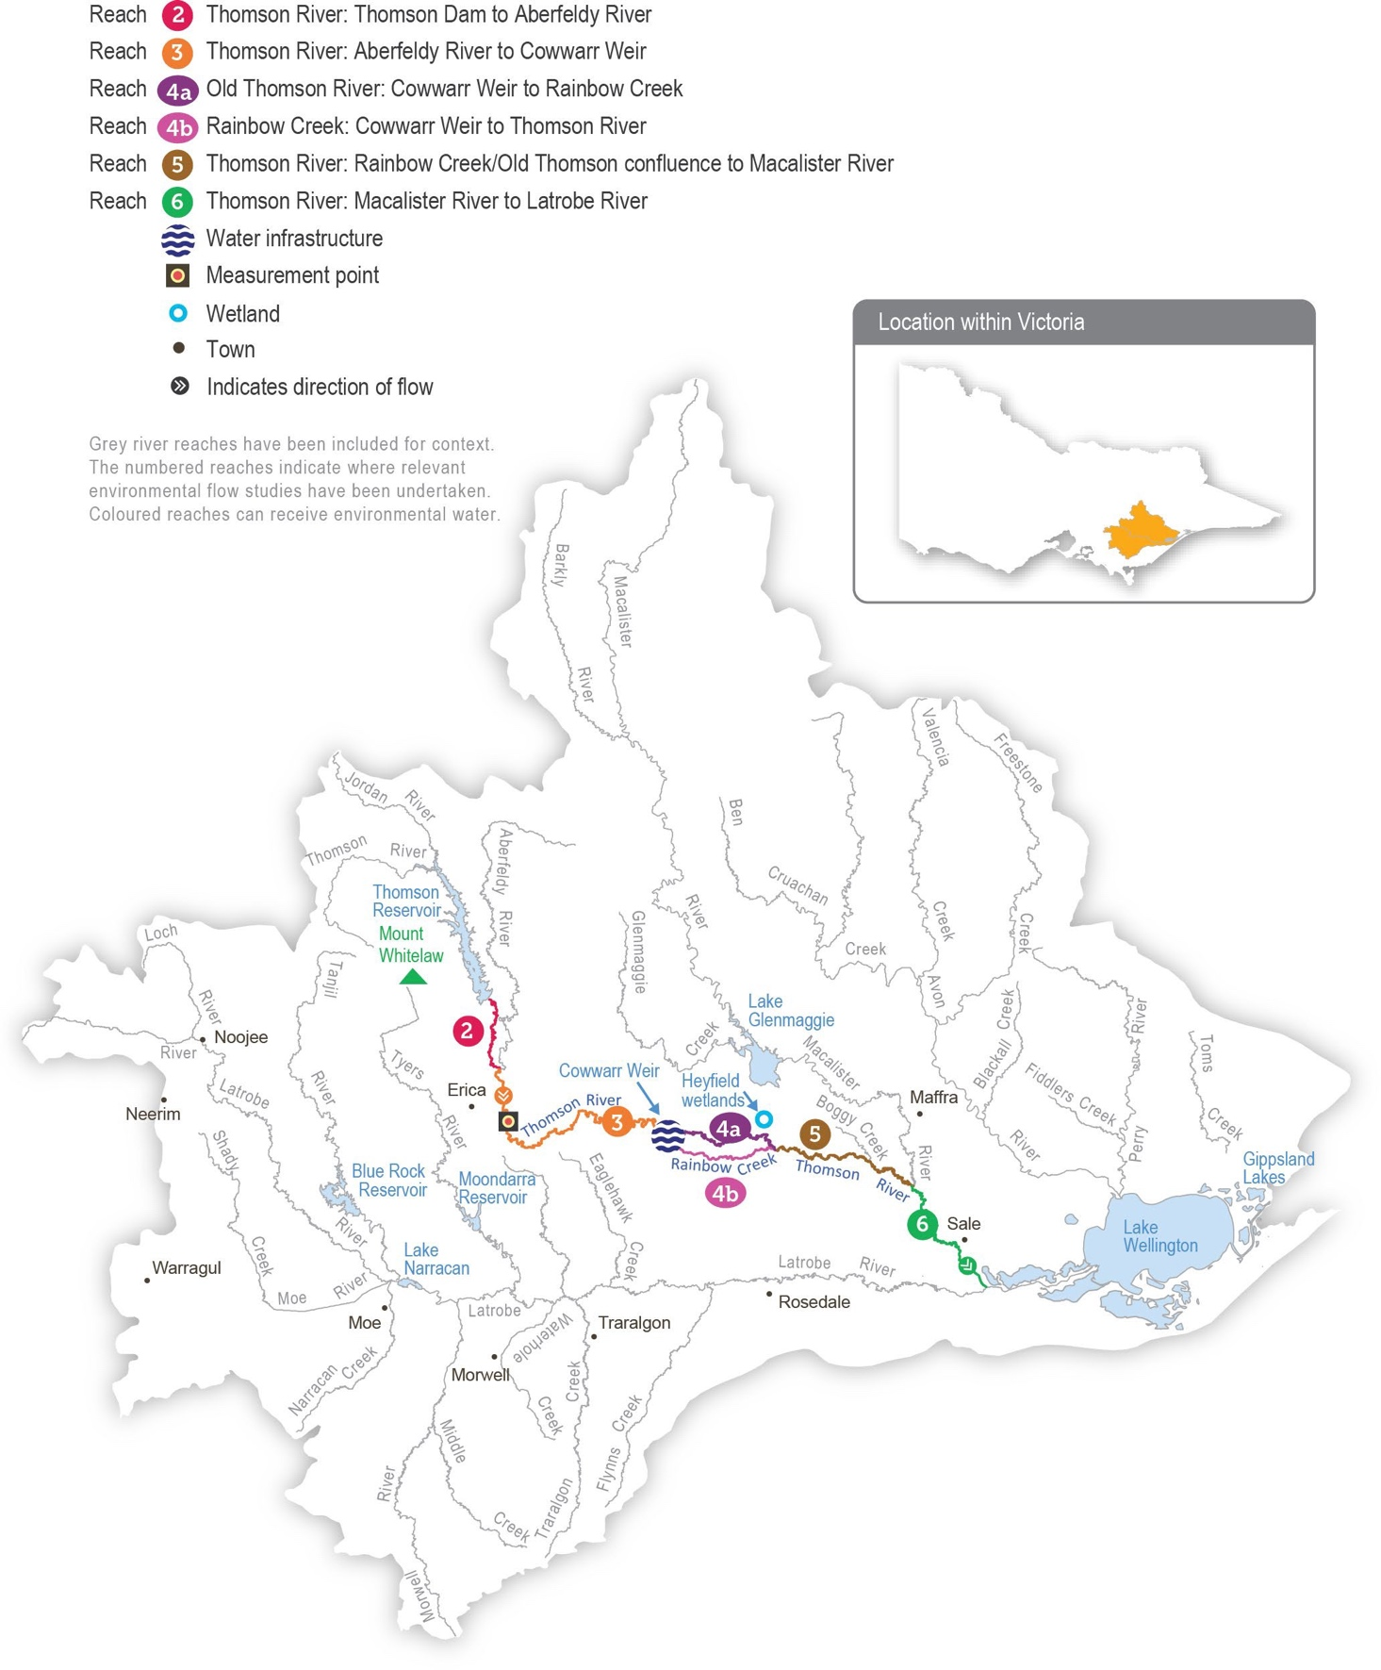

Return to start of section

Environmental values
The Thomson River supports native species of migratory fish that need to move between the sea and freshwater environments to complete their life cycles, including Australian grayling, tupong, short- and long-finned eel, Australian bass and pouched and short-headed lamprey. A focus for environmental flow management is the Australian grayling, which is a threatened species
in Victoria. Australian grayling spawn in response to autumn freshes, and the larvae and juveniles spend time at sea before returning to the freshwater sections of coastal rivers.
The composition and condition of streamside vegetation vary throughout the Thomson River catchment. The vegetation is intact and in near-natural condition above Thomson Reservoir in the Baw Baw National Park. Streamside vegetation between Thomson Reservoir and Cowwarr Weir is mostly in good condition but is affected by exotic weeds, including blackberry and gorse. Below the Cowwarr Weir, the vegetation is degraded due to stock access and widespread weed invasion.
The Heyfield wetlands are among the few remaining freshwater wetland sites in the Gippsland Plains landscape. They provide habitat for aquatic and terrestrial animals, including threatened migratory birds that prefer shallow, slow-moving waterbodies.

Environmental objectives in the Thomson system
Restore populations of native fish, specifically Australian grayling Enhance the structure of native fish communities
Maintain the existing frog population and provide suitable habitat
Maintain the physical form of the channel to provide a variety of channel features and habitats for aquatic animals Enhance river function by maintaining substrate condition and enabling carbon cycling
Increase the abundance of platypus
Maintain the structural diversity and appropriate distribution (zonation) of streamside vegetation along the riverbank and reduce terrestrial encroachment/invasion (Thomson River)
Increase the recruitment and growth of native in-stream, fringing and streamside vegetation (Thomson River)
Maintain the existing vegetation and promote the growth and establishment of semi-aquatic species (Heyfield wetlands)
Enhance the resilience of semi-aquatic species (Heyfield wetlands)
Provide freshwater habitat for migratory and non-migratory wetland birds within the Gippsland Plains landscape
Maintain the natural invertebrate community
Improve water quality in the Thomson River estuary
Traditional Owner cultural values and uses
The Gunaikurnai have had a continued connection to Gunaikurnai Country for many thousands of years, including with the waterways in the Latrobe system, into which Carran Carran (Thomson River) feeds. For the Gunaikurnai as Traditional Owners, there are immense challenges to heal, protect and manage Country which has been drastically altered since
colonisation. “As Gunaikurnai, we see our land (Wurruk), waters (Yarnda), air (Watpootjan) and every living thing as one. All things come from Wurruk, Yarnda and Watpootjan and they are the spiritual life-giving resources, providing us with resources and forming the basis of our cultural practices. We have a cultural responsibility to ensure that all of it is looked after” (Water is Life: Traditional Owner Access to Water Roadmap 2022 - Gunaikurnai Nation Statement). This cultural landscape is dependent on culture and Aboriginal management.
The Gunaikurnai Land and Waters Aboriginal Corporation (GLaWAC) is working with the West Gippsland CMA to determine how to express Gunaikurnai objectives for water in a way that contributes to seasonal watering proposals from the perspective of traditional custodians with traditional knowledge. GLaWAC was a member of the Steering Committee and Project Advisory Group for the 2020 review of the Carran Carran (Thomson River) FLOWS study and has membership on the Thomson Environmental Water Advisory Group (EWAG).
Return to start of section

GLaWAC Cultural Water Officers have completed Aboriginal Waterways Assessments on Carran Carran (Thomson River) and are assessing how to protect and further the river’s cultural values and uses. Traditionally, Carran Carran (Thomson River) was an important meeting place and a place to camp. Today, most of Carran Carran is inaccessible to the Gunaikurnai, making it difficult to meet and yarn along the river.
Assessments for watering requirements of Carran Carran (Thomson River) for the Gunaikurnai have been based on cultural indicators, including:
- the condition of the lower Latrobe wetlands (which Carran Carran helps supply)
- the condition and prevalence of plants and animals with cultural values and uses
- species known to be indicators of water quality, water regimes and healthy Country.

GLaWAC is working with the West Gippsland CMA to share traditional knowledge of plant and animal species of cultural significance in and around the waterways of the Latrobe Valley and the importance of specific watering decisions to support them.
Watering requirements to support cultural values and uses include:
- timing of deliveries of water for the environment planned in partnership with GLaWAC to support a seasonal flow regime and wet and dry periods that contribute to healthy Country
- maintaining freshwater supply to the Durt-Yowan (Latrobe River) estuary, Dowd Morass, Sale Common and Heart Morass, and associated freshwater habitats; the lower Latrobe wetlands are an important resource for the Gunaikurnai
- providing connectivity between reaches and onto floodplains to support dependent plants and animals with cultural values and uses of significance to the Gunaikurnai
- maintaining water quality to support the health of native plants and animals with cultural values and uses of significance to the Gunaikurnai.
West Gippsland CMA engaged with GLaWAC on Thomson watering priorities for 2023-24, with engagement planned to continue in the 2023-24 water year.

Social, recreational and economic values and uses
In planning the potential environmental watering actions in Table 2.3.1, the West Gippsland CMA considered how environmental flows could support values and uses, including:
- water-based recreation (such as kayaking, canoeing, fishing and swimming)
- riverside recreation and amenity (such as birdwatching, camping, hiking and duck hunting)
- community events and tourism (such as community education, events at the Heyfield wetlands and visitation by locals and non-locals)
- socioeconomic benefits (such as maintaining bankside vegetation and preventing erosion and the potential loss of private and public land).
If the timing or management of planned environmental flows may be modified to align with a community benefit, this is acknowledged in Table 2.3.1 with the following icons.

Watering planned to support water sports activities (e.g. canoeing and kayaking)
Watering planned to support peaks in visitation
Autumn, winter and spring freshes in the Thomson River create ideal conditions for white water rafting, kayaking and canoeing. The timing of environmental flows may be adjusted to optimise opportunities to support these recreation activities, where it does not compromise environmental outcomes. For example, a fresh that aims to cue the migration of Australian grayling and other native fish may be timed to coincide with recreation events or holiday periods when people take advantage of favourable rafting or kayaking conditions. Kayaking and rafting activities have inherent risks, and large environmental flows are ramped
up and down over several days to avoid sudden changes in water levels that may affect river users. The West Gippsland CMA also provides notification of planned large releases of water for the environment to alert river users about potential increases in the water level and velocity.
Interested community members can register on the West Gippsland CMA website to receive notifications of upcoming watering events.

Return to start of section

Scope of environmental watering
The term ‘environmental watering’ refers to the active delivery of water for the environment to support particular environmental objectives by altering the flow in a river or the water level in a wetland. While other terms are also used to describe the delivery of water for the environment, ‘environmental watering’ is deliberately used here and in seasonal watering statements to ensure consistency in the legal instruments that authorise the use of water for the environment in Victoria.
Table 2.3.1 describes the potential environmental watering actions in 2023-24, their expected watering effect (that is, the intended physical or biological effects of the watering action) and the longer-term environmental objectives they support. Each environmental objective relies on one or more potential environmental watering actions and their associated physical or biological effects.
Table 2.3.1 Potential environmental watering actions, expected watering effects and associated environmental objectives for the Thomson system

Potential environmental watering action | Expected watering effects | Environmental objectives
Thomson River (targeting reach 3)
Winter/spring/autumn low flow (125-350 ML/ day during July to November and  230-350 ML/day during April to June 2024) | - Maintain a minimum level of habitat and maintain water quality in pools and riffles for waterbugs and fish (when delivered at 125 ML/day); habitat availability and condition are increased when delivered at greater magnitudes  - Regulate the water temperature and wet large woody debris to provide food and shelter for waterbugs and fish  - Maintain sufficient water depth to facilitate platypus and fish movement between localised habitats and increase foraging opportunities (further enhanced when delivered at greater magnitudes)  - Wet low-lying benches (when delivered at greater magnitudes) to prevent encroachment by invasive plants and permit seed dispersal  - Additional benefits to the Thomson River estuary (reach 6) are expected when provided at 350 ML/day magnitude:  - partially flush the upper water column, helping to sustain waterbug communities and fish by maintaining oxygen levels  - prevent high salinity levels, helping to maintain emergent macrophyte vegetation  - provide freshwater to the Latrobe system
Spring fresh(es)  (one to two freshes of 800-900 ML/day for five to seven days during September to November) | - Trigger the migration of adult and juvenile native fish (in particular, the upstream migration of juvenile Australian grayling and Australian bass from marine/estuarine habitats)  - Improve and maintain streamside vegetation by inundating the benches and providing variable water levels for plant zonation  - Carry plant seeds from the upper catchment for deposition downstream  - Deposit fine particulate sediments on the benches and prevent pools from infilling  - Scour substrates to remove accumulated fine sediment and biofilms to improve habitat and food for waterbugs  - Additional benefits to the Thomson River and its estuary (reach 6) are expected when provided at 900 ML/day magnitude:  - wet vegetation on higher benches  - partially flush the upper water column in the Thomson River estuary, helping to sustain waterbug communities and fish by maintaining oxygen levels  - prevent high salinity levels, helping to maintain emergent macrophyte vegetation  - provide freshwater to the Latrobe system

Potential environmental watering action | Expected watering effects | Environmental objectives
Summer/autumn low flow (125 ML/day during December to April) | - Maintain habitat and water quality in pools and riffles for waterbugs and fish  - Facilitate localised movement between habitat types for small-bodied native fish and platypus  - Prevent encroachment into the in-stream channel by invasive plants
Summer/autumn fresh(es) (one to two freshes of 230-350 ML/ day for seven days during December to March) | - Wet aquatic and fringing vegetation to maintain its condition and support its growth  - Wet low-lying benches to prevent encroachment by invasive plants and enable vegetation zonation  - Provide velocity and depth diversity and prevent sediment smothering by fine sediments  - When delivered in February-March (at 230 ML/day), the fresh also aligns with and supports native fish movement:  - trigger downstream migration of adult short- and long-finned eel and upstream movement of juvenile Australian bass  - increase the water depth over riffles to facilitate local movement between habitats for large-bodied native fish
Autumn freshes (two freshes of 800 ML/day for five to seven days during April to May) | - Trigger the migration of adult and juvenile native fish, in particular:  - the downstream migration and spawning of adult Australian grayling (April)  - the downstream migration of adult tupong and upstream migration of adult and juvenile Australian bass (May)  - Carry plant seeds and propagules from the upper catchment for deposition downstream and help maintain the zonation of vegetation  - Prevent infilling of pools by mobilising fine sediments and depositing them on existing bars and benches to provide substrate for vegetation  - Scour substrates to remove accumulated fine sediment
Heyfield wetlands
Fill (during August to September) | - Wet ponds to capacity to stabilise the banks and support the spring growth of semi-aquatic vegetation  - Provide freshwater habitat for waterbirds and frogs (such as growling grass frogs and golden bell frogs)
Top-ups as required to maintain water level  (during October to May) | - Top up ponds before summer to maintain vegetation and enhance recruitment by triggering the release of seeds  - Top up ponds in late summer to ensure the survival of newly planted wetland vegetation  - Maintain habitat for waterbirds and frogs (such as growling grass frogs and golden bell frogs)  - When delivered in April to May, top-ups provide drought refuge habitat for waterbirds and frogs following prolonged dry conditions
Partial drawdown (during April to May) | - Oxygenate surface soils, break down accumulated organic matter and cycle nutrients  - Enhance waterbird food availability by exposing the mudflats and providing access to burrowing invertebrates

Scenario planning
Table 2.3.2 outlines potential environmental watering and expected water use in a range of planning scenarios.
The Thomson River has experienced wet conditions for the third consecutive year, which led to the Thomson Dam spilling in spring for the first time since 1996. This natural flow, combined with water for the environment, has created ideal conditions for native fish to breed and disperse throughout the system. Planned environmental flows for the Thomson River in 2023-24 will continue to focus on supporting the migration, spawning and recruitment of native fish.
Return to start of section
It is important to deliver a mix of low flow and freshes throughout the year in the Thomson River, but the magnitude, duration and frequency of these events will generally be lower in the drought and dry planning scenarios than in the average and wet scenarios. More higher-magnitude, longer-frequency events may be delivered in all planning scenarios if enough water is available throughout the year, but lower-than-expected carryover due to the Thomson Dam spilling in 2022-23 means less water is available for use in 2023-24 than in recent years. The estimated water demands for planned watering actions in Table
2.3.2 do not account for potential unregulated flows. As seen in recent years, natural tributary inflows are likely to achieve many of the planned watering actions in the wetter planning scenarios, so most or all of tier 1a and tier 1b actions proposed for the Thomson River in the wet and possibly average scenarios should be achievable with the available supply.
In all planning scenarios, the highest-potential environmental watering actions for the Thomson River are 800 ML per day freshes in autumn (in April/May) and spring (in October/November), which target migratory fish movement into or out of the system. These events are essential to cue the spawning and recruitment of the threatened Australian grayling population and other native migratory fish species, which have shown positive signs of recruitment over the last three years. These events are necessary every year in the average and wet planning scenarios to ensure regular recruitment and to align with environmental cues in the broader landscape. They are generally less important in the dry and drought planning scenarios, but they are considered important to deliver even under drier conditions in 2023-24 to consolidate recent population growth following three consecutive wet years. If enough water is available and is not delivered naturally, an additional spring fresh may be delivered in September in the wet planning scenario to help mix the water in and improve the water quality of the upper Thomson estuary. Where possible, the spring and autumn freshes may be timed to coincide with long weekends to provide additional recreational benefits for river users. Two autumn freshes will likely be delivered in the wet planning scenario, but only one fresh will be delivered in the drought, dry and average scenarios to conserve water. It will be important to deliver two summer/autumn freshes in all planning scenarios to clear fine silt and biofilms from in-stream habitat and facilitate the movement of native fish and platypus.
Delivery of a low flow throughout the year is expected to change depending on the planning scenario. A flow of 125 ML per day in reach 3 is the target magnitude from December to April, and it is the minimum recommended flow between May and November. This flow magnitude is expected to be delivered with the operational passing flow in all planning scenarios.
Increasing the low-flow magnitude up to 350 ML per day in July and November (following a spring fresh) is recommended in all planning scenarios to improve water quality in the Thomson estuary, but it may not be possible in the drought and dry scenarios. The upper magnitude of 350 ML per day during April to June is preferred in all planning scenarios to improve
outcomes for fringing and streamside vegetation, but it may only be possible in the wet scenario with the expected volume of water for the environment available. The magnitude and duration of the low flow throughout these months will be lowered in the drought, dry and average planning scenarios if water for the environment is limited. However, water will still be delivered at a rate that allows fish and platypus to move throughout the reach at critical breeding and dispersal times.
The recommended water regime for the Heyfield wetlands is the same in the dry, average and wet planning scenarios because the wetlands are expected to hold water for most of the year in these scenarios. Filling the wetlands in late winter or early spring and providing top-ups through summer and early autumn aim to help establish semi-aquatic and terrestrial fringing plants planted in the wetland and promote the natural recruitment of native wetland species. A partial drawdown in mid-to-late autumn will replicate a natural drying event and allow the breakdown of accumulated organic matter, promote nutrient cycling and provide mudflat habitats for waterbirds to feed. Ongoing top-ups will replace the planned autumn drawdown in the drought planning scenario to maintain some aquatic habitat for frogs and waterbirds in the region. In the average and wet planning scenarios, the natural run-off will likely meet some or all of the recommended watering actions at the Heyfield wetlands.
Table 2.3.2 Potential environmental watering for the Thomson system in a range of planning scenarios

Planning scenario | Drought | Dry | Average | Wet
Expected conditions | - Passing flow and limited natural flow from the Aberfeldy River and other tributaries contribute to low flow  - A large volume of consumptive water is released from storage | - Passing flow and natural flow from the Aberfeldy River and other tributaries contribute to low flow and some freshes  - A moderate volume of consumptive water is released from storage | - Passing flow and natural flow from the Aberfeldy River and other tributaries contribute to low flow and periods of high flow and freshes  - A small volume of consumptive water is released from storage | - Natural flow from the Aberfeldy River and other tributaries is expected to meet most low-flow requirements and provide large freshes and sustained high flow  - Minimal volume of consumptive water released from storage
Expected availability of water for the environment | - 15,800 ML | - 17,900 ML | - 20,100 ML | - 25,200 ML

Planning scenario | Drought | Dry | Average | Wet
Thomson River (targeting reach 3)
Potential environmental watering – tier 1 (high priorities) | Tier 1a (can be achieved with predicted supply)
 | - Winter/spring/ autumn low flow (partially delivered: 125 ML/day in  July, 350 ML/ day in November following spring  fresh and 230 ML/ day during mid- May to June)  - Spring fresh (one fresh of lower magnitude in October or November)  - Summer/autumn low flow  - Summer/autumn freshes (two freshes, one at upper, one at lower magnitude)  - Autumn fresh (one fresh of lower duration in April]) | - Winter/spring/ autumn low flow (partially delivered: 125 ML/day in  July, 350 ML/ day in November following spring  fresh and 230 ML/ day during May to June)  - Spring fresh (one fresh of lower magnitude in October or November)  - Summer/autumn low flow  - Summer/autumn freshes (two freshes, one at upper, one at lower magnitude)  - Autumn fresh (one fresh in April) | - Winter/spring/ autumn low flow (partially delivered: 350 ML/day in  July, 350 ML/ day in November following spring  fresh and 300 ML/ day during May to June)  - Spring fresh (one fresh of lower magnitude in October or November)  - Summer/autumn low flow  - Summer/autumn freshes (two freshes, one at upper, one at lower magnitude)  - Autumn fresh (one fresh in April) | - Winter/spring/ autumn low flow (350 ML/day in  July, 350 ML/ day in November following spring  fresh and 350 ML/ day during April to June)  - Spring fresh (one fresh of lower magnitude in October or November)  - Summer/autumn low flow  - Summer/autumn freshes (two freshes, one at upper, one at lower magnitude)  - Autumn freshes (two freshes)
 | Tier 1b (supply deficit)
 | - Winter/spring/ autumn low flow (at upper  magnitude in July)  - Autumn fresh (one fresh of lower duration in May) | - Winter/spring/ autumn low flow (at upper  magnitude in July)  - Autumn fresh (one fresh in May) | - Winter/spring/ autumn low flow (at upper  magnitude during May to June)  - Autumn fresh (one fresh in May) | - Spring fresh (one fresh in September)
Potential environmental watering – tier 2 (additional priorities) | - N/A
Heyfield wetlands
Potential environmental watering – tier 1 (high priorities) | Tier 1a (can be achieved with predicted supply)
 | - Fill  - Top-ups as required to maintain water level (during October to May) |  | - Fill  - Top-ups as required to maintain water level (during October to March)  - Partial drawdown (during April to May)
Potential environmental watering – tier 2 (additional priorities) | - N/A
Possible volume of water for the environment required to achieve objectives | - 15,600 ML (tier 1a)  - 7,700 ML (tier 1b) | - 17,800 ML (tier 1a)  - 10,600 ML (tier 1b) | - 19,700 ML (tier 1a)  - 7,300 ML (tier 1b) | - 24,400 ML (tier 1a)  - 3,600 ML (tier 1b)
Priority carryover requirements for 2024-25 | - 0 ML
Return to start of section

Macalister system
Waterway manager – West Gippsland Catchment Management Authority
Storage manager – Southern Rural Water
Environmental water holder – Victorian Environmental Water Holder

System overview
Wirn wirndook Yeerung (Macalister River) flows from Mt Howitt in the Alpine National Park and joins Carran Carran (Thomson River) south of Maffra (Figure 2.4.1). The river winds its way to the southeast through mostly forested, confined valleys and narrow floodplains above Lake Glenmaggie. The downstream reaches flow through wide alluvial floodplains that have been cleared for agriculture. The Wellington River and Glenmaggie Creek are the main tributaries of the Macalister River.
Lake Glenmaggie is the major water harvesting storage regulating the Macalister River. Maffra Weir is a small diversion weir located further downstream in Maffra.
Before the construction of Lake Glenmaggie, the Macalister River would regularly receive high and medium flows in winter and spring. Although Lake Glenmaggie regularly spills, high flows are less frequent than natural because the storage captures much of the water. A notable impact of irrigation and water harvesting is reversed seasonality of the flow between Lake Glenmaggie and Maffra Weir. Summer flows through this reach are much greater than natural due to the delivery of irrigation water. Winter flows in this reach are lower than natural because a large proportion of the inflows are captured and there are no irrigation demands over winter. Most irrigation water is diverted at Maffra Weir, and flow downstream of the weir is lower than natural year-round. The changed hydrology restricts fish migration, limits the growth and recruitment of in-stream and streamside plants and reduces the quality of in-stream habitat.
Water for the environment is stored in Lake Glenmaggie and released to the Macalister River. The river is divided into two reaches for the purposes of managing environmental flows: Lake Glenmaggie to Maffra Weir (reach 1) and Maffra Weir to the Thomson River (reach 2).
Maffra Weir is a major barrier to fish movement along the river, so delivery of water for the environment for migratory fish objectives mainly focuses on reach 2. All other objectives apply to both reaches 1 and 2. Construction of a new fish ladder on Maffra Weir to improve fish passage is scheduled to commence in 2024-25, and it is not expected to affect deliveries of water for the environment in 2023-24.

Return to start of section

Figure 2.4.1 The Macalister system

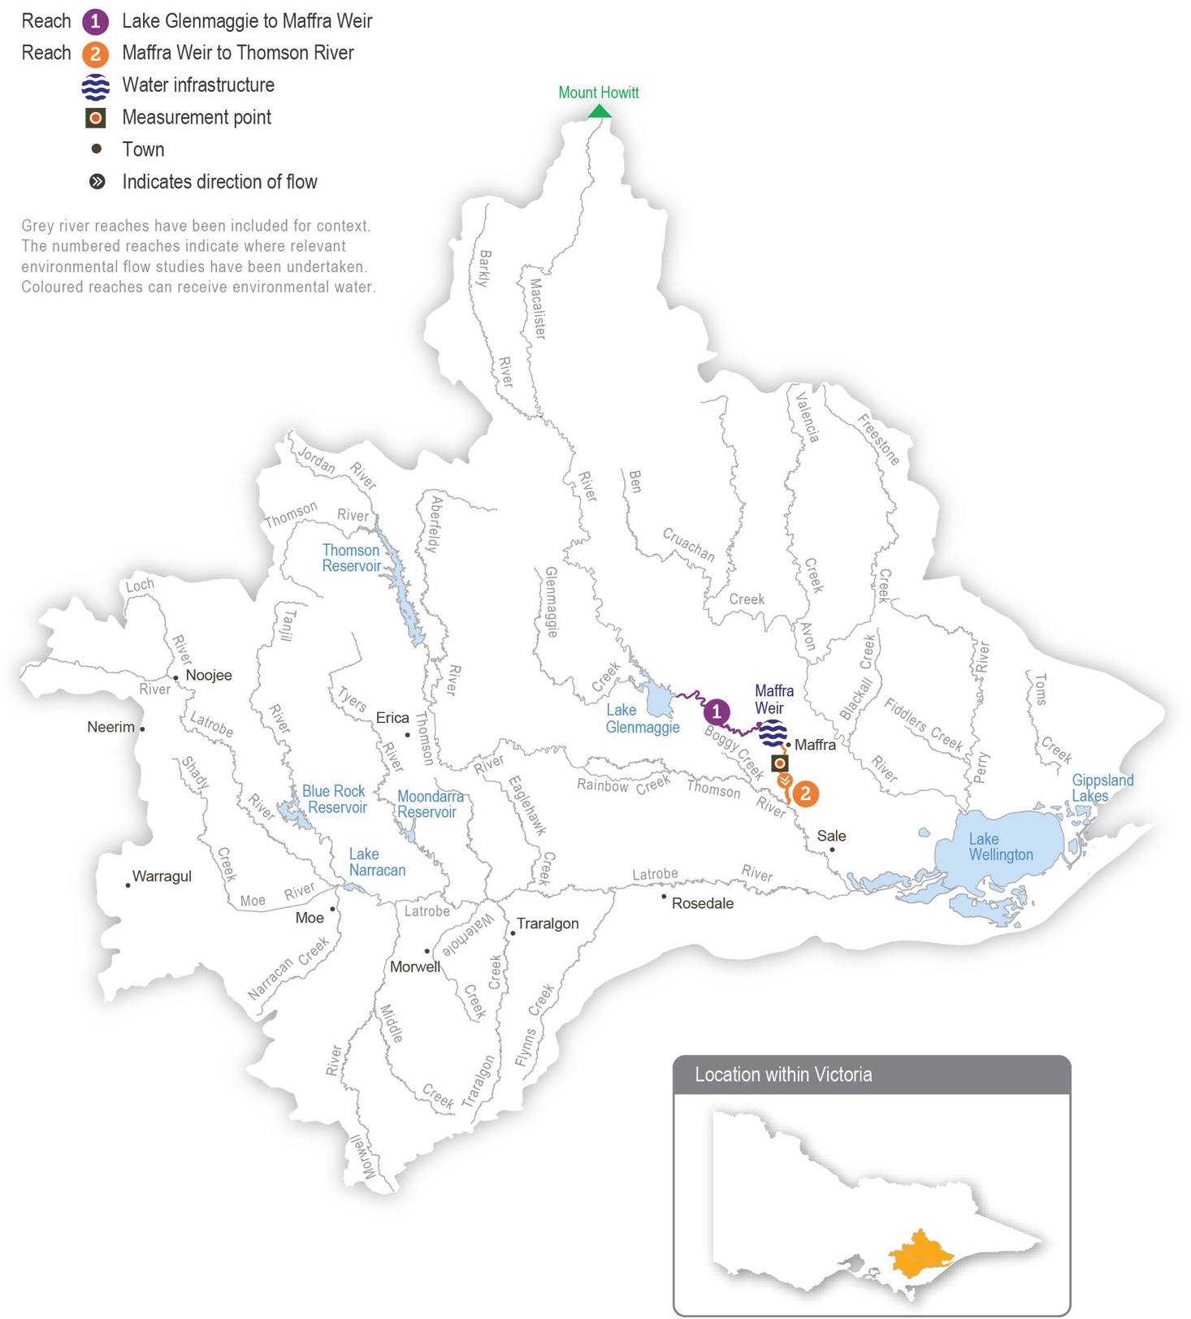

Return to start of section

Environmental values
Seven migratory native fish species move between the Macalister River, the estuary and the sea to complete their life cycle. These species include the Australian grayling, short-finned eel, long-finned eel, tupong, Australian bass, short-headed lamprey and common galaxias. Yellow-eye mullet, an estuarine species, has been recorded in the river. Platypus and rakali (water rats) are widely distributed through the Macalister River and its tributaries.
The streamside vegetation corridor along the regulated reaches of the Macalister River is fragmented. Immediately below Lake Glenmaggie, the vegetation is in good condition. It includes remnant river red gums and good-quality stands of shrubs, particularly in areas where revegetation has occurred in combination with stock exclusion. Further downstream, the vegetation is degraded. In recent years, the cover of in-stream vegetation has declined, possibly due to increased water turbidity, erosion and a lack of an appropriate water regime to encourage plant growth. The cover of non-woody plants (such as reeds, sedges and rushes) along the river’s fringes is patchy.

Environmental objectives in the Macalister system
Increase the distribution, recruitment and abundance of all native fish, and increase opportunities for the spawning and recruitment of native migratory fish (such as the Australian grayling)
Maintain the form of the riverbank and bed to provide physical habitat for aquatic animals and plants
Increase the abundance of platypus and rakali (water rats)
Maintain emergent (non-woody) and fringing (woody) vegetation in the streamside zone Reinstate submerged aquatic vegetation
Increase the abundance and number of functional groups of waterbugs
Improve water quality during periods of reduced or no passing flow from Lake Glenmaggie
Traditional Owner cultural values and uses
Wirn wirndook Yeerung (Macalister River) is a very important river to the Gunaikurnai people. It is a pathway that connects the Snow Country to the heart of Gippsland. It is a pathway to ceremonial grounds and a known special men’s place to Elders. Its traditional name is Wirn wirndook Yeerung, which translates to ‘song of the male fairy wren’.
Yeerung is the men’s totem. This river has many cultural resources and extensive important sites along the whole system.
The Gunaikurnai have had a continued connection to Gunaikurnai Country for over 50,000 years, including with the waterways in the Latrobe system into which Wirn wirndook Yeerung (Macalister River) feeds. For the Gunaikurnai as Traditional Owners, there are immense challenges to heal, protect and manage Country which has been drastically altered since colonisation. “As Gunaikurnai, we see our land (Wurruk), waters (Yarnda), air (Watpootjan) and every living thing as one. All things come from Wurruk, Yarnda and Watpootjan and they are the spiritual life-giving resources, providing us with resources and forming the basis of our cultural practices. We have a cultural responsibility to ensure that all of it is looked after” (Water is Life: Traditional Owner Access to Water Roadmap 2022 - Gunaikurnai Nation Statement). This cultural landscape is dependent on culture and Aboriginal management.
The Gunaikurnai Land and Waters Aboriginal Corporation (GLaWAC) is working with the West Gippsland CMA to determine how to express Gunaikurnai objectives for water in a way that contributes to seasonal watering proposals from the perspective of traditional custodians, with traditional knowledge. GLaWAC has membership on the Macalister Environmental Water Advisory Group (EWAG).
GLaWAC has expressed that more water needs to go down Wirn wirndook Yeerung (Macalister River) between Lake Glenmaggie and Lake Wellington to improve water quality, including to address the threat of salinity and to support plants and animals that have cultural values and uses.
GLaWAC has also questioned the timing of watering events and a desire to provide increased water depth to promote downstream fish migration and spawning, deeper water pools to prevent water-quality degradation, and more variation in water levels to better mimic natural conditions.
Traditionally the landscape – which includes Wirn wirndook Yeerung (Macalister River), and branches and associated floodplains – has been a rich source of food, medicine and resources for the Gunaikurnai people. In the area, there are many sites of cultural significance near the river and around Lake Glenmaggie. The Gunaikurnai have moved through the landscape along the waterways for thousands of years, sourcing food and plants along the way.
Return to start of section

From the perspective of the Gunaikurnai, the land and waterways flowing to the Gippsland Lakes are interconnected and cannot be considered separately where decisions can impact downstream areas. The lower Latrobe wetlands and the rivers that feed them, including Wirn wirndook Yeerung (Macalister River), have important cultural significance to the Gunaikurnai.
Watering requirements to support cultural values and uses include:
- timing the delivery of water for the environment planned in partnership with GLaWAC to support a seasonal flow regime and wet and dry periods that embody healthy Country
- maintaining freshwater supply to the Durt-Yowan (Latrobe River) estuary, Dowd Morass, Sale Common and Heart Morass, and associated freshwater habitats. The lower Latrobe wetlands are an important resource for the Gunaikurnai
- providing connectivity between reaches and onto floodplains to support dependent plants and animals with cultural values and uses of significance to the Gunaikurnai
- maintaining water quality to support the health of native plants and animals with cultural values and uses of significance to the Gunaikurnai.
West Gippsland CMA engaged with the GLaWAC Cultural Water Team about Macalister watering priorities for 2023-24, with engagement planned to continue in the 2023-2024 water year.

Social, recreational and economic values and uses
In planning the potential environmental watering actions in Table 2.4.1, the West Gippsland CMA considered how environmental flows could support values and uses, including:
- water-based recreation (such as canoeing, kayaking and swimming)
- riverside recreation and amenity (such as fishing)
- socioeconomic benefits (such as preventing erosion and potentially losing private and public land).

Scope of environmental watering
The term ‘environmental watering’ refers to the active delivery of water for the environment to support particular environmental objectives by altering the flow in a river or the water level in a wetland. While other terms are also used to describe the delivery of water for the environment, ‘environmental watering’ is deliberately used here and in seasonal watering statements to ensure consistency in the legal instruments that authorise the use of water for the environment in Victoria.
Table 2.4.1 describes the potential environmental watering actions in 2023-24, their expected watering effect (that is, the intended physical or biological effects of the watering action) and the longer-term environmental objectives they support. Each environmental objective relies on one or more potential environmental watering actions and their associated physical or biological effects.
Table 2.4.1 Potential environmental watering actions, expected watering effects and associated environmental objectives for the Macalister system

Potential environmental watering action | Expected watering effects | Environmental objectives
Macalister River (targeting reach 2)1
Winter/spring low flow (300 ML/day for at least 120 days during July  to November 2023 and June 2024) | - Provide permanent wetted habitat for waterbugs and maintain water depth over riffles to enable fish passage between local habitats  - Provide sustained wetting of low-level benches to limit the encroachment of terrestrial vegetation
Spring fresh (one fresh of 700 ML/day for five days during September to November) | - Cue the upstream migration of adult fish (e.g. short-headed lamprey) and the recruitment of juveniles (e.g. Australian grayling, tupong, common galaxias, Australian bass and short- and long-finned eels) from marine/ estuarine environments  - Wet mid-level benches to water woody vegetation, limit the encroachment of terrestrial vegetation and facilitate the dispersal of emergent and fringing vegetation seeds and propagules throughout the reach

Potential environmental watering action | Expected watering effects | Environmental objectives
Spring/summer fresh following spill  (one fresh peaking at 1,500-1,800 ML/day for three to 10 days during September to December) | - Shape the recession of a 1,500 ML/day or 3,000 ML/day spill to:  - wet mid- and higher-level benches to water emergent and woody vegetation and move organic matter into the channel to transport food resources downstream  - provide flow with sufficient shear stress to scour biofilms and flush fine sediment from pools and small gaps in the substrate to improve geomorphic habitat and food resources for waterbugs  - cue the upstream migration of adult fish (e.g. short-headed lamprey) and the recruitment of juveniles (e.g. Australian grayling, tupong, common galaxias, Australian bass and short- and long-finned eels) from marine/ estuarine environments
Spring/summer low flow (60-90 ML/day during September to January) | - Maintain the water depth in pools and hydraulic habitat for native fish  - Maintain permanent wetted habitat in pools and riffles for waterbugs  - Provide longitudinal connectivity for local movement of platypus and rakali (water rats), as well as protection from predation, access to food sources and maintenance of refuge habitats  Note: At 90 ML per day, expected watering effects are met in reach 1 and 2. At 60 ML per day, expected watering effects are met in reach 2 only
Trigger-based summer/ autumn low flow  (40-60 ML/day for five to 13 days during December to May)  Trigger: extended periods of reduced passing flow or no flow being released from Lake Glenmaggie | - Maintain permanent wetted habitat in pools and riffles for fish and waterbugs to survive  - Provide shallow, slow-flowing habitat to maintain in-stream vegetation  - Maintain a minimum depth in pools to allow for turnover of water and to slow degradation of water quality to support aquatic life
Summer/autumn fresh(es) (one to three freshes of 140 ML/day for three days during December to March) | - Increase water depth to allow fish to move throughout the reach  - Flush pools to maintain water quality for aquatic animals  - Flush substrates and improve the quality of existing waterbug habitat and food supply  - Wet low benches to facilitate the dispersal of seeds and propagules from emergent vegetation throughout the reach  - Provide flow with sufficient shear stress to flush fine sediment from small gaps to improve geomorphic habitat
Autumn fresh (one fresh of 350 ML/day for five days during April to May) | - Cue the downstream migration of Australian grayling towards the estuary for spawning  - Additional benefits for the Thomson River and the Latrobe system are expected when delivered for greater than three days:  - Fully flush the upper Thomson River estuary when delivered for more than three days and combined with freshes in the Thomson River, and contribute freshwater to the lower reaches of the Latrobe River and wetlands
Autumn/winter low flow (60-90 ML/day during March to August) | - Maintain pool and riffle habitat for waterbugs and a minimum depth over riffles to allow fish to move throughout the reach  - Provide connectivity throughout the river for the local movement of platypus and rakali (water rats), and provide protection from predation and access to food  - Provide a low-velocity flow and clear water to enable the establishment of submerged vegetation  Note: At 90 ML per day, expected watering effects are met in reach 1 and 2. At 60 ML per day, expected watering effects are met in reach 2 only.

Potential environmental watering action | Expected watering effects | Environmental objectives
Autumn/winter fresh (one fresh of 700 ML/day for five days during  July to August 2023 or May to June 2024) | - Cue the downstream migration of Australian bass and tupong towards the estuary for spawning/breeding  - Increase the wetted area and improve water quality by flushing pools, providing habitat and conditions for waterbugs  - Wet low and mid-level benches to facilitate the dispersal of emergent and fringing vegetation seeds and propagules throughout the reach
1 All freshes target reach 2 specifically. Low flows target reaches 1 and 2, but the magnitudes targeted apply to both reaches.
Scenario planning
Table 2.4.2 outlines potential environmental watering and expected water use in a range of planning scenarios.
The Macalister River has experienced wet conditions for the third consecutive year, with natural flow and storage spills from Lake Glenmaggie meeting or exceeding environmental flow recommendations throughout winter and spring 2022. Preliminary results of recent monitoring show that wet conditions have again provided ideal breeding conditions for native fish within the system. Planned environmental watering actions in 2023-24 will continue to focus on supporting the migration, spawning
and recruitment of native fish within the system. They are generally the same for all planning scenarios, but the duration and magnitude may vary depending on water availability throughout the year.
Providing a year-round low flow to maintain habitat connectivity for aquatic animals in the Macalister River is the highest- priority watering action in all planning scenarios to maintain critical habitat and food for native fish and platypus. The year- round operational passing flow of 60 ML per day will meet the minimum low-flow objectives for reach 2. Increasing the flow to 90 ML per day will meet the minimum low-flow objectives for both reaches 1 and 2 and will provide more habitat and food to help grow waterbugs, fish and platypus populations and exclude terrestrial vegetation from the main channel. A higher- magnitude low flow is therefore preferred and may be partly met by operational releases and natural inflows at certain times. Water for the environment will be used where possible to deliver a higher-magnitude low flow, but it will be prioritised in November in all planning scenarios when operational and consumptive water deliveries are expected to be low.
In the drought planning scenario, the passing flow from Lake Glenmaggie may be reduced during summer and autumn, and there may not be enough water for the environment to maintain a flow of at least 60 ML per day. If this happens, water for the environment may be used to deliver a trigger-based low flow of 40 ML per day for five to 13 days and summer/autumn freshes to maintain pool habitats that will serve as important refuges for native fish and platypus. The West Gippsland CMA will monitor water quality during such conditions and adapt the flow if necessary to limit stress on aquatic fauna. In the wet planning scenario, the low flow may be increased to 300 ML per day during winter and spring to wet the lower benches over a sustained period to discourage the encroachment of terrestrial vegetation.
Delivering at least one fresh of 350 ML per day in autumn and 700 ML per day in spring (both for five days) is a high priority in all planning scenarios to provide a migration trigger for native fish to move into or out of the system to complete their life cycles. An additional 700 ML per day fresh may be delivered in late autumn or winter to increase fish migration. These events are necessary yearly in the average and wet planning scenarios to ensure regular recruitment and align with environmental cues
in the broader landscape. They are generally a lower priority in the dry and drought planning scenarios when environmental allocations are low, but they are important to deliver even under drier conditions in 2023-24 to consolidate recent population growth following three previous wet years. Several other large freshes are recommended to slow the recession of flows following spills from Lake Glenmaggie, but they are a lower priority and will likely be at least partly met by operational releases in most planning scenarios.
As seen in recent years, natural tributary inflows and operational releases to manage storage levels are likely to achieve many of the planned watering actions in the wetter planning scenarios, so most or all tier 1a and tier 1b actions proposed for the Macalister River in the wet scenario should be achievable with the available supply.
A minimum carryover target of 1,400 ML has been prioritised in the dry and average planning scenarios to support early- season low flow requirements in the Macalister River in 2024-25. There is no carryover target in the drought planning scenario, as water for the environment will be prioritised for use to meet critical watering events in 2023-24 in this scenario. In the wet planning scenario, opening allocations in 2024-25 are expected to be high enough to meet early-season low-flow requirements.

Return to start of section

Table 2.4.2 Potential environmental watering for the Macalister system in a range of planning scenarios

Planning scenario | Drought | Dry | Average | Wet
Expected conditions | - Limited natural flow; freshes or high flow are unlikely  - Passing flow at Maffra Weir may be reduced | - Possible spills from Lake Glenmaggie in spring, minor flood levels may occur  - Passing flow at Maffra Weir may be reduced | - Regular spills from Lake Glenmaggie in spring, minor  to moderate flood levels may occur | - Large and frequent spills from Lake Glenmaggie, moderate to major flood levels may occur
Expected availability of water for the environment | - 15,500 ML | - 18,300 ML1 | - 19,200 ML1 | - 23,600 ML1
Potential environmental watering – tier 1  (high priorities) | Tier 1a (can be achieved with predicted supply)
 | - Spring fresh (one fresh)  - Spring/summer low flow (delivered at upper magnitude in November following the fresh, and lower  magnitude at other times)  - Trigger-based summer/autumn low flow  - Summer/autumn fresh (one fresh)  - Autumn fresh (one fresh)  - Autumn/winter low flow (delivered at upper magnitude during April to June and lower magnitude at other times) | - Spring fresh (one fresh)  - Spring/summer low flow (delivered at upper magnitude in November following the fresh, and lower  magnitude at other times)  - Summer/autumn freshes  (three freshes)  - Autumn fresh (one fresh)  - Autumn/winter low flow (delivered at upper magnitude during April to  mid-August and lower magnitude at other times)  - Autumn/winter fresh (one fresh) | - Spring fresh (one fresh)  - Spring/summer low flow (delivered at upper magnitude in November following the fresh, and lower  magnitude at other times)  - Summer/autumn freshes  (three freshes)  - Autumn fresh (one fresh)  - Autumn/winter low flow (continuous at upper magnitude)  - Autumn/winter fresh (one fresh) | - Spring fresh (one fresh)  - Spring/summer low flow (delivered at upper magnitude in November to  January and lower magnitude at other times)  - Summer/autumn freshes (three freshes)  - Autumn fresh (one fresh)  - Autumn/winter low flow (continuous at upper magnitude)  - Autumn/winter fresh (one fresh)
 | Tier 1b (supply deficit)
 | - Spring/summer low flow (upper magnitude continuous)  - Autumn/winter low flow (continuous at upper magnitude)  - Autumn/winter fresh (one fresh) | - Spring/summer low flow (upper magnitude continuous)  - Autumn/winter low flow (continuous at upper magnitude) | - Spring/summer low flow (continuous at upper magnitude)  - Spring/summer fresh following 1,500 ML/day spill (one fresh) | - Winter/spring low flow  - Spring/summer fresh following 3,000 ML/day spill (one fresh)
Potential environmental watering – tier 2 (additional priorities) | - N/A
Possible volume of water for the environment required to achieve objectives | - 15,100 ML (tier 1a)  - 11,500 ML (tier 1b) | - 16,800 ML (tier 1a)  - 4,700 ML (tier 1b) | - 17,800 ML (tier 1a)  - 6,700 ML (tier 1b) | - 19,900 ML (tier 1a)  - 6,700 ML (tier 1b)
Priority carryover requirements for 2024-25 | - 0 ML | - 1,400 ML |  | - 0 ML
1 Carryover from 2022-23 may be forfeited in the event of spill releases from Lake Glenmaggie.
Return to start of section

Snowy system
Waterway managers – East Gippsland Catchment Management Authority and New South Wales Department of Planning and Environment
Storage manager – Snowy Hydro Limited
Environmental water holders – Victorian Environmental Water Holder and New South Wales Department of Planning and Environment

System overview
The Snowy River originates on the slopes of Mount Kosciuszko. It drains the eastern slopes of the Snowy Mountains in New South Wales before flowing through the Snowy River National Park in Victoria and into Bass Strait (Figure 2.5.1).
There are four major dams and multiple diversion weirs in the upper Snowy River catchment that capture and divert water to the Murrumbidgee River and Murray River valleys. The hydrological effects of the Snowy Mountains Scheme are substantial, but they are partly alleviated by the contribution of flows from tributaries (such as the Delegate River in NSW and the Buchan and Brodribb rivers in Victoria).
The construction and operation of the Snowy Mountains Hydro-electric Scheme previously diverted 99 percent of the Snowy River’s mean annual natural flow at Jindabyne. The loss of flow changed the structure and function of the river, reduced the opening of the Snowy River entrance to Bass Strait and resulted in a decline in environmental values.
The Victorian, NSW and Commonwealth governments agreed to recover some of the water and, in 2002, delivered the first environmental flow to the Snowy River below Jindabyne Dam to help restore the damage done by decades of limited flow. The Victorian share of water for the environment available for use in the Snowy system is held in the Victorian Murray, Goulburn and Loddon systems. The NSW share of water for the environment available for use in the Snowy system is held in the NSW Murray and Murrumbidgee systems. Collectively, the water is made available for environmental flows in the Snowy River via a substitution method, whereby water for the environment allocated in Victoria and NSW replaces water earmarked for transfer from the Snowy to Victoria and NSW to support irrigation demands. The NSW Department of Planning and Environment
plans environmental flows in the Snowy River in consultation with the Snowy Advisory Committee. The committee includes representatives of the Aboriginal community, the local community, the Victorian Government, the NSW Government and environmental experts. The committee brings together local knowledge and expert advice to help inform the management and delivery of water for environmental outcomes.
The water year in the Snowy system runs from 1 May to 30 April, and the Snowy Advisory Committee plans the daily flow regime. Water for the environment is delivered daily to the Snowy River below Jindabyne Dam. The annual allocation of water for the environment varies based on water availability, rainfall and inflows. Environmental releases aim to deliver an average of 212,000 ML per year, the equivalent of 21 percent of the average annual natural flows before the construction of the Jindabyne Dam.

Return to start of section

Figure 2.5.1 The Snowy system

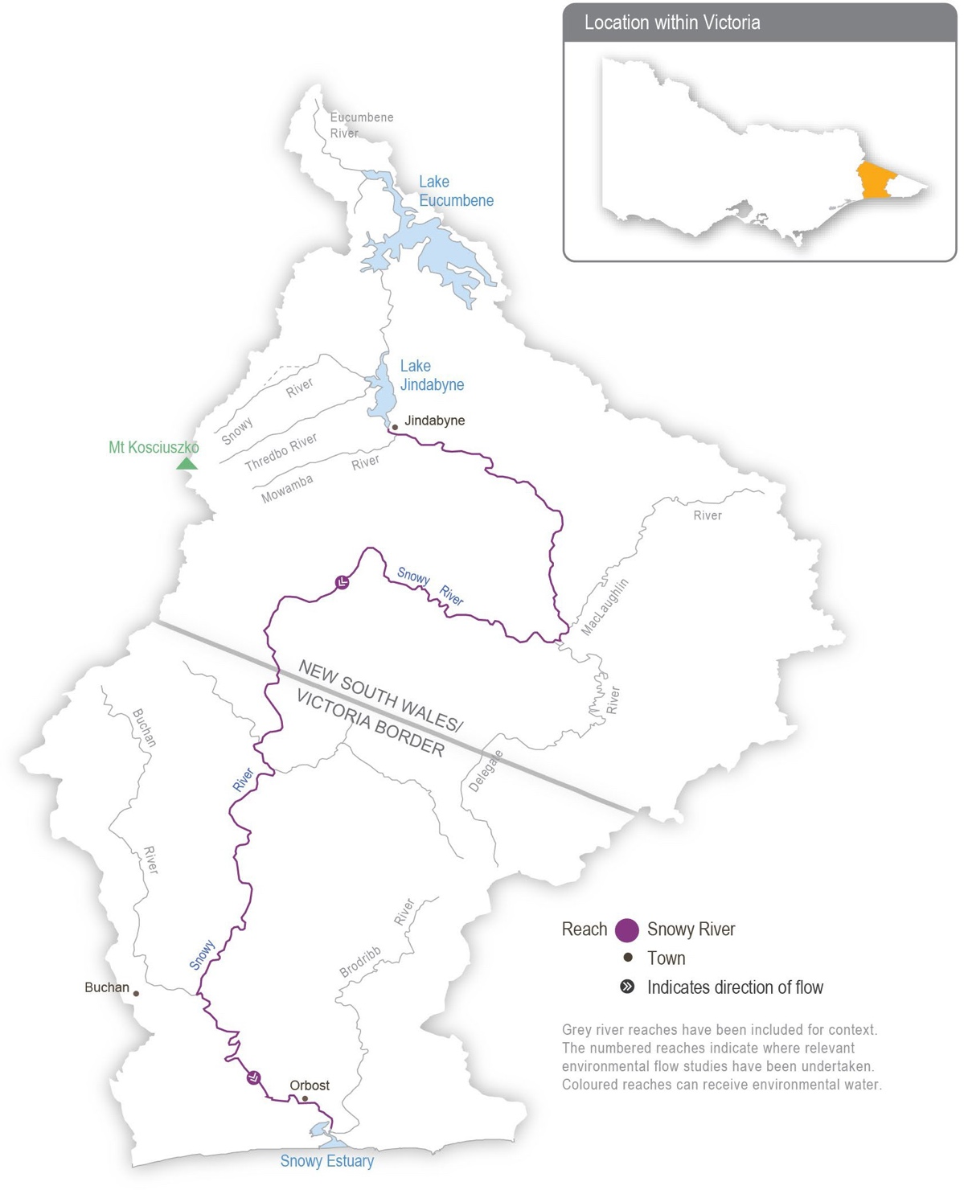

Return to start of section

Environmental values
Environmental values in the upper reaches and tributaries of the Snowy River include water-dependant plants and animals, including freshwater native fish (such as river blackfish and Australian grayling), platypus and frogs. The lower reaches support estuary perch and Australian bass that move between saltwater and freshwater systems. The estuary contains estuarine and saltwater species (such as flathead and black bream). The floodplain wetlands of the Snowy River near Marlo provide feeding and breeding areas for wetland and migratory birds.
Traditional Owner cultural values and uses
Traditional Owners with links to the Snowy River system Include the Gunaikurnai, Monero Ngarigo, and Bidhawal peoples.
The river and its associated systems and lands have significant cultural values, including as a functional and spiritual connective pathway. The Snowy River has enduring cultural importance as a place for the gathering of different Nations; ceremonies; access to food, fibre and other resources; stories; spirituality; and songlines.
The Gunaikurnai Land and Waters Aboriginal Corporation holds Registered Aboriginal Party status across a large section of East Gippsland, including the lower Snowy River, associated with the Krauatungalung clan. This landscape was largely a transitionary landscape, with people migrating seasonally from the high country to the coast and back, depending on
availability of different food sources throughout the year. Many trade routes travel through freshwater river systems, such as the Snowy River system.
GLaWAC provided input to the draft Snowy River estuary flows study.
Scope of environmental watering
The total volume available for release to the Snowy River in 2023-24 is 220,500 ML, which for the third year in a row is one of the highest volumes of water for the environment ever available for the Snowy River.
Due to operating rules in the system, the daily flow regime that will be delivered in 2023-24 is pre-planned. The storage manager will make daily releases of varying magnitudes from Lake Jindabyne between May 2023 and April 2024 to mimic the typical flow patterns of a mixed snowmelt/rainfall river system characteristic of the Snowy Mountains. A ‘natural flow
scaling’ approach is applied, and the continuous daily releases aim to support ecological processes in the Snowy River below Jindabyne Dam and maintain a healthy river that is much smaller than the natural channel that existed before the river was regulated.
Following wet years in 2021-22 and 2022-23, the availability of water for the environment will again allow for a large number of high-flow releases in 2023-24 to improve ecological conditions and build additional resilience into the system. The flow pattern is similar to previous years and mimics a snowmelt river, with a greater flow during winter and spring. Eight high-flow events exceeding 2,500 ML per day are scheduled between May and November 2023 to move sediment and improve in-stream habitat for native fish, platypus, frogs and waterbugs. The largest release, known as a flushing flow, will occur in either May
or October 2023 if Lake Jindabyne is high enough to enable delivery through the required infrastructure. It has a target peak flow rate of at least 5,000 ML per day, which will be held for about eight hours to flush fine sediment and wet high benches and backwaters. Other peak flows will mimic winter rainfall and spring snowmelt events. Moderate-to-high flow rates will be sustained from the end of May to December 2023 to mix water in the estuary to benefit plants and fish (such as Australian bass). Lower flow rates will be maintained from January until the end of the water year in April 2024, but peaks of over 1,000 ML per day will be provided each month where possible.
For further information, visit the NSW Department of Planning and Environment’s Water for the environment website at https://www.environment.nsw.gov.au/topics/water/water-for-the-environment/snowy-and-montane.

Return to start of section

Section 3
Central region

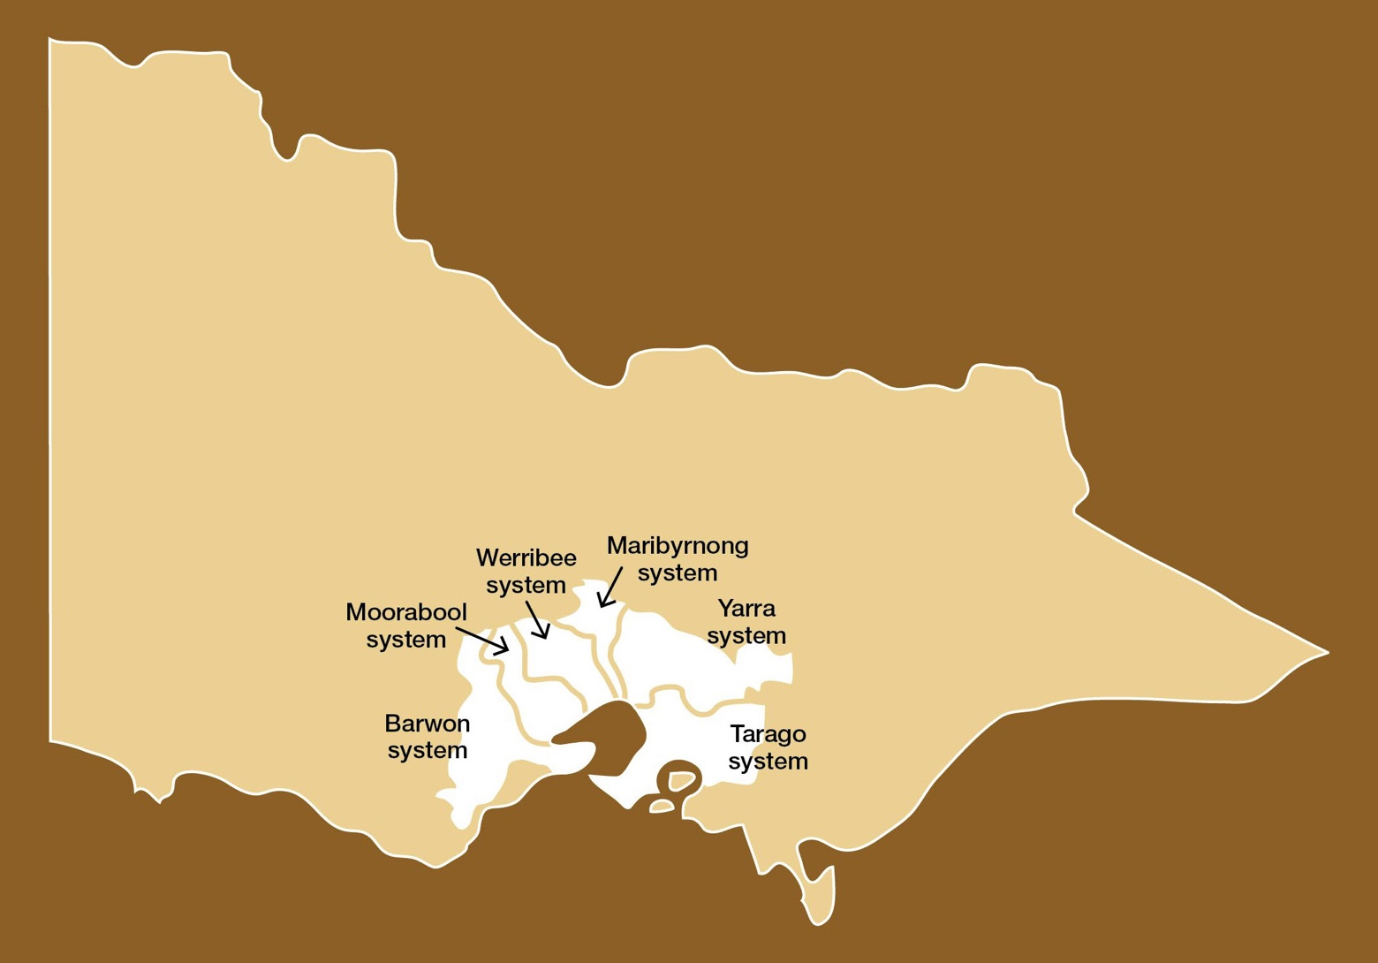

  - Central region overview 60
  - Yarra system 66
  - Tarago system 74
  - Maribyrnong system 80
  - Werribee system 85
  - Moorabool system 92
  - Barwon system 98
    - Upper Barwon River 98
    - Lower Barwon wetlands 103

Central region overview
The systems in the central region that can receive water from the VEWH’s environmental entitlements are Birrarung (Yarra River) and Tarago River in the east and Wirribi Yaluk/Weariby Yallok (Werribee River), Murrabul Yaluk (Moorabool River) and Barwon (upper Barwon River and lower Barwon wetlands) in the west. The VEWH does not hold an environmental entitlement in the Maribyrnong system, but in some years, the VEWH
purchases available allocation to allow delivery of water for the environment in selected reaches of the Maribyrnong system.
Environmental values, objectives and planned actions for delivering water for the environment for each system in the central region are presented in the system sections that follow.
Traditional Owners in the central region
Traditional Owners in the central region have a deep connection to Country that has endured for tens of thousands of years. This includes inherent rights and cultural obligations to Country and community.
The Bunurong Land Council Aboriginal Corporation, Eastern Maar Aboriginal Corporation, Wadawurrung Traditional Owners Aboriginal Corporation and Wurundjeri Woi Wurrung Cultural Heritage Aboriginal Corporation are the Registered Aboriginal Parties under the Victorian Aboriginal Heritage Act 2006 for the areas incorporating waterways covered by this section of the seasonal watering plan.
In 2023 formal recognition of Eastern Maar’s rights under the Commonwealth Native Title Act 1993 was extended to include much of the coastline of the Great Ocean Road and part of the Great Otway National Park. In relation to this seasonal watering plan, it also includes parts of the Barwon River catchment. The native title determination acknowledges Eastern Maar’s ongoing connection and intrinsic relationship to Country in south-western Victoria.
Gunaikurnai Land and Waters Aboriginal Corporation is also a Registered Aboriginal Party within the central region geographic area. Gunaikurnai waterways managed with water for the environment are covered in the Gippsland region section of the seasonal watering plan.
Traditional Owner objectives for water in the central region have been acknowledged in several strategies and plans recently, including the Rivers of the Barwon (Barre Warre Yulluk) Action Plan, the Waterways of the West Action Plan, the Yarra Strategic Plan (Burndap Birrarung burndap umarkoo), and the Central and Gippsland Region Sustainable Water Strategy.
The Victorian Government is committed to self-determination for Traditional Owners through Treaty negotiations and policies such as Water is Life: Traditional Owner Access to Water Roadmap 2022 and through actions in the Central and Gippsland Region Sustainable Water Strategy. The VEWH and partners are working with Traditional Owners to embed the outcomes of government policy in the Victorian environmental watering program. Program partners in the environmental watering program are aware that structural changes (such as legislative, policy and governance changes) to how water is managed may be made in the future in recognition of Aboriginal water rights. Program partners have heard that Traditional Owners want empowerment and agency in water management and, in many cases, want to manage water on Country on their own terms.
Engagement
The environmental watering program is informed by engagement with Traditional Owners, stakeholders and local communities. Program partners undertake extensive engagement at the local level to understand community priorities for the delivery of water for the environment in the coming year.
Program partners also seek to understand how cultural, social, economic and recreational values, uses and objectives may be supported by delivering environmental flows. Opportunities to support these values, uses and objectives are incorporated into watering decisions where possible and provided they do not compromise environmental outcomes. Cultural, social, economic and recreational values considered for each system in the central region are presented in the following system sections.
Environmental flows objectives are also informed by engagement undertaken through other strategies, plans and processes. These include regional catchment strategies, regional waterway strategies and technical studies (such as environmental flows studies and environmental water management plans). Traditional Owners’ cultural objectives for environmental flows may refer to cultural flows studies, Aboriginal Waterway Assessments, Traditional Owner Country Plans and other tools. These strategies, plans and technical reports collectively describe a range of environmental, economic, social and Traditional Owner perspectives and longer-term integrated catchment and waterway management objectives that influence environmental flows and priorities for water for the environment.
Return to start of section

Table 3.1.1 Partners and stakeholders engaged by Corangamite Catchment Management Authority in developing seasonal watering proposals for the Moorabool system, upper Barwon River and lower Barwon wetlands and other key foundation documents that have directly informed the proposals (grouped in alphabetical order)

 | Moorabool system | Upper Barwon River | Lower Barwon wetlands
Community groups and environment groups | - Corangamite Waterwatch  - Geelong Landcare Network  - Moorabool Catchment Landcare Group  - People for A Living Moorabool | - Environment Victoria  - Friends of the Barwon  - Geelong Field Naturalists Club  - Land and Water Resources Otway Catchment  - Otway Agroforestry Network Ltd  - Upper Barwon Landcare Network  - Winchelsea Land and Rivercare Group | - Corangamite EstuaryWatch  - Geelong Environment Council Inc.  - Geelong Field Naturalists Club
Government agencies | - Barwon Water  - Central Highlands Water  - Department of Energy, Environment and Climate Action  - Parks Victoria  - Southern Rural Water  - Golden Plains Shire Council  - Moorabool Shire Council  - Victorian Environmental Water Holder | - Barwon Water  - Department of Energy, Environment and Climate Action  - Southern Rural Water  - Victorian Environmental Water Holder  - Colac Otway Shire Council | - Barwon Water  - City of Greater Geelong  - Department of Energy, Environment and Climate Action  - Parks Victoria  - Southern Rural Water  - Victorian Environmental Water Holder  - Victorian Fisheries Authority
Landholders/farmers | - Landholders on the Moorabool Stakeholder Advisory Committee | - Individual landholders | - Individual landholders
Local businesses | - Adelaide Brighton Cement |  | - Commercial eel fishers
Recreational users |  | - Individual users | - Field and Game Australia (Geelong Branch)  - Geelong Gun and Rod Association Inc.  - VRFish
Traditional Owners | - Wadawurrung Traditional Owners Aboriginal Corporation | - Wadawurrung Traditional Owners Aboriginal Corporation  - Eastern Maar Aboriginal Corporation | - Wadawurrung Traditional Owners Aboriginal Corporation

Table 3.1.2 Partners and stakeholders engaged by Melbourne Water in developing seasonal watering proposals for the Yarra, Tarago, Maribyrnong and Werribee systems and other key foundation documents that have directly informed the proposals (grouped in alphabetical order)

 | Yarra system | Tarago system | Maribyrnong system | Werribee system
Community groups and environment groups | - Collingwood Children’s Farm  - Environment Victoria  - Friends of Yarra Flats Park  - Friends of Yarran Dheran Nature Reserve  - Independent community members | - Cardinia Environment Coalition  - Environment Victoria  - Friends of Mt Cannibal Flora and Fauna Reserve  - Friends of Robin Hood Reserve  - Independent community members  - Native Fish Australia  - Waterwatch coordinators | - Environment Victoria  - Friends of Holden Flora Reserve  - Friends of the Maribyrnong Valley Inc.  - Independent community members  - Jacksons Creek EcoNetwork | - Ecolinc  - Environment Victoria  - Friends of Toolern Creek Reserve  - Friends of Werribee Gorge & Long Forest Mallee Inc.  - Independent community members
 | - Native Fish Australia  - Waterwatch coordinators  - Yarra Riverkeeper |  | - Native Fish Australia  - Waterwatch coordinators | - Moorabool Environment Group/Platypus Alliance - Bacchus Marsh  - Native Fish Australia
 |  |  |  | - NatureWest
 |  |  |  | - Pinkerton Landcare and Environment Group
 |  |  |  | - Waterwatch coordinators
 |  |  |  | - Werribee Riverkeeper

 | Yarra system | Tarago system | Maribyrnong system | Werribee system
Government agencies | - Banyule City Council  - City of Boroondara  - City of Melbourne  - City of Whittlesea  - Commissioner for Environmental Sustainability Victoria  - Department of Energy,  Environment and Climate Action  - Environment Protection Authority Victoria  - Manningham City Council  - Melbourne Water (Service Delivery)  - Nillumbik Shire Council  - Parks Victoria  - Victorian Fisheries Authority  - Victorian Freshwater Fish Habitat and Flows Roundtable  - Yarra Ranges Shire Council | - Baw Baw Shire Council  - Cardinia Shire Council  - Commissioner for Environmental Sustainability Victoria  - Department of Energy,  Environment and Climate Action  - Environment Protection Authority Victoria  - Melbourne Water (Service Delivery)  - Parks Victoria  - Southern Rural Water  - Victorian Fisheries Authority  - Victorian Freshwater Fish Habitat and Flows Roundtable | - Commissioner for Environmental Sustainability Victoria  - Department of Energy,  Environment and Climate Action  - Environment Protection Authority Victoria  - Greater Western Water  - Hume City Council  - Maribyrnong City Council  - Melbourne Water (Service Delivery)  - Moonee Valley City Council  - Parks Victoria  - Port Phillip and Westernport CMA  - Southern Rural Water  - Victoria Police  - Victorian Fisheries Authority | - Commissioner for Environmental Sustainability Victoria  - Department of Energy,  Environment and Climate Action  - Environment Protection Authority Victoria  - Greater Western Water  - Melbourne Water (Service Delivery)  - Melton City Council  - Parks Victoria  - Southern Rural Water  - Victorian Fisheries Authority  - Wyndham City Council
Landholders/farmers | - Individual landholders  - Licensed diverters | - Individual landholders | - Licensed diverters | - Individual landholders  - Zoos Victoria
Local businesses | - East Coast Kayaking  - Melbourne Adventure Hub  - Sea Kayak Australia  - Warburton Holiday Park  - Warrior Spirit Adventures | - Glen Cromie Reserve | - Atlas Ecology Pty Ltd  - Blackbird Cruises | - Camp Sunnystones
Recreational users | - Kirinari Kayak Club  - Paddle Victoria  - Patterson Lakes Canoe Club  - VRFish  - Victorian Sea Kayak Club  - Whitehorse Canoe Club Inc. | - VRFish | - VRFish | - VRFish  - Werribee & District Anglers Club

 | Yarra system | Tarago system | Maribyrnong system | Werribee system
Technical experts | - Arthur Rylah Institute  - Australian Platypus Conservancy  - Cesar Australia  - Melbourne Water subject matter experts  - Research collaborators at Melbourne University | - Arthur Rylah Institute  - Australian Platypus Conservancy  - Cesar Australia  - Melbourne Water subject matter experts  - Research collaborators at Melbourne University | - Arthur Rylah Institute  - Australian Platypus Conservancy  - Cesar Australia  - Melbourne Water subject matter experts  - Research collaborators at Melbourne University | - Arthur Rylah Institute  - Australian Platypus Conservancy  - Cesar Australia  - Melbourne Water subject matter experts  - Research collaborators at Melbourne University
Traditional Owners | - Bunurong Land Council Aboriginal Corporation  - Wurundjeri Woi wurrung  Cultural Heritage Aboriginal Corporation | - Bunurong Land Council Aboriginal Corporation  - Wurundjeri Woi wurrung  Cultural Heritage Aboriginal Corporation | - Bunurong Land Council Aboriginal Corporation  - Wurundjeri Woi wurrung  Cultural Heritage Aboriginal Corporation | - Bunurong Land Council Aboriginal Corporation  - Wadawurrung Traditional Owners Aboriginal Corporation  - Wurundjeri Woi wurrung  Cultural Heritage Aboriginal Corporation

Integrated catchment management
Altered water regimes are one of many threats to the health of Victoria’s waterways. To be effective, environmental flows need to be part of an integrated approach to catchment management. Many of the environmental objectives of water for the environment in the central region will not be fully met without simultaneously addressing issues such as barriers to fish movement, high nutrient loads, loss of streambank vegetation and invasive species.
Victorian and Australian government agencies, Traditional Owner groups, community groups and private landholders collectively implement a wide range of programs that aim to protect and improve the environmental condition and function of land, soils and waterways throughout Victoria’s catchments.
Examples of complementary programs that support the outcomes of environmental flows in the central region include:
- works to protect and enhance streambanks along priority reaches, including willow removal, revegetation and fencing to exclude stock
- urban billabong restoration along the lower Birrarung (Yarra River) using ecological and Traditional Owner knowledge
- an update to the Werribee Diversion Weir (proposed in the Central and Gippsland Regional Sustainable Water Strategy) to improve fish passage and delivery of environmental flows.
For more information about integrated catchment management programs in the central region, refer to the Corangamite CMA and Melbourne Water regional catchment strategies and regional waterway strategies.

Risk management
During the development of the seasonal watering proposals for the Yarra, Tarago, Maribyrnong, Werribee, Moorabool and Barwon systems, environmental watering program partners assessed risks associated with potential environmental flows for 2023-24 and identified appropriate mitigating strategies. Risks and mitigating actions are continually assessed by program partners throughout the year (see subsection 1.2.7).

Return to start of section

Seasonal outlook 2023-24
Catchments in the central region received above-average winter and spring rainfall for the third consecutive year in 2022, but late summer and autumn 2023 were drier than the long-term average. Parts of the Barwon, Moorabool and Yarra systems recorded their highest October rainfall totals, which caused significant flooding. Reservoirs in all systems spilled during 2022- 23, including Rosslynne Reservoir, which spilled for the first time since 1996. Upper Yarra Reservoir reached its maximum operating capacity in October, but Melbourne Water released additional water to prevent it from spilling. Those releases increased flow in the Yarra River during November and December and meant water for the environment that had been carried over from 2021-22 was lost. Additional water was also released from Merrimu Reservoir in 2022-23 to prevent it from spilling. These spills, managed releases and natural inflows met many planned environmental watering actions across the region during winter and spring, but water for the environment was still needed to deliver the planned low flows and freshes in many systems during summer and autumn. The VEWH purchased water from licence holders in the Maribyrnong system to deliver environmental flows in Jacksons Creek.
The Bureau of Meteorology has forecast below-median rainfall and above-median temperatures during autumn, winter and spring 2023 across the central region.
All systems in the central region are expected to receive full allocations of water for the environment in 2023-24, but the loss of some carryover due to reservoir spills and/or pre-spill releases in the Yarra and Werribee systems in 2022-23 means that the total water availability for 2023-24 may be less than it was in 2022-23.
Forecast available supply in the Yarra, Tarago and Werribee systems should be sufficient to deliver the potential environmental watering actions in all climate scenarios to build on environmental outcomes achieved over the last three wet years.
A near-full Rosslynne Reservoir will likely create an opportunity to purchase water to deliver environmental flows in the Maribyrnong system. However, outcomes in upper Jacksons Creek continue to be limited by infrastructure delivery constraints.
Options for delivering water for the environment in the Moorabool and Barwon systems in 2023-24 will be heavily influenced by local climatic conditions due to their smaller and more variable environmental allocations. Larger flows in the Moorabool and upper Barwon systems rely on significant contributions from local rainfall and are, therefore, only likely to be achieved under average or wet climatic conditions. Natural inflows will also have a significant bearing on the low flows and freshes
in the Moorabool and upper Barwon systems, and summer and autumn flows may need to be delivered at the lower end
of their recommended range to conserve available environmental supply if those seasons are dry. Delivery of water for the environment in the lower Barwon wetlands is not affected by annual allocations of water for the environment, and the proposed fill in winter/spring and partial drawdown in summer/autumn should be possible in all climate scenarios if river levels allow.

Return to start of section

Yarra system
Waterway manager – Melbourne Water
Storage manager – Melbourne Water
Environmental water holder – Victorian Environmental Water Holder

The Yarra system includes Birrarung (Yarra River), the Plenty River and Yarra billabongs.
System overview
Birrarung (Yarra River) flows west from the Yarra Ranges above Warburton, through the Yarra Valley and then opens out into a wider plain as it meanders through the suburbs and city of Melbourne before entering Port Phillip Bay (Figure 3.2.1). Over time, the Yarra River below Warrandyte has been straightened, widened and cleared of natural debris as Melbourne has developed.
Up to 400,000 ML per year (long-term average diversion limit) can be harvested from the Yarra system for consumptive use in Melbourne and surrounding areas. The Upper Yarra, O’Shannassy and Maroondah reservoirs harvest water from headwater tributaries, and a pump station at Yering Gorge is used to divert water from the Yarra River to Sugarloaf Reservoir.
Tributaries, including Armstrong Creek, McMahons Creek, Starvation Creek, Woori Yallock Creek and the Watts and Little Yarra rivers, influence flow in the upper reaches of the Yarra River. Urbanised tributaries (such as Olinda Creek, Mullum Mullum Creek, Diamond Creek, Plenty River and Merri Creek) provide additional water to the middle and lower reaches of the Yarra River.
Environmental flows can be released from the Upper Yarra, Maroondah and O’Shannassy reservoirs to support ecological processes and environmental outcomes in downstream river reaches and wetlands. Requests can also be made to cease diversions from the Yarra River at the Yering Gorge Pumping Station, allowing the flow to pass down the whole river system. The priority Yarra River reaches for water for the environment are 2 and 5, shown in Figure 3.2.1. Reach 6 is also a priority in summer and autumn to manage poor water quality upstream of Dights Falls, as flow targets in reach 5 may not be sufficient. Water for the environment delivered to reaches 2 and 5 will help meet flow targets in other reaches. Occasionally, watering actions met naturally in reaches 2 and beyond are not achieved in reach 1 due to the lack of unregulated tributary inflows immediately downstream of Upper Yarra Reservoir. If so, water for the environment can also be used to meet flow targets in reach 1.
The Plenty River rises from the slopes of Mount Disappointment in the Great Dividing Range about 50 km north of Melbourne. It flows downstream through rural and semi-rural areas and Plenty Gorge before joining the Yarra River near Viewbank, east of Banyule Flats Reserve. Yan Yean Reservoir is located off the waterway north of Plenty Gorge, and it receives a flow from Toorourrong Reservoir via a channel. The Plenty River has not received managed environmental flows before, but there may be opportunities to deliver water for the environment from Yan Yean Reservoir in the coming years.

Return to start of section

Figure 3.2.1 The Yarra system

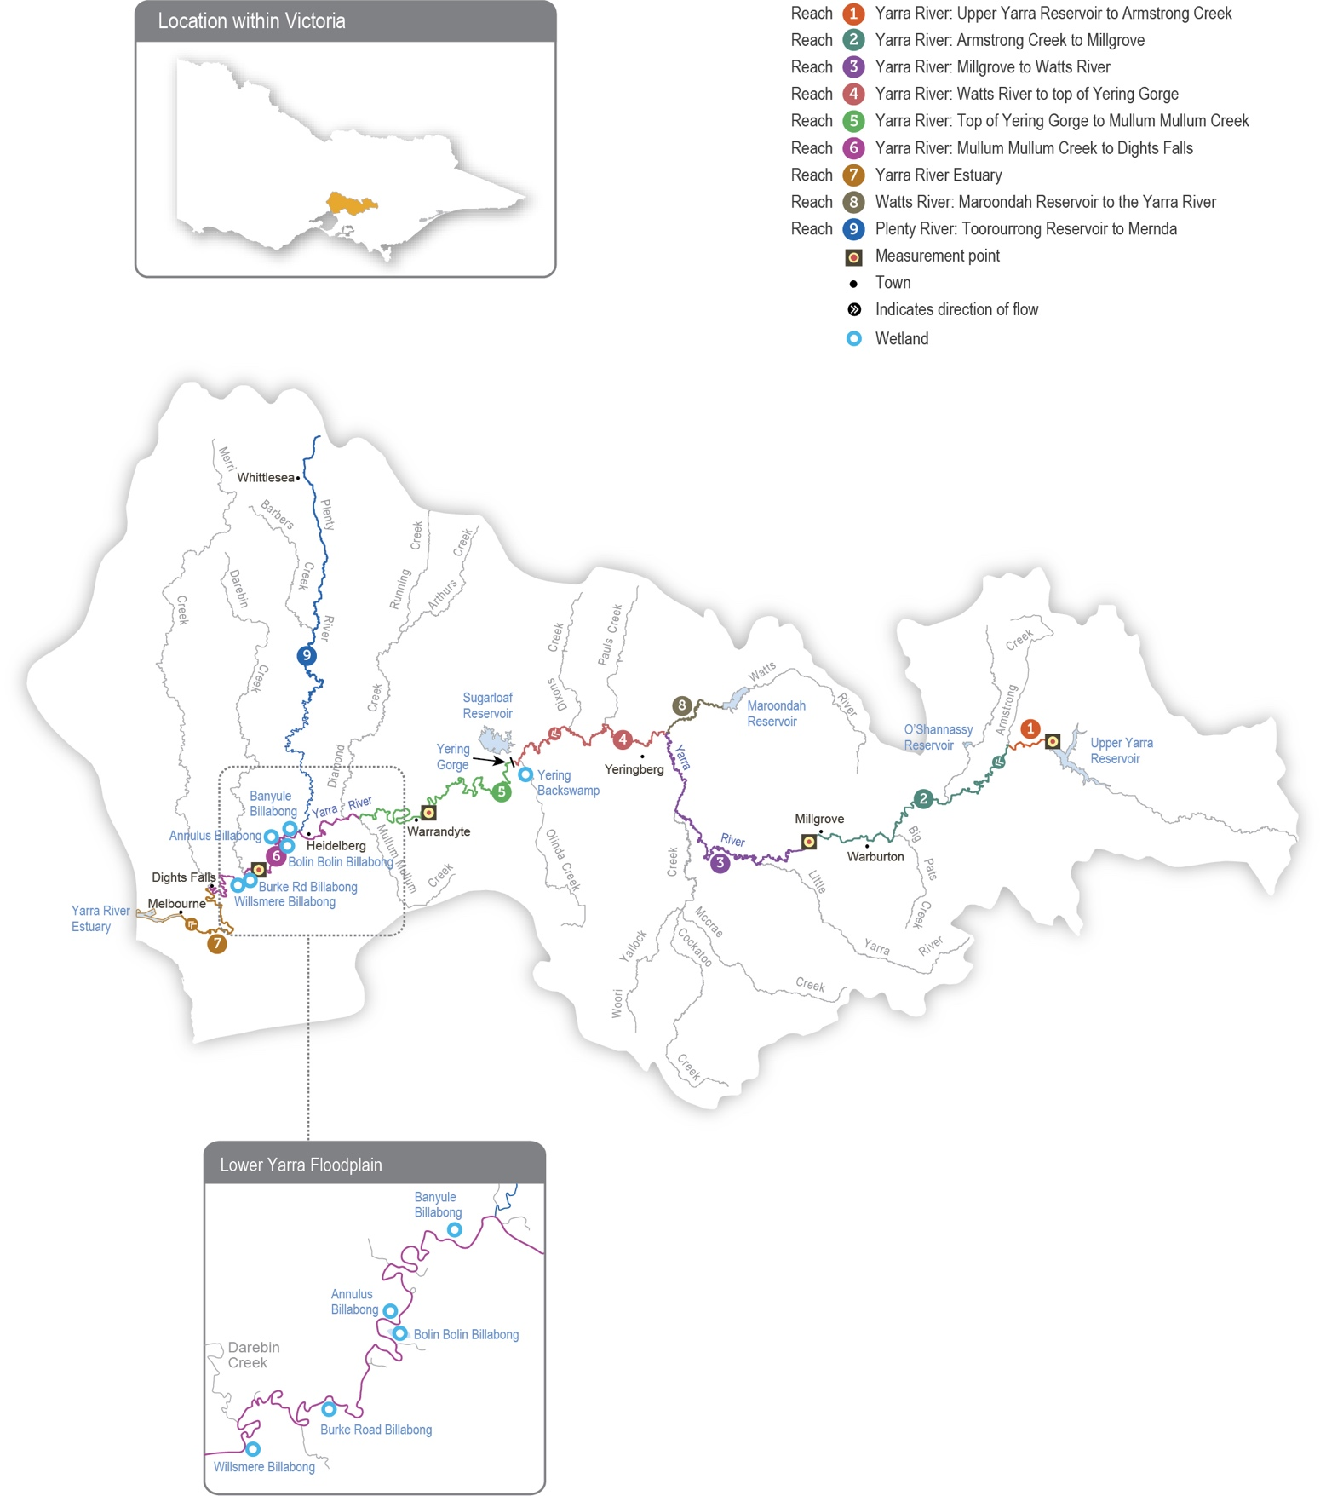

Return to start of section

Environmental values
The upper reaches of the Yarra River (reaches 1-3) have good-quality streamside and aquatic vegetation and provide habitat for native fish species, including river blackfish, mountain galaxias and common galaxias. The middle and lower reaches
of the Yarra River (reaches 4-6) flow through forested gorges, cleared floodplains and some highly-urbanised areas, and they support several populations of native fish, including Australian grayling, river blackfish, Macquarie perch and tupong. Macquarie perch were introduced to the Yarra River last century, and the population is now considered one of Victoria’s largest and most important.
The Plenty River (reach 9) provides habitat for waterbugs and native fish species (such as common galaxias). Platypus have been detected in the Plenty River in the past, but none were recorded in recent surveys.
Billabongs are an important feature of the lower Yarra River floodplain between Heidelberg and Dights Falls and in the upper reach around Yarra Glen. The billabongs support distinct vegetation communities and provide foraging and breeding habitat for waterbirds and frogs. Except in times of very high flow, most billabongs are disconnected from the Yarra River.
Environmental objectives in the Yarra system
Protect and increase populations of native fish, including threatened species (such as the Australian grayling, Macquarie perch and river blackfish)
Maintain the population of frogs, particularly on the mid-Yarra River floodplain
Maintain the form of the river channel Scour silt from riffles and clean cobbles
Provide sufficient rates of carbon and nutrient production and processing to support native fish and waterbug communities
Maintain the population of resident platypus
Maintain native streamside and aquatic vegetation on the riverbank and in the channels
Increase the growth of threatened wetland plant species to rehabilitate shallow marsh, deep marsh and freshwater meadows on the floodplain and billabongs
Maintain the diversity and increase the abundance of waterbugs to support aquatic food webs
Improve water quality in river pools, ensuring adequate oxygen concentration in the water to support fish, crustaceans and waterbugs

Traditional Owner cultural values and uses
Melbourne Water is working with the Registered Aboriginal Parties (RAPs) within the Birrarung (Yarra River) system — the Wurundjeri Woi Wurrung Cultural Heritage Aboriginal Corporation, the Bunurong Land Council Aboriginal Corporation and the Taungurung Land and Waters Council Aboriginal Corporation — to develop and strengthen relationships with them and to increase Traditional Owners’ involvement in the planning and delivery of water for the environment.
Melbourne Water is in discussions with each of the Traditional Owner corporations to work towards developing overarching partnership agreements. In terms of environmental water management, the intent is for Traditional Owners to be active partners in the planning, delivery and monitoring of all deliveries of water associated with Birrarung (Yarra River) and the Plenty River.
The part of the lower Birrarung (Yarra River) floodplain included in the environmental watering program is on Wurundjeri Woi wurrung Country upstream of Chandler Highway. The parts of the lower Birrarung (Yarra River) floodplain on Bunurong Country are not currently in the environmental watering program.
In 2021, changes to the RAP boundaries resulted in the lower Birrarung (Yarra River) from just upstream of Moonee Ponds Creek to Port Phillip Bay now falling within the Bunurong Land Council Aboriginal Corporation’s boundaries. The Bunurong Land Council Aboriginal Corporation is working with the Bunurong people to determine the cultural objectives for the Birrarung (Yarra River) on Bunurong Country.
In early 2023, Melbourne Water met with the Wurundjeri Woi Wurrung Cultural Heritage Aboriginal Corporation to discuss 2023-24 priorities for water for the environment on the lower Birrarung (Yarra River) floodplain. The Wurundjeri Woi Wurrung Cultural Heritage Aboriginal Corporation indicated it supports the priorities for the year ahead.
Return to start of section

Where possible, Melbourne Water and the Wurundjeri Woi Wurrung Cultural Heritage Aboriginal Corporation work together to link water for the environment on the lower Birrarung (Yarra River) floodplain with cultural outcomes for the Wurundjeri Woi wurrung people. In general, environmental flows management on the lower Birrarung (Yarra River) floodplain aligns with a landscape-scale approach for billabong watering, developed in consultation with Wurundjeri Woi wurrung people.
Management of water for the environment (including wetting and drying) at Annulus, Banyule and Bolin Bolin billabongs is closely aligned with Wurundjeri Woi wurrung aspirations.
Increasing the involvement of Traditional Owners in environmental flows management and progressing opportunities towards self-determination in the environmental watering program is a core commitment of the VEWH and its agency partners. This is reinforced by a range of legislative and policy commitments, including the Water Act 1989, the Victorian Aboriginal Affairs Framework, the 2016 Water for Victoria, the 2022 Central and Gippsland Region Sustainable Water Strategy, the 2022 Water
is Life: Traditional Owner Access to Water Roadmap, and in some cases, agreements under the Traditional Owner Settlement Act 2010.
Where Traditional Owners are more deeply involved in the planning and/or delivery of environmental flows for a particular site, their contribution is acknowledged in Table 3.2.1 with an icon. The use of this icon is not intended to indicate that these activities are meeting all the needs of Traditional Owners but is used in the spirit of valuing that contribution.

Watering planned and/or delivered in partnership with Traditional Owners to support cultural values and uses
There are many places of tangible and intangible cultural significance for the Wurundjeri Woi wurrung people and the Bunurong people on the lower Birrarung (Yarra River) floodplain.
A monitoring project continues at the billabongs with the Wurundjeri Woi Wurrung Cultural Heritage Aboriginal Corporation’s Narrap (‘Country’) Unit, the University of Melbourne and Melbourne Water. The group has been monitoring vegetation and water quality outcomes from environmental flows and held an on-Country knowledge-sharing day in 2022 to discuss learnings. The intent is to further the role and leadership of the Wurundjeri Woi Wurrung people in managing the billabongs, including vegetation management, research and being partners in decision-making processes.
In 2023-24, filling Bolin Bolin Billabong in the average and wet scenarios will provide an exit strategy for eels that have entered the billabong while connected with Birrarung (Yarra River). The Narrap Unit suggested this watering action to support the landscape-scale approach to watering floodplain billabongs. The Narrap Unit will collaborate on Bolin Bolin water delivery and monitoring, depending on the unit’s availability in 2023-24.

Social, recreational and economic values and uses
In planning the potential environmental watering actions in Table 3.2.1, Melbourne Water considered how environmental flows could support values and uses, including:
- water-based recreation (such as kayaking, canoeing, fishing and swimming)
- riverside recreation and amenity (such as birdwatching, camping, picnicking, cycling, running and walking)
- community events and tourism (such as the Moomba Festival and the Inflatable Regatta)
- socioeconomic benefits (such as for diverters for irrigation, stock needs and domestic use: water levels and water quality can rely on the delivery of water for the environment, particularly in summer).

Scope of environmental watering
The term ‘environmental watering’ refers to the active delivery of water for the environment to support particular environmental objectives by altering the flow in a river or the water level in a wetland. While other terms are also used to describe the delivery of water for the environment, ‘environmental watering’ is deliberately used here and in seasonal watering statements to ensure consistency in the legal instruments that authorise the use of water for the environment in Victoria.
Table 3.2.1 describes the potential environmental watering actions in 2023-24, their expected watering effect (that is, the intended physical or biological effects of the watering action) and the longer-term environmental objectives they support. Each environmental objective relies on one or more potential environmental watering actions and their associated physical or biological effects.
Return to start of section

Table 3.2.1 Potential environmental watering actions, expected watering effects and associated environmental objectives for the Yarra system

Potential environmental watering action | Expected watering effects | Environmental objectives
Yarra River
The highest priority reaches for the Yarra River are reaches 2 (upper Yarra River) and 5 (lower Yarra River); water delivered to these reaches generally benefits other reaches
Winter/spring low flow (June to November)  Reach 2: 80-350 ML/day  Reach 5: 350-750 ML/  day | - Physically mix pools to minimise the risk of stratification and low oxygen  - Maintain access to habitats for fish, waterbugs and platypus  - Wet bank vegetation to promote growth
Winter/spring freshes (two freshes for three to seven days during June to September)  Reach 2: 700 ML/day  Reach 5: 1,300-  2,500 ML/day | - Scour sediment and biofilm from gravel in riffles to improve spawning opportunities for Macquarie perch  - Wet native streamside vegetation on the banks of the river to promote growth  - Provide cues for upstream migration of juvenile migratory fish (e.g. Australian grayling and tupong)  - Entrain organic material to support carbon cycling
Winter/spring high flow (one high flow for three days during June- September)  Reach 1: 300 ML/d | - Scour sediment and biofilm from gravel in riffles  - Provide prolonged wetting to favour flood-tolerant native vegetation in the streamside zone  - Entrain organic material to support carbon cycling
Spring high flow (one high flow for 14 days during September to October)  Reach 2: 700 ML/day  Reach 5: 2,500 ML/day | - Scour sediment and biofilm from gravel in riffles  - Provide prolonged wetting to favour flood-tolerant native vegetation in the streamside zone  - Provide cues for upstream migration of juvenile migratory fish (e.g. Australian grayling and tupong)  - Trigger spawning of Macquarie perch  - Entrain organic material to support carbon cycling
Summer/autumn low flow (December to May)  Reach 2: 80 ML/day  Reach 5: 200 ML/day  Reach 6: 300-450 ML/ day | - Physically mix pools to minimise the risk of stratification and low oxygen  - Maintain access to habitats for fish, waterbugs and platypus
Summer/autumn freshes (three freshes for two days during December to May)  Reach 2: 350 ML/day  Reach 5: 750 ML/day | - Flush pools to prevent a decline in water quality  - Scour sediment and biofilm from gravel in riffles and pools to maintain habitat quality for fish and waterbugs  - Provide opportunities for the localised movement of fish and platypus  - Wet the banks of the river to maintain flood-tolerant vegetation on the banks
Autumn high flow (one high flow for seven to 14 days during April to May)  Reach 2: 560 ML/day  Reach 5: 1,300 ML/day | - Cue the migration of Australian grayling  - Scour sediment and biofilm from gravel in riffles and pools to maintain habitat quality for fish and waterbugs

Potential environmental watering action | Expected watering effects | Environmental objectives
Yarra billabongs
Bolin Bolin Billabong (fill in spring/summer) | - Fill the wetland to full supply level to engage the inlet/outlet channel to the Yarra River as an exit strategy for eels  - Allow to draw down to support the growth of threatened wetland plant species and encourage the regeneration of spreading aquatic herbs  - Maintain a permanent pool to provide habitat for frogs, waterbugs and any remaining eels
Yering Backswamp (fill in autumn/winter/spring) | - Wet the deepest parts of the wetland to about 80 cm to provide habitat for fish, frogs and waterbugs  - Wet remaining areas of the wetland to about 40-60 cm to support the growth of threatened wetland plant species and encourage the regeneration of spreading aquatic herbs

Scenario planning
Table 3.2.2 outlines potential environmental watering and expected water use in a range of planning scenarios.

In the Yarra system, dry, average and wet planning scenarios are considered. A drought planning scenario for the Yarra has not been included as the actions would be almost identical to the dry scenario and because drought conditions don’t affect the allocation of water for the environment.
Wet conditions in 2022-23 caused widespread flooding in the Yarra catchment, which naturally met most of the planned environmental flows actions for the year and delivered a range of larger flows that cannot be achieved with water for the environment. The wet conditions also caused reservoirs in the Yarra-Thomson system to spill, meaning accumulated carryover from previous years was deducted from the VEWH’s accounts. Accordingly, water availability heading into 2023-24 will be less than in recent years. The reliable allocation of 17,000 ML per year that is provided on 1 July will allow critical watering actions to be delivered in all planning scenarios in 2023-24, but the lower carryover volume may restrict some watering actions that would otherwise be planned. This represents a relatively low risk for the environmental values of the Yarra system, given the environmental flow recommendations have been met or exceeded for the last three years.
Environmental flow planning in the Yarra River focuses on providing a sufficiently low flow throughout the year to maintain habitat for aquatic life and providing a high flow at critical times to support the migration and breeding requirements of native fish. A summer/autumn low flow and freshes, a winter/spring high flow (in reach 1) and a winter/spring low flow and freshes are needed to achieve these outcomes in all planning scenarios. The extent to which these flows are likely to be met by natural tributary inflows varies between the dry, average and wet planning scenarios, and water for the environment will be used to fill the main deficits in each scenario, where possible.
A spring high flow is required every year in the average and wet planning scenarios to meet environmental objectives for streamside vegetation fully, but most other objectives associated with this flow – Macquarie perch spawning and upstream migration of Australian grayling and tupong – can be met with lower-magnitude winter/spring freshes. Given spring high flows have occurred naturally in each of the last three years and the potentially high volume of environmental flow required to deliver an equivalent flow when it does not naturally occur, a spring high flow is considered a lower priority in 2023-24.
The main objective of the autumn high flow is to trigger Australian grayling to migrate downstream to the estuary and spawn. Ideally, Australian grayling will have spawning opportunities every year, and spawning is preferred every year to maintain a healthy population, but it is critically required in two out of every three years. Autumn high flows have occurred naturally in the Yarra River in each of the last three years. Given the volume of water for the environment available in 2023-24, delivering an autumn high flow is considered a lower priority in the dry and average planning scenarios. However, Melbourne Water may still deliver an autumn high flow in any planning scenario in 2023-24 if the natural flow delivers some planned watering actions in spring and summer, freeing up the available supply.
Melbourne Water is adopting a landscape-scale approach to delivering environmental flows across its floodplain billabongs. The approach specifically considers the ecosystem services different billabongs provide, the importance of wetting and drying phases for wetland health, and which billabongs need to be watered at any given time to support regionally important plant and animal populations. Numerous billabongs throughout the Yarra River catchment are drier than natural due to river regulation and modifications to natural flow paths. Ensuring some billabongs are inundated at any given time is necessary to provide habitat for waterbirds and frogs, including some rare or threatened species.

Return to start of section

All the Yarra billabongs filled naturally in spring 2022 and were in various states of drawdown in autumn 2023. Melbourne Water’s landscape approach to planning environmental flows has identified watering Bolin Bolin Billabong and Yering Backswamp as high priorities in 2023-24. The distinct vegetation community at Yering Backswamp has adapted to frequent or near-permanent inundation. As such, it is the only managed wetland on the Yarra floodplain actively watered annually
in all planning scenarios. Filling Yering Backswamp annually also provides reliable habitat for native frogs and waterbirds, especially when other wetlands are drawing down or in their dry phases. Bolin Bolin Billabong may be watered in the average and wet planning scenarios to help eels that entered the billabong during the 2022 floods move back to the main river channel. Scientists from the Arthur Rylah Institute for Environmental Research have tagged eels in Bolin Bolin Billabong to track their movement in response to natural and managed watering events. The results of that work will help future watering at Bolin Bolin and other Yarra billabongs. All other actively managed billabongs on the Yarra floodplain will be allowed to draw down during 2023-24 to support vegetation objectives and to provide foraging habitats for birds and other fauna that use wetlands in their drawdown and drying phases.
A target carryover volume has not been prioritised in the Yarra system this year. The highly reliable environmental allocation (17,000 ML on 1 July each year) means that there will be sufficient supply for potential environmental watering actions in 2024- 25 without carryover from 2023-24.
Table 3.2.2 Potential environmental watering for the Yarra system in a range of planning scenarios

Planning scenario | Dry | Average | Wet
Expected conditions | - Low streamflow year- round  - Lack of unregulated freshes and high flow  - Passing flow is not likely to meet the minimum environmental flow recommendations  - Potential poor water quality, particularly in summer  - Pools may stratify  - Plenty River may experience cease-to-flow events | - Low-flow recommendations are likely to be met by passing flow  - Natural flow may provide some freshes, but its duration and/or magnitude will likely be less than recommended environmental flow  - Potentially poor water quality, particularly in summer  - Pools may stratify  - Small reservoirs may spill  - Overbank flow is not likely | - Low-flow recommendations are likely to be met by passing flow  - High, natural flow will occur, most likely in winter/spring  - Major spills from reservoirs may occur  - Some natural wetting of billabongs may occur
Expected availability of water for the environment | - 22,000 ML | - 22,000 ML | - 22,000 ML
Yarra River (targeting reach 2 and 5)
Potential environmental watering – tier 1 (high priorities) | Tier 1a (can be achieved with predicted supply)
 | - Winter/spring low flow  - Winter/spring fresh (one fresh)  - Winter/spring high flow (one high flow)  - Summer/autumn low flow  - Summer/autumn freshes (three freshes)  - Yering Backswamp | - Winter/spring low flow  - Winter/spring freshes (two freshes)  - Winter/spring high flow (one high flow)  - Summer/autumn low flow  - Summer/autumn freshes (three freshes)  - Bolin Bolin Billabong  - Yering Backswamp | - Winter/spring low flow  - Winter/spring freshes (two freshes)  - Winter/spring high flow (one high flow)  - Summer/autumn low flow  - Summer/autumn freshes (three freshes)  - Autumn high flow (one high flow)  - Bolin Bolin Billabong  - Yering Backswamp
 | Tier 1b (supply deficit)
 | - Winter/spring fresh (one fresh)  - Autumn high flow (one high flow) | - Spring high flow (one high flow)  - Autumn high flow (one high flow) | - Spring high flow (one high flow)  - Winter/spring high flow (one high flow)

Planning scenario | Dry | Average | Wet
Potential environmental watering – tier 2 (additional priorities) | - N/A
Possible volume of water for the environment required to achieve objectives | - 21,750 ML (tier 1a)  - 16,660 ML (tier 1b) | - 20,250 ML (tier 1a)  - 15,800 (tier 1b) | - 20,900 ML (tier 1a)  - 5,600 ML (tier 1b)
Priority carryover requirements for 2024-25 | - 0 ML | - 0 ML | - 0 ML
Return to start of section

Tarago system
Waterway manager – Melbourne Water
Storage manager – Melbourne Water
Environmental water holder – Victorian Environmental Water Holder

System overview
The Tarago River rises in the Tarago State Forest and flows into the Tarago Reservoir at Neerim (Figure 3.3.1). The reservoir harvests inflows from all upstream tributaries to supply towns on the Mornington Peninsula and around the Western Port area. Water is released from the reservoir to supply downstream irrigators. Below the reservoir, the Tarago River flows close to Rokeby before meeting the Bunyip River at Longwarry North. From there, the Bunyip River flows through a modified, straightened channel called Bunyip Main Drain that discharges into Western Port. The Bunyip Main Drain supplies many irrigators in the catchment.
Water available under the Tarago and Bunyip Rivers Environmental Entitlement 2009 is stored in and released from Tarago Reservoir. This water is primarily used to meet environmental objectives in reach 2, between the reservoir and the confluence of the Tarago and Bunyip rivers, as Figure 3.3.1 shows. Water for the environment delivered to reach 2 also supports environmental flow recommendations in reach 6 (Bunyip Main Drain).
Year-round passing flows in the Bunyip and Tarago rivers are stipulated under both the environmental entitlement and Melbourne Water’s bulk entitlement. These passing flows contribute toward meeting the minimum low-flow requirements in summer/autumn and winter/spring, but they are less than the recommended minimum flows. The passing flows do not provide any of the freshes or greater flows that are needed throughout the year to support environmental outcomes.
Water released to meet irrigation demands creates variable flow patterns in the Tarago and Bunyip rivers throughout the year. The magnitude and timing of these releases can influence environmental outcomes, and Melbourne Water continues to work with Southern Rural Water to optimise the shared value derived from irrigation releases.

Return to start of section

Figure 3.3.1 The Tarago system

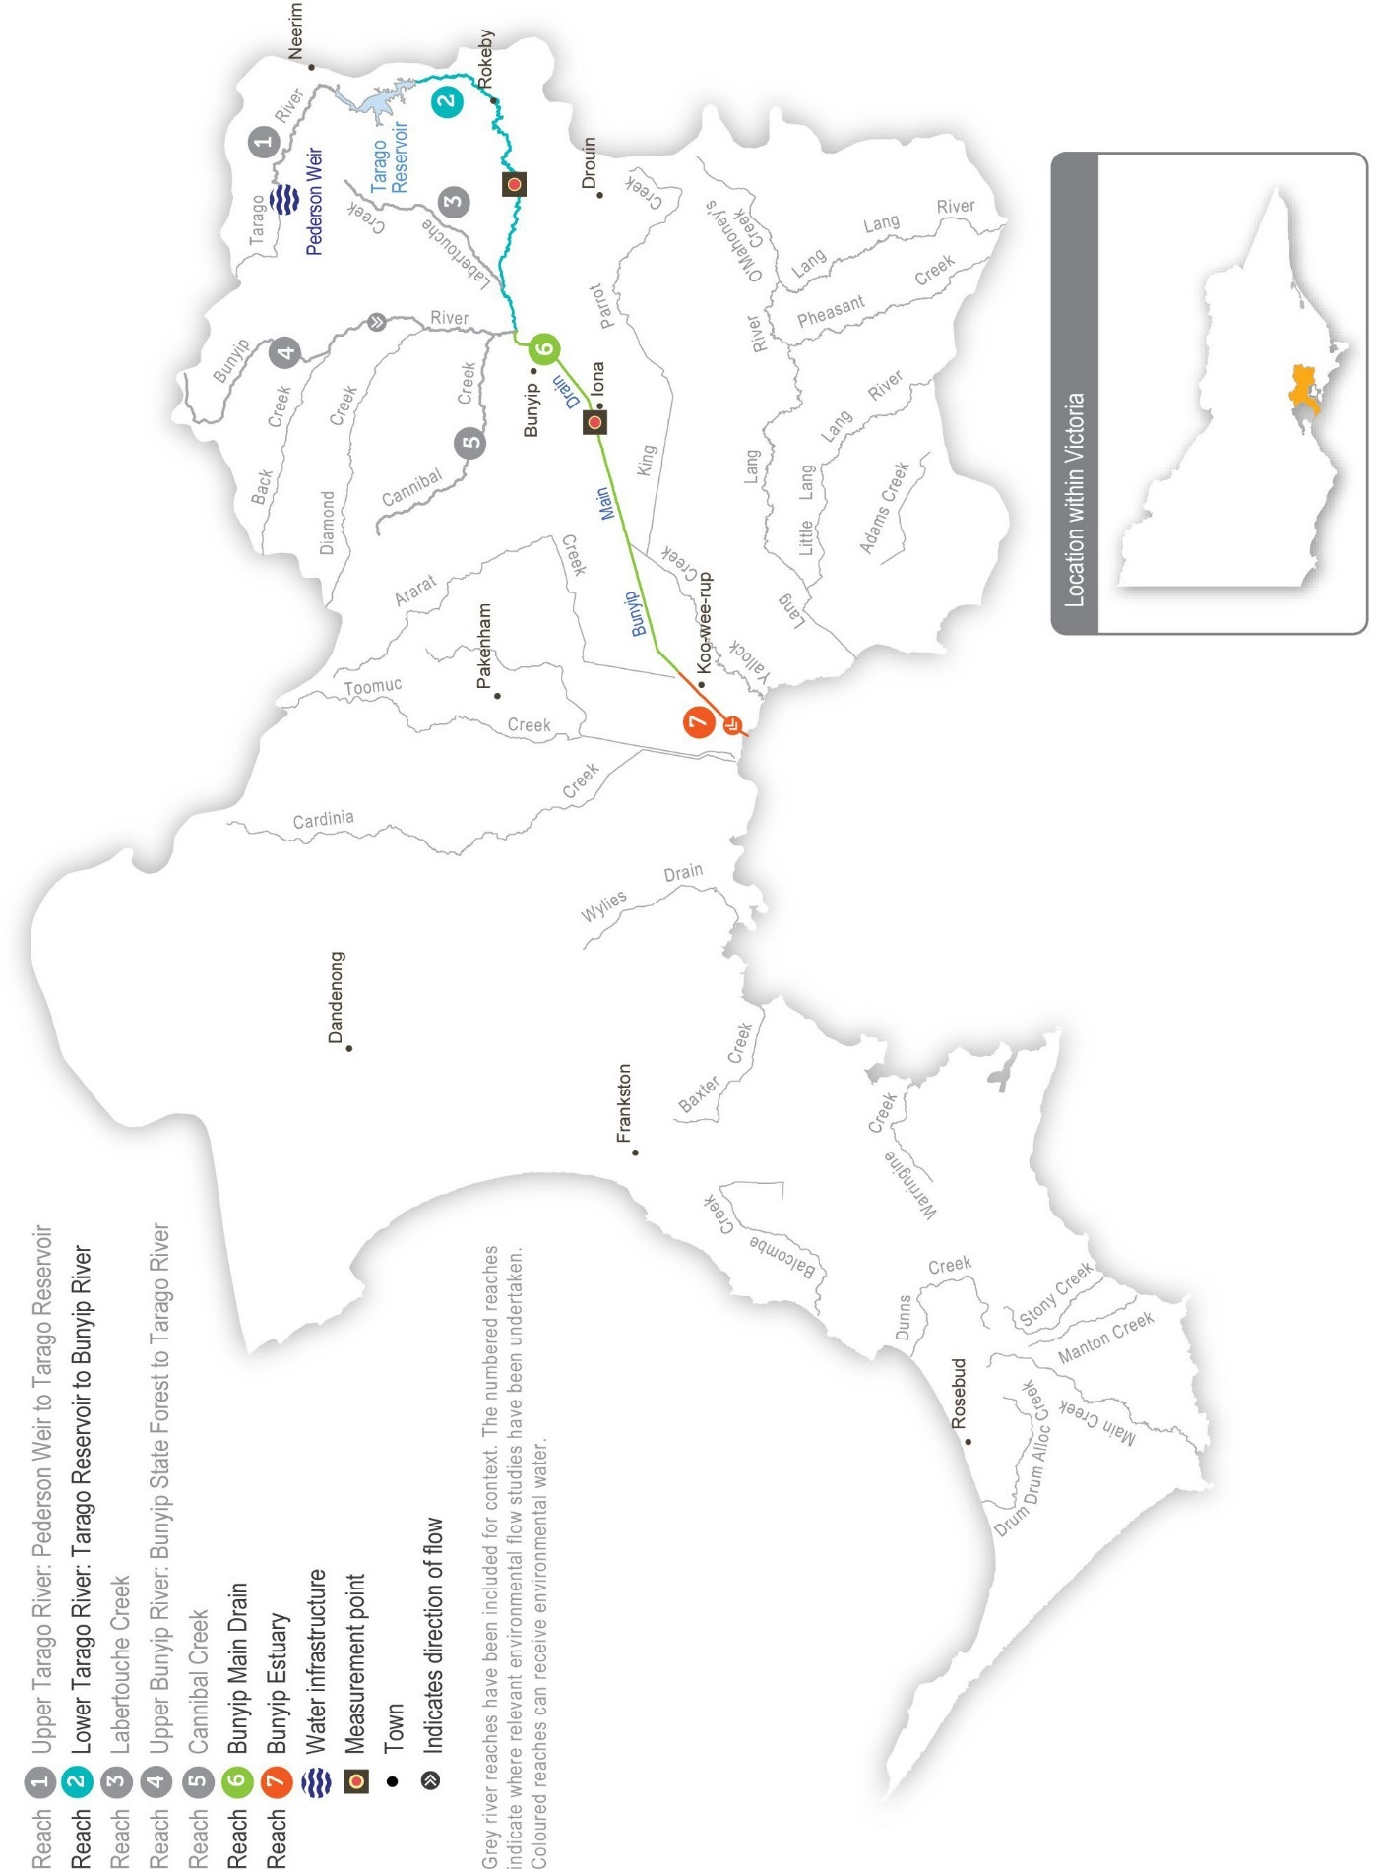
Return to start of section

Environmental values
The Tarago system contains several significant and threatened native animal and plant species, including Australian grayling, long pink-bells, tree geebung and swamp bush pea. The upper catchment (reach 2) has healthy streamside vegetation and diverse in-stream habitat that supports platypus and native fish, including river blackfish, tupong, short-finned eels and mountain galaxias. The lower catchment (reach 6) has been highly modified but still contains patches of remnant vegetation and is a key migration pathway for Australian grayling. It also has healthy platypus populations.

Environmental objectives in the Tarago system
Increase populations of native fish, including threatened species (such as the Australian grayling)
Maintain channel form and structure
Increase platypus populations
Increase native streamside and aquatic plant communities on the riverbank and in the channel
Increase the diversity and biomass of waterbugs to support aquatic foodwebs
Improve water quality in river pools, ensuring adequate oxygen concentration in the water to support fish, crustaceans and waterbugs

Traditional Owner cultural values and uses
Melbourne Water is working with interested Traditional Owner groups and the Registered Aboriginal Party within the Tarago system – the Bunurong Land Council Aboriginal Corporation – to develop and strengthen relationships and to
increase Traditional Owners’ involvement in the planning and delivery of water for the environment. As of January 2023, one overarching partnership agreement had been finalised between Melbourne Water and the Gunaikurnai Land and Waters Aboriginal Corporation that frames relations and obligations between the two organisations. Discussions were also occurring with the Bunurong Land Council Aboriginal Corporation to determine whether similar partnership agreements would benefit Bunurong. The intent is for Traditional Owners to be active partners in the planning, delivering and monitoring water for the environment associated with the Tarago and Bunyip rivers.
The Bunurong Land Council Aboriginal Corporation has expressed a desire to be more involved in environmental flows planning and management in the Tarago River.
Melbourne Water and the VEWH will continue to work with the Traditional Owner groups to identify and integrate cultural values and their flow requirements into the environmental watering program on an ongoing basis.

Social, recreational and economic values and uses
In planning the potential environmental watering actions in Table 3.3.1, Melbourne Water considered how environmental flows could support values and uses, including:
- water-based recreation (such as fishing and swimming)
- riverside recreation and amenity (such as cycling, camping, caravanning, short- and long-term visiting and walking)
- community events and tourism (such as visiting and residing in the Glen Cromie Caravan Park)
- socioeconomic benefits (such as for diverters for irrigation, stock needs and domestic use: water levels and water quality can rely on the delivery of water for the environment, particularly in summer).
If the timing or management of planned environmental flows may be modified to align with a community benefit, this is acknowledged in Table 3.3.1 with the following icon.

Watering planned to support peaks in visitation (e.g. camping or other public activities on long weekends or school holidays)
Melbourne Water may time the release of a summer fresh in the Tarago River to coincide with long weekends in January or March, so visitors and long-term residents of the Glen Cromie Caravan Park can enjoy the additional flow in the river.
Return to start of section

Scope of environmental watering
The term ‘environmental watering’ refers to the active delivery of water for the environment to support particular environmental objectives by altering the flow in a river or the water level in a wetland. While other terms are also used to describe the delivery of water for the environment, ‘environmental watering’ is deliberately used here and in seasonal watering statements to ensure consistency in the legal instruments that authorise the use of water for the environment in Victoria.
Table 3.3.1 describes the potential environmental watering actions in 2023-24, their expected watering effect (that is, the intended physical or biological effects of the watering action) and the longer-term environmental objectives they support. Each environmental objective relies on one or more potential environmental watering actions and their associated physical or biological effects.
Table 3.3.1 Potential environmental watering actions, expected watering effects and associated environmental objectives for the Tarago system

Potential environmental watering action | Expected watering effects | Environmental objectives
Tarago River (targeting reach 2)
Winter/spring low flow (75 ML/day or natural during June to November) | - Prevent the encroachment of terrestrial vegetation in the channel  - Wet the banks to promote streamside vegetation growth  - Maintain an adequate depth through riffles to allow access to habitats for fish and platypus  - Mix pools to maintain water quality and increase habitat for fish and macroinvertebrates during wetter months
Winter/spring fresh(es) (one to two freshes with a peak of 100-200 ML/ day for two days during June to September) | - Flush sediment and scour biofilm from stream substrate and large woody debris to maintain habitat for macroinvertebrates and fish, including river blackfish  - Create extra depth to allow greater fish movement between pools and reaches  - Cue the downstream migration of species, including eel and tupong  - Wet the banks and low benches to maintain the fringing aquatic vegetation
Spring high flow (one high flow with a peak of 200-300 ML/day for two days in a seven-to- 10-day duration during September to October) | - Form and maintain scour holes around large wood  - Prevent the encroachment of terrestrial vegetation into the channel  - Cue the upstream migration of juvenile diadromous fish (e.g. Australian grayling) from the sea or estuary into the river  - Wet the higher benches to maintain the fringing aquatic vegetation and ensure vertical zonation of the fringing vegetation  - Encourage female platypus to select a nesting burrow higher up the bank to reduce the risk of greater flow later in the year flooding the burrow when juveniles are present
Summer/autumn low flow (20 ML/day or natural during December to May) | - Maintain adequate depth through riffles to support waterbugs and allow access to habitats for fish and platypus  - Maintain adequate foraging habitat in pools for fish and platypus  - Maintain water quality (especially oxygen concentration) in pools
Summer/autumn freshes (three to five freshes of  75 ML/day for two days during December to May) | - Flush fine silt from hard substrates and around large woody debris to maintain habitat for native fish in low-flow periods  - Allow the localised movement of native fish  - Prevent terrestrial vegetation growth on sandbars  - Maintain water quality by aeration in times of low flow
Autumn high flow (one high flow with a peak of 100 ML/day for two days in a minimum seven-day duration during April to May) | - Cue the downstream migration and spawning of diadromous fish (e.g. Australian grayling)  - Assist the dispersal of juvenile platypus

Scenario planning
Table 3.3.2 outlines potential environmental watering and expected water use in a range of planning scenarios.

The Tarago River generally requires similar watering actions every year, although the magnitude of its low flow and the frequency of high flows is less in the drought and dry planning scenarios than in the wet or average scenarios. Natural catchment inflows, passing flow and reservoir spills will meet many of the required watering actions and provide natural flow variation throughout the year, especially in the wet planning scenario. Water for the environment will be used where possible to deliver critical flow components not met by other means. Melbourne Water will monitor water levels and water quality throughout the year and adjust releases as necessary to limit stress on existing plants and animals.
In the drought planning scenario, there will not be enough water to compensate for low passing flow and low natural inflows fully. The highest-priority environmental watering actions will be a series of summer/autumn freshes to protect species, including Australian grayling and platypus, by maintaining water levels and water quality in critical refuge habitat. These freshes will provide relief from long periods of low streamflow and help prevent localised extinctions and fish deaths in the drought planning scenario.
Water for the environment will be used for summer/autumn freshes, winter/spring freshes, an autumn high flow in all other planning scenarios and a spring high flow in the wet scenario. Summer/autumn freshes in all planning scenarios help maintain water quality and habitat for native fish and platypus. In the average and wet planning scenarios, when the natural streamflow increases, the number of freshes increases to five to improve the condition and size of native fish and platypus populations.
An autumn high flow is needed to trigger Australian grayling movement and spawning. Australian grayling require favourable breeding conditions in at least two of every three years to maintain and grow their population. Wet conditions have delivered high autumn flows in the Tarago River in each of the last four years, so an additional flow is not essential in 2023-24, but it will be delivered if the available supply allows for the consolidation of recent population increases. Winter/spring freshes are
needed to cue and facilitate fish movement, including the downstream migration of tupong and eels, and to support the growth of new fringing vegetation. One winter/spring fresh is planned in the dry planning scenario to maintain the current condition of native fish populations and streamside vegetation, and extra freshes are planned in the average and wet planning scenarios to enhance native fish and plant communities. The spring high flow aims to water vegetation higher up the bank and cue the upstream migration of juvenile fish, including Australian grayling. While it would be good to deliver a spring high flow in the average and wet planning scenarios, there is only likely to be enough supply to deliver it in the wet scenario.
Carryover requirements vary depending on seasonal conditions. Under drought and dry conditions, a greater volume (1,000 ML) is recommended to carry over into 2024-25 to ensure sufficient water is available for summer/autumn freshes to
maintain water quality if dry conditions continue. Less carryover is needed in the average and wet planning scenarios because adequate allocation in 2024-25 can be expected under those scenarios.

Return to start of section

Table 3.3.2 Potential environmental watering for the Tarago system in a range of planning scenarios

Planning scenario | Drought1 | Dry | Average | Wet
Expected conditions | - Very low streamflow  - Reduction in passing flow  - Irrigation releases likely | - Low streamflow  - Some reduction in passing flow  - Irrigation releases likely | - Average streamflow  - Partial freshes naturally provided  - Some irrigation releases likely | - Above-average streamflow  - Partial or full freshes naturally provided  - Irrigation releases unlikely  - Tarago Reservoir spills
Expected availability of water for the environment | - 3,000 ML2 | - 3,000 ML | - 3,500 ML | - 4,500 ML
Tarago River (targeting reach 2)
Potential environmental watering – tier 1 (high priorities) | Tier 1a (can be achieved with predicted supply)
 | - Summer/autumn freshes (five freshes) | - Winter/spring fresh (one fresh)  - Summer/autumn freshes (three freshes)  - Autumn high flow (one high flow) | - Winter/spring freshes (two freshes)  - Summer/autumn freshes (five freshes)  - Autumn high flow (one high flow) | - Winter/spring freshes (two freshes)  - Spring high flow (one high flow)  - Summer/autumn freshes (five freshes)  - Autumn high flow (one high flow)
 | Tier 1b (supply deficit)
 | - Winter/spring low flow  - Winter/spring fresh (one fresh)  - Winter/spring high flow (one high flow)  - Summer/autumn low flow  - Autumn high flow (one high flow) | - Winter/spring low flow  - Spring high flow (one high flow)  - Summer/autumn low flow  - Summer/autumn freshes (two freshes) | - Winter/spring low flow  - Spring high flow (one high flow)  - Summer/autumn low flow | - Winter/spring low flow  - Summer/autumn low flow
Possible volume of water for the environment required to achieve objectives | - 2,000 (tier 1a)  - 5,750 (tier 1b) | - 1,850 ML (tier 1a)  - 5,900 ML (tier 1b) | - 2,900 ML (tier 1a)  - 4,700 (tier 1b) | - 4,200 ML (tier 1a)  - 2,150 ML (tier 1b)
Priority carryover requirements for 2024-25 | - 1,000 ML | - 1,000 ML | - 500 ML | - 300 ML
- The drought planning scenario has been added for 2023-24 to demonstrate target actions under conditions where the recommended watering actions for the dry scenario could not be met due to further reduced streamflow.
- Supply is expected to be the same in the drought as in the dry planning scenario in 2023-24 because of storage levels, and the changes in planned watering actions are driven more by the expected reduction in the natural flow through the system because of drier, hotter conditions.

Return to start of section

Maribyrnong system
Waterway manager – Melbourne Water Storage manager – Southern Rural Water Environmental water holder – Not applicable

System overview
The Maribyrnong catchment is located to the northwest of Melbourne. The main waterways in the catchment are Jacksons Creek, which flows southeast from Mount Macedon, and Deep Creek, which flows south from Lancefield (Figure 3.4.1). These two tributaries join at Keilor North to form Mirrangbamurn (Maribyrnong River), which flows south to join Birrarung (Yarra River) at Yarraville before flowing into Port Phillip Bay.
Rosslynne Reservoir is in the upper reaches of Jacksons Creek near Gisborne and is the only major storage in the Maribyrnong catchment. The reservoir has a maximum release capacity of 20 ML per day under ideal conditions, which significantly constrains the environmental outcomes that can be achieved in the Maribyrnong system. Water for the environment is primarily used to support environmental outcomes in Jacksons Creek between Rosslynne Reservoir and the confluence with Riddles Creek (that is, delivery of water for the environment to reach 6, as shown in Figure 3.4.1). Jacksons Creek is a known groundwater-dependent ecosystem on the national Groundwater Dependent Ecosystems Atlas. This means ecological components in the system rely on groundwater for at least some period of time.
The VEWH does not hold an environmental entitlement in the Maribyrnong system, and it relies on opportunistic, temporary trade to meet demands. Melbourne Water (as diversion manager) and the VEWH work with local diversion licence holders to purchase unused water when it is available to support environmental outcomes. This arrangement is negotiated each year, is subject to water availability in the bulk entitlement and storage capacity, and only occurs with all parties’ agreement.

Return to start of section

Figure 3.4.1 The Maribyrnong system

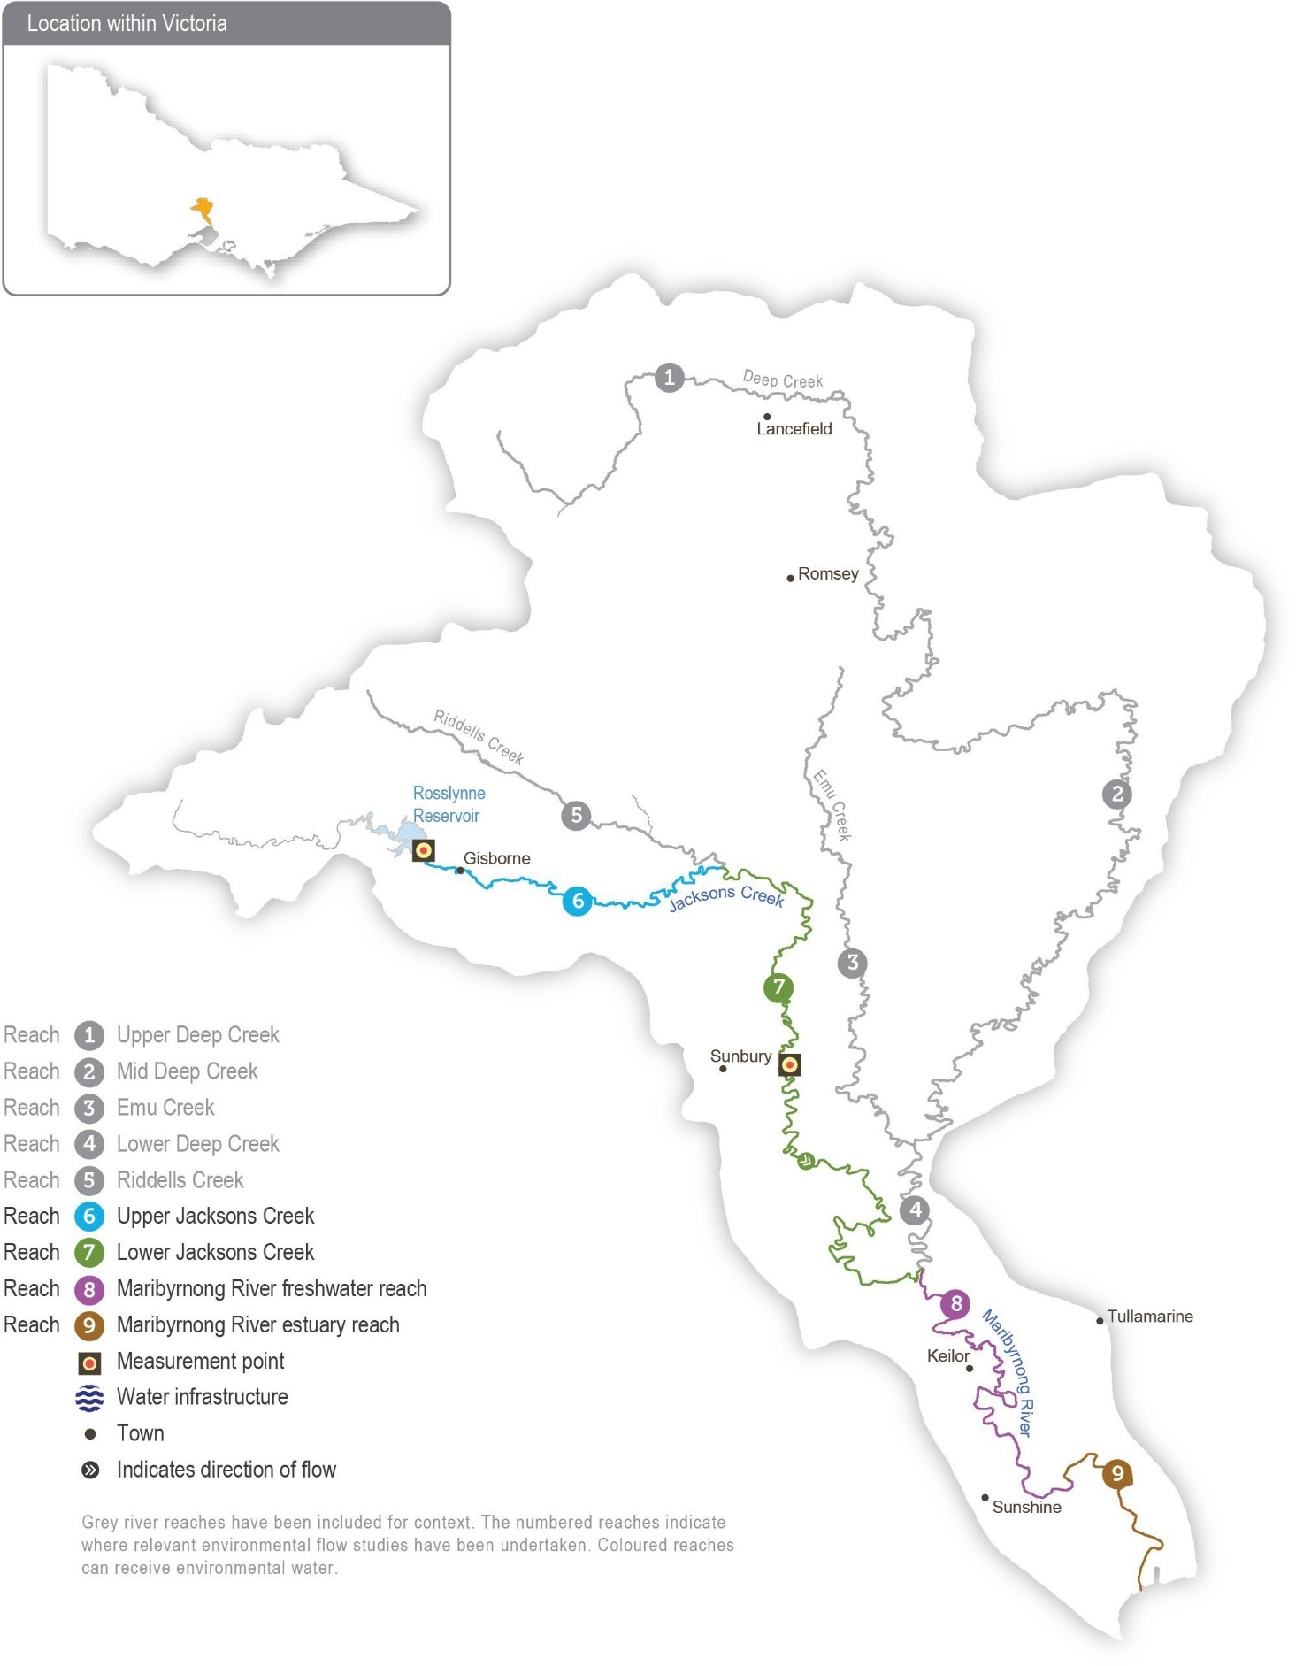
Return to start of section

Environmental values
The upper Maribyrnong catchment contains areas of intact streamside vegetation, which provide important habitat for native fish, including migratory short-finned eels, common and ornate galaxias, flathead gudgeon, tupong and Australian smelt.
A large population of waterbugs provides abundant food for a significant platypus population in several reaches of the Maribyrnong system.

Environmental objectives in the Maribyrnong system
Protect populations of native small-bodied fish
Protect platypus populations
Maintain the condition, abundance, diversity and structure of in-stream and streamside vegetation
Support a wide range and high biomass of waterbugs to break down dead organic matter and support the river’s food chain
Maintain water quality, particularly oxygen concentrations

Traditional Owner cultural values and uses
Melbourne Water is working with the Registered Aboriginal Parties within the Maribyrnong system — the Wurundjeri Woi Wurrung Cultural Heritage Aboriginal Corporation and the Bunurong Land Council Aboriginal Corporation — to strengthen relationships and increase Traditional Owner involvement in the planning and delivery of water for the environment.
There are more opportunities for Melbourne Water and the VEWH to work with Traditional Owner groups to identify and better integrate cultural values and their flow requirements into the environmental watering program on an ongoing basis.

Social, recreational and economic values and uses
In planning the potential environmental watering actions in Table 3.4.1, Melbourne Water considered how environmental flows could support social values such as community connection and amenity by planning flows that will maintain healthy habitat and improve water quality.

Scope of environmental watering
The term ‘environmental watering’ refers to the active delivery of water for the environment to support particular environmental objectives by altering the flow in a river or the water level in a wetland. While other terms are also used to describe the delivery of water for the environment, ‘environmental watering’ is deliberately used here and in seasonal watering statements to ensure consistency in the legal instruments that authorise the use of water for the environment in Victoria.
Table 3.4.1 describes the potential environmental watering actions in 2023-24, their expected watering effect (that is, the intended physical or biological effects of the watering action) and the longer-term environmental objectives they support. Each environmental objective relies on one or more potential environmental watering actions and their associated physical or biological effects.

Return to start of section

Table 3.4.1 Potential environmental watering actions, expected watering effects and associated environmental objectives for the Maribyrnong system

Potential environmental watering action | Expected watering effects | Environmental objectives
Jacksons Creek (targeting reach 6)
Winter/spring low flow (15 ML/day during June to November) | - Maintain depth in pools and riffles to provide habitat for small-bodied native fish, platypus and waterbugs  - Prevent terrestrial vegetation encroachment
Summer/autumn low flow (4-6 ML/day during December to May) | - Maintain pool habitat availability for small-bodied fish and platypus during low-flow periods  - Maintain a > 0.1 m median depth over riffles to provide macroinvertebrate habitat and inundate in-stream vegetation  - Maintain continuous flow to limit pool stratification and maintain water quality
Summer/autumn freshes (five freshes of 15 ML/ day for four days every four to six weeks during December to May) | - Increase depth over riffle to provide local movement of small-bodied native fish and platypus during the low flow period  - Maintain habitat and food resources for waterbugs  - Flush pools to maintain water quality

Scenario planning
Table 3.4.2 outlines potential environmental watering and expected water use in a range of planning scenarios.

There is no permanent environmental entitlement in the Maribyrnong system, so water for the environment can only be delivered in 2023-24 if other entitlement holders are willing to sell some of their annual allocations to the VEWH.
An adequate low flow throughout the year and summer/autumn freshes are a high priority in all planning scenarios to maintain habitat for native fish and platypus and to prevent poor water quality. In the average and wet planning scenarios, local catchment run-off, tributary inflows and groundwater contributions will likely meet and exceed these flow requirements in lower Jacksons Creek (reach 7). However, in all planning scenarios, the mandated passing flow and water for the environment will be needed to achieve these watering actions in upper Jacksons Creek (reach 6).
The VEWH is unable to carry over water in the Maribyrnong system to support multi-year planning.

Return to start of section

Table 3.4.2 Potential environmental watering for the Maribyrnong system in a range of planning scenarios

Planning scenario | Dry | Average | Wet
Expected river conditions | - Low volumes of unregulated flow  - Passing flow may meet some low-flow objectives  - Some baseflow from groundwater contributions in Jacksons Creek | - Unregulated flow meets some objectives  - Passing flow may meet several low-flow objectives  - Groundwater contributions provide baseflow in Jacksons Creek | - Unregulated flow meets most objectives  - Passing flow may meet most low-flow objectives  - Groundwater contributions provide baseflow in Jacksons Creek
Expected availability of water for the environment | - There is no environmental entitlement in the Maribyrnong system. Water will need to be traded with willing irrigators to support watering actions
Jacksons Creek (targeting reach 6)
Potential environmental watering – tier 1 (high priorities) | Tier 1a (can be achieved with predicted supply)
 | - N/A
 | Tier 1b (supply deficit)
 | - Winter/spring low flow  - Summer/autumn low flow  - Summer/autumn freshes (three freshes) | - Winter/spring low flow  - Summer/autumn low flow  - Summer/autumn freshes (three freshes) | - Winter/spring low flow  - Summer/autumn low flow  - Summer/autumn freshes (three freshes)
Possible volume of water for the environment required to achieve objectives | - 2,400 ML | - 2,400 ML | - 2,400 ML
Return to start of section

Werribee system
Waterway manager –Melbourne Water
Storage manager – Southern Rural Water
Environmental water holder – Victorian Environmental Water Holder
Proportions of water entitlements in the Werribee basin held by private users, water corporations and environmental water holders on 30 June 2020
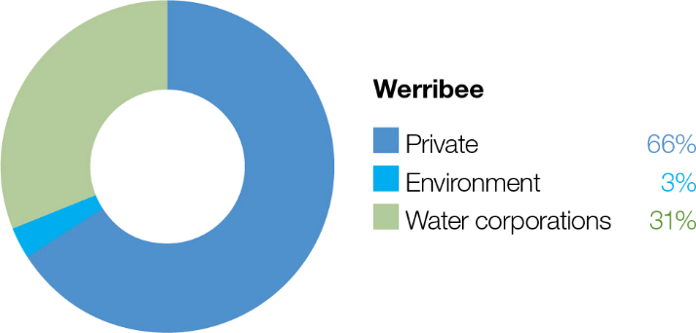

System overview
Wirribi Yaluk (in Wadawurrung language)/Weariby Yallok (in Bunurong language) (Werribee River) flows southeast from the Wombat State Forest near Ballan, through the Werribee Gorge to Bacchus Marsh and then into Port Phillip Bay at Werribee (Figure 3.5.1). The Lerderderg River is a major tributary that joins the river at Bacchus Marsh. The main storages in the Werribee system are Pykes Creek Reservoir, Melton Reservoir and Merrimu Reservoir.
The four reaches in the Werribee system that can receive water for the environment are Pyrites Creek between Lake Merrimu and Melton Reservoir (reach 6), the Werribee River between Melton Reservoir and the Werribee Diversion Weir (reach 8), Werribee River between the Werribee Diversion Weir and Werribee Park Tourism Precinct (reach 9) and the Werribee River estuary below the Werribee Park Tourism Precinct.
Environmental flows that target environmental objectives in reach 9 and the estuary are delivered from Melton Reservoir and therefore also benefit reach 8. Water for the environment released from Lake Merrimu is re-harvested in Melton Reservoir, where it can be held and released at an appropriate time to achieve environmental objectives in the lower Werribee River.

Return to start of section

Figure 3.5.1 The Werribee system

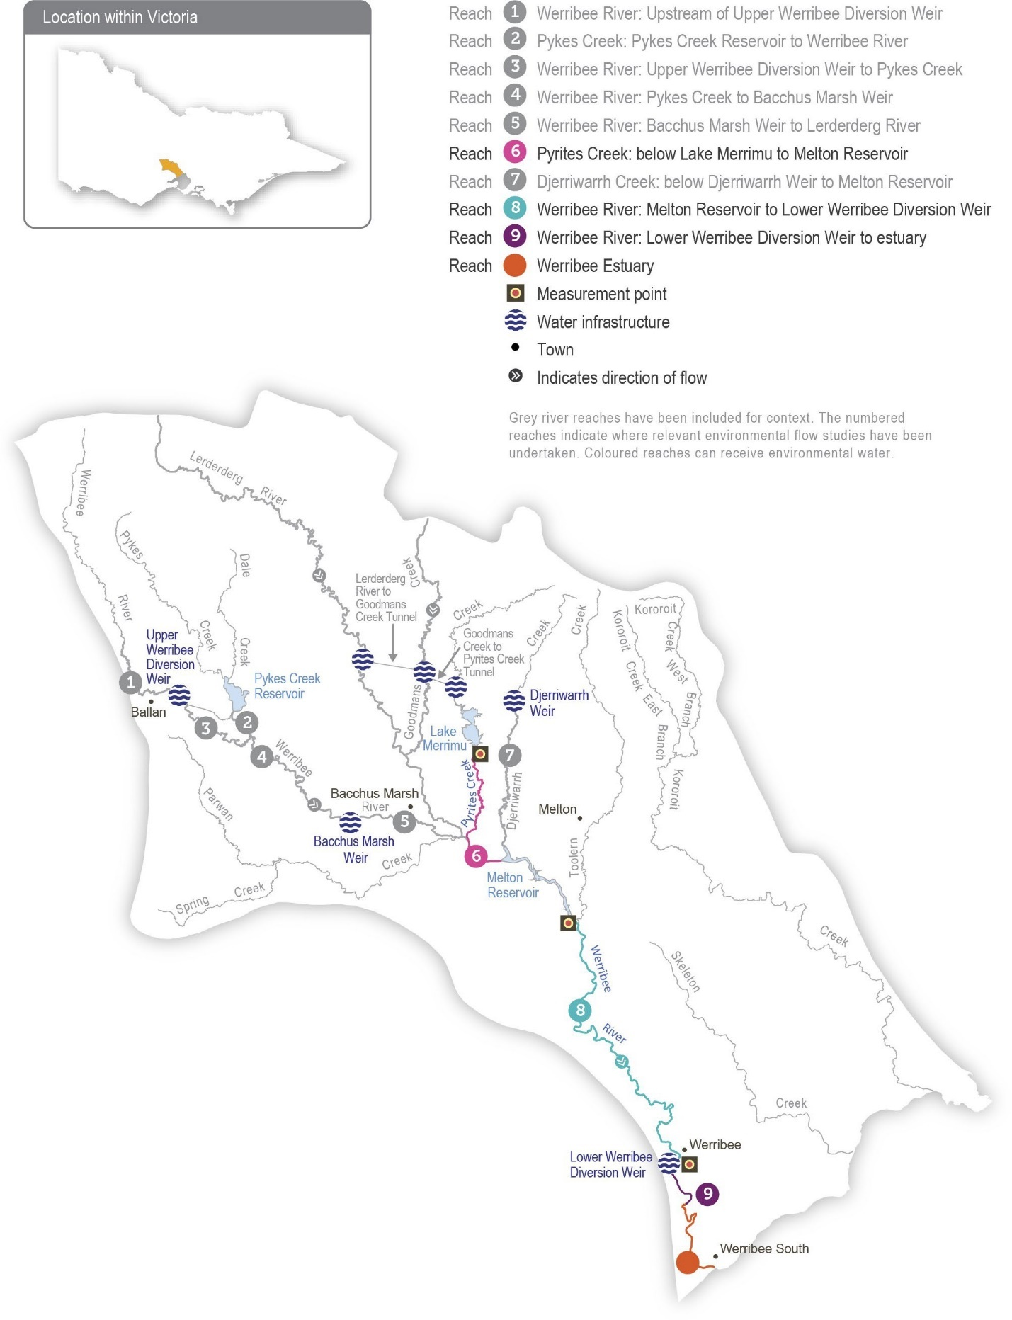
Return to start of section

Environmental values
The Werribee system supports a range of native fish, including Australian grayling, river blackfish, flathead gudgeon, short- finned eel, tupong, Australian smelt, several species of galaxiids and a large population of black bream in the estuary. Several species of frogs, a diverse waterbug community and platypus inhabit the upper and lower reaches. The freshwater-saltwater interface of the Werribee River estuary is a regionally significant ecosystem due to the many aquatic plants and animals it supports, and it provides nursery habitat for juvenile freshwater and estuarine fish species (such as black bream).

Environmental objectives in the Werribee system
Protect and increase populations of native freshwater fish, including galaxiids and Australian grayling Protect and support populations of black bream in the estuary
Maintain native frog populations
Maintain channel beds and pool habitats
Maintain clean substrate surfaces to support biological processes
Maintain the platypus population
Maintain the health and increase the cover of in-stream, streamside and estuary plants
Limit the spread of terrestrial plants, and promote the recruitment of native water-dependent plant species on the banks and benches of waterways
Maintain and enhance the population of waterbugs, to help break down dead organic matter and support the river’s food chain
Maintain oxygen and salinity levels in pools

Traditional Owner cultural values and uses
Melbourne Water is working with the Registered Aboriginal Parties within the Werribee system – the Wadawurrung Traditional Owners Aboriginal Corporation, the Wurundjeri Woi Wurrung Cultural Heritage Aboriginal Corporation and the Bunurong Land Council Aboriginal Corporation – to strengthen relationships and increase Traditional Owners’ involvement in the planning and delivery of water for the environment. As of June 2023, an overarching partnership agreement was near completion between Melbourne Water and Wadawurrung Traditional Owners Aboriginal Corporation to frame relations and obligations between the organisations. Melbourne Water was also in discussions with Wurundjeri Woi Wurrung Cultural Heritage Aboriginal Corporation and the Bunurong Land Council Aboriginal Corporation to work towards developing a similar partnership agreement. The intent is for Traditional Owners to be active partners in the planning, delivering and monitoring water for the environment associated with Wirribi Yaluk/Weariby Yallok (Werribee River).
All three Registered Aboriginal Parties in the Werribee system were involved in the upper Wirribi Yaluk/Weariby Yallok
(Werribee River) environmental flows study, completed in 2022-23.

The Bunurong Land Council Aboriginal Corporation is working with Bunurong people to determine the cultural objectives for Weariby Yallok (Werribee River) on Bunurong Country. There are concerns about low flow in the lower reaches and that fish of cultural importance to the Bunurong are not supported by the flow and are restricted in movement. This concern may be partially addressed through the implementation of Action 8-10 in the Central and Gippsland Region Sustainable Water Strategy, which aims to improve fish passage and the delivery of water for the environment to the lower Weariby Yallok (Werribee River) on Bunurong Country.
The Wadawurrung Traditional Owners Aboriginal Corporation has reviewed the environmental values of the Wirribi Yaluk (Werribee River) system. It has identified environmental values that also have cultural significance to Wadawurrung Traditional Owners, which the table below shows. However, further work is required to understand how potential environmental watering actions can improve these cultural values.

Return to start of section

Reach | Extent | Key environmental values with cultural significance to the Wadawurrung
8 | Wirribi Yaluk (Werribee River)
9 | Wirribi Yaluk (Werribee River) between Wyndham Vale and Bluestone Ford
Estuary | Werribee River downstream of Bluestone Ford

Social, recreational and economic values and uses
In planning the potential environmental watering actions in Table 3.5.1, Melbourne Water considered how environmental flows could support values and uses, including:
- water-based recreation (such as canoeing, fishing, kayaking and swimming)
- riverside recreation and amenity from urban cooling (such as camping, walking, cycling and picnicking)
- community events and tourism (such as Werribee Zoo).

Scope of environmental watering
The term ‘environmental watering’ refers to the active delivery of water for the environment to support particular environmental objectives by altering the flow in a river or the water level in a wetland. While other terms are also used to describe the delivery of water for the environment, ‘environmental watering’ is deliberately used here and in seasonal watering statements to ensure consistency in the legal instruments that authorise the use of water for the environment in Victoria.
Table 3.5.1 describes the potential environmental watering actions in 2023-24, their expected watering effect (that is, the intended physical or biological effects of the watering action) and the longer-term environmental objectives they support. Each environmental objective relies on one or more potential environmental watering actions and their associated physical or biological effects.
Table 3.5.1 Potential environmental watering actions, expected watering effects and associated environmental objectives for the Werribee system

Potential environmental watering action | Expected watering effects | Environmental objectives
Pyrites Creek (targeting reach 6)
Winter/spring/summer low flow (2 ML/day or natural during June to December) | - Provide sufficient water depth in riffle habitats for macroinvertebrates native fish  - Maintain habitat for frogs at the margin of the stream channel  - Provide sufficient water depth to support the growth of flood-tolerant vegetation within the stream channel  - Provide sufficient water depth to allow for native fish to move between pools
Winter/spring freshes (three to five freshes of 30-40 ML/day for two days during June to November) | - Drown terrestrial plants that encroach into the waterway  - Increase the growth and recruitment of streamside and in-stream vegetation  - Transport carbon to drive aquatic food webs  - Scour silt, biofilms and algae from substrates to maintain the quality and quantity of food and habitat for waterbugs  - Improve water quality and the quantity of food and habitat for waterbugs, frogs and native fish  - Wet depressions adjacent to the stream that frogs can use for breeding

Potential environmental watering action | Expected watering effects | Environmental objectives
Spring high flow (one high flow of 70-130 ML/ day for one to two days during September to October) | - Maintain access to food and habitat for waterbugs, native fish and frogs  - Increase the growth and recruitment of in-stream vegetation  - At 130 ML/day, the effects above plus:  - inundate the full width of the channel and high backwaters to flush accumulated organic matter and promote the growth and recruitment of streamside vegetation
Werribee River (targeting reaches 8, 9 and estuary)
Winter/spring low flow (80 ML/day during June to November) | - Provide sufficient depth to allow fish to move upstream past natural and artificial barriers  - Facilitate the downstream movement of diadromous fish to the estuary  - Drown terrestrial plant species and support the growth and recruitment of water-dependent streamside vegetation  - Maintain permanent pools and increase the extent of habitat for waterbugs, fish, platypus and frogs  - Maintain flow through pool habitats to allow mixing or suppression/dilution of saline groundwater
Winter/spring freshes (two to four freshes of 350 ML/day for three days during June to October) | - Support the growth and recruitment of water-dependent streamside vegetation  - Flush silt and scour biofilms and algae from substrates on the stream bed and maintain pools and channel dimensions  - Provide movement cues and enough flow for fish to move upstream past natural and artificial barriers  - Maintain water quality and quantity of food and habitat for waterbugs and platypus  - Wet depressions adjacent to the stream that frogs can use for breeding
Summer/autumn low flow (10 ML/day during December to May) | - Maintain habitat for in-stream and water-dependent streamside vegetation  - Maintain access to habitat and improve water quality for native fish, frogs, platypus and waterbugs  - Maintain flow through pool habitats to allow mixing or suppression/dilution of saline groundwater intrusion
Summer/autumn freshes (three to five freshes  of 135-215 ML/day for one to two days during December to May) | - Increase the growth and recruitment of water-dependent streamside vegetation  - Flush silt and scour biofilms and algae from substrates on the stream bed and maintain pools and channel dimensions  - Maintain access to habitat and improve water quality for native fish, frogs and platypus  - Provide enough flow for native fish to move downstream past natural or artificial barriers  - Maintain the quality of water within pools by dispersing azolla and blue- green algae blooms
Return to start of section

Scenario planning
Table 3.5.2 outlines potential environmental watering and expected water use in a range of planning scenarios.

The Pyrites Creek catchment downstream of Merrimu Reservoir relies on passing flow, operational releases and environmental flows for virtually all of its flow. Recommended watering actions through reach 6 do not vary significantly between planning scenarios due to the need to move water for the environment to Melton Reservoir to support outcomes in the lower reaches of the Werribee River and because this reach relies on releases to maintain any flow. Water for the environment will provide a low flow to maintain enough pool and riffle habitat to allow existing fish, macroinvertebrate and aquatic vegetation communities to persist. Freshes and a high flow will help to achieve geomorphological objectives, improve the condition of
in-stream and streamside vegetation and help grow populations of native fish and frogs. The forecast available supply will not be sufficient to deliver all the required flow in the dry planning scenario, so the winter/spring/summer low flow will be delivered for a shorter duration to conserve water for freshes and a high flow. Pyrites Creek is naturally ephemeral, and the freshes are considered more important to maintain and regularly flush pools that will support native fish and frogs.
The lower Werribee River relies on passing flow, operational deliveries and environmental flows to provide a low flow and freshes, but unregulated spills from Melton Reservoir, downstream tributary inflows and local run-off, including stormwater from urbanised areas of Werribee provide a greater flow, especially in wet years. Passing flow and operational deliveries for irrigation customers are expected to partially meet low-flow requirements in the lower Werribee River in all planning scenarios. Water for the environment will be used to top up the low flow when needed throughout the year and to deliver summer/autumn freshes to manage water quality and control potential algal blooms. In all planning scenarios, there is insufficient water for the environment to meet the low-flow demands year-round in the lower Werribee River. In the dry and average planning scenarios, the demands are so large compared to the predicted supply that the demands would not be fully met even if all available water was prioritised for this purpose. For this reason, ‘partial compliance’ of low flow is the target under tier 1a. A low flow will be topped up as needed to manage water quality or provide longitudinal connectivity for fish and platypus. More work to define critical triggers for action has been identified as a priority area for monitoring in the lower Werribee River. Winter/spring freshes will be used to support the movement and recruitment of native fish and platypus and to support streamside vegetation in the average and wet planning scenarios. More freshes could be delivered in the average and wet planning scenarios than in the dry scenario.
In all scenarios, a minimum of 400 ML is planned to be carried over to ensure high-priority flows can be delivered to Pyrites Creek (reach 6) and the lower Werribee River in 2024-25. Maintaining sufficient carryover in Lake Merrimu and Melton Reservoir will be prioritised over the delivery of tier 1b potential environmental watering actions in 2023-24.
Table 3.5.2 Potential environmental watering for the Werribee system in a range of planning scenarios

Planning scenario | Dry | Average | Wet
Expected conditions | - Regulated flow conditions below Melton Reservoir year-round  - Minimal passing flow to reach 6, possible operational water  transfers during summer  - Consumptive releases out of storage into reach 8 in summer/autumn | - Some spills from Melton Reservoir in winter/ spring and periods of unregulated flow in reaches 8 and 9 and the estuary  - Most low flow in reach 6 met by passing flow  - Consumptive releases out of storage into reach 8 in summer/autumn | - Regular large spills from Melton Reservoir in winter/spring and lengthy periods of unregulated flow in reaches 8 and 9 and the estuary  - All low flow in reach 6 provided by passing flow  - Consumptive releases out of storage into reach 8 in summer/autumn
Expected availability of water for the environment | - 1,280 ML | - 2,530 ML | - 3,760 ML
Pyrites Creek (targeting reach 6)
Potential environmental watering – tier 1 (high priorities) | Tier 1a (can be achieved with predicted supply)
 | - Winter/spring/summer low flow (partial compliance)  - Winter/spring freshes (three freshes)  - Spring high flow | - Winter/spring/summer low flow  - Winter/spring freshes (four freshes)  - Spring high flow | - Winter/spring/summer low flow  - Winter/spring freshes (five freshes)  - Spring high flow
 | Tier 1b (supply deficit)
 | - Winter/spring/summer low flow (full compliance) | - N/A | - N/A

Planning scenario | Dry | Average | Wet
Werribee River (targeting reaches 8, 9 and estuary)
Potential environmental watering – tier 1 (high priorities) | Tier 1a (can be achieved with predicted supply)
 | - Summer/autumn low flow (partial compliance)  - Summer/autumn freshes (three freshes) | - Winter/spring freshes (two freshes)  - Summer/autumn low flow (partial compliance)  - Summer/autumn freshes (five freshes) | - Winter/spring freshes (four freshes)  - Summer/autumn low flow  - Summer/autumn freshes (five freshes)
 | Tier 1b (supply deficit)
 | - Winter/spring low flow  - Winter/spring freshes (two freshes)  - Summer/autumn low flow (full compliance) | - Winter/spring low flow  - Winter/spring freshes (two freshes)  - Summer/autumn low flow (full compliance) | - Winter/spring low flow
Possible volume of water for the environment required to achieve objectives | - 880 ML (tier 1a)  - 18,720 ML (tier 1b) | - 2,130 ML (tier 1a)  - 8,100 ML (tier 1b) | - 3,360 ML (tier 1a)  - 1,000 ML (tier 1b)
Return to start of section

Moorabool system
Waterway manager – Corangamite Catchment Management Authority
Storage manager – Central Highlands Water
Environmental water holder – Victorian Environmental Water Holder
Proportions of water entitlements in the Moorabool system held by private users, water corporations and environmental water holders on 30 June 2020
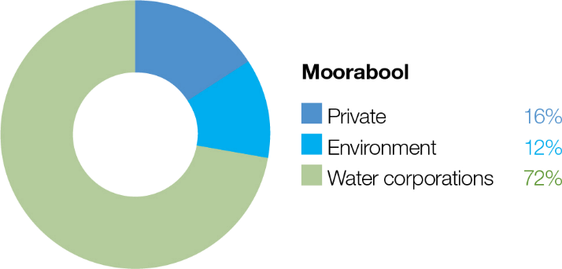

System overview
Moorabool Yulluk (Moorabool River) is a tributary of the Barwon River. It flows south from the Central Highlands between Ballarat and Ballan to join the Barwon River at Fyansford, just north of Geelong (Figure 3.6.1). The Moorabool catchment is highly regulated with major storages, including Lal Lal, Moorabool and Bostock reservoirs.
The lower section of the Moorabool River between She Oaks and Batesford has nine private diversion weirs that are significant barriers to fish. These barriers have increased the extent of slow-flowing habitat and reduced habitat diversity.
Water allocated to the Moorabool River environmental entitlement is stored in Lal Lal Reservoir. The entitlement references passing flow, a significant component of annual streamflow and helps maintain a low flow through winter. Water use is limited by inflows to the reservoir and by a use cap specified in the entitlement. The priority reaches for deliveries of water for the environment are between Lal Lal Reservoir and She Oaks Weir (reaches 3a and 3b, as shown in Figure 3.6.1), as that is where the small amount of available water can have the most benefit. Environmental flows may also benefit flow-dependent values in the reach between She Oaks Weir and the confluence with the Barwon River.
The Moorabool system is a water supply catchment for Barwon Water and Central Highlands Water. Releases from Lal Lal Reservoir for urban water supply contribute to environmental outcomes in reach 3a and 3b (above Barwon Water’s
diversion point at She Oaks) and allow more efficient delivery of water for the environment to reach 4. Barwon Water and the Corangamite CMA coordinate operational and environmental releases, where possible, to optimise these benefits.

Return to start of section

Figure 3.6.1 The Moorabool system

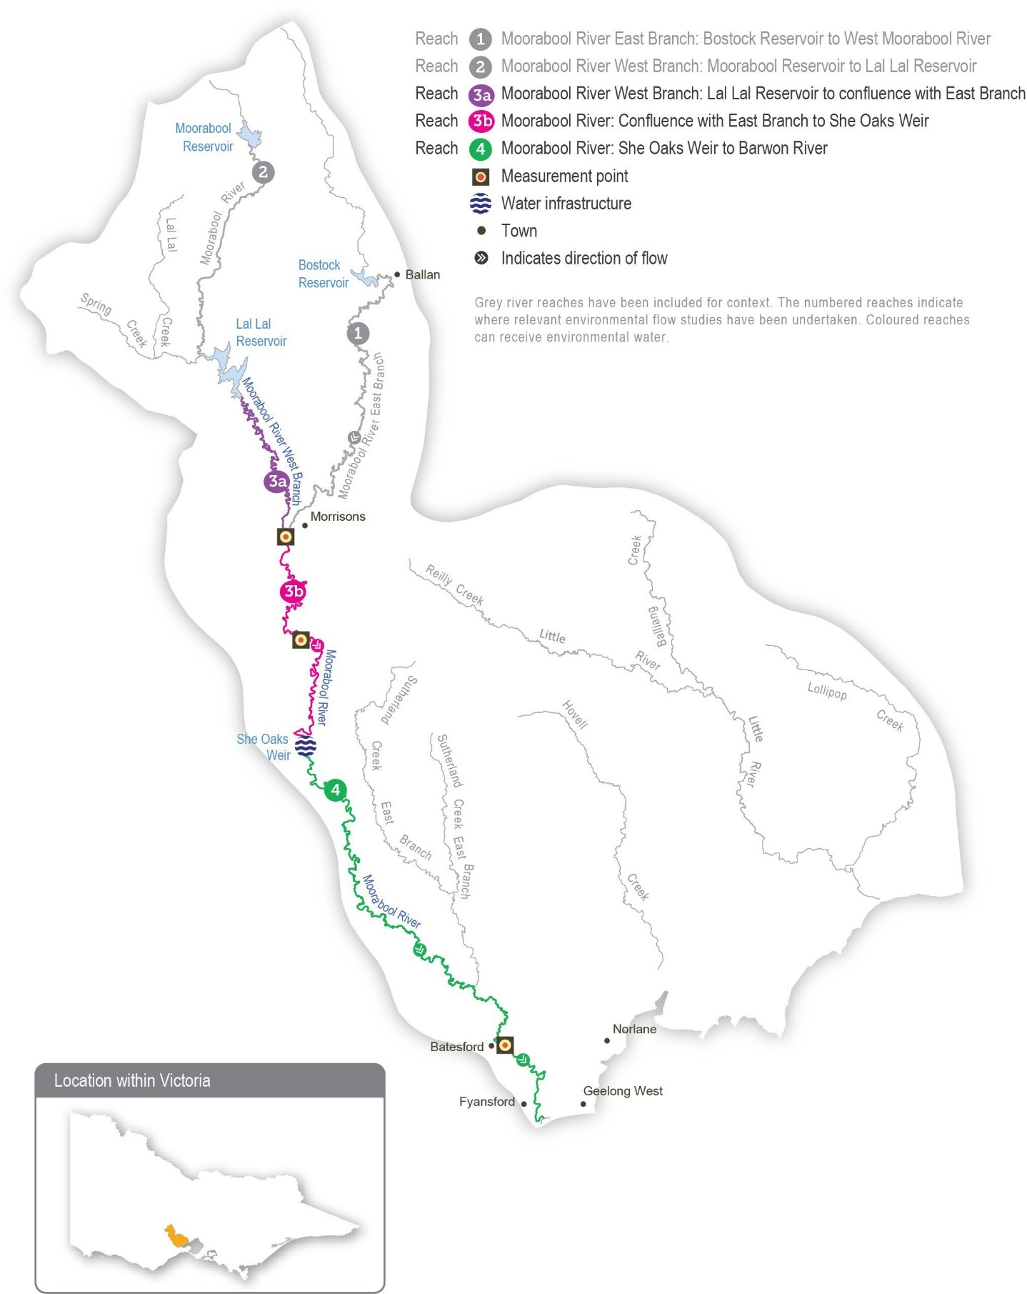
Return to start of section

Environmental values
The Moorabool River is a highly flow-stressed system, but it retains significant environmental values. The river is home to native fish species, including the Australian grayling, river blackfish, Australian smelt, flat-headed gudgeon, southern pygmy perch, short-finned eel, spotted galaxias and tupong. The system also contains extensive areas of endangered remnant vegetation, including streambank shrubland and streamside woodland ecological vegetation communities. Platypus, rakali (water rats) and a range of waterbugs are also present. The Moorabool River flows into the Barwon River, connecting it to the Ramsar-listed lower Barwon wetlands.

Environmental objectives in the Moorabool system
Increase the distribution, abundance and diversity of migratory species (tupong, short-finned eel, common galaxias, spotted galaxias, short-headed lamprey and Australian grayling)
Increase the distribution, abundance and diversity of non-migratory species (flat-headed gudgeon, Australian smelt, southern pygmy perch and river blackfish)
Maintain channel form and processes

Maintain diverse physical habitat
Maintain a self-sustaining breeding population of platypus and support the dispersal of juveniles and the movement of adults
Maintain in-stream macrophyte communities

Maintain streamside vegetation communities and promote recruitment
Maintain the abundance and diversity of waterbug communities
Maintain water quality

Prevent hypoxic blackwater events

Traditional Owner cultural values and uses
The Wadawurrung are the Traditional Owners of the land of Moorabool Yulluk (Moorabool River) and parts of the Barwon, Leigh and Yarrowee rivers.
Wadawurrung Traditional Owners have a strong connection to Moorabool Yulluk (Moorabool River) and place high cultural value on it. The Wadawurrung Traditional Owners Aboriginal Corporation (WTOAC) is a key partner in advocating for additional water recovery to help support a healthy river and associated cultural water objectives.
In 2020, WTOAC released Paleert Tjaara Dja Let’s make Country good together 2020 – 2030 Wadawurrung Country Plan. The plan identifies waterways, rivers, estuaries and wetlands – Yulluk – as key values to look after.
In 2019, the WTOAC partnered with the Corangamite CMA to complete an environmental flows study for the upper Barwon, Yarrowee and Leigh rivers. Environmental flows studies are essential technical references for river managers that identify the types of flows needed to support environmental values in a river system. The 2019 flows study also identified cultural values in all waterways within Wadawurrung Country, including Moorabool Yulluk (Moorabool River).
The values include:
- significant aquatic species such as wad-dirring/peridak (platypus), buniya (short-finned eel), turrpurt (tupong), ware-up (river blackfish), tark (common reed) and bal-yan (bull rush), which are traditional sources of food, materials and medicines
- waterway confluences and deep pools, which are places for meeting, ceremonies, trade and marking clan boundaries.
In early 2023, a meeting was held between the Corangamite CMA and WTOAC to discuss proposed 2023-24 environmental flows in the Moorabool Yulluk (Moorabool River). WTOAC supports the proposed environmental flows and may partner with the Corangamite CMA to coordinate the delivery of summer/autumn freshes and some winter/spring freshes to coincide with cultural events.
Social, recreational and economic values and uses
In planning the potential environmental watering actions in Table 3.6.1, the Corangamite CMA considered how environmental flows could support values and uses, including:
- water-based recreation (such as camping, fishing, kayaking and swimming)
- riverside recreation and amenity (such as birdwatching, bushwalking, camping, picnicking and lookouts), community events and tourism.
- Return to start of section

If the timing or management of planned environmental flows may be modified to align with a community benefit, this is acknowledged in Table 3.6.1 with the following icon.

Watering planned to support peaks in visitation (e.g. camping or other public activities on long weekends or school holidays)
Summer/autumn freshes provide a freshening flow in the Moorabool River and are planned to coincide with school and public holidays where possible. This freshened flow improves riverside and water-based recreation opportunities, particularly camping and fishing.

Scope of environmental watering
The term ‘environmental watering’ refers to the active delivery of water for the environment to support particular environmental objectives by altering the flow in a river or the water level in a wetland. While other terms are also used to describe the delivery of water for the environment, ‘environmental watering’ is deliberately used here and in seasonal watering statements to ensure consistency in the legal instruments that authorise the use of water for the environment in Victoria.
Table 3.6.1 describes the potential environmental watering actions in 2023-24, their expected watering effect (that is, the intended physical or biological effects of the watering action) and the longer-term environmental objectives they support. Each environmental objective relies on one or more potential environmental watering actions and their associated physical or biological effects.
Table 3.6.1 Potential environmental watering actions, expected watering effects and associated environmental objectives for the Moorabool system

Potential environmental watering action | Expected watering effects | Environmental objectives
Moorabool River (targeting reach 3a)
Winter/spring low flow (5-60 ML/day during June to November) | - Maintain in-stream vegetation  - Maintain connectivity and allow fish movement through the reach  - Maintain pool and riffle habitat for platypus and native fish  - Reduce intrusion by terrestrial vegetation into the stream bed
Autumn/winter/spring freshes (two to three freshes of 80-90 ML/day for five to 10 days during May to November) | - Maintain pool and riffle habitats and provide connectivity to support fish and platypus movement through the reach  - Trigger downstream spawning migration of tupong (May-August) and upstream migration of juvenile turrpurt (galaxias), tupong, buniya (short- finned eel) and Australian grayling (September-November)  - Temporarily inundate the lower part of the riverbank to maintain species diversity of the fringing vegetation and promote the growth and recruitment of streamside vegetation  - Flush silt, scour pools and remove biofilms from hard substrates and the stream bed to maintain waterbug communities and transport organic matter to prevent blackwater events
Summer/autumn low flow (5-401 ML/day during December to May) | - Maintain refuge pools and riffle habitat for fish, waterbugs and platypus and submerged aquatic vegetation  - Maintain water quality for aquatic life by reducing periods of low oxygen, high temperature and high salinity
Small summer/autumn fresh (one fresh of  30-60 ML/day for three days during February to March) | - Maintain pool and riffle habitat and the condition of streamside vegetation and water-fringing marginal zone vegetation, and promote recruitment  - Allow fish movement through the reach

Potential environmental watering action | Expected watering effects | Environmental objectives
Large summer/autumn fresh(es) (one to two freshes of 60-80 ML/ day for five days during December to May) | - Trigger the downstream spawning migration of adult buniya (short-finned eel) (January-February), tupong (May-August), Australian grayling (April- May) and short-headed lamprey  - Maintain pool and riffle habitat and the condition of streamside vegetation, and promote recruitment  - Allow fish and platypus to move through the reach to access habitat  - Flush silt and scour biofilms and algae from the stream bed and substrates to improve habitat quality for waterbugs  - Maintain water quality by reducing periods of low oxygen, high water temperature and salinity
Year-round freshes (trigger-based, of 30 ML/ day for three days)  Triggers: oxygen below 5 mg/L; electrical conductivity above 10,000 µs/cm; water temperature above 25°C | - Maintain water quality by reducing periods of low oxygen, high water temperature and salinity
1 The flow will generally target between 5 and 20 ML per day at the compliance point, but 40 ML per day could be achieved in combination with Barwon Water’s transfer to She Oaks Weir and passing flow.

Scenario planning
Table 3.6.2 outlines potential environmental watering and expected water use in a range of planning scenarios.
There is limited variation in the proposed watering regime year to year due to high confidence in the water made available by the Moorabool River Environmental Entitlement 2010. Up to 7,086 ML can be stored, but a maximum of 7,500 ML can be used over three consecutive years. Use in 2023-24 will be restricted to 2,500 ML where possible to ensure sufficient water can be delivered in subsequent years.
The Moorabool River requires a continuous low flow throughout the year and periodic freshes in all planning scenarios to achieve the intended environmental outcomes.
In the drought and dry planning scenarios, the main objective is to provide sufficient habitat to maintain existing populations of native fish and platypus, and the flow can therefore be at the lower end of its recommended size range and frequency
to ensure connecting flows are maintained for as long as possible. Water for the environment may be added to operational transfers at times to increase flow variability downstream of Lal Lal Reservoir and to maintain some flow in the reaches downstream of She Oaks Weir once operational water is diverted. Even with these proposed watering actions, sections of the Moorabool River are likely to periodically cease flowing in the dry or drought planning scenarios, which would reduce the
river’s environmental condition and the size of plant and animal populations. In the drought planning scenario, water quality will be regularly monitored to inform the delivery of trigger-based, year-round freshes as needed.
In the average and wet planning scenarios, most of the recommended flow is expected to be provided through a combination of the natural flow, passing flow and operational releases, which will mean water for the environment can be used to deliver additional freshes to improve environmental conditions and increase populations of native plants and animals. Delivering one large summer/autumn fresh in April/May will be a high priority in all planning scenarios to trigger Australian grayling migration and spawning. In the average and wet planning scenarios, a second large summer/autumn fresh is proposed for January/ February to maintain and grow Australian grayling populations. Two large summer/autumn freshes occurred in the Moorabool system in 2021-22 and 2022-23.
Although environmental flows in the Moorabool River primarily target outcomes in reaches 3a and 3b, deliveries will be planned where possible to also provide benefits in reach 4.
Return to start of section

Table 3.6.2 Potential environmental watering for the Moorabool system in a range of planning scenarios

Planning scenario | Drought | Dry | Average | Wet
Expected conditions | - Little rainfall with no inflow to Lal Lal Reservoir  - Regular periods of no flow | - Below-average rainfall and inflow to Lal Lal Reservoir  - Cease-to-flow events | - Average rainfall and moderate inflows to Lal Lal Reservoir,  especially during winter and spring  - Low flow over summer and high peaks in winter months | - Lal Lal Reservoir is likely to fill and spill  - Continuous flow year-round  - Overbank flow in some parts during winter/spring
Expected availability of water for the environment | - 2,500 ML1
Moorabool River (targeting reach 3a)
Potential environmental watering – tier 1 (high priorities) | Tier 1a (can be achieved with predicted supply)
 | - Winter/spring low flow (5 ML/day)  - Summer/autumn low flow (5 ML/ day)  - Large summer/ autumn fresh (one fresh of 60 ML/ day)  - Year-round fresh(es) (one or two freshes if required) | - Winter/spring low flow (5 ML/day)  - Autumn/winter/ spring fresh (one fresh for five days of 80 ML/day)  - Summer/autumn low flow (5 ML/ day)  - Large summer/ autumn fresh (one fresh of 60 ML/ day) | - Winter/spring low flow (5-10 ML/day)  - Autumn/winter/ spring fresh (one fresh for five days of 80 ML/day)  - Summer/autumn low flow (5 ML/ day)  - Small summer/ autumn fresh (one fresh of 30 ML/ day)  - Large summer/ autumn freshes (two freshes of 60 ML/day) | - Winter/spring low flow (of greater than 10 ML/day)  - Autumn/winter/ spring freshes (three freshes)  - Summer/autumn low flow (of greater than 10 ML/day)  - Small summer/ autumn fresh (one fresh of 30 ML/ day)  - Large summer/ autumn freshes (two freshes of 60 ML/day)
 | Tier 1b (supply deficit)
 | - Autumn/winter/ spring freshes (two freshes for five days of 80 ML/ day) | - Autumn/winter/ spring fresh (one fresh for five days of 80 ML/day) | - Autumn/winter/ spring freshes (two freshes for five days of 80 ML/ day) | - N/A
Potential environmental watering – tier 2 (additional priorities) | - Tier 1a and 1b watering actions delivered at the upper end of the recommended magnitude range
Possible volume of water for the environment required to achieve objectives | - 2,493 ML (tier 1a)  - 1,130 ML (tier 1b)  - 2,440 ML (tier 2) | - 2,508 ML (tier 1a)  - 565 ML (tier 1b)  - 2,440 ML (tier 2) | - 2,510 ML (tier 1a)  - 990 ML (tier 1b)  - 14,900 ML (tier 2) | - 780 ML (tier 1a)  - 0 ML (tier 1b)  - 9,400 ML (tier 2)
Priority carryover requirements for 2024-25 | - The environmental entitlement for the Moorabool system caps use at 7,500 ML over three years. Use in 2023-24 will be capped at 2,500 ML, which will leave sufficient allocation to support watering actions in 2024-25 and 2025-26
1 Up to 7,086 ML can be stored under the Moorabool River Environmental Entitlement 2010. However, the entitlement is subject to delivery rules – a maximum of 7,500 ML over three consecutive years – which restricts available water to an average of 2,500 ML per year.

Return to start of section

Barwon system
Waterway manager – Corangamite Catchment Management Authority
Storage manager – Barwon Water
Environmental water holder – Victorian Environmental Water Holder
Proportions of water entitlements in the Barwon basin held by private users, water corporations and environmental water holders on 30 June 2020
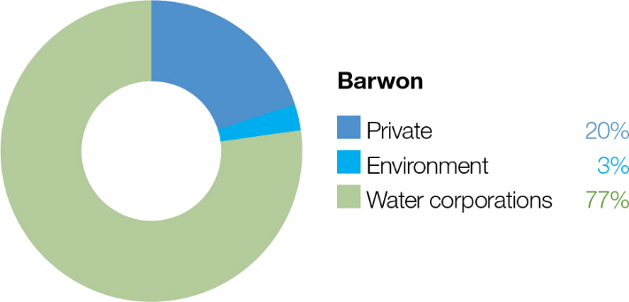

The Barwon system includes the upper Barwon River and lower Barwon wetlands.

The Barwon River flows east from the Otway Ranges, passing the towns of Forrest, Birregurra, Winchelsea and Inverleigh and the City of Geelong before discharging into Bass Strait at Barwon Heads. The Leigh and Moorabool rivers are major tributaries, joining the Barwon River at Inverleigh and Fyansford, respectively. Other tributaries, including Birregurra, Boundary, Callahan, Dewing, Matthews, Pennyroyal, Deans Marsh and Gosling creeks, flow into the Barwon River above Winchelsea. The main storages in the Barwon River catchments are the West Barwon and Wurdee Boluc reservoirs.
The Barwon estuary contains a Ramsar-listed system of wetlands and lakes collectively called the lower Barwon wetlands. Water for the environment can be used to manage the flow in the upper Barwon River and manage water levels in Reedy Lake and Hospital Swamps, which connect to the lower Barwon River.

Upper Barwon River
System overview
The operation of the West Barwon Reservoir regulates flows in the upper Barwon River. Water can be released directly from the reservoir into the west branch or into the east branch via a diversion tunnel. The junction of the two branches is near Boundary Creek. Downstream of the reservoir, operational water can be diverted into the Wurdee Boluc inlet channel, a 57 km concrete-lined channel that transfers water to Wurdee Boluc Reservoir.
Barwon Water releases passing flow in the order of 1-5 ML per day in both the upper east and west branch from the West Barwon Reservoir. These releases may increase to 15 ML per day in September in a wet year. When the reservoir holds more than 40,000 ML, all the natural flow is passed down the east branch between January and March. Flood spills from the reservoir and natural inflows from unregulated and regulated tributaries add to the passing flow in the west branch. Regulated and unregulated tributaries add to the passing flow in the east branch.
The Upper Barwon River Environmental Entitlement 2018 enables water for the environment to be made available from the West Barwon Reservoir. The entitlement provides an average of 1,000 ML per year and up to 2,000 ML of the total storage capacity at full supply. Water for the environment was first delivered to the upper Barwon River in 2018-19. The current entitlement provides only enough water to meet the highest-potential environmental watering actions in the upper Barwon east branch (reach 4) and the upper Barwon west branch (reach 3) under particular climatic conditions.
Return to start of section

Figure 3.7.1 The Barwon system

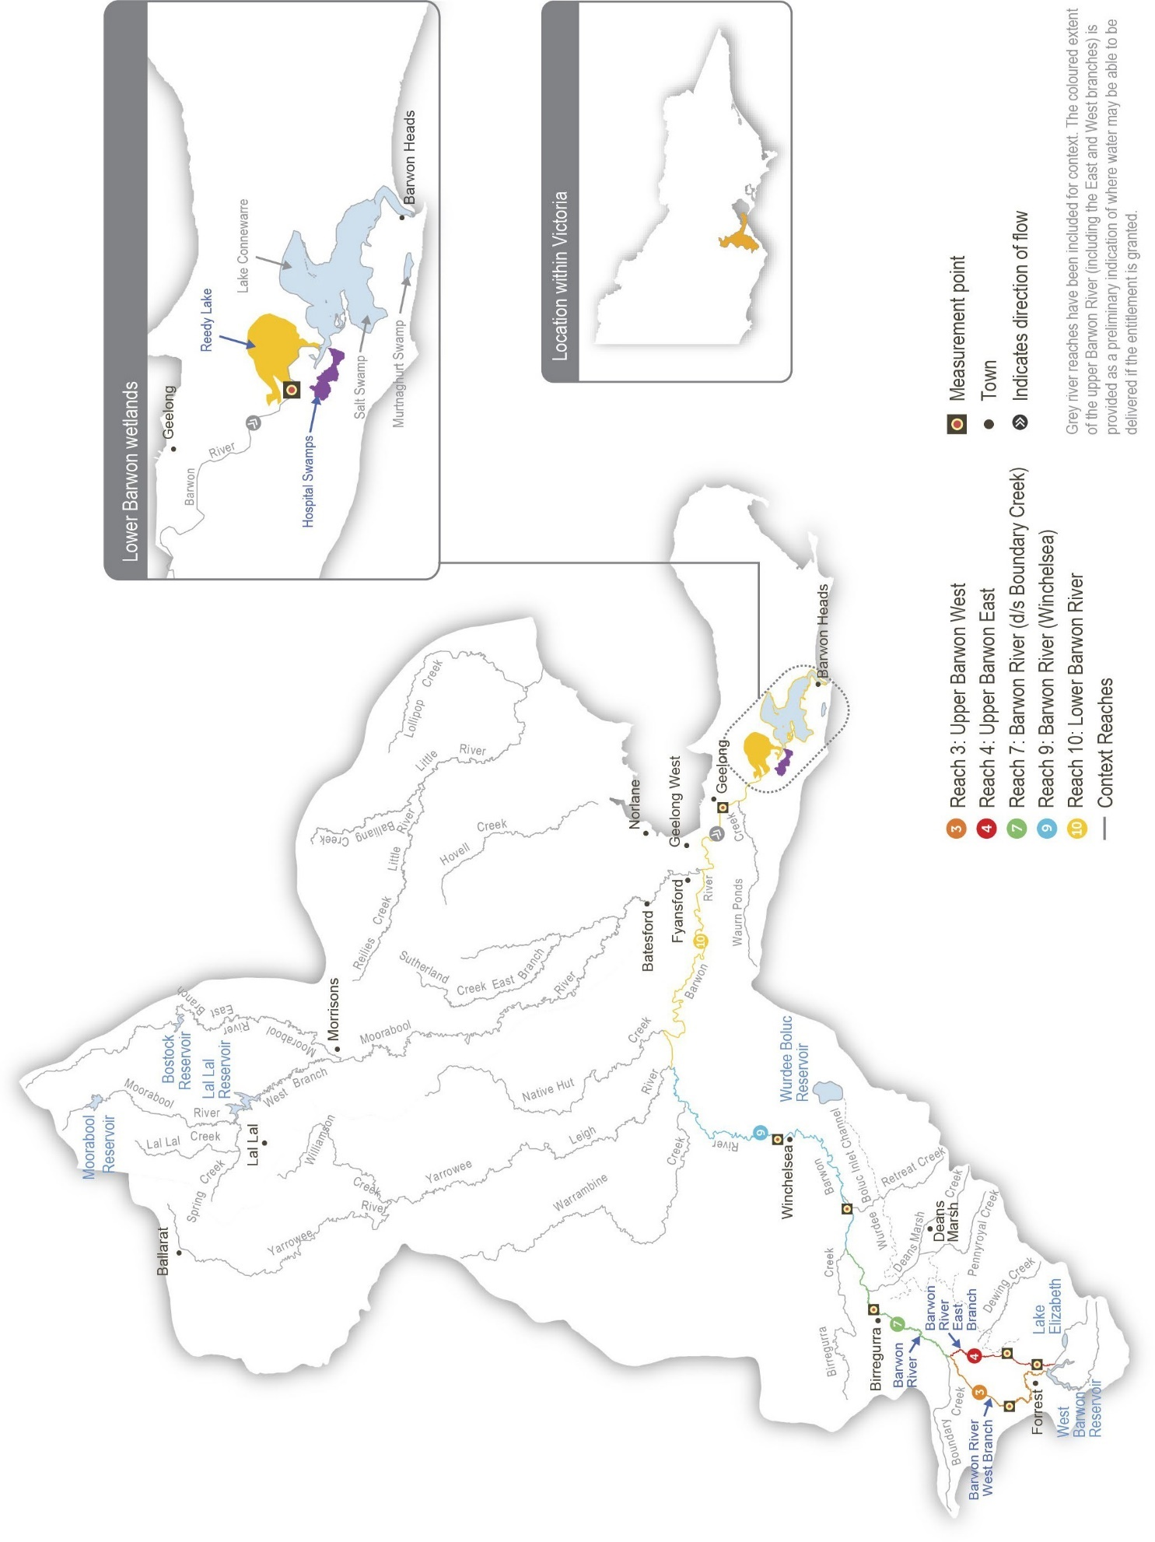
Return to start of section

Environmental values
The upper Barwon River is home to native fish species, including the Australian grayling, river blackfish, short-finned eel, southern pygmy perch, Australian smelt and various galaxias. The system retains some submerged aquatic vegetation, undercut banks, overhanging vegetation and riffle-pool sequences, which provide important habitat for fish and other aquatic animals.
Long-term environmental objectives for the upper Barwon system are based on delivering watering actions recommended in the Upper Barwon, Yarrowee and Leigh rivers Environmental FLOWS Study. These include improving the breeding
and recruitment of various fish, platypus and macroinvertebrate species, as well as improving the condition, extent and diversity of in-stream, emergent, streamside and floodplain vegetation. However, due to the limited entitlement to water for the environment and channel constrictions, the recommended flow magnitudes have been modified to less than the known channel constraints. It is unlikely that there will be significant improvements in the river’s ecological condition by delivering the
watering actions in this plan. Until works are carried out to address channel constraints and other factors (such as unrestricted livestock access and weed infestation), this plan’s potential environmental watering actions aim to maintain the current ecological condition and prevent cease-to-flow events.

Environmental objectives in the upper Barwon River
Maintain the abundance of migratory fish species, including short-finned eels, Australian grayling and tupong
Maintain the abundance of resident freshwater fish, including several species of galaxias, Australian smelt, big-headed gudgeon, Yarra pygmy perch, southern pygmy perch and river blackfish
Maintain the abundance of platypus populations
Maintain the condition and extent of in-stream vegetation to provide structural habitat for waterbugs and various fish species
Maintain the condition, extent and diversity of emergent macrophyte vegetation and streamside vegetation to provide structural habitat and stabilise the channel and lower banks
Maintain the abundance of waterbugs as a food source for fish, frog and platypus populations
Maintain water quality for native fish, waterbugs, aquatic vegetation and other water-dependent animals

Traditional Owner cultural values and uses
The reaches of the Barwon River that can be most influenced by water delivered from the West Barwon Reservoir sit on Eastern Maar Country.
In February 2020, the Eastern Maar Aboriginal Corporation (EMAC) received Registered Aboriginal Party (RAP) status under the Victorian Aboriginal Heritage Act 2006 over a large portion of land in south-west Victoria, including the Barwon River upstream of Winchelsea. In 2023 Eastern Maar gained formal recognition of their rights under the Commonwealth Native Title Act 1993 for over half of the RAP area, adding to initial recognition in 2011 under the Native Title Act, though further areas remain in negotiation. Native Title determination acknowledges Eastern Maar’s ongoing connection and intrinsic relationship to Country across south-west Victoria, including parts of the Barwon River catchment.
Eastern Maar obligations to Country and objectives for Country are described in the Eastern Maar Country Plan Meerreengeeye Ngakeepoorryeeyt. Eastern Maar assertions for parreeyt (water) are further documented in Eastern Maar’s Nation Statement (Water is Life: Traditional Owner Access to Water Roadmap 2022).
In early 2023, a meeting was held between the Corangamite CMA and EMAC to discuss proposed 2023-24 environmental flows in the upper Barwon River. EMAC also reviewed and provided feedback about the Corangamite CMA’s upper Barwon seasonal watering proposal, which outlined proposed environmental flows for the year ahead.
The Corangamite CMA is also working with Wadawurrung Traditional Owners Aboriginal Corporation (WTOAC) to understand opportunities to provide for cultural values and uses and other aspirations for the management of water for the environment in the Barwon River downstream of Winchelsea, on Country where WTOAC holds Registered Aboriginal Party status. In early 2023, the Corangamite CMA met with WTOAC to discuss environmental flows management in the Barwon River.
EMAC and WTOAC have formal plans for how to heal Country in the region, and the Corangamite CMA continues to work with them to identify their cultural objectives and associated values and uses that align with environmental flows.
Return to start of section

Social, recreational and economic values and uses
In planning the potential environmental watering actions in Table 3.7.1, the Corangamite CMA considered how environmental flows could support values and uses, including:
- water-based recreation (such as canoeing, kayaking, swimming and fishing, particularly for river blackfish)
- riverside recreation and amenity (such as birdwatching, camping and walking)
- socioeconomic benefits (such as for diverters for stock needs and domestic use: water levels and water quality can rely on the delivery of water for the environment, particularly in summer).
Scope of environmental watering
The term ‘environmental watering’ refers to the active delivery of water for the environment to support particular environmental objectives by altering the flow in a river or the water level in a wetland. While other terms are also used to describe the delivery of water for the environment, ‘environmental watering’ is deliberately used here and in seasonal watering statements to ensure consistency in the legal instruments that authorise the use of water for the environment in Victoria.
Table 3.7.1 describes the potential environmental watering actions in 2023-24, their expected watering effect (that is, the intended physical or biological effects of the watering action) and the environmental objectives they support. Each environmental objective relies on one or more potential environmental watering actions and their associated physical or biological effects.
Table 3.7.1 Potential environmental watering actions, expected watering effects and associated environmental objectives for the upper Barwon River

Potential environmental watering action | Expected watering effects | Environmental objectives
Upper Barwon River (targeting reach 3 – west branch)
Winter/spring low flow (3-30 ML/day during June to November) | - Maintain permanent water in the channel/pools to provide habitat to support resident and migratory fish, platypus and waterbugs  - With a low flow of 30 ML/day:  - maintain an adequate depth of permanent water in the channel to promote the recruitment of aquatic and streamside plants and to limit the encroachment of terrestrial species  - provide minimum velocity to mix and flush pools
Summer/autumn low flow (3-30 ML/day during December to May)
Upper Barwon River (targeting reach 4 – east branch)
Winter/spring low flow (1-9 ML/day during June to November) | - Maintain an adequate depth of permanent water in the channel and pools to provide habitat to support resident and migratory fish, platypus and waterbugs  - Maintain an adequate depth of permanent water in the channel to promote the recruitment of aquatic and streamside plants and to limit the encroachment of terrestrial species  - Provide sufficient flow velocity to mix pools
Summer/autumn low flow (0.5-5 ML/day during December to May) | - Maintain an adequate depth of permanent water in the channel/pools to provide habitat to support resident and migratory fish, platypus and waterbugs  - Reduce encroachment by terrestrial plants into the aquatic zone  - Provide minimum velocity to mix pools
Summer/autumn freshes (two to three freshes of 6-9 ML/day for two days during December to May) | - Increase the water depth in the channel and pools to provide habitat to support resident and migratory fish, platypus and waterbugs  - Provide a mosaic of wetted areas to improve emergent and streamside vegetation  - Provide minimum velocity to mix pools  - With freshes of 9 ML/day:  - provide longitudinal connectivity where the water depth exceeds 0.2 m over riffles to allow platypus to move between pools to breed, feed and find new habitats
Return to start of section

Scenario planning
Table 3.7.2 outlines potential environmental watering and expected water use in a range of planning scenarios.

Planned watering actions for the upper Barwon River are derived from recommendations in the Upper Barwon, Yarrowee and Leigh rivers Environmental FLOWS Study. Many of the flow magnitudes recommended in the study cannot be delivered due to the size of the environmental entitlement and the risk of inundating private land.
The planned watering actions presented in Table 3.7.2 are deliberately less than the known channel capacity constraints and would provide a lower environmental benefit. Given the limitation described above, the primary aim of watering actions is to deliver enough flow through the system to maintain pool habitat and food – waterbugs – for aquatic animals. A low flow will aim to prevent or limit cease-to-flow events, and small freshes will be delivered as needed to manage potential water quality issues. The magnitude of these freshes will vary in different planning scenarios, depending on supply. The overall approach to environmental flows in the upper Barwon River in 2023-24 will help maintain existing populations, and it relies on natural events to deliver the greater flow needed to facilitate the movement and potential breeding of fish and platypus.
The Corangamite CMA will monitor conditions during deliveries of water for the environment in 2023-24 so that release rates can be promptly adjusted to avoid inundating private land and affecting streamside landholders. The Corangamite CMA will continue to work with relevant agencies and landholders to investigate options that will allow future deliveries of water for the environment to be closer to their recommended magnitude, without affecting private land. The Upper Barwon Flagship Project is a newly established, integrated catchment management project working with stakeholders to address flow restrictions through streamside management and to improve the overall health of the upper Barwon River.
The carryover reserve for 2024-25 for the upper Barwon River is 500 ML, the drought reserve amount agreed upon with the Upper Barwon Surface Water Advisory Group.
Table 3.7.2 Potential environmental watering for the upper Barwon River in a range of planning scenarios

Planning scenario | Dry | Average | Wet
Expected conditions | - Disconnected pools during summer and autumn  - Cease-to-flow events | - Low flow in summer and autumn  - Peak flow in winter and spring | - Continuous flow throughout the year  - Reservoir spills are likely, especially during winter and spring
Expected availability of water for the environment | - 2,500 ML | - 3,000 ML | - 3,500 ML
Upper Barwon River (targeting reach 3 – west branch)
Potential environmental watering – tier 1 (high priorities) | Tier 1a (can be achieved with predicted supply)
 | - Summer/autumn low flow (delivered at a lower magnitude in the range) | - Summer/autumn low flow (delivered at a lower magnitude in the range) | - Summer/autumn low flow
 | Tier 1b (supply deficit)
 | - Winter/spring low flow  - Summer/autumn low flow (delivered at a higher magnitude) | - Winter/spring low flow  - Summer/autumn low flow (delivered at a higher magnitude) | - Winter/spring low flow
Potential environmental watering – tier 2 (additional priorities) | - N/A

Planning scenario | Dry | Average | Wet
Upper Barwon River (targeting reach 4 – east branch)
Potential environmental watering – tier 1 (high priorities) | Tier 1a (can be achieved with predicted supply)
 | - Summer/autumn low flow  - Summer/autumn freshes (two freshes) | - Summer/autumn low flow  - Summer/autumn freshes (two freshes) | - Summer/autumn low flow  - Summer/autumn freshes (three freshes)  - Winter/spring low flow
 | Tier 1b (supply deficit)
 | - Winter/spring low flow | - Winter/spring low flow
Potential environmental watering – tier 2 (additional priorities) | - N/A
Possible volume of water for the environment required to achieve objectives | - 1,947 (tier 1a)  - 6,697 (tier 1b) | - 2,513 (tier 1a)  - 4,308 (tier 1b) | - 2,986 (tier 1a)  - 2,896 (tier 1b)
Priority carryover requirements for 2024-25 | - 500 ML

Lower Barwon wetlands

System overview
The estuarine reach of the Barwon River contains a system of wetlands and lakes, including Lake Connewarre, Reedy Lake and Hospital Swamps, Salt Swamp and Murtnaghurt Lagoon. For thousands of years, the system has been a place of great significance to the Wadawurrung Traditional Owners. Paleert Tjaara Dja Let’s make Country good together 2020 – 2030 Wadawurrung Country Plan acknowledges the special place the system has in their Dreaming: ‘The chain of ponds from the Barwon River to Reedy Lake, Hospital Lake, Lake Connewarre and Estuary Bay is connected through water and our Connewarre (Black Swan) Dreaming’.
Water for the environment can be used to manage water levels in Reedy Lake and Hospital Swamps, which connect to the Barwon River. The environmental entitlement for the lower Barwon wetlands does not provide access to water held in storage. Instead, it allows water to be diverted from the Barwon River into Reedy Lake and Hospital Swamps when river levels are above 0.7 m AHD. High water levels in the Barwon River can also result in the natural wetting of the wetlands.

Environmental values
Reedy Lake and Hospital Swamps form part of the internationally recognised Port Phillip Bay (Western Shoreline) and Bellarine Peninsula Ramsar site, which is used by many thousands of migratory birds from around the world. The wetlands support 47 known threatened plant and animal species and communities. These include some of Victoria’s rarest species (such as the brolga, orange-bellied parrot, Australasian bittern, growling grass frog, Australian grayling and dwarf galaxias) and subtropical and temperate coastal saltmarsh communities. Reedy Lake also supports a range of vegetation communities, including coastal saltmarsh, herbfields and reed beds.
Reedy Lake was naturally a partly ephemeral system, but river regulation meant the lake was nearly permanently wet from the 1970s until 2016. This long-term wetting resulted in a decline in biodiversity, so wetting and drying regimes are now recommended to maintain the lake’s ecological character and diverse habitats.
Following a four-year (2016-17 to 2019-20) watering regime trial at Reedy Lake, the Lower Barwon Review in 2020 proposed to implement a long-term, seasonally adaptive water regime that avoids complete drying. At Reedy Lake, this means having the wetland full for a quarter of all years and having a partial drawdown in summer and autumn in three-quarters of all years. The review’s recommendations informed 2023-24 watering actions and future directions.
Hospital Swamps comprises five wetland basins that support important ecological processes and significant ecological values, including large areas of threatened coastal saltmarsh and diverse waterbird communities. Hospital Swamps has retained a more natural wetting and drying pattern. As a result, the swamp’s vegetation community has remained largely unchanged since the 1980s.

Return to start of section

Environmental objectives in the lower Barwon wetlands
Provide habitat for fish breeding and growth and improved conditions for migration and dispersal when wetlands are connected to the Barwon River
Reduce carp populations
Maintain nutrient cycling and improve lake productivity Improve soil health
Increase the diversity of ecological vegetation communities in the wetlands and increase the recruitment of aquatic vegetation
Increase the growth and extent of coastal saltmarsh, herbfields and lignum shrubland ecological vegetation communities
Retard colonisation of tall reed in low-lying areas and increase open-water habitat
Provide varying water levels and conditions to promote soil salinisation and support the persistence and growth of threatened, salt-dependent ecological vegetation communities
Provide suitable feeding and breeding habitat for waterbirds, including mudflats and shallow water for wading birds, flooded vegetation and wetland fringes
Maintain waterbird breeding events
Increase the waterbug population and its biomass
Provide flushing inflows to remove accumulated salts Maintain surface water and groundwater interactions

Traditional Owner cultural values and uses
The Corangamite CMA works with the Wadawurrung Traditional Owners Aboriginal Corporation (WTOAC) during the development of plans to deliver water for the environment for the lower Barwon wetlands. This is part of an ongoing conversation to respect and incorporate Wadawurrung knowledge and culture in decision-making, with the aim of meeting watering requirements for culturally significant species.
In early 2023, a meeting was held between the Corangamite CMA and WTOAC to discuss the proposed 2023-24 management of environmental flows in the lower Barwon wetlands. WTOAC supports the proposed watering.
WTOAC is a member of the Lower Barwon Community Advisory Committee.

WTOAC released Paleert Tjaara Dja Let’s make Country good together 2020 – 2030 Wadawurrung Country Plan in 2020. Important cultural values and recommendations identified for the lower Barwon wetlands include:
- culturally significant wetland species such as porronggitj (brolga), toolim (black duck), kunuwarra (black swan), buniya
(short-finned eel), tark (common reed) and bal-yan (bull rush)
- recognition of wetlands as meeting, ceremony and trade places
- maintaining water holes and refuge pools
- maintaining access to culturally important story places and ceremonial places
- protection of artefact sites
- use of appropriate Wadawurrung language for places of cultural importance
- increased opportunities for the Wadawurrung to be involved in monitoring and evaluation activities
- inclusion of the Wadawurrung in all communication about releases of water for the environment and other wetland-related activities.
Paleert Tjaara Dja acknowledges the special place Reedy Lake and Hospital Swamps have in Wadawurrung Dreaming: “The chain of ponds from the Barwon River to Reedy Lake, Hospital Lake, Lake Connewarre and Estuary Bay is connected through water and our Connewarre (Black Swan) Dreaming”.

Return to start of section

Social, recreational and economic values and uses
In planning the potential environmental watering actions in Table 3.7.3, the Corangamite CMA consulted widely with stakeholders to ensure it considered shared benefits, including social, economic and recreational values relevant to environmental flows management in the lower Barwon wetlands. Opportunities for social, recreational and economic values and uses are incorporated into planning and watering decisions if they do not compromise environmental outcomes.
Expert advice (such as the 2012 environmental flows study for the lower Barwon wetlands and the 2020 Lower Barwon Review) emphasised that the entire lower Barwon recommended watering regime – providing a fill to the wetlands and allowing water levels to draw down at the right times – would have to be implemented to improve biodiversity and protect the long-term health of the wetlands. This may mean it is not possible to meet some community expectations for shared benefits that don’t maintain or improve environmental outcomes. However, the Corangamite CMA, where possible, manages water levels in the wetlands to meet ecological requirements and also support a range of social, economic and recreational values and uses, including:
- water-based recreation (such as boating, duck hunting and fishing)
- wetlands recreation and amenity (such as birdwatching and spending time outdoors)
- community events and tourism (such as community events and Traditional Owner events)
- socioeconomic benefits (such as commercial fishing).

The Corangamite CMA works with its community advisory group and stakeholders and seeks to accommodate their interests where possible while maintaining the overall health of the wetlands.

Scope of environmental watering
The term ‘environmental watering’ refers to the active delivery of water for the environment to support particular environmental objectives by altering the flow in a river or the water level in a wetland. While other terms are also used to describe the delivery of water for the environment, ‘environmental watering’ is deliberately used here and in seasonal watering statements to ensure consistency in the legal instruments that authorise the use of water for the environment in Victoria.
Table 3.7.3 describes the potential environmental watering actions in 2023-24, their expected watering effect (that is, the intended physical or biological effects of the watering action) and the longer-term environmental objectives they support. Each environmental objective relies on one or more potential environmental watering actions and their associated physical or biological effects.
Table 3.7.3 Potential environmental watering actions, expected watering effects and associated environmental objectives for the lower Barwon wetlands

Potential environmental watering action | Expected watering effects | Environmental objectives
Reedy Lake
Autumn/winter/spring fill (April to November) and top-ups as required (year-round) (targeting 0.8 m AHD) | - Maintain a mosaic of water depths and resources across the wetland to support waterbird breeding events  - Inundate fringing wetland vegetation to provide foraging habitat for waterbirds  - Maintain a sufficient depth of water around wetland vegetation to provide fish breeding habitat  - Temporarily inundate the outer edges of the wetland to initiate the growth and recruitment of diverse vegetation communities while permanently inundating the inner wetland vegetation communities  - Allow fish to move between the river, lake and estuary  - Stimulate waterbug communities to breed for waterbird feeding  - Dilute soil and surface water salts and initiate the decomposition of organic matter

Potential environmental watering action | Expected watering effects | Environmental objectives
Summer/autumn drawdown (December to May) (targeting 0.3 m AHD) | - Dry out wetland fringing vegetation to reduce potential waterlogging of saltmarsh communities to support germination  - Expose mudflats and margins to provide feeding habitat for wading/ migratory waterbirds  - Manage reed colonisation of low-lying areas by allowing drying and saline groundwater intrusion to reduce reed growth  - Support a drying phase for vegetation communities that require drying to grow and recruit  - Restrict carp movement and access to habitat  - Allow vegetation to decay and soils to oxidise and release nutrients to improve lake productivity and maintain biogeochemical processes  - Enable surface water/groundwater interaction by allowing saline groundwater to discharge to the wetland bed
Hospital Swamps
Autumn/winter/spring fill (April to November) and top-up as required (year- round) (targeting 0.5 m AHD) | - Maintain a mosaic of water depths and resources across the wetland and inundate various vegetation communities and create nesting, breeding and feeding opportunities for waterbirds, fish and waterbugs  - Increase water levels to trigger fish spawning and waterbird breeding; high water levels will allow fish to access the wetland from the river  - Increase freshwater to dilute the salt in the soil and surface water over winter  - Initiate the decomposition of organic matter  - Inundate the outer edges and margins to initiate the growth and maintain the condition of important wetland vegetation communities
Summer/autumn drawdown (December to May) (targeting 0.1-0.3 m AHD) | - Dry out the wetland fringing vegetation and expose mudflats and margins to support the feeding of wading/migratory waterbirds  - Manage reed colonisation of low-lying areas by allowing drying and saline groundwater intrusion to reduce reed growth  - Support a drying phase for vegetation communities that require drying to grow and recruit  - Restrict carp movement and access to habitat  - Allow vegetation to decay and soils to oxidise and release nutrients to improve lake productivity and maintain biogeochemical processes  - Enable the interaction of surface water and groundwater by allowing saline groundwater to discharge to the wetland bed
Scenario planning
Table 3.7.4 outlines potential environmental watering and expected water use in a range of planning scenarios.
As explained under ‘Environmental values’ above, a four-year watering regime trial was conducted at Reedy Lake from 2016- 17 to 2019-20, and an independent review of the trial was completed in 2020. That review concluded that the wetting and drying regimes for Reedy Lake and Hospital Swamps were largely appropriate, but the timing of planned drawdowns should be adapted to avoid disrupting significant waterbird breeding events.
Wet conditions in recent years have prevented the target drawdown at Reedy Lake since 2019-20 and are expected to prevent the target drawdown in Hospital Swamps in 2022-23. Therefore, partial summer/autumn drawdowns are a priority at both sites in all planning scenarios in 2023-24.
Drawdowns at Reedy Lake and Hospital Swamps support waterbird breeding and provide muddy margins for migratory shorebirds that actively forage in mudflats during summer and early autumn before returning to the Northern Hemisphere. The planned summer/autumn drawdown will be delayed if there is significant waterbird breeding. The planned wetland drying may be difficult to implement in the wet planning scenario, especially if there are multiple high-flow events in the Barwon River
during summer and autumn. The planned wetland fill might also be difficult to achieve in the drought-dry planning scenario due to the wetland’s potential disconnection from the Barwon River for long periods.
Return to start of section

Table 3.7.4 Potential environmental watering for the lower Barwon wetlands in a range of planning scenarios

Planning scenario | Drought-Dry | Average | Wet
Expected conditions | - Limited to no flow from the Barwon River in winter/spring  - Disconnection between wetlands and the Barwon River for a long period  - Natural drawdown may begin earlier than planned | - Some natural inflow from the Barwon River in winter/spring  - More gradual lowering of water levels during drawdown | - Overbank flow from the Barwon River is likely to fill the wetlands  - Stormwater inflow and local rain/run-off will provide regular top-ups  - Extensive drying of the wetland is unlikely
Reedy Lake
Potential environmental watering | - Reedy Lake fill1 and top- up (as required)  - Reedy Lake drawdown | - Reedy Lake fill and top- up (as required)  - Reedy Lake drawdown | - Reedy Lake fill and top- up (as required)  - Reedy Lake drawdown2
Hospital Swamps
Potential environmental watering | - Hospital Swamps fill1 and top-up (as required)  - Hospital Swamps drawdown | - Hospital Swamps fill and top-up (as required)  - Hospital Swamps drawdown | - Hospital Swamps fill and top-up (as required)  - Hospital Swamps drawdown2
- The planned wetland fill might be difficult to achieve in the drought-dry planning scenario due to the wetland’s potential disconnection from the Barwon River for long periods.
- The planned wetland drying may be difficult to implement in the wet planning scenario, especially if there are multiple high-flow events in the Barwon River during summer and autumn.
Return to start of section

Section 4
Western region

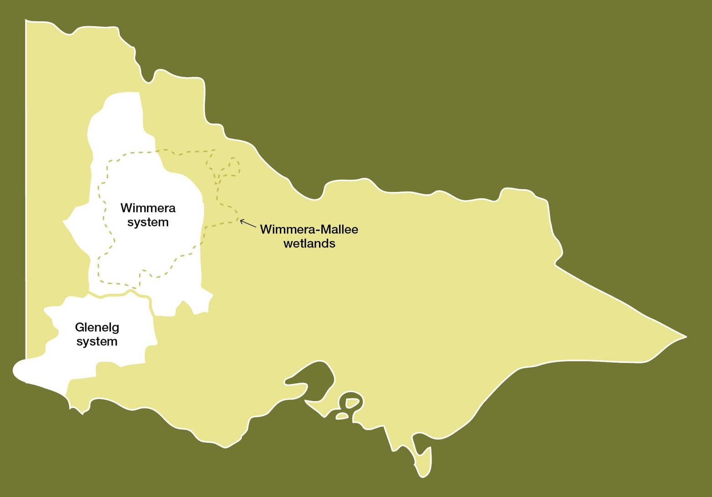

  - Western region overview 110
  - Glenelg system 116
  - Wimmera system 127
  - Wimmera-Mallee wetlands 138

Western region overview
The systems in the western region that can receive water from the VEWH’s environmental entitlements are Bochara-Bogara-Pawur (Glenelg River), the Wimmera River system and the Wimmera-Mallee wetlands. The Wimmera River system and Wimmera-Mallee wetlands are part of the Murray-Darling Basin, although Barringgi Gadyin (Wimmera River) ends in terminal lakes without directly flowing into the Murray River.
Water for the environment in the western region is supplied from the Wimmera-Mallee System Headworks, which is a series of on-stream reservoirs, off-stream storages and connecting channels that harvest water (mainly near the Grampians) and distribute it to entitlement holders throughout the Wimmera catchment and parts of the Avoca, Loddon, Glenelg and Mallee catchments.
The Wimmera and Glenelg systems share water available under the Wimmera and Glenelg Rivers Environmental Entitlement 2010, and the VEWH works with the Wimmera and Glenelg Hopkins CMAs to determine how available allocation will be used in each river in a given year. An additional volume of water is available to the Glenelg River as a compensation flow account.
The Commonwealth Environmental Water Holder (CEWH) also holds entitlement in the Wimmera system that can be used to supply the Wimmera River and lower Mount William Creek systems. Water for the environment available to the Wimmera-
Mallee wetlands is provided under the same entitlement but not shared with the Glenelg system. Instead, the water is available for use in small wetlands supplied by the Wimmera-Mallee Pipeline across the Wimmera, Mallee and North Central CMA areas.
Environmental values, objectives and planned actions for each system in the western region are presented in the following system sections.
Traditional Owners in the western region
Traditional Owners and their Nations in the western region have deep connections to Country that have endured for tens of thousands of years. These include inherent rights and cultural obligations to Country and community.
The Barengi Gadjin Land Council Aboriginal Corporation, Dja Dja Wurrung Clans Aboriginal Corporation and Gunditj Mirring Traditional Owners Aboriginal Corporation are the Registered Aboriginal Parties under the Victorian Aboriginal Heritage Act 2006 for waterways covered by this section of the seasonal watering plan.
The Burrandies Aboriginal Corporation (based in South Australia) works in partnership with the South East Aboriginal Focus Group (SEAFG), which as First Nations from the South East of South Australia, have ancestral connections across Bunganditj/ Boandik Country from the Limestone Coast region in South Australia to the western parts of the Glenelg River catchment in Victoria. The SEAFG ancestral connections include Tanganekald (Southern Clans), Tatiara/Ngarkat, Meintangk/Moandik/ Mootatunga/Thangal, Potaruwutij/Pinejunga, Wichantunga/Wattunga and Bunganditj/Boandik.
The SEAFG has had some engagement around Victorian water initiatives, including the 2009 Western Region Sustainable Water Strategy, the 2013 Wimmera Waterway Strategy and increased engagement through Burrandies in the Glenelg Cultural Flows discussions starting around 2017.
In 2005, the Wotjobaluk, Jaadwa, Jadawadjali, Wergaia and Jupagalk peoples, who are often referred to collectively as the Wotjobaluk Peoples and who are represented by the Barengi Gadjin Land Council, were recognised in a Native Title
Consent Determination under the Commonwealth Native Title Act 1993. The Barengi Gadjin Land Council also entered into an Indigenous Land Use Agreement with the Victorian and Australian governments in 2005. In 2022, the Victorian Government Gazette published the Barengi Gadjin Land Council Natural Resource Agreement under the Traditional Owner Settlement Act 2010. It pays homage to the trailblazers of 2005.
In 2007, the Gunditjmara people were granted nonexclusive native title rights and interests over almost 140,000 ha of Crown land, national parks, reserves, rivers, creeks and sea in Victoria’s western district, and the State of Victoria reached an Indigenous Land Use Agreement with the Gunditjmara People that establishes how they will exercise their rights and interests in the determination area, including the Glenelg River.
In 2013, the Dja Dja Wurrung Clans Aboriginal Corporation entered into a recognition and settlement agreement under the Traditional Owner Settlement Act 2010 in Victoria. Under the agreement, Dja Dja Wurrung people have rights to access and use water for traditional purposes, providing the take of water does not affect other parties.
The Eastern Maar Aboriginal Corporation holds Native Title under the Commonwealth Native Title Act 1993 and is also a Registered Aboriginal Party within the geographic area.
Some parts of the Wimmera-Mallee wetlands area are on Barapa Barapa Country.
Return to start of section

The Victorian Government is committed to self-determination for Traditional Owners through Treaty negotiations and policies such as Water is Life: Traditional Owner Access to Water Roadmap 2022. The VEWH and partners are working with Traditional Owners to embed the outcomes of government policy into the Victorian environmental watering program. Program partners in the environmental watering program are aware that structural changes (such as legislative, policy and governance changes) to how water is managed may be made in the future in recognition of Aboriginal water rights. Program partners have heard that Traditional Owners want empowerment and agency in water management, and in many cases, they want to manage water on Country on their own terms.

Engagement
The environmental watering program is informed by engagement with Traditional Owners, stakeholders and local communities. Program partners undertake extensive engagement at the local level to understand community priorities for the delivery of water for the environment in the coming year.
Program partners also seek to understand how cultural, social, economic and recreational values may be supported by delivering environmental flows. Opportunities to support these values are incorporated into watering decisions where possible and provided they do not compromise environmental outcomes. Cultural, social, economic and recreational values considered for each system in the western region are presented in the following system sections.
Environmental flows objectives are also informed by engagement undertaken through other strategies, plans and processes. These include regional catchment strategies, regional waterway strategies and technical studies (such as environmental flows studies and environmental water management plans). Traditional Owner cultural objectives for environmental water may refer to cultural flow studies, Aboriginal Waterway Assessments, Traditional Owner Country Plans and other tools to influence environmental water planning. These strategies, plans and technical reports collectively describe a range of environmental, economic, social and Traditional Owner perspectives and longer-term integrated catchment and waterway management objectives that influence environmental flows and priorities for water for the environment.
Table 4.1.1 Partners and stakeholders engaged by Glenelg Hopkins Catchment Management Authority in developing seasonal watering proposals for the Glenelg system and other key foundation documents that have directly informed the proposal (grouped in alphabetical order)

Partner/stakeholder | Glenelg system
Community groups and environment groups | - Friends of the Glenelg River Inc.  - Glenelg River User Group
Government agencies | - Department of Energy, Environment and Climate Action  - Grampians Wimmera Mallee Water  - Limestone Coast Landscape Board  - Natural Resources South East (South Australia)  - Parks Victoria  - Victorian Fisheries Authority  - Wimmera CMA
Landholders/farmers | - Individual landholders
Local businesses | - Glenelg River Boat Cruises  - Harrow Discovery Centre  - Nelson Boat and Canoe Hire  - Paestan Canoe Hire  - Vickery Bros (sand extraction)
Recreational users | - Casterton Angling Society Inc.  - Individual anglers  - Kayakers  - Southwest Victoria fishing reports  - VRFish
Traditional Owners | - Barengi Gadjin Land Council  - Burrandies Aboriginal Corporation  - Gunditj Mirring Traditional Owners Aboriginal Corporation
Return to start of section

Table 4.1.2 Partners and stakeholders engaged by Wimmera Catchment Management Authority in developing the seasonal watering proposal for the Wimmera system and other key foundation documents that have directly informed the proposal (grouped in alphabetical order)

Partner/stakeholder | Wimmera system
Community groups and environment groups | - Friends of Bungalally and Burnt Creek Group  - Lake Lonsdale Action Group  - Yarriambiack Creek Advisory Committee
Government agencies | - Commonwealth Environmental Water Office  - Department of Energy, Environment and Climate Action  - Glenelg Hopkins CMA  - Grampians Wimmera Mallee Water  - Hindmarsh Shire Council  - Horsham Rural City Council  - Murray-Darling Basin Authority  - Northern Grampians Shire Council  - Parks Victoria  - Victorian Fisheries Authority  - Yarriambiack Shire Council
Landholders/farmers | - Wimmera community members, especially landholders and stock and domestic water users
Recreational users | - Dimboola Boat and Water Ski Club  - Dimboola Fishing Classic  - Dimboola Rowing Club  - Field and Game  - Hindmarsh Ski Club  - Horsham Fishing Competition Inc.  - Horsham Triathlon Committee  - Jeparit Anglers Club  - Murtoa Angling Club  - Natimuk Lake water ski club  - Paddle Victoria  - Stawell and District Angling Club  - VRFish  - Warracknabeal Angling Club  - Wimmera Anglers Association
Traditional Owners | - Barengi Gadjin Land Council
Return to start of section

Table 4.1.3 Partners and stakeholders engaged by Mallee Catchment Management Authority, North Central Catchment Management Authority and Wimmera Catchment Management Authority seasonal watering proposals for the Wimmera-Mallee wetlands and other key foundation documents that have directly informed the proposals (grouped in alphabetical order)

Partner/stakeholder | Wimmera-Mallee wetlands
Community groups and environment groups | - Berriwillock Landcare  - Birchip Cropping Group  - Birchip Landcare Group  - Cokum community group  - Community members on the Mallee CMA Land and Water Advisory Committee  - Culgoa Landcare  - Curyo-Watchupga Landcare  - Donald and District Landcare Group  - Green Lake Regional Park  - Hopetoun Landcare  - Lake Tuhum Committee  - Lalbert Landcare  - Millewa-Carwarp Landcare  - Nullawil Landcare  - Ouyen Lake Project  - OzFish Unlimited  - Sea Lake Landcare  - Ultima Landcare  - Waitche Landcare  - Wimmera Bushwalking Club  - Woomelang-Lascelles Landcare
Government agencies | - Buloke Shire Council  - Commonwealth Environmental Water Office  - Department of Energy, Environment and Climate Action  - Grampians Wimmera Mallee Water  - Mallee CMA  - Mildura Rural City Council  - North Central CMA  - Parks Victoria  - Wimmera CMA  - Yarriambiack Shire Council
Landholders/farmers | - Private landholders  - Wimmera-Mallee Pipeline Environmental Water Advisory Group (North Central CMA)
Local businesses | - Ouyen Lake Project  - Wimmera Mallee Tourism
Recreational users | - Natimuk & District Field & Game Inc.  - Recreational users in the local community
Traditional Owners | - Barapa Barapa Nation Aboriginal Corporation  - Barengi Gadjin Land Council  - Dja Dja Wurrung Clans Aboriginal Corporation
Return to start of section

Integrated catchment management
Altered water regimes are one of many threats to the health of Victoria’s waterways. To be effective, environmental flows need to be part of an integrated approach to catchment management. Many of the environmental objectives of water for the environment in the western region will not be fully met without simultaneously addressing issues such as barriers to fish movement, high nutrient loads, loss of streambank vegetation and invasive species.
Victorian and Australian government agencies, Traditional Owner groups, community groups and private landholders collectively implement a wide range of programs that aim to protect and improve the environmental condition and function of land, soils and waterways throughout Victoria’s catchments.
Examples of complementary programs that support environmental flows outcomes in the western region include:
- fish passage works at Sandford Weir, Dergholm Gauge and Warrock are used in combination with the delivery of water for the environment to facilitate the movement of migratory fish from the estuary to the upstream reaches of the Glenelg and Wannon rivers
- installation of artificial wetland pontoons in the Dimboola weir pool and a regulating structure to reconnect Langlands Anabranch in the Horsham weir pool, as well as walking tracks to manage recreational access along the Wimmera River to reduce bank erosion
- weed and rabbit control to prevent bank erosion in the upper Wimmera catchment to improve water quality and stream form and increase native biodiversity
- stock-exclusion fencing along priority waterways throughout the Wimmera and Glenelg catchments to support the re- establishment of streamside and in-stream vegetation
- sand management, removal of excess bedload sand to improve the availability and quality of habitat for native fish, platypus and crayfish
- carp management activities in the Wimmera and Glenelg systems to reduce the number of carp and to better understand their behaviour in both rivers
- restoration of complex habitat for native fish by installing large wood in reach 2 of the Glenelg River using red gum trunks and root balls
- control of invasive species and stock-exclusion fencing in the Wimmera-Mallee wetlands.

For more information about integrated catchment management programs in the western region, refer to the Glenelg Hopkins, Mallee, North Central and Wimmera CMA’s regional catchment strategies and regional waterway strategies.

Risk management
During the development of the seasonal watering proposals for the Glenelg, Wimmera and Wimmera-Mallee wetland systems, environmental watering program partners assessed risks associated with potential environmental flows for 2023-24 and identified appropriate mitigating strategies. Risks and mitigating actions are continually assessed by program partners throughout the year (see subsection 1.2.7).

Seasonal outlook 2023-24
Total rainfall in the Grampians-Wimmera-Mallee headworks catchment area during 2022-23 was above average and was particularly high in spring and early summer. Inflows to storage in October and November were 465 percent and 860 percent of the long-term average for each month, respectively.
All major rivers and creeks in the western region flooded during spring 2022. The Wimmera River at Horsham peaked at 11,628 ML per day on 19 October, the MacKenzie River at MacKenzie Creek peaked at 1,263 ML per day on 14 October, Mount William Creek at Lake Lonsdale peaked at 1,417 ML per day on 21 November, and the Glenelg River at Dergholm peaked at 5,598 ML per day on 2 November. The high flow from the Wimmera River filled Lake Hindmarsh to about 50 percent capacity, the highest lake level since 2011-12.
The wet conditions and associated run-off met or exceeded planned environmental watering actions in the Wimmera and Glenelg river systems and most Wimmera-Mallee wetlands from July 2022 to February 2023, triggering significant ecological responses. Fish surveys conducted in early 2023 detected large numbers of juvenile Tupong in the Glenelg River for the
first time in several years, and Angler Report Card Fish Surveys indicated larger catches of golden and silver perch in the Wimmera River compared to recent years.
Return to start of section

Water storages across the Wimmera-Mallee System Headworks were collectively at 31 percent capacity at the start of 2022- 23, peaked at 79.5 percent in late November and had dropped to 65 percent capacity at the start of April 2023. The Wimmera and Glenelg Rivers Environmental Entitlement 2010 received a 100 percent allocation in November 2022. This allocation, combined with carryover from 2021-22, meant 66,722 ML of water for the environment was available in the VEWH’s accounts in 2022-23. The CEWH also received a 100 percent allocation in the Wimmera system for the first time, boosting available water by 28,000 ML. Rules associated with the CEWH allocation mean it can only be used in the Wimmera River and lower Mount William creeks. The Wimmera-Mallee wetlands also received a 100 percent allocation in 2022-23, which is only the second time the entitlement has received a full allocation since it was established in 2010.
The Bureau of Meteorology has forecast below-average rainfall across the western region during autumn and winter 2023. GWMWater has indicated the VEWH can expect opening allocations on 1 July 2023 of roughly 30 percent for the combined Wimmera and Glenelg Rivers Environmental Entitlement 2010 for 2023-24. Longer range outlooks for September 2023 have river allocations ranging from 30 to 96 percent and Wimmera-Mallee wetland allocations from zero to 84 percent in the
planning scenarios. The CEWH is not likely to receive any allocation in 2023-24 unless storage inflows are significantly above the long-term average. The VEWH expects to carry over about 48,100 ML in the Wimmera and Glenelg rivers environmental entitlement and 970 ML for use in the Wimmera-Mallee wetlands on 1 July 2023. The CEWH is expecting to carry over about 21,300 ML. These combined carryover volumes will help support environmental watering actions in 2023-24 and subsequent years if dry conditions develop and persist.
Annual environmental water allocations in the western region in each of the four years before 2022-23 were less than the minimum volume needed to deliver planned watering actions to the Wimmera and Glenelg rivers and Wimmera-Mallee wetlands. Carryover requirements were a key consideration in each of those years and significantly influenced the range of environmental watering actions that were authorised and delivered. The relatively full storages and high allocations received in 2022-23 have significantly boosted environmental water supplies for the short to medium term. This means that additional environmental watering actions can potentially be delivered in 2023-24 to increase the size and condition of native plant and animal communities in rivers and wetlands across the western region to make them more resilient to the next dry period. The Glenelg Hopkins and Wimmera CMAs have planned potential environmental watering actions for 2023-24 to consolidate recent improvements in environmental condition without setting a target carryover volume for 2024-25. The VEWH will monitor allocations and forecast climatic conditions during winter and spring and work with the Glenelg Hopkins and Wimmera CMAs to set a carryover target for 2024-25 if necessary.
The Wimmera-Mallee Pipeline wetland portion of the environmental entitlement is only likely to receive an allocation in 2023- 24 if storage inflows are close to or greater than the long-term average. The planned watering actions for the wetlands in 2023-24 are expected to use up to 400 ML of available carryover, which will leave about 575 ML to support watering actions in future years. The current supply for the Wimmera-Mallee wetlands may allow essential watering actions to the end of 2026-27 without new allocations.
Return to start of section

Glenelg system
Waterway manager – Glenelg Hopkins Catchment Management Authority
Storage manager – Grampians Wimmera Mallee Water
Environmental water holder – Victorian Environmental Water Holder
Proportions of water entitlements in the Wimmera-Mallee System Headworks held by private users, water corporations and environmental water holders on 30 June 2020
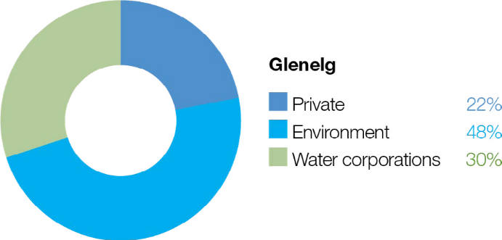

The Wimmera-Mallee System Headworks captures run-off from both the Wimmera and Glenelg catchments. Entitlements to water held in this system cannot be accounted for separately in the two river basins, so this figure shows the proportion of entitlements across both systems.

System overview
Bochara-Bogara-Pawur (Glenelg River) rises in Gariwerd (the Grampians National Park) and flows west through Harrow and then south to Casterton and Dartmoor (Figure 4.2.1). The Glenelg River estuary flows through South Australia for a short distance before returning to Victoria and flowing into the sea at Nelson. At over 500 km, the Glenelg River is one of the longest rivers in Victoria.
Moora Moora Reservoir and Rocklands Reservoir are Wimmera-Mallee System Headworks water storages in the Glenelg River system that contribute to the supply of water to towns and properties across the Wimmera, Mallee, Glenelg, Loddon and Avoca catchments. Water for the environment is actively managed in the Glenelg River below Rocklands Reservoir. There are passing flow rules for the Glenelg River and upper Wannon River.
The priority reaches of the Glenelg River for deliveries of water for the environment are:
- Rocklands Reservoir to 5-Mile Outlet (reach 1a),
- 5-Mile Outlet to the confluence with the Chetwynd River (reach 1b),
- Chetwynd River to the Wannon River (reach 2), and
- Wannon River to the tidal extent just below the confluence with Crawford River (reach 3).

Water for the environment in the Glenelg system is released from Rocklands Reservoir for reach 1a via the reservoir wall outlet and for reaches 1b, 2 and 3 via the 5-Mile and 12-Mile outlets.
The Glenelg River estuary benefits from releases of water for the environment to upstream reaches, but releases do not currently target the estuary. The Glenelg Hopkins CMA has investigated the importance of water for the environment in the Glenelg River estuary, listed as a heritage river reach and a site of international significance under the Ramsar Convention. Environmental flows provide landscape-scale benefits that support estuarine values.
Return to start of section

Figure 4.2.1 The Glenelg system
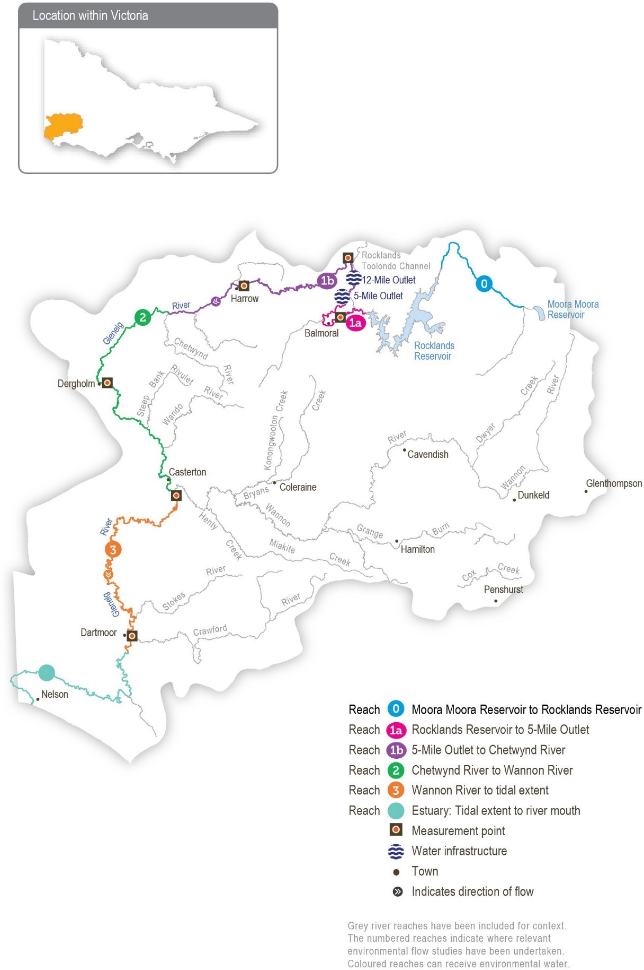

Return to start of section

Environmental values
The Glenelg River starts in Gariwerd (the Grampians National Park) and flows to the sea through the Lower Glenelg National Park. The lower reaches of the Glenelg River are part of a landscape recognised as one of Australia’s 15 national biodiversity hotspots, and the Glenelg Estuary and Discovery Bay site was listed under the Ramsar Convention as a site of international significance in February 2018.
The Glenelg River supports a range of rare and unique aquatic life, including the endangered Glenelg freshwater mussel, Glenelg spiny crayfish and a newly described species of river blackfish. It is also home to platypus and populations of native fish, including estuary perch, short-finned eel, tupong and three species of pygmy perch, including the threatened variegated pygmy perch and Yarra pygmy perch. Some of these fish species migrate long distances to and from the Glenelg River estuary to complete their life cycles. Sand extraction currently occurs around the Casterton to Dergholm reaches to provide deep pools, habitats and drought refuge areas, important to fish species and the macroinvertebrates that feed them.
Frasers Swamp is another important feature of the upper Glenelg system and is home to a healthy growling grass frog population. The swamp also meets the habitat requirements for the Australasian Bittern, and investigations are underway to determine if they use this habitat.
The Glenelg River supports a variety of streamside vegetation communities and species, including the endangered Wimmera bottlebrush. Streamside and floodplain vegetation comprises river red gum woodlands with paperbark, bottlebrush and tea tree understorey.

Environmental objectives in the Glenelg system
Protect, maintain, and, where possible, enhance populations of endemic fish, including threatened and diadromous species
Maintain deep pool habitats and connectivity along the river
Maintain the platypus population
Maintain healthy and diverse mosaics of water-dependent vegetation (such as river red gums and Wimmera River bottlebrush)
Maintain a wide range and large number of waterbugs to break down organic matter and support the river’s food chain
Maintain water quality for native fish, waterbugs, aquatic vegetation and other water-dependent animals
Traditional Owner cultural values and uses
The Glenelg River, known as Bochara in Dhauwurd Wurrung, Pawur in Bunganditj and Bogara in Wergaia-Jadawadjali languages, is a significant feature in the cultural landscape of south-western Victoria. The river features in the region’s creation stories. Bochara-Bogara-Pawur (Glenelg River) continues to be an important place for Traditional Owners, who have inhabited the area for thousands of years, using the rich resources available along the river and the associated habitats.
In planning for environmental flows in the Glenelg River, several on-Country meetings have been held to increase Traditional Owner involvement in environmental watering. There has also been an increase in communicating operational changes to water deliveries. When planning for the Glenelg River seasonal watering proposal, the Gunditj Mirring Traditional Owners Aboriginal Corporation, Barengi Gadjin Land Council, Burrandies Aboriginal Corporation and Glenelg Hopkins CMA have considered:
- supporting the health of cultural heritage sites (such as scar trees, ring trees, stone structures, middens and rock paintings) and native plants, which are sources of traditional foods and medicines
- that improving the health and abundance of totem species and their habitat by delivering water for the environment also benefits Traditional Owners’ spiritual wellbeing
- supporting contemporary cultural events such as the Johnny Mullagh cricket match in March each year. A summer fresh is delivered to support environmental outcomes, but it also supports this event on the river.
Aboriginal Peoples across the Glenelg catchment have retained a strong identity and connection to the traditional lands for which they have custodial rights and responsibilities. Cultural values in the Bochara-Bogara-Pawur (Glenelg River) system align strongly with environmental values. Cultural values are holistic and interrelated: they are bound up with the health of the river system overall and the Country of which the river is part. Traditional Owners’ wellbeing is connected to the health of the river and of Country.
Return to start of section

Gunditjmara Traditional Owners have identified that it is a priority to spend time on the river and increase cultural practices and connection to Country. They have highlighted the importance of increasing ceremonial and on-Country gatherings along the river, including at Casterton and the Glenelg Estuary.
The Glenelg River Yarns website was launched in late 2021 as part of the Glenelg River Cultural Flows project. The website shares cultural values and stories on a virtual tour and welcomes all visitors to Country.
Figure 4.2.2 Glenelg River Environmental Flow Seasonal Calendar
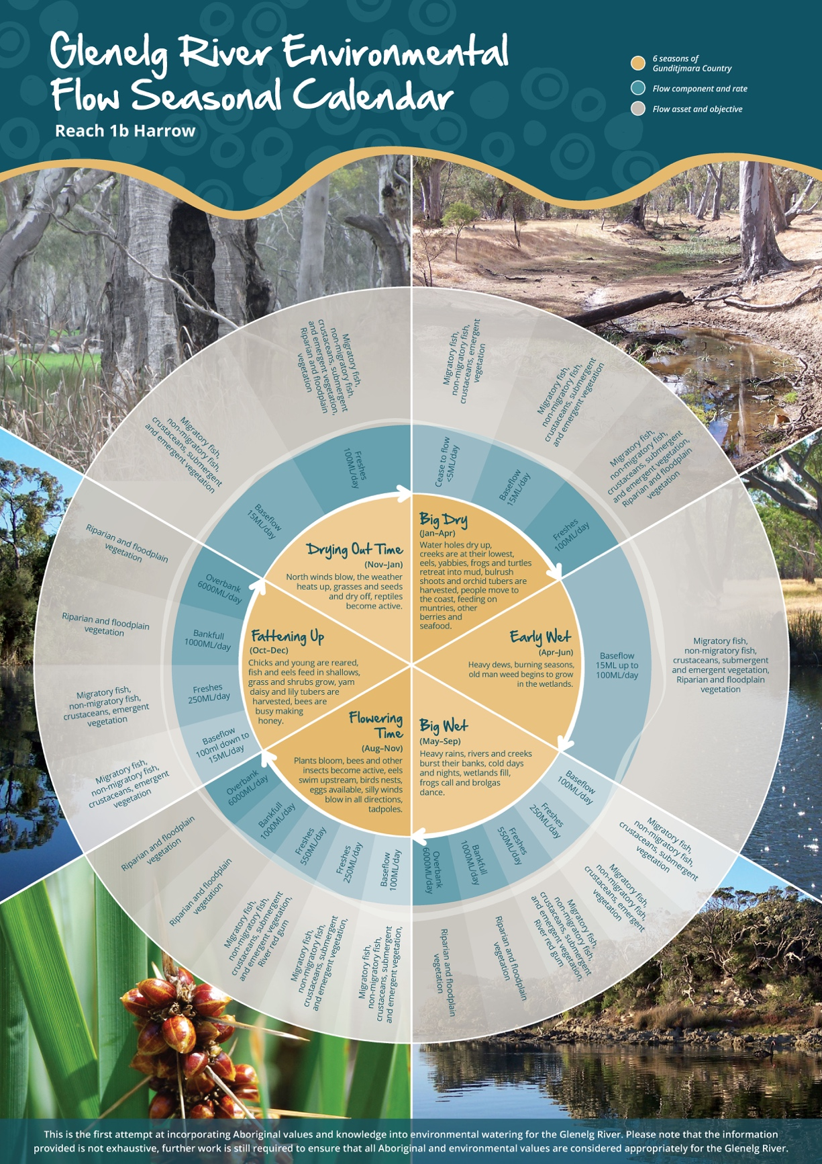

Return to start of section

Figure 4.2.2 was produced by the Gunditj Mirring Traditional Owners Aboriginal Corporation and describes the six seasons of Gunditjmara Country. The northern part of the river upstream of the Harrow area is in Jadawadjali Country, and the south- western part of the system is in Boandik Country. The calendar describes the six seasons alongside flow components for reach 1b of the Glenelg River – from 5-Mile Outlet to Chetwynd River – and aligns them with corresponding watering effects and objectives. The calendar reflects the seasonal flow conditions that all Traditional Owner groups recognise.
The value of the calendar is in its clear visual depiction of Traditional Owners’ knowledge, developed over many generations, of how varying flows correspond to seasonal conditions and broader environmental patterns. The six seasons will eventually be embedded in environmental flow recommendations and scenario planning in future years.
Increasing the involvement of Traditional Owners in the planning and managing environmental flows and ultimately providing opportunities to progress towards self-determination within the environmental watering program is a core commitment of the VEWH and the Glenelg Hopkins CMA. This is reinforced by a range of legislative and policy commitments, including the Water Act 1989, the Victorian Aboriginal Affairs Framework, the 2016 Water for Victoria and in some cases, agreements under the Traditional Owner Settlement Act 2010.
Where Traditional Owners are more deeply involved in the planning and/or delivery of environmental flows for a particular site, their contribution is acknowledged in Table 4.2.1 with an icon. The use of this icon is not intended to indicate that these activities are meeting all the needs of Traditional Owners, but is incorporated in the spirit of valuing their contribution and indicating progress towards deeper involvement.

Watering planned and/or delivered in partnership with Traditional Owners to support cultural values and uses
The timing of the summer/autumn fresh is planned to support the annual Johnny Mullagh Cup cricket match between Gunditj Mirring and Barengi Gadjin Traditional Owners.

Social, recreational and economic values and uses
In planning the potential environmental watering actions in Table 4.2.1, the Glenelg Hopkins CMA considered how environmental flows could support values and uses, including:
- water-based recreation (such as canoeing and fishing)
- community events and tourism (such as the Johnny Mullagh Cup and visitation)
- socioeconomic benefits (such as for diverters for stock needs and domestic use: water levels and water quality can rely on the delivery of water for the environment, particularly in summer).
If the timing or management of planned environmental flows may be modified to align with a community benefit, this is acknowledged in Table 4.2.1 with the following icons.

Watering planned to support angling activities
Watering planned to support water sports activities (e.g. canoeing)
Watering planned to support peaks in visitation (e.g. camping or other public activities on long weekends or school holidays)
Environmental flow releases support the spawning and recruitment of popular angling species like estuary perch and bream. Local anglers continue to report increased fish activity associated with the delivery of freshes, improving fishing opportunities in the river. Releases also support numerous fishing competitions, including the Casterton angling club.
The planning of the summer fresh improves accessibility, water quality and amenity for canoeists planning trips on the Glenelg River over the summer holiday period.
Summer and spring freshes improve conditions at popular riverside campgrounds in the upper reaches of the Glenelg River, including Fulham Reserve near Balmoral and the Johnny Mullagh Reserve at Harrow.
Scope of environmental watering
The term ‘environmental watering’ refers to the active delivery of held environmental water to support particular environmental objectives by altering the flow in a river or the water level in a wetland. While other terms are sometimes used to describe the delivery of environmental water, ‘environmental watering’ is deliberately used here and in seasonal watering statements to ensure consistency in the legal instruments that authorise the use of water for the environment in Victoria.
Return to start of section

Table 4.2.1 describes the potential environmental watering actions in 2023-24, their expected watering effect (that is, the intended physical or biological effects of the watering action) and the longer-term environmental objectives they support. Each environmental objective relies on one or more potential environmental watering actions and their associated physical or biological effects.
Table 4.2.1 Potential environmental watering actions, expected watering effects and associated environmental objectives for the Glenelg system

Potential environmental watering action | Expected watering effects | Environmental objectives
Winter/spring low flow in reach 1a (60 ML/day or natural during June to November) | - Maintain water quality for fish and waterbugs  - Wet aquatic vegetation to maintain its condition and prevent encroachment by terrestrial species  - Maintain shallow-water habitat for fish, waterbugs and platypus
Winter/spring low flow in reach 1b (100 ML/day
or natural during June to November)
Winter/spring low flow in reach 2 (160 ML/day or natural during June to November)
Winter/spring low flow in reach 3 (400 ML/day or natural during June to November) | - Wet benches to increase habitat and allow widespread fish passage
Winter/spring fresh(es) in reach 1b (one to five freshes of 250 ML/ day for one to five days during June to November/Big Wet to Fattening Up1) | - Wet benches to improve the condition of emergent vegetation and vegetation on the riverbanks to support recruitment and growth and maintain habitat diversity  - Provide adequate depth for fish passage and cue fish movement  - Encourage female platypus to select a nesting burrow higher up the bank to reduce the risk of greater flow later in the year flooding the burrow when juveniles are present  - Scour sand from pools to improve the quality of fish habitat
Winter/spring fresh(es) in reach 2 (one to five freshes of 300 ML/ day for one to five days during June to November)

Potential environmental watering action | Expected watering effects | Environmental objectives
Summer/autumn low flow in reach 1a (10 ML/day or natural during December to May) | - Protect against rapid water-quality decline over the low-flow period  - Maintain edge habitats, pools and shallow-water habitats for fish, waterbugs and platypus  - Maintain a near-permanent wetted stream channel to promote the growth of in-stream vegetation and prevent encroachment by terrestrial plants
Summer/autumn low flow in reach 1b (15 ML/day or natural during December to May/Big Dry to Early Wet1)
Summer/autumn low flow in reach 2 (25 ML/day or natural during December to May)
Summer/autumn low flow in reach 3 (80 ML/day or natural during December to May)

Potential environmental watering action | Expected watering effects | Environmental objectives
Summer/autumn fresh(es) in reach 1a (one to two freshes of 60 ML/day for two to three days during December to May) | - Flush fine silt from the stream bed and hard substrate to improve the quality of the fish and waterbug habitat  - Wet emergent vegetation on the lower banks to improve its condition and prevent the encroachment of terrestrial species  - Flush pools to improve water quality and lower temperatures  - Provide sufficient flow to allow native fish and platypus to access habitat
Summer/autumn fresh(es) in reach 1b (one to two freshes of 100 ML/ day for two to three days during December to May/ Big Dry to Early Wet1)
Summer/autumn fresh(es) in reach 2 (one to two freshes of 150 ML/ day for two to three days during December to May)
Summer/autumn fresh(es) in reach 3 (one to two freshes of 150 ML/day for three days each or natural during December to May)
1 See the Glenelg River Environmental Flow Seasonal Calendar in this section.
Scenario planning
Table 4.2.2 outlines potential environmental watering and expected water use in a range of planning scenarios.
2022-23 was a wet year, and above-average rainfall during spring resulted in all entitlements receiving 100 percent allocation. High storage inflows provided a large volume of held passing flow in Rocklands Reservoir for release into the Glenelg River. These factors contributed to reduced demand on the Wimmera-Glenelg environmental water entitlement during 2022-23, providing for a high carryover into 2023-24 and allowing for a wider range of possible watering actions during 2023-24.
Environmental watering actions in the Glenelg River typically target reaches 1b and 2 because that is where managed flows can have the greatest environmental effect. However, greater water availability during 2023-24 will allow water for the environment to be delivered to more reaches.
The priority ecological objectives for environmental flows in 2023-24 are to:
- maintain channel form and water quality
- maintain connectivity and provide migration opportunities for native fish
- support juvenile recruitment of native fish
- promote in-stream vegetation and edge habitat for macroinvertebrates, fish and platypus.
Return to start of section

In all planning scenarios, a summer/autumn low flow is the highest priority in reaches 1a, 1b and 2 to maintain a continuous flow through these reaches. Monitoring in recent years has demonstrated that maintaining continuous flow and thereby avoiding cease-to-flow events is the most effective way of preventing declines in the abundance and condition of native fish and platypus populations in the reaches of the Glenelg River. A summer/autumn low flow is recommended in reaches 1a, 1b and reach 2 in all planning scenarios and is the only environmental watering action proposed for reaches 1a and 2 in the drought planning scenario. In the drought planning scenario, other flows are not planned for reaches 1a and 2 because they cannot be delivered with the forecast available supply and are expected to have less environmental benefit than flows
delivered in reach 1b. Water for the environment will not be used to deliver a low flow to reach 3 because small releases from Rocklands Reservoir are unlikely to have much effect that far downstream in the drought and dry planning scenarios, and low- flow objectives in that reach will be met by tributary inflows in the average and wet planning scenarios.
Summer/autumn freshes are the next-highest priority watering action in the Glenelg River and are needed to provide flow variation, support fish migration and improve water quality outcomes. In the drought planning scenario, summer/autumn freshes will only be delivered to reach 1b because environmental water can be efficiently delivered to that reach via the Five Mile and Twelve Mile outlets, and it supports some of the Glenelg River’s most flow-sensitive environmental values. A
combination of increased availability of environmental water and increased natural inflows will allow summer/autumn freshes to be delivered to reaches 1a and 2 in the very dry planning scenario and to all reaches (including reach 3) under the dry-to-wet planning scenarios.
Environmental watering actions in reach 1a are significantly constrained by releases that can be made from the Rocklands Reservoir wall and the hydraulic interactions at Frasers Swamp. Reach 1a is immediately downstream of Rocklands Reservoir, meaning it has little natural inflow and relies heavily on mandated passing flow and managed environmental flows. However, large releases from Rocklands Reservoir can potentially flood private land adjacent to Frasers Swamp. A winter/spring low flow is proposed to be delivered to reach 1a under the dry-to-wet planning scenarios if sufficient water is available, and while a larger flow is expected to have an environmental benefit, it is not planned due to the potential risk of flooding private land.
Winter/spring freshes will be delivered in reach 1b where possible in the average and wet planning scenarios to trigger fish and platypus movement, wet vegetation higher up the bank and scour sand from some pool substrates to improve habitat quality for fish and macroinvertebrates. There is unlikely to be enough supply to deliver these flows in any reach under drier planning scenarios, and they are generally met in reach 2 and reach 3 by tributary inflows and local catchment run-off in the average and wet planning scenarios.
During the scenario planning process, the Glenelg Hopkins CMA used a flow delivery model to inform the volumes of environmental water required. The model cannot accurately predict the contribution of passing flow to proposed environmental watering actions. Those contributions are potentially significant in the average and wet planning scenarios, and therefore the demands presented in Table 4.2.2 are likely to be greater than needed in the average and wet planning scenarios.
Carryover will be vital to ensure sufficient water availability to deliver the highest-priority flows during summer and autumn 2024-25 if there are low allocations during the year. The VEWH will work with the Wimmera and Glenelg Hopkins CMAs to set a carryover target for 2024-25 once winter and spring storage inflows are known and the potential resource outlook for the following year is clearer.
Table 4.2.2 Potential environmental watering for the Glenelg River system in a range of planning scenarios

Planning scenario | Drought | Very dry | Dry | Average | Wet
Expected conditions | - No passing flow and low volumes of compensation and natural flow | - Low volumes of passing, compensation and natural flow | - Some passing, compensation and natural flow | - Some passing, compensation and significant natural flow, particularly in winter/spring | - Passing, compensation and natural flow meet many watering requirements in winter/spring
Expected availability of water for the environment1 | - 53,374 ML | - 59,864 ML | - 71,221 ML | - 80,955 ML | - 88,661 ML

Planning scenario | Drought | Very dry | Dry | Average | Wet
Glenelg River (targeting reach 1a)
Potential environmental watering – tier 1 (high priorities) | Tier 1a (can be achieved with predicted supply)
 | - Summer/ autumn low flow | - Summer/ autumn low flow  - Summer/ autumn freshes (two freshes) | - Winter/spring low flow  - Summer/ autumn low flow  - Summer/ autumn freshes (two freshes) | - Winter/spring low flow  - Summer/ autumn low flow  - Summer/ autumn freshes (two freshes) | - Winter/spring low flow  - Summer/ autumn low flow  - Summer/ autumn freshes (two freshes)
 | Tier 1b (supply deficit)
 | - N/A
Potential environmental watering – tier 2 (Low priority) | - Winter/spring low flow  - Summer/ autumn freshes (two freshes) | - Winter/spring low flow | - N/A
Glenelg River (targeting reach 1b)
Potential environmental watering – tier 1 (high priorities) | Tier 1a (can be achieved with predicted supply)
 | - Summer/ autumn low flow  - Summer/ autumn fresh (one fresh) | - Summer/ autumn low flow  - Summer/ autumn freshes (two freshes) | - Summer/ autumn low flow  - Summer/ autumn freshes (two freshes) | - Winter/spring freshes (three freshes)  - Summer/ autumn low flow  - Summer/ autumn freshes (two freshes) | - Winter/spring low flow  - Winter/spring freshes (five freshes)  - Summer/ autumn low flow  - Summer/ autumn freshes (two freshes)
 | Tier 1b (supply deficit)
 | - N/A
Potential environmental watering – tier 2 (Low priority) | - Winter/spring low flow  - Winter/spring fresh (one fresh)  - Summer/ autumn fresh (one additional fresh) | - Winter/spring low flow  - Winter/spring fresh (one fresh) | - Winter/spring low flow  - Winter/spring freshes (two freshes) | - Winter/spring low flow
Glenelg River (targeting reach 2)
Potential environmental watering – tier 1 (high priorities) | Tier 1a (can be achieved with predicted supply)
 | - Summer/ autumn low flow | - Summer/ autumn low flow  - Summer/ autumn freshes (two freshes) | - Summer/ autumn low flow  - Summer/ autumn freshes (two freshes) | - Summer/ autumn low flow  - Summer/ autumn freshes (two freshes) | - Summer/ autumn low flow  - Summer/ autumn freshes (two freshes)
 | Tier 1b (supply deficit)
 | - N/A

Planning scenario | Drought | Very dry | Dry | Average | Wet
Potential environmental watering – tier 2 (Low priority) | - Winter/spring low flow  - Winter/spring fresh (one fresh)  - Summer/ autumn freshes (two freshes) | - Winter/spring low flow  - Winter/spring fresh (one fresh) | - Winter/spring low flow  - Winter/spring freshes (two freshes) | - Winter/spring low flow  - Winter/spring freshes (three freshes) | - Winter/spring low flow  - Winter/spring freshes (five freshes)
Glenelg River (targeting reach 3)
Potential environmental watering – tier 1 (high priorities) | Tier 1a (can be achieved with predicted supply)
 | - N/A |  | - Summer/ autumn freshes (two freshes) | - Summer/ autumn freshes (two freshes) | - Summer/ autumn freshes (two freshes)
 | Tier 1b (supply deficit)
 | - N/A
Potential environmental watering – tier 2 (Low priority) | - Winter/spring low flow  - Summer/ autumn low flow  - Summer/ autumn freshes (two freshes) | - Winter/spring low flow  - Summer/ autumn low flow  - Summer/ autumn freshes (two freshes) | - Winter/spring low flow  - Summer/ autumn low flow | - Winter/spring low flow  - Summer/ autumn low flow | - Winter/spring low flow  - Summer/ autumn low flow
Possible volume of water for the environment required  to achieve objectives | - 10,115 ML | - 14,669 ML | - 15,595 ML | - 25,343 ML | - 36,867 ML
Priority carryover requirements for 2024-252 | - N/A2

- Volume represents the available water for the Wimmera and Glenelg systems under the shared Wimmera and Glenelg Rivers Environmental Entitlement 2010
and is the sum of carryover and estimated new allocations
- The VEWH will monitor allocations and forecast climatic conditions during winter and spring and work with the Glenelg Hopkins and Wimmera CMAs to set a carryover target for 2024-25 if necessary
Return to start of section

Wimmera system
Waterway manager – Wimmera Catchment Management Authority
Storage manager – Grampians Wimmera Mallee Water
Environmental water holders –Victorian Environmental Water Holder and Commonwealth Environmental Water Holder
Proportions of water entitlements in the Wimmera-Mallee System Headworks held by private users, water corporations and environmental water holders on 30 June 2020
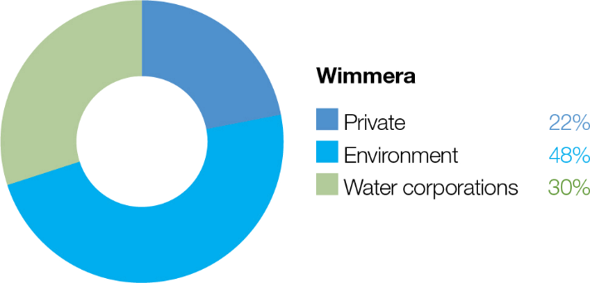

The Wimmera-Mallee System Headworks capture run-off from the Wimmera and Glenelg catchments. Entitlements to water held in this system cannot be accounted for separately in the two river basins, so this figure shows the proportion of entitlements across both systems.

System overview
Barringgi Gadyin (Wimmera River) rises in the Pyrenees Ranges near Elmhurst and flows through Horsham, Dimboola and Jeparit before terminating at Lake Hindmarsh, which is Victoria’s largest freshwater lake and the first of a series of terminal lakes. The Wimmera River receives flows from several regulated tributaries, including the MacKenzie River, Mount William Creek and Burnt Creek (Figure 4.3.1). These tributaries – Bungalally Creek and the Wimmera River below Mount William Creek – can receive water for the environment. In exceptionally wet periods, Lake Hindmarsh will overflow into Outlet Creek and then to Lake Albacutya, an internationally recognised Ramsar-listed wetland. There are numerous wetlands beyond Lake Albacutya that have not filled with water for decades.
Water in the Wimmera system is stored in three on-stream reservoirs (Lake Wartook on the MacKenzie River, Lake Lonsdale on Mount William Creek and Lake Bellfield on Fyans Creek) and in several off-stream storages (Taylors Lake, Lake Fyans and Toolondo Reservoir). A channel system enables water to be moved between several storages. Water can also be transferred from Rocklands Reservoir in the Glenelg system to the Wimmera system via the Rocklands-Toolondo Channel and from Moora Moora Reservoir via the Moora Channel. The connected storages and channels are collectively called the Wimmera-Mallee System Headworks. Water harvested in the system headworks is used for town, stock and domestic supply throughout the Wimmera catchment and parts of the Avoca, Hopkins, Loddon, Glenelg and Mallee catchments. Passing flows are provided to the Wimmera River and lower Mount William and Fyans creeks.
Priority reaches in the Wimmera system that can receive water for the environment are Wimmera River reaches 3 and 4, MacKenzie River reaches 2 and 3, upper and lower Mount William Creek, upper and lower Burnt Creek and Bungalally Creek.
Yarriambiack Creek is a distributary of the upper Wimmera River that would have naturally received flow during high-flow events. Modifications to the Yarriambiack Creek offtake increase flow rates in Yarriambiack Creek compared to what would have naturally happened, but they reduce the flow rates to the high-priority reaches of the Wimmera River.
Two wetlands in the Wimmera system are also included in the environmental watering program.

Dock Lake, near Horsham, would have naturally filled via spills from nearby Green Lake when there was significant run-off from the northern edge of the Grampians. In the 1930s, Dock Lake was modified to allow it to be used as a water storage for irrigation supply in the Wimmera-Mallee system. Dock Lake was removed from the supply system after the Wimmera-Mallee Pipeline was completed in 2010. Water can be actively delivered to Dock Lake from Green Lake via a gravity-fed channel when there is sufficient water in Green Lake.
Ranch Billabong, near Dimboola, is located on land managed by the Barengi Gadjin Land Council Aboriginal Corporation. The billabong was disconnected from the Wimmera River by changes to a road that traverses land between the river and the billabong. Restoring elements of the natural water regime at Ranch Billabong aims to improve habitat for native animal and plant communities and is an important outcome for Traditional Owners and their Nations.
Return to start of section

Figure 4.3.1 The Wimmera system

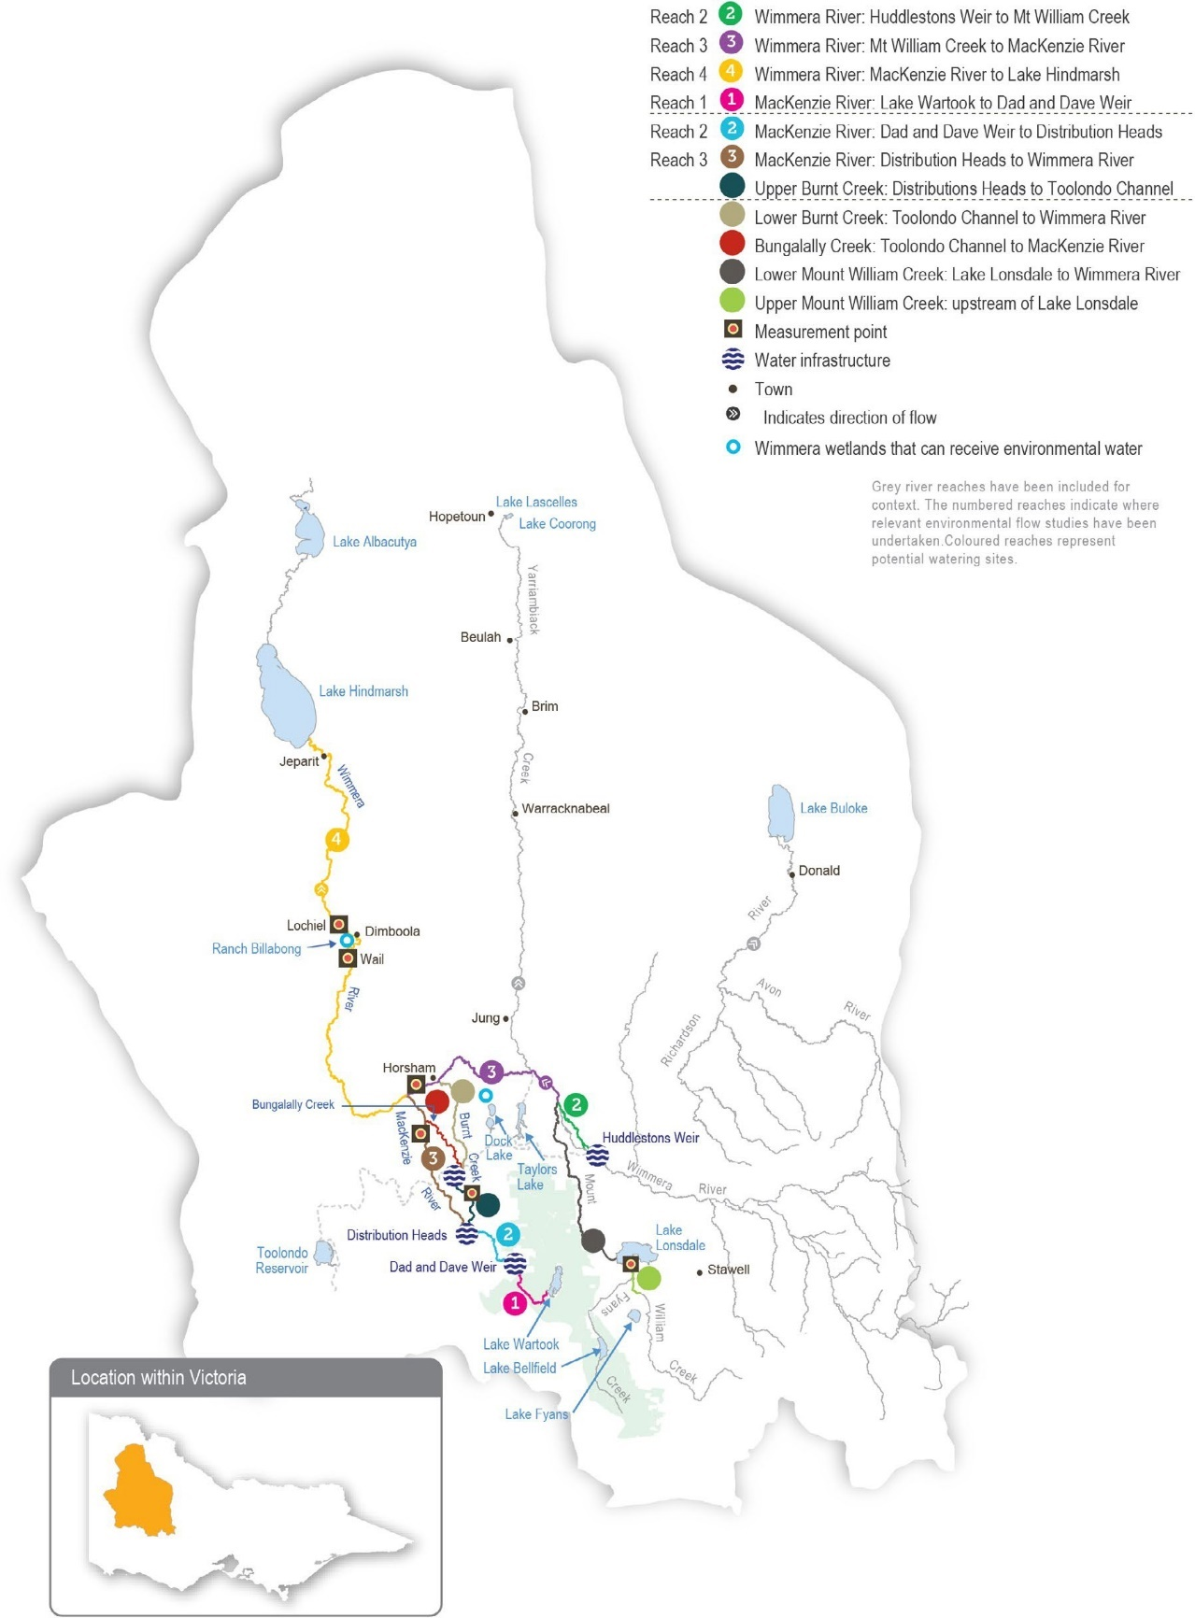
Return to start of section

Environmental values
The Wimmera River supports abundant native fish populations, including one of Victoria’s few self-sustaining populations of freshwater catfish. The Wimmera River also supports native waterbird, turtle, frog and rakali (water rat) populations.
The MacKenzie River contains the only confirmed remaining platypus population in the Wimmera system and supports locally important populations of native fish, including river blackfish and southern pygmy perch. It also supports populations of threatened Glenelg spiny crayfish, western swamp crayfish and turtles, as well as the critically endangered Wimmera bottlebrush. Managed releases from Lake Wartook for urban supplies and environmental flows maintain regular flow in the middle and upper reaches of the MacKenzie River and provide important refuges for these regionally important populations during dry periods.
Vegetation along Burnt and Bungalally creeks provides habitat corridors for terrestrial wildlife. Upper Burnt Creek contains an important native fish community and a threatened western swamp crayfish population, which is also becoming established in lower Burnt Creek. Mount William Creek supports regionally important populations of obscure galaxias, southern pygmy perch and rakali (water rats).
Dock Lake is a natural wetland that was modified and used as part of the Wimmera-Mallee System Headworks until 2010. When wet, Dock Lake provides feeding and breeding habitat for large numbers of waterbirds and frogs.
Ranch Billabong is a small wetland near Dimboola that supports river red gums, a variety of aquatic plant species, waterbirds and frogs.
Environmental objectives in the Wimmera system
Protect and increase populations of native fish, including one of Victoria’s few self-sustaining populations of freshwater catfish
Maintain the frog population by providing feeding and breeding habitat
Maintain channel capacity and diversity and prevent the colonisation of waterways by terrestrial plant species
Increase the abundance and distribution of platypus populations by providing places to breed and feed, as well as opportunities for juveniles to disperse
Maintain the turtle population by providing feeding and breeding habitat
Improve the condition, abundance and diversity of native aquatic, emergent and streamside vegetation
Maintain the waterbird population by providing roosting, feeding and breeding habitat in floodplain wetlands.
Increase the abundance and diversity of waterbugs to break down dead organic matter and support the waterway’s food web
Maintain crayfish populations by providing feeding and breeding habitat
Maintain water quality to provide suitable conditions for waterbugs, native fish and other water-dependent plants and animals
Traditional Owner cultural values and uses
The Wimmera’s waterways are important to the Wotjobaluk Nations, and there are significant cultural values throughout the landscape. Native title is held along much of the lower Barringgi Gadyin (Wimmera River). In planning for environmental flows in Barringgi Gadyin (Wimmera River), the Barengi Gadjin Land Council and Wimmera CMA work together to support Wotjobaluk cultural values, including supporting contemporary cultural events (such as the Wotjobaluk festival).
Increasing the involvement of Traditional Owners in environmental water management and progressing opportunities towards self-determination in the environmental watering program is a core commitment of the VEWH and its agency partners. This is reinforced by a range of legislation and policy commitments, including the Water Act 1989, the Victorian Aboriginal Affairs Framework, the 2016 Water for Victoria, the Water is Life: Traditional Owner Access to Water Roadmap 2022, and in some cases, agreements under the Traditional Owner Settlement Act 2010.
Return to start of section

Where Traditional Owners are more deeply involved in the planning and/or delivery of environmental flows for a particular site, their contribution is acknowledged in Table 4.3.1 with an icon. The use of this icon is not intended to indicate that these activities are meeting all the needs of Traditional Owners, but is incorporated in the spirit of valuing that contribution.

Watering planned and/or delivered in partnership with Traditional Owners to support cultural values and uses
In the Wimmera system, the Wimmera CMA and Barengi Gadjin Land Council work in partnership to support cultural values at Ranch Billabong. The delivery of water for the environment at Ranch Billabong aims to provide a more-natural flooding regime, restore indigenous plant species (such as old man weed and sneezeweed) and animal habitats, control selected weed species and improve amenity and suitability for gatherings and events (such as earth oven and bark canoe cultural activities).
Water for the environment was delivered to Ranch Billabong in 2018, 2019, 2020 and 2021. In 2022, Ranch Billabong was filled naturally by flooding. Watering over the last five years has improved water quality and vegetation condition, consistent with the cultural objectives of the Traditional Owners. The Barengi Gadjin Land Council manages the site and has controlled weed species and enhanced accessibility by building walking tracks and culvert crossings around the billabong. In 2022, jetty construction commenced but was interrupted due to flooding.

Social, recreational and economic values and uses
In planning the potential environmental watering actions in Table 4.3.1, the Wimmera CMA considered how environmental flows could support values and uses, including:
- water-based recreation (such as canoeing, fishing, rowing and water skiing)
- riverside recreation and amenity (such as birdwatching, cycling, running and walking)
- community events and tourism such as fishing competitions at Dimboola, Jeparit and Horsham; rowing at Dimboola; Kannamaroo Festival at Horsham, Wimmera River Duck Race; Wimmera River Park Run; Peter Taylor Memorial Barefoot Water Ski Tournament and Night Jump at Dimboola; and supporting small business, including chartered river cruises, pop- up food vendor caravans and general visitation
- socioeconomic benefits such as for diverters for irrigation, stock needs and domestic use: water levels and water quality, which can rely on the delivery of water for the environment, particularly in summer, and associated tourism events.
If the timing or management of planned environmental flows may be modified to align with a community benefit, this is acknowledged in Table 4.3.1 with the following icons.

Watering planned to support angling activities
Watering planned to support water sports activities (e.g. canoeing, kayaking, rowing, swimming and water skiing)
Water for the environment can be used to temporarily raise water levels in the Horsham, Dimboola and Jeparit weir pools to improve conditions for community events, including fishing competitions and water skiing and rowing events. Water for the environment held in the weir pools is released after the community events to support ecological objectives further downstream when required.

Scope of environmental watering
The term ‘environmental watering’ refers to the active delivery of held environmental water to support particular environmental objectives by altering the flow in a river or the water level in a wetland. While other terms are sometimes used to describe the delivery of environmental water, ‘environmental watering’ is deliberately used here and in seasonal watering statements to ensure consistency in the legal instruments that authorise the use of water for the environment in Victoria.
Table 4.3.1 describes the potential environmental watering actions in 2023-24, their expected watering effect (that is, the intended physical or biological effects of the watering action) and the longer-term environmental objectives they support. Each environmental objective relies on one or more potential environmental watering actions and their associated physical or biological effects.
Return to start of section

Table 4.3.1 Potential environmental watering actions, expected watering effects and associated environmental objectives for the Wimmera system

Potential environmental watering action | Expected watering effects | Environmental objectives
Wimmera River (reach 4)
Winter/spring low flow (30 ML/day during June to November) | - Maintain access to habitat for native fish, waterbugs and in-stream vegetation
Small winter/spring fresh(es) (one to five freshes of 70 ML/day for one to four days during June to November) | - Increase water depth to provide a stimulus for fish movement  - Provide flow variability to maintain water quality and diversity of fish habitats
Medium winter/spring fresh(es) (one to three freshes of 200 ML/ day for one to three days during June to November) | - Provide variable flow during the high-flow season for fish movement  - Provide flow variability to maintain water quality and diversity of fish habitats  - Wet lower benches to support native streamside vegetation, entrain organic debris and maintain habitat for waterbugs and fish
Summer/autumn low flow (15 ML/day or natural during December to May) | - Maintain edge habitats in deeper pools and in-stream habitat to support native fish populations and waterbugs  - Maintain soil moisture for streamside vegetation and near-permanent inundated stream channel for aquatic vegetation and prevent the growth of terrestrial plants in the stream bed
Summer/autumn fresh(es) (one to three freshes of 70 ML/day for two to seven days during December to May) | - Flush pools to prevent a decline in water quality and to maintain habitat for fish and waterbugs  - Provide fish passage to allow fish to move through the reach
MacKenzie River (reach 3)
Winter/spring low flow (10 ML/day or natural during June to November) | - Maintain edge habitats and deeper pools and runs for waterbugs and platypus  - Maintain soil moisture for streamside vegetation and near-permanent inundated stream channel for aquatic vegetation and prevent the growth of terrestrial plants in the stream bed  - Maintain pool habitat for native fish and crayfish populations
Winter/spring freshes (five freshes of 35 ML/ day for two to seven days during June to November) | - Stimulate fish movement by increasing flow rates and water depth and increase habitat availability for platypus and waterbugs  - Flush pools to prevent a decline in water quality  - Maintain soil moisture for streamside vegetation

Potential environmental watering action | Expected watering effects | Environmental objectives
Summer/autumn low flow (10 ML/day or natural during December to May) | - Maintain edge habitats and deeper pools and runs for waterbugs and platypus  - Maintain soil moisture for streamside vegetation and near-permanent inundated stream channel for aquatic vegetation and prevent the growth of terrestrial plants in the stream bed  - Maintain pool habitat for native fish and crayfish populations
Summer/autumn freshes (three to four freshes  of 35 ML/day for two to seven days each during December to May) | - Flush pools to prevent a decline in water quality and to increase habitat availability for waterbugs and native fish
Upper Burnt Creek
Winter/spring low flow (1 ML/day or natural during June to November) | - Maintain edge habitats and shallow-water habitat for waterbugs  - Maintain soil moisture for streamside vegetation and near-permanent inundated stream channel for aquatic vegetation and prevent the growth of terrestrial plants in the stream bed  - Maintain a sufficient area of pool habitat for native fish and crayfish populations
Winter/spring fresh(es) (one to five freshes of 55 ML/day for three to seven days during June to November) | - Allow fish to move throughout the reach  - Flush sediments from hard substrates to increase biofilm production and food for waterbugs
Summer/autumn low flow (1 ML/day or natural during December to May) | - Maintain edge habitats and shallow-water habitat for waterbugs  - Maintain soil moisture for streamside vegetation and near-permanent inundated stream channel for aquatic vegetation and prevent the growth of terrestrial plants in the stream bed  - Maintain a sufficient area of pool habitat for native fish and crayfish populations
Summer/autumn freshes (three freshes of 30 ML/ day for two to seven days each during December to May) | - Prevent a decline in water quality by flushing pools in the low-flow season  - Allow fish to move throughout the reach  - Flush sediments from hard substrates to increase biofilm production and food for waterbugs
Lower Burnt Creek
Bankfull fresh (one fresh of 45 ML/day for two days at any time) | - Inundate streamside vegetation to maintain plant condition and facilitate recruitment  - Move organic debris in the channel to support waterbugs  - Maintain the structural integrity of the channel
Bungalally Creek
Bankfull fresh (one fresh of 60 ML/day for two days at any time) | - Inundate the streamside zone to maintain its condition and facilitate the recruitment of streamside vegetation communities  - Maintain the structural integrity of the channel and prevent the loss of channel capacity

Potential environmental watering action | Expected watering effects | Environmental objectives
Lower Mount William Creek
Year-round low flow (5 ML/day or natural) | - Maintain edge habitats and shallow-water habitat for waterbugs and endemic fish  - Maintain soil moisture for streamside vegetation and near-permanent inundated stream channel for aquatic vegetation and prevent the growth of terrestrial plants in the stream bed
Winter/spring fresh(es) (one to five freshes of 100 ML/day for one to seven days during June to November) | - Wet benches to entrain organic debris and allow native fish to move throughout the reach  - Flush surface sediments from hard substrates to support waterbugs  - Inundate the streamside zone to maintain its condition and facilitate the recruitment of streamside vegetation communities
Summer/autumn freshes (three freshes of 20-30 ML/day for two to seven days during December to May) | - Prevent a decline in water quality by flushing pools during low flow  - Provide a variable flow and allow the movement of fish and waterbugs throughout the reach during the low-flow season
Upper Mount William Creek
Top-up of pools (summer/autumn) | - Maintain edge and shallow-water habitat for native fish and waterbugs  - Maintain water quality
Dock Lake
Winter/spring partial fill | - Trigger the growth and germination of wet-phase wetland vegetation communities  - Support feeding and breeding habitat for waterbirds, frogs, waterbugs and turtles
Ranch Billabong
Top-ups (winter/spring and summer/autumn) | - Inundate wetland vegetation to maintain plant condition and facilitate recruitment  - Improve water quality for frogs and waterbirds
Scenario planning
Table 4.3.2 outlines potential environmental watering and expected water use in a range of planning scenarios.
Wet conditions in 2022-23 caused widespread flooding across the Wimmera system and filled all storages. Flow in the Wimmera River peaked in October 2022 and filled Lake Hindmarsh to its highest level since 2011-12. This flow increased food supplies for fish, provided opportunities for fish and platypus movement and triggered the germination and growth of streamside vegetation. It also triggered a significant carp-breeding event. Most wetlands in the region (including Dock Lake and Ranch Billabong) filled and supported large numbers of breeding waterbirds and frogs. Lake Lonsdale filled and spilled, which diluted and flushed the saline water that had limited environmental releases into Mount William Creek in recent years.
The combined volume of water held in the Wimmera Headworks system reached its highest level since 2016-17, and the volume available for environmental watering in 2023-24 will be the highest on record. These factors will allow more of the recommended environmental flows to be delivered to the region’s rivers and wetlands to achieve environmental objectives. In contrast to previous years, when low water availability severely restricted watering actions under the drought and extreme dry planning scenarios, the proposed watering actions for the three driest planning scenarios in 2023-24 are similar.
Return to start of section

Wimmera River
In all planning scenarios, the highest-priority potential watering actions in the Wimmera River are a winter/spring and summer/ autumn low flow, which is needed to maintain aquatic habitat connectivity and water quality throughout the system. In the drought and very dry planning scenarios, a low flow may be delivered at the lower end of its recommended range to conserve water, but it will be increased at any time or supplemented with freshes if a greater flow is needed to manage potential
water quality issues. In the average and wet planning scenarios, there should be enough water to deliver a low flow at its recommended magnitude and additional freshes to boost the river’s ecological health.
The Wimmera CMA may temporarily restrict or cease flow during the spring low-flow period to encourage carp to congregate below the Horsham weir (and potentially other suitable locations) so they can be removed using electrofishing. Any cease-to- flow events would have a short duration and be followed by a fresh to avoid water quality problems and prevent harm to native fish and platypus. Restricting flow to manage carp will only be attempted in cooler seasons to avoid potential water quality impacts and may not be possible under wetter planning scenarios.
MacKenzie River/Burnt Creek/Bungalally Creek
In the MacKenzie River and upper Burnt Creek, water for the environment will be used to maintain low flows throughout the year to maintain habitat for native fish, platypus and crayfish that recruited or improved their condition during 2022-23. There will be a mix of freshes at various times throughout the year to improve water quality, transport organic material, support
fish and platypus dispersal and water streamside vegetation. Under drought and dry planning scenarios, freshes will only be delivered as needed to prevent poor water quality and will likely be delivered at the lower end of their recommended magnitude and duration to conserve available supply. In the average and wet planning scenarios, freshes in the MacKenzie River will be delivered at their full recommended magnitude and duration to increase opportunities for native fish and platypus to disperse and to increase the quality and quantity of their food to improve their condition and provide potential breeding opportunities.
Maintaining the connection between reach 3 of the MacKenzie River and the Wimmera River is a high priority in all planning scenarios to allow fish to move between the two systems, thereby growing the populations and increasing their genetic diversity. Watering actions for reach 3 of the MacKenzie River typically provide a suitable flow to meet objectives in reach 2.
A bankfull flow may be delivered to Bungalally Creek and lower Burnt Creek in the average and wet planning scenarios to improve the health of streamside vegetation. This flow can only be delivered during periods of high natural flow throughout the system, so it is not considered under drier planning scenarios.
Mount William Creek
Maintaining a year-round low flow in the reach downstream of Lake Lonsdale to provide habitat for small-bodied native fish is the highest priority for environmental watering in lower Mount William Creek in all planning scenarios and is the only flow
planned under the drought-to-dry planning scenarios. Summer/autumn and winter/spring freshes are likely to occur naturally in the average and wet planning scenarios but may be actively delivered with water for the environment if needed to flush organic material through the system and/or provide opportunities for native fish dispersal. Water in Lake Lonsdale is often used to meet environmental flow targets in the Wimmera River in years when there is near-continuous flow in lower Mount William Creek.
These conditions are likely to be met in 2023-24. Therefore, most of the proposed environmental watering actions for lower Mount William Creek will likely be met through deliveries from Lake Lonsdale that target the Wimmera River.
Water from Lake Fyans may be used in any planning scenario in 2023-24 to top up refuge pools in upper Mount William Creek to improve water quality and habitat availability for native fish populations.
Ranch Billabong and Dock Lake
Water for the environment will likely be used to top up water levels in Ranch Billabong in all planning scenarios to maintain water quality and support the ongoing recovery of the river red gum and associated understorey vegetation surrounding the billabong. Environmental flow objectives for Dock Lake require large volumes of water that can only be achieved with
significant contributions from natural events and only when Green Lake is full. These conditions are only likely to be met in the average and wet planning scenarios in 2023-24.
Carryover will be vital to ensure sufficient water is available to deliver the highest-potential watering actions during summer and autumn 2024-25 if there are low allocations during the year. The VEWH will work with the Wimmera and Glenelg Hopkins CMAs to set a carryover target for 2024-25 once winter and spring storage inflows are known and the potential resource outlook for the following year is clearer.
Return to start of section

Table 4.3.2 Potential environmental watering for the Wimmera system in a range of planning scenarios

Planning scenario | Drought | Very dry | Dry | Average | Wet
Expected river conditions | - Infrequent, unregulated flow for reach 2 of the MacKenzie River, upper Burnt Creek and lower Mt William Creek  - Regulated releases provide flow at other times and locations | - Periodic, unregulated flow for reach 2 of the MacKenzie River, upper Burnt Creek and lower Mt William Creek  - Regulated releases provide flow at other times and locations | - Periodic, unregulated flow for reach 2 of the MacKenzie River, upper Burnt Creek and lower Mt William Creek  - Regulated releases provide flow at other times and locations, apart from the modest passing flow | - Regular, unregulated flow for reach 2 of the MacKenzie River, upper Burnt Creek and lower Mt William Creek  - Reasonable passing flow and unregulated releases for  the Wimmera River and lower Mt William Creek  - Regulated releases provide flow at other times and locations | - Regular, unregulated flow for reach 2 of the MacKenzie River, upper Burnt Creek and lower Mt William Creek  - Frequent passing flow and unregulated releases for  the Wimmera River and lower Mt William Creek  - Regulated releases provide flow at other times and locations
Predicted supply of water for the environment under the Wimmera-Glenelg environmental entitlement1 | - 53,374 ML | - 59,864 ML | - 71,221 ML | - 80,955 ML | - 88,661 ML
Predicted supply of water for the environment under the CEWH’s  entitlement2 | - 18,399 ML | - 18,399 ML | - 21,199 ML | - 25,399 ML | - 46,399 ML
Wimmera River (targeting reach 4)
Potential environmental watering – tier 1 (high priorities) | - Winter/spring low flow  - Small winter/spring fresh (one fresh)  - Summer/autumn low flow  - Summer/autumn freshes (three freshes, at three days duration) |  | - Winter/spring low flow  - Small winter/ spring freshes (two freshes)  - Summer/ autumn low flow  - Summer/ autumn freshes (three freshes at five days duration) | - Winter/spring low flow  - Small winter/ spring freshes (two freshes)  - Summer/ autumn low flow  - Summer/ autumn freshes (three freshes) | - Winter/spring low flow  - Small winter/ spring freshes (five freshes)  - Summer/ autumn low flow  - Summer/ autumn freshes (three freshes)
Potential environmental watering – tier 2 (additional priorities) | - Summer/autumn freshes (tier 1 actions at full duration) |  | - Summer/ autumn freshes (tier 1 actions at full duration) | - Small winter/ spring fresh (one fresh)  - Medium winter/ spring fresh (one fresh) | - Medium winter/ spring freshes (three freshes)

Planning scenario | Drought | Very dry | Dry | Average | Wet
MacKenzie River (targeting reach 3)3
Potential environmental watering – tier 1 (high priorities) | - Winter/spring low flow  - Winter/spring freshes (three freshes at two days duration)  - Summer/autumn low flow  - Summer/autumn freshes (four freshes at five days duration) |  |  | - Winter/spring low flow  - Winter/spring freshes (three freshes)  - Summer/ autumn low flow  - Summer/ autumn freshes (four freshes) | - Winter/spring low flow  - Winter/spring freshes (five freshes)  - Summer/ autumn low flow  - Summer/ autumn freshes (four freshes)
Potential environmental watering – tier 2 (additional priorities) | - Winter/spring freshes (tier 1 actions at full duration) |  |  | - Winter/spring freshes (two freshes)
Upper Burnt Creek
Potential environmental watering – tier 1 (high priorities) | - Year-round low flow  - Winter/spring fresh (one fresh)  - Summer/autumn freshes (three freshes at three days duration) |  |  | - Year-round low flow  - Winter/spring freshes (three freshes)  - Summer/ autumn freshes (three freshes at five days duration) | - Year-round low flow  - Winter/spring freshes (five freshes)  - Summer/ autumn freshes (three freshes)
Potential environmental watering – tier 2 (additional priorities) | - Summer/autumn freshes (tier 1 actions at full magnitude/ duration) |  |  | - Winter/spring freshes (two freshes)
Lower Burnt Creek
Potential environmental watering – tier 1 (high priorities) | - N/A |  |  | - Bankfull fresh
Bungalally Creek
Potential environmental watering – tier 1 (high priorities) | - N/A |  |  | - Bankfull fresh
Lower Mount William Creek4
Potential environmental watering – tier 1 (high priorities) | - Year-round low flow |  |  | - Year-round low flow  - Summer/ autumn freshes (three freshes) | - Year-round low flow  - Winter/spring fresh (one fresh)  - Summer/ autumn freshes (three freshes)

Planning scenario | Drought | Very dry | Dry | Average | Wet
Potential environmental watering – tier 2 (additional priorities) | - Summer/ autumn freshes (three freshes) | - Summer/ autumn freshes (three freshes) | - Summer/ autumn freshes (three freshes) |  | - Winter/spring freshes (four freshes)
Upper Mount William Creek
Potential environmental watering – tier 1 (high priorities) | - Top-ups
Dock Lake
Potential environmental watering – tier 1 (high priorities) | - N/A |  |  | - Winter/spring partial fill
Ranch Billabong
Potential environmental watering – tier 1 (high priorities) | - Top-ups (winter/spring and summer/autumn) (one winter and one autumn top-up after drawing down if needed)
Possible volume of water for the environment required  to achieve objectives | - 23,552 ML | - 24,032 ML | - 26,946 ML | - 21,723 ML | - 18,909 ML
Priority carryover requirements for 2024-25 | - N/A5

- Volumes represent the available water for the Wimmera and Glenelg systems under the shared Wimmera and Glenelg Rivers Environmental Entitlement 2010
and is the total of carryover and estimated new allocations,
- Volumes represent the available water for the Wimmera system held by the Commonwealth Environmental Water Holder under the Bulk Entitlement (Wimmera and Glenelg Rivers – GWMWater) Order 2010 and is the total of carryover and estimated new allocations.
- Potential watering actions targeting reach 3 of the MacKenzie River will also benefit reach 2.
- All deliveries targeting Wimmera River reach 4 are expected to provide this flow. Demands for water for the environment for these actions are zero as a result.
- The VEWH will monitor allocations, forecast climatic conditions during winter and spring and work with the Glenelg Hopkins and Wimmera CMAs to set a carryover target for 2024-25 if necessary.
Return to start of section

Wimmera-Mallee wetlands system
Waterway manager – Mallee, North Central and Wimmera catchment management authorities
Storage manager – Grampians Wimmera Mallee Water
Environmental water holder – Victorian Environmental Water Holder

System overview
The Wimmera-Mallee wetlands include 52 sites on public and private land spread across north-west Victoria (Figure 4.4.1). From the early 20th century until the construction of the Wimmera-Mallee Pipeline Project (WMPP) in 2010, the deeper areas of these wetlands received water most years from the open channels associated with the Wimmera Mallee Domestic and Stock Channel System.
The WMPP replaced stock and domestic supply dams with tanks, and the open-channel distribution system with pipelines, to improve water efficiency. A portion of the water savings from the WMPP was converted to an environmental entitlement to improve the condition of the area’s flow-stressed rivers, creeks and wetlands; the rest was used to create regional
development opportunities and boost supply reliability for other users. The WMPP reduced the amount of open-water habitat in largely agricultural areas formerly supplied by the open-channel system, so a separate 1,000 ML environmental entitlement was created to water some of the wetlands that were previously supplied through the channel system. Fifty-two priority wetlands can receive water from this environmental entitlement.
Water for the environment can only be delivered to the wetlands when there is sufficient capacity in the Wimmera-Mallee Pipeline system, which can be affected by demand from other pipeline customers. The North Central, Mallee and Wimmera CMAs work closely with GWMWater and land managers (including Parks Victoria, the Department of Energy, Environment and Climate Action and private landowners) to take account of pipeline capacity constraints when ordering environmental deliveries to wetlands.
Return to start of section

Figure 4.4.1 The Wimmera-Mallee wetlands

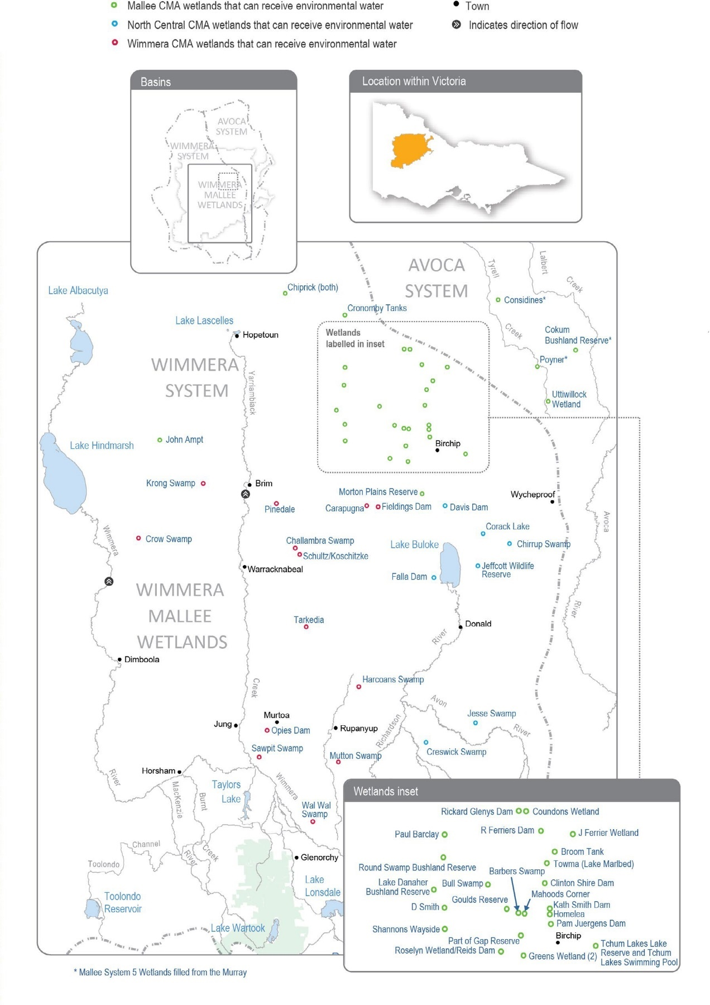
Return to start of section
Environmental values
There are many wetland types in the Wimmera-Mallee wetlands system, including freshwater meadows, open freshwater lakes and freshwater marshes. This diversity provides various wetland habitats for plants and animals across the Wimmera- Mallee region. The wetlands also vary in size and support different vegetation communities. Some support native waterbird populations, including brolgas, egrets, blue-billed ducks, freckled ducks, Australian painted snipes and glossy ibis. The vulnerable growling grass frog, turtles and many other native animals may use the wetlands as drought refuges and drinking holes. Rare and vulnerable vegetation species (such as spiny lignum, ridged water-milfoil, chariot wheels and cane grass) are also present in some wetlands.

Environmental objectives in the Wimmera-Mallee wetlands
Maintain populations of frogs
Maintain populations of turtles
Provide watering holes for native animals and terrestrial birds across the landscape
Maintain the condition of aquatic and fringing plants, including lignum, river red gum and black box communities Improve the diversity of wetland vegetation communities
Maintain populations of waterbirds and other native birds by providing resting, feeding and breeding habitat

Traditional Owner cultural values and uses
Spanning a broad geographic area, several Wimmera-Mallee wetlands show indications of the longstanding cultural heritage and importance of these sites to the Traditional Owners of the region, including but not limited to Barapa Barapa Traditional Owners and other Traditional Owner groups represented by the Barengi Gadjin Land Council and the Dja Dja Wurrung Clans Aboriginal Corporation (trading as Djaara). Some sites have artefacts and scar trees recorded in or adjacent to them, and further cultural surveys could better inform the management of water for the environment at those sites.
The Barengi Gadjin Land Council is the Registered Aboriginal Party for a significant land area of the Wimmera-Mallee wetlands. The Barengi Gadjin Land Council represents the Wotjobaluk, Jaadwa, Jadawadjali, Wergaia and Jupagalk peoples.
In recent years, the Barengi Gadjin Land Council Aboriginal Water Officers and the Wimmera CMA have undertaken monitoring at Sawpit Swamp Wildlife Reserve, Wal Wal Swamp Wildlife Reserve, Carapugna (Watchem Bushland Reserve) and Mutton Swamp Wildlife Reserve, helping to understand environmental flow deliveries and values at the sites.
The Barengi Gadjin Land Council and the North Central CMA have discussed opportunities for projects that facilitate reconnection with and healing of Country. Recent meetings have highlighted several areas where collaboration is possible including on-Country events and revegetation projects. In May 2022, the Barengi Gadjin Land Council and the North Central CMA undertook a cultural values assessment at Creswick Swamp. Cultural values identified at the site include river red gums and eastern grey kangaroos. Environmental water management at Creswick Swamp supports a local population of eastern grey kangaroos. Prints left in the mud nearby suggest regular visitation.
The Barengi Gadjin Land Council has discussed the significance of the wetlands and their aspiration to undertake work at these sites in future and provided the following statement to the Mallee CMA when discussing environmental watering:
“The Wimmera-Mallee is living cultural landscape and there is a lack of recorded data regarding the cultural values over many sections of the Wimmera-Mallee Pipeline. Several highly significant places are outlined through our Country Plan, but like all places across our Country, the rivers, creeks, lakes, wetlands and swamps, and all other landscape features in this area are of high cultural significance. We wish to care for Country again through our traditional land management
practices and revive and share the ancient narrative of this area. Mapping the cultural values of places along the Wimmera- Mallee Pipeline will be essential in contributing to integrated catchment management.
“We are unable to identify places of particular cultural values and uses confidently until Aboriginal Water Assessment/ Cultural Heritage Surveys are systematically undertaken across Wimmera-Mallee Pipeline sites. All the swamps, wetlands and soaks of this area are of high cultural significance as they are linked to Traditional trading routes that extend in all directions. It is essential that all of these places are managed correctly and water quality and biodiversity are improved.”
Return to start of section

Social, recreational and economic values and uses
In planning the potential environmental watering actions in Table 4.4.1, the Mallee, North Central and Wimmera CMAs considered how environmental flows could support values and uses, including:
- water-based recreation (such as fishing, swimming and yabbying)
- riverside recreation and amenity (such as birdwatching, duck and quail hunting, photography, camping, picnicking and walking)
- community events and tourism (such as orienteering and citizen science, including collecting data about bird species and abundance, frog species and microbat recordings).

Scope of environmental watering
The term ‘environmental watering’ refers to the active delivery of held environmental water to support particular environmental objectives by altering the flow in a river or the water level in a wetland. While other terms are sometimes used to describe the delivery of environmental water, ‘environmental watering’ is deliberately used here and in seasonal watering statements to ensure consistency in the legal instruments that authorise the use of water for the environment in Victoria.
Table 4.4.1 describes the potential environmental watering actions in 2023-24, their expected watering effect (that is, the intended physical or biological effects of the watering action) and the longer-term environmental objectives they support. Each environmental objective relies on one or more potential environmental watering actions and their associated physical or biological effects.
Delivery of water for the environment to the Wimmera-Mallee wetlands is impacted by a range of different constraints associated with delivery infrastructure, surrounding private land and competing demands on pipeline capacity. This means most sites don’t have a target wetting and drying cycle which shapes planning for most other wetlands in this plan. Instead, the expected watering effects outlined here describe the overall outcomes expected from watering multiple wetlands across each CMA region during 2023-24.
Some sites have a deep central dam that can provide a near-permanent water source for aquatic vegetation, frogs, waterbirds and turtles, as well as shallow marsh or floodplain woodland areas that are inundated when the dam overtops. In some circumstances, water for the environment may be used to overtop the central dams to support wetland vegetation and create additional foraging opportunities in the surrounding wetland/floodplain habitats.
Return to start of section

Table 4.4.1 Potential environmental watering actions, expected watering effects and associated environmental objectives for the Wimmera-Mallee wetlands

Potential environmental watering action | Expected watering effects | Environmental objectives
Mallee wetlands
Barbers Swamp | - Stimulate the growth of aquatic and fringing vegetation and allow the plants, including ridged water-milfoil, black box and spiny lignum, to complete their life cycles  - Provide a permanent water source for refuge and to support feeding and breeding opportunities for frogs, turtles, waterbirds and terrestrial species
Broom Tank
Bull Swamp
Chiprick
Clinton Shire Dam
Cokum Bushland Reserve
Considines
Coundons Wetland
Cronomby Tanks
D Smith Wetland
Goulds Reserve
Greens Wetland
Homelea
J Ferrier Wetland
John Ampt
Kath Smith Dam
Lake Danaher Bushland Reserve
Mahoods Corner
Morton Plains Reserve
Newer Swamp
Pam Juergens Dam
Part of Gap Reserve
Paul Barclay
Poyner
R Ferriers Dam
Rickard Glenys Dam
Roselyn Wetland
Shannons Wayside
Tchum Lake – dam (Tcham Lakes Lake Reserve)
Tchum Lake – wetland (Tcham Lakes Lake Reserve)
Uttiwillock Wetland

Potential environmental watering action | Expected watering effects | Environmental objectives
North Central wetlands
Chirrup Swamp | - Provide a permanent water source for refuge and to support feeding and breeding opportunities for frogs, waterbirds and turtles  - Maintain varying depths of water to support aquatic and fringing plants’ life cycles  - Maintain varying depths of water to support a variety of feeding habitats for waterbirds  - Maintain water levels to prolong wetting and ensure successful waterbird breeding events, if they start  - Wet black box and rare cane grass to allow plants to complete their life cycles and support juvenile plants  - Maintain varying depths of water to support the life cycles of aquatic and fringing plants
Corack Lake
Creswick Swamp
Davis Dam
Falla Dam
Jeffcott Wildlife Reserve
Jesse Swamp
Wimmera wetlands
Carapugna | - Provide a permanent water source for refuge and to support feeding and breeding opportunities for frogs, turtles, waterbirds and terrestrial species  - Stimulate the growth of aquatic and fringing vegetation and allow the plants, including chariot wheels, sneezeweed, ridged water-milfoil and spiny lignum, to complete their life cycles
Challambra Swamp
Crow Swamp
Fieldings Dam
Harcoans Swamp
Krong Swamp
Mutton Swamp
Opies Dam
Pinedale
Sawpit Swamp
Schultz/Koschitzke
Tarkedia Dam
Wal Wal Swamp

Scenario planning
Table 4.4.2 outlines potential environmental watering and expected water use in a range of planning scenarios.
Wet conditions in 2022-23 meant many of the Wimmera-Mallee wetlands filled from local catchment run-off. Wetlands that did not reach their target level were topped up with environmental water in autumn 2023, so most of the Wimmera-Mallee wetlands are expected to start 2023-24 with moderate-to-high water levels.
The wetlands proposed to be watered under each planning scenario in 2023-24 were determined according to the following principles. Under drought conditions, the highest priority is to maintain permanent water in the deeper sections of the wetlands to provide drought refuge for waterbirds, frogs, turtles and terrestrial animals and to support the growth and life cycles of wetland plants. Under wetter planning scenarios, water for the environment may be delivered, depending on pipeline system capacity, to water larger areas of a wetland. Large rainfall events and catchment inflows may partially or completely fill some wetlands in the average and wet planning scenarios, and water for the environment may be used in those cases to top up,
fill or overtop wetlands to improve fringing wetland plant communities and provide additional habitat for waterbirds, frogs and turtles.
Goulds Reserve, Homelea, part of Gap Reserve (Stephen Smith Dam), Round Swamp Bushland Reserve (Marlbed Lake Swamp/Newer Swamp), Shannons Wayside and Towma (Lake Marlbed) all received significant inflow during 2022-23, and most spilled into surrounding wetland areas. These sites are all expected to hold water through winter/spring 2023-24 and will not be actively watered in any planning scenario to allow them to draw down and dry through the remainder of the year.
Return to start of section

Chiprick Bushland Reserve, Tchum Lake – dam (Tcham Lakes Lake Reserve) and Tchum Lake – Wetland (Tcham Lakes Lake Reserve) will potentially be topped up under the dry-to-wet planning scenarios but are a low priority for watering in the drought planning scenario because they generally dry up quickly under very hot and dry conditions and are not considered important drought refuges. Krong Swamp is also considered a poor drought refuge and will only potentially be watered in the wet planning scenario.
The high water levels in many wetlands at the start of the year and high environmental water allocations will provide an opportunity to overtop some of the Wimmera-Mallee wetlands to improve the condition of surrounding wetland vegetation communities and provide additional feeding and breeding opportunities for frogs and possibly waterbirds. Overtopping flows may be provided at 12 wetlands in all planning scenarios to consolidate the environmental benefits of recent wet conditions. If sufficient environmental water is available, another 12 wetlands will be overtopped in the average and wet planning scenarios.
Allocations to the environmental entitlement that supplies the wetlands in the Wimmera-Mallee wetland system are highly variable, and the ability to carry over unused water from one year to another allows waterway managers and the VEWH to effectively manage the system in dry periods. Experience shows that high allocations in wet years (such as 2022-23) are needed to support watering actions for multiple years if there is a return to dry conditions. The forecast carryover volume at the end of 2022-23 will help to meet expected demands across the Wimmera-Mallee wetlands for at least the next two to three years in all planning scenarios. The North Central, Mallee and Wimmera CMAs and the VEWH will monitor climatic conditions and seasonal allocation outlooks during 2023-24 to inform a carryover target in the Wimmera-Mallee wetland system for 2024- 25.
Table 4.4.2 Potential environmental watering for the Wimmera-Mallee wetland system in a range of planning scenarios

Planning scenario | Drought | Dry | Average | Wet
Predicted supply of water for the environment | - 1,145 ML | - 1,145 ML | - 1,395 ML | - 2,145 ML
Potential environmental watering –  tier 1 (high priorities) | - Barbers Swamp  - Bull Swamp  - Broom Tank  - Carapugna (Watchem Bushland Reserve)  - Challambra Swamp*  - Chirrup Dam*  - Clinton Shire Dam  - Cokum Bushland Reserve  - Considines  - Corack Lake  - Coundons Wetland  - Creswick Swamp  - Cronomby Tanks  - Crow Swamp*  - D Smith Wetland  - Davis Dam*  - Falla Dam  - Fieldings Dam  - Greens Wetland  - Harcoans Swamp (Burrereo Bushland Reserve)*  - J Ferrier Wetland  - Jeffcott Wildlife Reserve | - Barbers Swamp  - Bull Swamp  - Broom Tank  - Carapugna (Watchem Bushland Reserve)  - Challambra Swamp*  - Chirrup Dam*  - Chiprick Bushland Reserve  - Clinton Shire Dam  - Cokum Bushland Reserve  - Considines  - Corack Lake  - Coundons Wetland  - Creswick Swamp  - Cronomby Tanks  - Crow Swamp*  - D Smith Wetland  - Davis Dam*  - Falla Dam  - Fieldings Dam  - Greens Wetland  - Harcoans Swamp (Burrereo Bushland Reserve)*  - J Ferrier Wetland | - Barbers Swamp*  - Bull Swamp*  - Broom Tank  - Carapugna (Watchem Bushland Reserve)  - Challambra Swamp*  - Chirrup Dam*  - Chiprick Bushland Reserve*  - Clinton Shire Dam  - Cokum Bushland Reserve*  - Considines  - Corack Lake  - Coundons Wetland*  - Creswick Swamp  - Cronomby Tanks  - Crow Swamp*  - D Smith Wetland  - Davis Dam*  - Falla Dam  - Fieldings Dam  - Greens Wetland  - Harcoans Swamp (Burrereo Bushland Reserve)*  - J Ferrier Wetland* | - Barbers Swamp*  - Bull Swamp*  - Broom Tank  - Carapugna (Watchem Bushland Reserve)  - Challambra Swamp*  - Chirrup Dam*  - Chiprick Bushland Reserve*  - Clinton Shire Dam*  - Cokum Bushland Reserve*  - Considines  - Corack Lake  - Coundons Wetland*  - Creswick Swamp  - Cronomby Tanks  - Crow Swamp*  - D Smith Wetland  - Davis Dam*  - Falla Dam  - Fieldings Dam  - Greens Wetland*  - Harcoans Swamp (Burrereo Bushland Reserve)*  - J Ferrier Wetland*

Planning scenario | Drought | Dry | Average | Wet
Potential environmental watering –  tier 1 (high priorities) | - Jesse Swamp*  - John Ampt (House Dam)  - Kath Smith Dam  - Lake Danaher Bushland Reserve  - Mahoods Corner  - Morton Plains Reserve  - Mutton Swamp*  - Opies Dam  - Pam Juergens Dam  - Paul Barclay  - Pinedale*  - Poyner  - R Ferriers Dam  - Rickard Glenys Dam  - Roselyn Wetland/ Reids Dam  - Sawpit Swamp*  - Schultz/Koschitzke*  - Tarkedia Dam*  - Uttiwillock Wetland  - Wal Wal Swamp* | - Jeffcott Wildlife Reserve  - Jesse Swamp*  - John Ampt (House Dam)  - Kath Smith Dam  - Lake Danaher Bushland Reserve  - Mahoods Corner  - Morton Plains Reserve  - Mutton Swamp*  - Opies Dam  - Pam Juergens Dam  - Paul Barclay  - Pinedale*  - Poyner  - R Ferriers Dam  - Rickard Glenys Dam  - Roselyn Wetland/ Reids Dam  - Sawpit Swamp*  - Schultz/Koschitzke*  - Tarkedia Dam*  - Tchum Lake – dam (Tcham Lakes Lake Reserve)  - Tchum Lake – wetland (Tcham Lakes Lake Reserve)  - Uttiwillock Wetland  - Wal Wal Swamp* | - Jeffcott Wildlife Reserve  - Jesse Swamp*  - John Ampt (House Dam)  - Kath Smith Dam  - Lake Danaher Bushland Reserve  - Mahoods Corner  - Morton Plains Reserve*  - Mutton Swamp*  - Opies Dam  - Pam Juergens Dam  - Paul Barclay  - Pinedale*  - Poyner  - R Ferriers Dam  - Rickard Glenys Dam  - Roselyn Wetland/ Reids Dam*  - Sawpit Swamp*  - Schultz/Koschitzke*  - Tarkedia Dam*  - Tchum Lake – dam (Tcham Lakes Lake Reserve)  - Tchum Lake – wetland (Tcham Lakes Lake Reserve)*  - Uttiwillock Wetland*  - Wal Wal Swamp* | - Jeffcott Wildlife Reserve  - Jesse Swamp*  - John Ampt (House Dam)  - Kath Smith Dam  - Krong Swamp*  - Lake Danaher Bushland Reserve  - Mahoods Corner  - Morton Plains Reserve*  - Mutton Swamp*  - Opies Dam  - Pam Juergens Dam  - Paul Barclay*  - Pinedale*  - Poyner*  - R Ferriers Dam*  - Rickard Glenys Dam  - Roselyn Wetland/ Reids Dam*  - Sawpit Swamp*  - Schultz/Koschitzke*  - Tarkedia Dam*  - Tchum Lake – dam (Tcham Lakes Lake Reserve)*  - Tchum Lake – wetland (Tcham Lakes Lake Reserve)*  - Uttiwillock Wetland*  - Wal Wal Swamp*
Possible volume of water for the environment required  to achieve objectives | - 159 ML | - 235 ML | - 301 ML | - 399 ML
* Delivery to the site is expected to provide temporary, shallow inundation of at least part of the surrounding wetland or floodplain.
Return to start of section

Section 5
Northern region

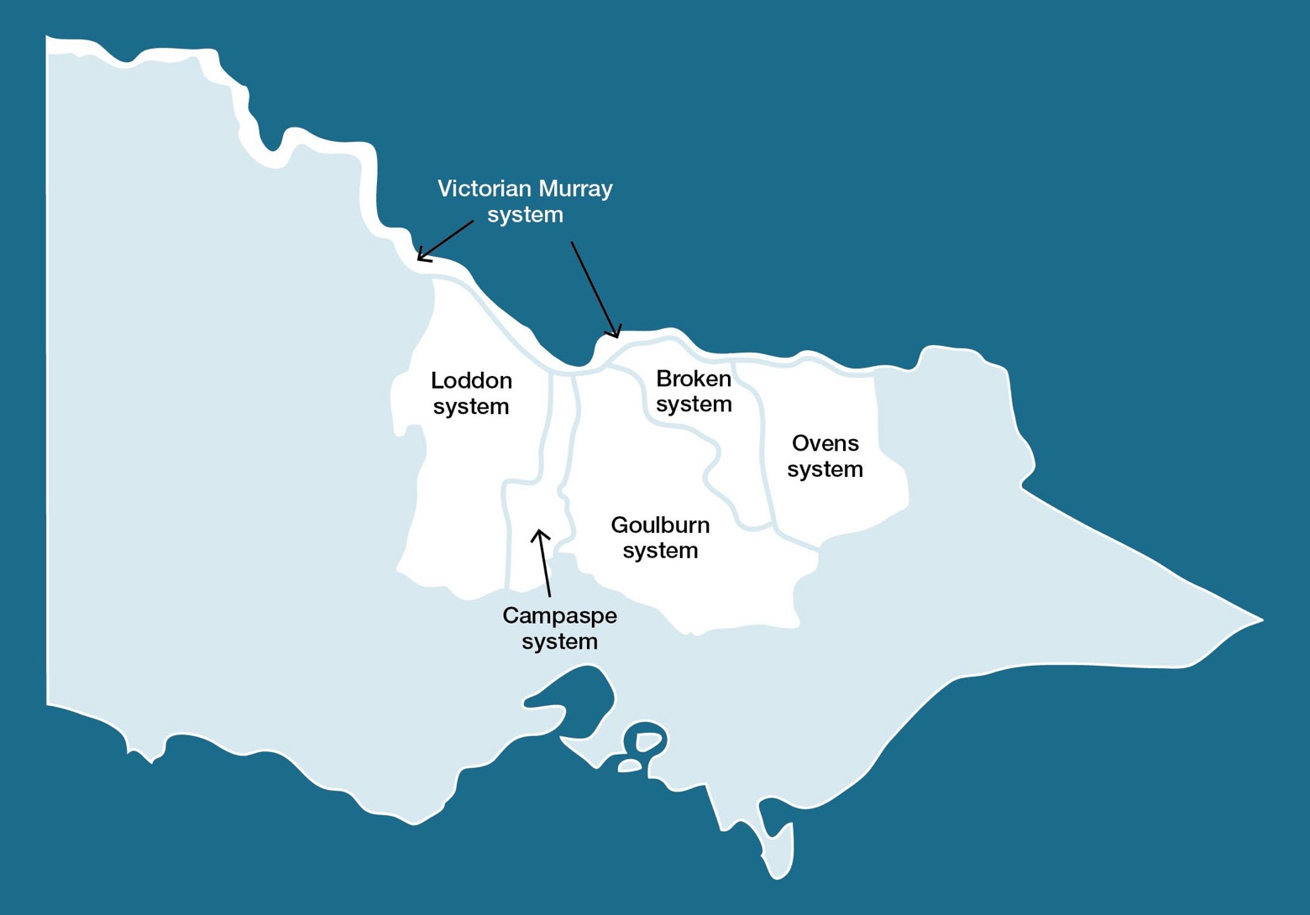

  - Northern region overview 148
  - Victorian Murray system 160
    - Upper Murray wetlands 161
    - Barmah Forest 164
    - Gunbower Creek and Forest 170
    - Central Murray wetlands 179
    - Hattah Lakes 186
    - Lower Murray wetlands 191
    - Lindsay, Mulcra and Wallpolla islands 195
  - Ovens system 203
  - Goulburn system 209
    - Goulburn River 209
    - Goulburn wetlands 216
  - Broken system 221
    - Broken River and upper Broken Creek 221
    - Lower Broken Creek 227
    - Broken wetlands 231
  - Campaspe system 234
    - Campaspe River 234
    - Coliban River 240
  - Loddon system 244
    - Loddon River system (including Tullaroop, Serpentine and Pyramid creeks) 244
    - Boort wetlands 255
    - Birchs Creek 258

Northern region overview
The northern region has six river systems, four major floodplain sites and many wetlands that can receive water for the environment. The Broken, Campaspe, Goulburn, Loddon and Ovens river systems are tributaries of the Murray River. The four major floodplain sites along the Murray River corridor are Barmah Forest, Gunbower Forest, Hattah Lakes and Lindsay, Mulcra and Wallpolla islands. The other wetlands are distributed across the Broken, Goulburn, Loddon and Murray floodplains. The Goulburn Broken, Mallee, North Central and North East CMAs manage the rivers and wetlands in the northern region.
Many of the water systems in the northern region are connected through infrastructure (such as Goulburn Weir and the Waranga Western Channel), which allows water to be physically delivered from the Goulburn River to the Loddon and Campaspe systems. Water trading also enables transfers of allocation between systems. Within the limitations of each mechanism, water for the environment can be moved between systems for delivery to environmental sites across northern Victoria, although most water for the environment is used to provide benefits in the systems in which the water is held.
Environmental values, objectives and planned actions for each system in the northern region are presented in the following system sections.

Traditional Owners in the northern region
Traditional Owners and their Nations in the northern region have a deep connection to Country that has endured for tens of thousands of years. This includes inherent rights and cultural obligations to Country and community.
The Traditional Owner groups in and around northern Victoria include Barapa Barapa, Bangerang, Dja Dja Wurrung, Duduroa, Dhudhuroa, Latji Latji, Ngintait, Nyeri Nyeri, Taungurung, Tati Tati, Wadi Wadi, Wamba Wemba, Waywurru, Weki Weki, Yorta Yorta and Yaithmathang. The Dja Dja Wurrung Clans Aboriginal Corporation (trading as Djaara), First People of the Millewa- Mallee Aboriginal Corporation (representing Latji Latji and Ngintait), Taungurung Land and Waters Council and Yorta Yorta Nation Aboriginal Corporation are Registered Aboriginal Parties under the Victorian Aboriginal Heritage Act 2006.
Several formal agreements are in place with Traditional Owners in the northern region.

In 2013, Djaara entered into a recognition and settlement agreement under the Traditional Owner Settlement Act 2010 in Victoria. In 2020, the Victorian Government and the Taungurung Land and Waters Council Aboriginal Corporation entered a recognition and settlement agreement (signed in 2018) under the Traditional Owner Settlement Act 2010.
In 2004, the Victorian Government entered into a cooperative management agreement with the Yorta Yorta Nation Aboriginal Corporation to improve collaboration in the management of Yorta Yorta Country, including Barmah State Forest and reserves along the Goulburn River. In 2010, the Traditional Owner Land Management Agreement under the Conservation, Forests and Lands Act 1987 over Barmah National Park was signed, enabling the Yorta Yorta Traditional Owner Land Management Board to jointly manage Barmah National Park. In 2020, the Joint Management Plan for Barmah National Park, prepared by the Yorta Yorta Traditional Owner Land Management Board, was publicly released. The plan guides the strategic management of Barmah National Park to 2030.
The Victorian Government is committed to self-determination for Traditional Owners through Treaty negotiations and policies such as Water is Life: Traditional Owner Access to Water Roadmap 2022. The VEWH and partners are working with Traditional Owners to embed the outcomes of government policy into the Victorian environmental watering program. Program partners
in the environmental watering program are aware that structural changes to how water is managed (such as legislative, policy and/or governance changes) may be made in the future in recognition of Aboriginal water rights. Program partners have heard that Traditional Owners want empowerment and agency in water management, and in many cases, they want to manage water on Country on their own terms.
Return to start of section

Engagement
The environmental watering program is informed by engagement with Traditional Owners, stakeholders and local communities. Program partners undertake extensive engagement at the local level to understand community priorities for the delivery of water for the environment for the coming year.
Program partners also seek to understand how cultural, social, economic and recreational values, uses and objectives may be supported by delivering environmental flows. Opportunities to support these values, uses and objectives are incorporated into watering decisions where possible, and provided they do not compromise environmental outcomes. Cultural, social, economic and recreational values considered for each system in the northern region are presented in the following system sections.
Engagement through other strategies, plans and processes also informs environmental flows objectives. These include regional catchment strategies, regional waterway strategies and technical studies (such as environmental flows studies and environmental water management plans). Traditional Owner cultural objectives for environmental water may refer to cultural flow studies, Aboriginal Waterway Assessments, Traditional Owner Country Plans, Water Resource Plans and other tools to influence environmental water planning. These strategies, plans and technical reports collectively describe a range of environmental, economic, social and Traditional Owner perspectives and longer-term integrated catchment and waterway management objectives that influence environmental flows and priorities for water for the environment.
Return to start of section

Table 5.1.1 Partners and stakeholders engaged by Goulburn Broken Catchment Management Authority in developing seasonal watering proposals for the Barmah Forest, Goulburn River, Goulburn wetlands and Broken wetlands, Broken River and upper Broken Creek and lower Broken Creek systems and other key foundation documents that have directly informed the proposals (grouped in alphabetical order)

Partner/stakeholder | Barmah Forest | Goulburn system | Goulburn wetlands | Broken wetlands | Broken River and upper Broken Creek | Lower Broken Creek
Community groups and environment groups | - Goulburn Broken Wetland Advisory Group members | - Goulburn Valley Environment Group | - Goulburn Murray Landcare Network  - Goulburn Valley Environment Group  - Turtles Australia | - Goulburn Murray Landcare Network  - Goulburn Valley Environment Group  - Turtles Australia | - Goulburn Valley Environment Group | - Goulburn Valley Environment Group  - Broken Boosey Conservation Management Network  - Broken Creek Field Naturalists Club  - Goulburn Murray Landcare Network
Government agencies | - Commonwealth Environmental Water Office  - Goulburn-Murray Water  - Moira Shire Council  - Parks Victoria  - Victorian Environmental Water Holder | - Commonwealth Environmental Water Office  - Goulburn-Murray Water  - Murray-Darling Basin Authority  - Parks Victoria  - Victorian Environmental Water Holder | - Department of Energy, Environment and Climate Action  - Goulburn-Murray Water  - Greater Shepparton City Council  - Parks Victoria  - Victorian Environmental Water Holder | - Department of Energy, Environment and Climate Action  - Goulburn-Murray Water  - Greater Shepparton City Council  - Moira Shire Council  - Parks Victoria  - Victorian Environmental Water Holder | - Commonwealth Environmental Water Office  - Goulburn-Murray Water  - Parks Victoria  - Victorian Environmental Water Holder | - Commonwealth Environmental Water Office  - Goulburn-Murray Water  - Moira Shire Council  - Parks Victoria  - Victorian Environmental Water Holder
Landholders/farmers | - None in Victoria (NSW consults with Bullatale Creek landholders) | - Goulburn Environmental Water Advisory Group | - Landowners who adjoin wetlands that receive water for the environment and/  or use the delivery channel | - Landowners who adjoin wetlands that receive water for the environment and/  or use the delivery channel | - Individual landholders who are on the Broken  Environmental Water Advisory Group | - Individual landholders who are on the Broken  Environmental Water Advisory Group
Local businesses |  | - Local ecotourism operator  - Trellys Fishing and Hunting | - Trellys Fishing and Hunting | - Trellys Fishing and Hunting

Partner/stakeholder | Barmah Forest | Goulburn system | Goulburn wetlands | Broken wetlands | Broken River and upper Broken Creek | Lower Broken Creek
Recreational users | - Goulburn Broken Wetland Advisory Group members |  | - Field & Game Australia  - Local fishing clubs | - Field & Game Australia  - Individual community members on  the Broken Environmental Water Advisory Group  - Local fishing clubs | - Individual community members on  the Broken Environmental Water Advisory Group | - Individual community members on  the Broken Environmental Water Advisory Group  - Nathalia Angling Club  - Numurkah Fishing Club
Technical experts |  | - Goulburn to Murray Trade Review Scientific Advisory Panel  - Scientific leads from the CEWO Monitoring, Evaluation and  Research Program – Goulburn River | - Arthur Rylah Institute  - Rakali Consulting  - Water’s Edge Consulting | - Arthur Rylah Institute  - Rakali Consulting  - Water’s Edge Consulting
Traditional Owners | - Yorta Yorta Nation Aboriginal Corporation | - Taungurung Land and Waters Council  - Yorta Yorta Nation Aboriginal Corporation | - Taungurung Land and Waters Council  - Yorta Yorta Nation Aboriginal Corporation | - Yorta Yorta Nation Aboriginal Corporation | - Taungurung Land and Waters Council  - Yorta Yorta Nation Aboriginal Corporation | - Taungurung Land and Waters Council  - Yorta Yorta Nation Aboriginal Corporation
Return to start of section

Table 5.1.2 Partners and stakeholders engaged by Mallee Catchment Management Authority in developing seasonal watering proposals for the Hattah Lakes, Lower Murray wetlands and Lindsay, Mulcra and Wallpolla islands systems and other key foundation documents that have directly informed the proposals (grouped in alphabetical order)

Partner/stakeholder | Hattah Lakes | Lower Murray wetlands | Lindsay, Mulcra and Wallpolla islands
Community groups and environment groups | - Mallee CMA Land and Water Advisory Committee  - OzFish Unlimited  - Wider community | - Mallee CMA Land and Water Advisory Committee  - Millewa-Carwarp Landcare Group  - OzFish Unlimited  - Red Cliffs Landcare Group  - Wider community  - Yelta Landcare Group | - Mallee CMA Land and Water Advisory Committee  - Millewa-Carwarp Landcare Group  - OzFish Unlimited  - Wider community  - Yelta Landcare Group
Government agencies | - Commonwealth Environmental Water Office  - Department of Energy, Environment and Climate Action  - Goulburn-Murray Water  - Lower Murray Water  - Victorian Murray Floodplain Restoration Project Team  - Mildura Rural City Council  - Murray-Darling Basin Authority  - Parks Victoria  - Victorian Environmental Water Holder | - Department of Energy, Environment and Climate Action  - Lower Murray Water  - Mildura Rural City Council  - NSW Department of Planning, Industry and Environment  - Parks Victoria  - Swan Hill Rural City Council  - Victorian Environmental Water Holder  - Victorian Murray Floodplain Restoration Project Team | - Commonwealth Environmental Water Office  - Department of Energy, Environment and Climate Action  - Lower Murray Water – Victorian Murray  Floodplain Restoration Project Team  - Mildura Rural City Council  - Murray-Darling Basin Authority  - NSW Department of Planning, Industry and Environment  - Parks Victoria  - SA Water  - Victorian Environmental Water Holder
Landholders/farmers | - Landholders and farmers who live around the Hattah Lakes | - Robertson Wetland property owner
Local businesses | - Hattah Lakes Store  - Mallee Tours  - Mildura Visitor Information and Booking Centre  - Murray Offroad Adventures  - Victorian Apiarists’ Association (Sunraysia branch)  - Visit Mildura  - Wildside Outdoors | - Mallee Tours  - Mildura Visitor Information and Booking Centre  - Murray Offroad Adventures  - Victorian Apiarists’ Association (Sunraysia branch)  - Visit Mildura  - Wildside Outdoors | - Lake Cullulleraine Store  - Mallee Tours  - Mildura Visitor Information and Booking Centre  - Murray Offroad Adventures  - Victorian Apiarists’ Association (Sunraysia branch)  - Visit Mildura  - Wildside Outdoors

Partner/stakeholder | Hattah Lakes | Lower Murray wetlands | Lindsay, Mulcra and Wallpolla islands
Recreational users | - BirdLife Mildura  - Mildura 4WD Club  - Sunraysia Bushwalkers Inc. | - BirdLife Mildura  - Cabarita Community Inc.  - Friends of Merbein Common  - Mid-Murray Field Naturalists  - Mildura 4WD club  - Sunraysia Bushwalkers Inc. | - BirdLife Mildura  - Mildura 4WD Club  - Sunraysia Bushwalkers Inc.
Traditional Owners | - See the ‘Traditional Owner cultural values and uses’ section | - See the ‘Traditional Owner cultural values and uses’ section | - First People of the Millewa-Mallee Aboriginal Corporation  - Local Aboriginal community
Return to start of section

Table 5.1.3 Partners and stakeholders engaged by North Central Catchment Management Authority in developing seasonal watering proposals for the Gunbower Creek and Forest, central Murray wetlands and Boort wetlands, Campaspe River, Coliban River, Loddon River, Birchs Creek and Guttrum Forest systems and other key foundation documents that have directly informed the proposals (grouped in alphabetical order)

Partner/ stakeholder | Gunbower Creek and Forest | Central Murray wetlands | Campaspe system | Coliban River | Loddon system (including Boort wetlands) | Birchs Creek | Guttrum Forest
Community groups and environment groups |  | - Birdlife Australia  - Turtles Australia | - Ashbourne Landcare  - Echuca Moama Landcare Group  - Landcare groups  - Strathallan Family Landcare | - Malmsbury and District Landcare Group | - Birdlife Australia  - Turtles Australia | - Tullaroop Catchment Restoration Project | - Birdlife Australia  - Turtles Australia
Government agencies | - Campaspe Shire Council  - Commonwealth Environmental Water Office  - Department of Energy,  Environment and Climate Action  - Forestry Corporation of NSW  - Forestry NSW  - Gannawarra Shire Council  - Goulburn-Murray Water  - Murray-Darling Basin Authority  - Parks Victoria  - VicForests | - Commonwealth Environmental Water Office  - Department of Energy,  Environment and Climate Action  - Goulburn-Murray Water  - Parks Victoria  - Victorian Environmental Water Holder | - Commonwealth Environmental Water Office  - Department of Energy,  Environment and Climate Action  - Goulburn-Murray Water  - Victorian Environmental Water Holder | - Coliban Water  - Commonwealth Environmental Water Office  - Department of Energy,  Environment and Climate Action  - Victorian Environmental Water Holder | - Commonwealth Environmental Water Office  - Department of Energy,  Environment and Climate Action  - Goulburn-Murray Water  - Parks Victoria  - Victorian Environmental Water Holder | - Department of Energy,  Environment and Climate Action  - Goulburn-Murray Water  - Parks Victoria  - Victorian Environmental Water Holder | - Commonwealth Environmental Water Office  - Department of Energy,  Environment and Climate  - Goulburn-Murray Water  - Parks Victoria  - Victorian Environmental Water Holder

Partner/ stakeholder | Gunbower Creek and Forest | Central Murray wetlands | Campaspe system | Coliban River | Loddon system (including Boort wetlands) | Birchs Creek | Guttrum Forest
Landholders/ farmers | - Dairy farmers, irrigators and local residents including via the Enhancing Northern Waterways Advisory Group | - Individual landholders and community members | - Individual landholders and community members including via the Campaspe Environmental Water Advisory Group | - Coliban Water’s Rural Advisory Group  - Individual landholders and community members | - Individual landholders and community members including via the Loddon Environmental Water Advisory Group | - Individual landholders and community members | - Individual landholders and community members
Recreational users | - Field & Game Australia | - Field & Game Australia | - Field & Game Australia  - Local canoe clubs  - VRFish | - VRFish | - Boort Angling Club  - Field & Game Australia | - VRFish | - Field & Game Australia
Technical experts | - Environmental chemists  - Vegetation, fish and bird ecologists |  | - Arthur Rylah Institute
Traditional Owners | - Barapa Barapa Traditional Owners  - Yorta Yorta Nation Aboriginal Corporation | - Barapa Barapa Traditional Owners  - Wamba Wemba Traditional Owners  - Yorta Yorta Nation Aboriginal Corporation | - Dja Dja Wurrung Clans Aboriginal Corporation  - Taungurung Land and Waters Council  - Yorta Yorta Nation Aboriginal Corporation | - Dja Dja Wurrung Clans Aboriginal Corporation | - Barapa Barapa Traditional Owners  - Dja Dja Wurrung Clans Aboriginal Corporation’s Kapa Gatjin (water advisory) Group  - Wamba Wemba Traditional Owners | - Dja Dja Wurrung Clans Aboriginal Corporation’s Kapa Gatjin (water advisory) Group | - Barapa Barapa Traditional Owners  - Wamba Wemba Traditional Owners  - Yorta Yorta Nation Aboriginal Corporation
Return to start of section

Table 5.1.4 Partners and stakeholders engaged by North East Catchment Management Authority in developing the seasonal watering proposal for the Ovens system and other key foundation documents that have directly informed the proposal (grouped in alphabetical order)

Partner/stakeholder | Ovens system
Community groups and environment groups | - Mullinmur Management Committee  - Wangaratta Landcare and Sustainability Incorporated
Government agencies | - Commonwealth Environmental Water Office  - Goulburn-Murray Water  - Rural City of Wangaratta  - Victorian Environmental Water Holder  - Victorian Fisheries Authority
Landholders/farmers | - Borinya Community Partnership School  - Galen Catholic College  - A private landholder on the King River
Technical experts | - Arthur Rylah Institute
Traditional Owners | - Non-RAP groups  - Taungurung Land and Waters Council  - Yorta Yorta Nation Aboriginal Corporation
Integrated catchment management
Altered water regimes are one of many threats to the health of Victoria’s waterways. Environmental flows need to be part of an integrated approach to catchment management to be effective. Many of the environmental objectives of water for the environment in the northern region will not be fully met without simultaneously addressing issues such as barriers to fish movement, high nutrient loads, loss of streambank vegetation, bank erosion and invasive species.
Victorian and Australian government agencies, Traditional Owner groups, community groups and private landholders collectively implement a wide range of programs that aim to protect and improve the environmental condition and function of land, soils and waterways throughout Victoria’s catchments.
The following are examples of complementary programs that support environmental flow outcomes in the northern region.
A strategic action plan to protect floodplain marshes in Barmah Forest is being implemented. The plan identifies management actions to address key threats to the delicate floodplain vegetation. Specific actions include removing feral horses and other invasive animals and controlling invasive plants. Parks Victoria and the Yorta Yorta Nations jointly manage Barmah National Park.
Implementation of the native fish recovery plan for the North Central CMA region continues to progress, with the construction of a fishway on Taylors Creek Weir, just north of Ghow (Kow) Swamp. The fishway is another important element of a fish ‘superhighway’, which will allow native fish to migrate up and down rivers in the region, supporting diverse and healthy populations. This follows on from other recent projects, including the construction of fishways at Koondrook and Cohuna weirs in Gunbower Creek in 2021 and fish screens installed in Gunbower Creek to reduce the number of native fish lost to irrigation channels.
An additional 270 km of native fish habitat and refuge was opened up to native fish in the Ovens River with the construction of the Tea Garden Weir fishway in April 2023.
Multiple approaches, including planting native aquatic plants and reintroducing woody habitat (such as snags) in lower Broken Creek, are helping accelerate the recovery of in-stream vegetation, which provides shelter and foraging habitat for native fish, platypus and other aquatic animals. The creek may also be restocked with native fish following the November 2022 blackwater fish death event.
For more information about integrated catchment management programs in the northern region, see the Goulburn Broken, Mallee, North Central and North East CMAs’ regional catchment strategies and regional waterway strategies.
Risk management
During the development of the seasonal watering proposals for the northern region systems, environmental watering program partners assessed risks associated with potential environmental flows for 2023-24 and identified appropriate mitigating strategies. Risks and mitigating actions are continually assessed by program partners throughout the year (see subsection 1.2.7).
Return to start of section

What is the Basin Plan 2012?
Northern Victoria is a part of the Murray-Darling Basin, and deliveries of water for the environment in the northern region are subject to the requirements of the Basin Plan 2012, also known as the Murray-Darling Basin Plan or just the Basin Plan.
The Murray-Darling Basin Authority developed the Basin Plan under the Commonwealth Water Act 2007, and it became law in November 2012. The Basin Plan sets legal limits on the amount of water that can be taken from the Murray-Darling Basin’s surface and groundwater resources. Chapter 8 of the Basin Plan sets out a high-level environmental watering plan, which defines environmental objectives to protect, restore and build the resilience of water-dependent ecosystems and their associated functions. The VEWH’s environmental planning and delivery are consistent with the requirements of the Basin
Plan. The potential environmental flows outlined in sections 4 and 5 of this seasonal watering plan fulfil Victoria’s obligations to identify annual priorities for the delivery of water for the environment for Victoria’s water resource areas under section
8.26 of the Basin Plan 2012.
What is River Murray Increased Flows (RMIF)?
River Murray Increased Flows (RMIF) is water for the environment that has been recovered as part of the Snowy Water Initiative, established in 2002 to address environmental impacts associated with the operation of the Snowy Mountains Scheme. RMIF is stored in Snowy Hydro Limited’s storages and released to maintain and improve environmental values in the Murray River. RMIF becomes available when:
- Snowy Hydro Limited releases more than its nominated annual release volume as part of its power-generation operations and/or
- managers of water for the environment request additional RMIF be made available when volumes in Murray River storages exceed specified limits.
The call for and use of RMIF are coordinated by the Southern Connected Basin Environmental Watering Committee, and they must be authorised by the VEWH and NSW Department of Planning and Environment.
What is River Murray Unregulated Flows (RMUF)?
River Murray Unregulated Flows (RMUF) is the remaining unregulated water in the Murray system once Victoria and New South Wales have exercised their rights to use unregulated flows. Unregulated flow events are formally declared by the Murray-Darling Basin Authority when there is more water in the river than is needed to meet demands or can be captured in storage at the time. The use of RMUF is coordinated by the Southern Connected Basin Environmental Watering Committee for environmental outcomes.
Northern Victoria and the southern Murray-Darling Basin
Rivers, creeks and floodplains in northern Victoria form part of the southern connected Murray-Darling Basin. Water flows directly from the Victorian rivers and floodplains into the Murray River, which means that environmental flows delivered in northern Victorian systems can achieve ecological objectives at multiple sites throughout the Murray-Darling Basin. For example, water for the environment delivered in the Goulburn River flows into the Murray River and can be managed to ensure it flows all the way to the Lower Lakes and Coorong in South Australia, providing environmental outcomes at Gunbower Forest, Hattah Lakes, Lindsay Island and the Chowilla floodplain along the way.
Planning
The Basin Plan 2012 and the Basin-wide environmental watering strategy (second edition, 2019) guide the long-term planning of water for the environment in the Murray-Darling Basin. Under the Basin Plan, environmental objectives are met by achieving outcomes for connectivity, native vegetation, waterbirds and native fish.
Objectives and outcomes under the Basin Plan reflect local site- and state-based objectives, though site-based objectives are often broader in scope and cover additional values (such as frogs, turtles, waterbugs and physical processes like sediment movement). Watering actions that support Basin Plan outcomes have significant benefits for many other species that rely on the surrounding landscape (such as squirrel gliders living along the lower Campaspe River or flocks of regent parrots moving into the Hattah Lakes floodplain after watering).
The VEWH coordinates its activities with other environmental water holders in northern Victoria, NSW and South Australia to achieve environmental outcomes at the southern connected Murray-Darling Basin scale. Collaborative planning focuses on how upstream and downstream objectives align and how the broader operation of the Murray River system can help
support environmental outcomes. The Murray Lower Darling River Indigenous Nations Statement on environmental water use (available at www.vewh.vic.gov.au) is important for understanding Traditional Owner objectives and desired outcomes.
Annual planning is documented in basin annual environmental watering priorities (by the Murray-Darling Basin Authority under the Basin Plan), in annual portfolio management plans (by the Commonwealth Environmental Water Office) and in the VEWH’s annual seasonal watering plan (this document). The Southern Connected Basin Environmental Watering Committee publishes its annual operational scenarios for environmental flow coordination in the Murray River. In Victoria, all water for the environment must be delivered in line with the VEWH’s seasonal watering plan, meaning coordination during annual planning is fundamental to successful basin-scale outcomes.
Return to start of section

Delivery coordination and monitoring
Environmental water holders in the Murray-Darling Basin are increasingly emphasising the coordination of water deliveries to achieve landscape-scale environmental outcomes. Examples include:
- delivering a winter fresh in the Goulburn River, which subsequently passed through to the Lower Lakes in South Australia and through the barrages to the Coorong to trigger upstream migration of fish (such as lamprey)
- delivering a spring flow from Hume Dam to support floodplain sites (such as Barmah-Millewa Forest) and the river channel from the mid-Murray to the lower Murray all the way to the Lower Lakes and Coorong in South Australia. This event carries carbon and nutrients from the floodplain to the river and transports them through the system, increasing food availability, helping native fish to move and breed and supporting native aquatic plants in the river channel.
To assess the effectiveness of landscape-scale responses to environmental flows, the Southern Connected Basin Environmental Watering Committee developed the River Murray Channel Monitoring Plan 2021-22 to 2025-26. The plan focuses on productivity and fish indicators to inform the management of environmental flows. This monitoring complements site-based monitoring programs across the Murray system.
Water holder partnerships and collaboration
The VEWH holds Victorian environmental entitlements for water recovered under interstate projects and agreements – Living Murray and RMIF entitlements – and these require coordinated decision-making about where they are used. The primary objective of Living Murray entitlements is to support Murray icon sites, which include the Barmah Forest, Gunbower Forest, Hattah Lakes and the Lindsay-Mulcra-Wallpolla islands in Victoria. RMIF also supports environmental objectives along the Murray system in Victoria, NSW and South Australia. The Southern Connected Basin Environmental Watering Committee recommends how the Living Murray allocation, RMIF and RMUF should be coordinated and used.
The VEWH partners with the Commonwealth Environmental Water Office to optimise the benefits of water for the environment held by the Commonwealth Environmental Water Holder (CEWH) and delivered in Victoria. Delivery of the Living Murray’s and the Commonwealth’s environmental Water Holdings to meet Victorian environmental flow objectives is included in relevant system sections in the following pages of this plan.
Water for the environment delivered through northern Victorian waterways can often be re-used to achieve further environmental benefits downstream. If return flows are not re-used at Victorian environmental sites, VEWH, the Living Murray and CEWH return flows continue to flow across the border to South Australia, where they will be used to provide environmental benefits along the Murray River and in the Coorong, Lower Lakes and Murray Mouth icon sites.
The VEWH may order, or authorise waterway managers to order, Living Murray and Commonwealth water for the environment for environmental outcomes at downstream (non-Victorian) sites. The VEWH may also order water for delivery in the Murray system to non-Victorian sites under river operating rules that help improve environmental outcomes while maintaining the reliability of entitlements for all water users. In previous years, this has included deliveries to the Murray from the lower Darling, orders for delivery from Lake Victoria and orders for delivery to the Murray River.

Murray system-scale planning and Traditional Owners in the southern Murray-Darling Basin
Environmental water holders consider the objectives and cultural values of First Nations in the Murray-Darling Basin, and they seek to support these values where possible. The health of the Murray-Darling Basin benefits from meaningful partnerships with Traditional Owners, and their involvement in water planning, coordination and delivery from the local to the basin scales is a priority for environmental water holders.
In April 2021, a forum on Latji Latji Country in Mildura brought together Traditional Owner representatives from many parts of the southern Murray-Darling Basin to share information about the health of Country and to discuss the preferred outcomes of the management of environmental flows. Participants produced the Murray Lower Darling River Indigenous Nations Statement on environmental water (available at www.vewh.vic.gov.au).

Seasonal outlook 2023-24
Rainfall across most of northern Victoria in 2022-23 was very much above the long-term average, and record-breaking rainfall in spring caused severe flooding in the Murray, Goulburn, Campaspe, Loddon and Avoca rivers. All major water storages filled and spilled, and large areas of floodplain, including remnant river red gum and black box forests, were inundated. Flooding in the Mallee region was prolonged by inflows from the Murrumbidgee and lower Darling rivers. While this is the third consecutive year of generally wet conditions in northern Victoria, it’s the first of the three with widespread natural floodplain connection.
Return to start of section

Widespread floodplain inundation can be devastating for riverside communities. It is an infrequent, natural event that benefits a broad range of native plants and animals, including river red gum and black box trees, aquatic (wetland) plants, waterbugs, frogs, turtles, native fish and waterbirds. The environment’s ‘boom’ response is essential for long-term environmental health, but unfortunately, pest animals (such as European carp) also benefit from these conditions, which highlights the importance of integrated catchment management to address environmental threats. The large spring floods also triggered low oxygen levels in waterways, including Boosey/lower Broken Creek and the Loddon and Murray rivers, which caused fish deaths. The water quality was less affected in the Ovens, Goulburn and Campaspe rivers, and these systems potentially provided refuges for some fish.
Summer and autumn 2023 were close to or slightly drier than the long-term average for northern Victoria, and river flows, excluding that of the lower Murray, returned to typical in-channel low flow rates. Inter-valley transfers from the Goulburn system were relatively small for the second consecutive year, which meant the summer and autumn flows in the Goulburn and Campaspe rivers were largely in line with environmental flow targets.
Water for the environment was managed in line with a wet planning scenario across northern Victoria in 2022-23. Natural flows met or exceeded the planned watering actions for most systems in winter, spring and early summer, but water for the environment was used in waterways, including the Goulburn River and lower Broken Creek, to provide local refuges of better- quality water during blackwater events. Water for the environment was also used to deliver autumn pulses in the Broken, Campaspe and Loddon rivers to improve water quality and support native fish.
As of late-May 2023, the Bureau of Meteorology predicted drier, warmer-than-average conditions across northern Victoria for winter and spring 2023.
The allocation outlook provided by the Northern Victorian Resource Manager in May 2023 indicated all systems would reach 100 percent high-reliability allocation in 2023-24 under the dry-to-wet planning scenarios. The Campaspe system holds sufficient water to allocate 100 percent at the beginning of July. In average-to-wet conditions, allocations are expected to reach 100 percent by mid-August in the Goulburn/Loddon and Murray systems and by mid-October in the Broken system.
In an extremely dry planning scenario, allocations in the larger Goulburn/Loddon and Murray systems are forecast to reach 80 percent or more, while the smaller Broken and Bullarook systems are likely to receive 15 percent and zero allocation, respectively. The risk of spill estimate by the Northern Victorian Resource Manager in May 2023 indicated the spill risk to be greater than 90 percent in the Murray and Goulburn systems and above 60 percent in the Campaspe system. Combined with high and early 2023-24 allocations, carryover into 2023-24 is therefore, less critical to meet winter and early spring forecast demands.
Environmental watering actions across northern Victoria in 2023-24 have been planned to consolidate and, where possible, build on the environmental gains of the natural flooding in 2022. The forecast water availability is expected to be sufficient to support the planned watering actions in all planning scenarios.
All the wetlands that can receive water for the environment filled in spring 2022, and many need either relatively small top-ups to maintain target levels during 2023-24 or will be allowed to draw down naturally to support important dry-phase ecological processes. Some wetlands and floodplain complexes, including Gunbower Forest, will be deliberately inundated again in 2023- 24 to ensure there is sufficient habitat and food across the landscape to support the large number of juvenile waterbirds that hatched and fledged after last year’s floods.
In rivers the focus will be on delivering a low flow and freshes to support native fish, which had mixed outcomes in 2022-
23. The floods increased the available food resources and triggered some likely successful breeding in spring 2022, although these outcomes were partially offset by low oxygen levels in some waterways resulting in fish deaths and a large carp-breeding event. Maintaining water quality and fish habitat and encouraging native fish dispersal and migration are key objectives for 2023-24. Bank and in-channel vegetation will also be a focus, especially where post-flood recovery has been slow (such as the lower section of the riverbank along the lower Goulburn River). Under drier planning scenarios,
significant deliveries of operational water from Hume Dam or the Goulburn inter-valley trade account may reduce the use of environmental water, potentially making re-use return flows less able to meet Murray demands and environmental flows to South Australia. Wetter conditions may result in spills from relatively full storages, which may cause more high river flows and floodplain inundation.
Return to start of section

Victorian Murray system
Waterway manager – Goulburn Broken, Mallee, North Central and North East catchment management authorities
Storage manager – Goulburn-Murray Water, Lower Murray Water, Murray-Darling Basin Authority (River Murray Operations), SA Water and Water NSW
Environmental water holders – Victorian Environmental Water Holder (including the Living Murray program) and Commonwealth Environmental Water Holder
Proportions of water entitlements in the Victorian Murray system held by private users, water corporations and environmental water holders on 30 June 2020
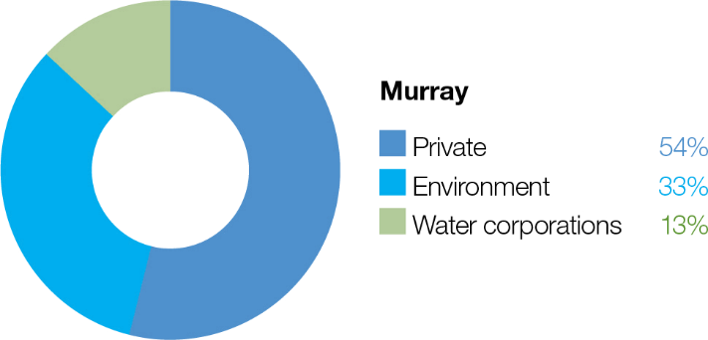

The lands and waters of the Murray River system are central to the culture of the many Traditional Owner groups that have lived along the Murray River for tens of thousands of years. Traditional Owners along the Murray have distinct cultural boundaries, languages and cultural practices. The Murray River has many different names in Aboriginal languages; for example, the Yorta Yorta people know the Murray as Dhungulla. The Victorian Murray system referred to in this plan includes waterways, storages, weirs, locks and regulators managed under state and federal legislation. This system overlays many Traditional Owner boundaries.
Within the Victorian Murray system, there are many significant floodplains and wetland systems covering the North East, Goulburn Broken, North Central and Mallee CMA areas. They are sites of significance for Traditional Owners, with tangible and intangible cultural connections dating back thousands of years and continuing to the present day. The Barmah Forest, Kerang wetlands and the Hattah Lakes are internationally recognised Ramsar-listed sites due to the significance of their wetland types and the abundance and range of waterbird species that use them. Many other wetlands in the system are either nationally or regionally significant.
Water for the environment can be supplied to the Victorian Murray system from a range of sources. These include entitlements held by the VEWH, which includes those held on behalf of the Living Murray program and the Commonwealth Environmental Water Holder (CEWH), re-use of return flows, and in some instances, use of operational water en route. The source of the water used for individual watering actions and the ability to deliver all watering actions will depend on water availability, water commitments by other environmental water holders and operational requirements. As a result, the following Victorian Murray system sections do not specify the expected availability of water for the environment.
Victorian Murray system water availability
In 2022-23, allocations against Murray system high-reliability water shares opened at 94 percent and reached 100 percent in August. Low-reliability water shares began receiving allocations in September and reached their full allocations in November. This is the second consecutive water year that Murray seasonal determinations have reached maximum availability since the introduction of the current entitlements in 2007. Spills from Hume Dam resulted in the deduction of all spillable carryover from 2021-22.
Prolonged periods of declared unregulated flow conditions in the Murray River enabled access to unregulated components of environmental entitlements and access to River Murray Unregulated Flows (RMUF). Victorian unregulated entitlements were primarily used to meet Murray floodplain demands at the Gunbower and Hattah icon sites and various central Murray wetlands in winter-spring, while RMUF remained in the Murray River channel (Hume to the Coorong) to meet water actions agreed
by the Southern Connected Basin Environmental Watering Committee (SCBEWC). The strong resource position allowed the Barmah-Millewa Forest Environmental Water Account to be repaid to the environment in mid-August, but it wasn’t used because of the large Murray flood through spring.
Return to start of section

The SCBEWC accepted 112,000 ML – 56,000 ML held in Victoria and 56,000 ML held in New South Wales – of River Murray Increased Flows (RMIF) from Snowy Hydro releases in May 2022. A small portion of this volume was used to support native fish and waterbirds in the Murray River through summer 2022-23. Significant volumes were released from the Snowy system to the Murray system in 2022-23, which may result in additional RMIF being available in the Murray system in May 2023. The SCBEWC has the first option on RMIF when it is available.
Total water availability for the environment was high in 2022-23, and there was sufficient supply to meet planned Victorian Murray system demands and carryover needs for 2023-24. The high water availability allowed the VEWH to trade up to 45,000 ML of its allocation in summer-autumn 2023.
This summary covers water availability for all of the waterway systems described in section 5.2.

Upper Murray wetlands
System overview
The upper Murray wetlands are located on the Murray River floodplain between Lake Hume and Lake Mulwala. The wetland system includes the Ryans Lagoon wetland complex, which has two main lagoons: Ryans Lagoon 1 and Ryans Lagoon 2.
The Ryans Lagoon wetland complex is a network of wetlands positioned downstream of the Lake Hume water storage and upstream of the Kiewa River confluence with the Murray River.
Flows into the complex are mainly influenced by regulated releases from Lake Hume, which travel via Ryans Creek, an anabranch of the Murray River. The complex begins to fill from Ryans Lagoon Floodway when the flow in the Murray River exceeds 23,000 ML per day, but a flow above 26,000 ML per day for extended periods is needed to completely fill both lagoons. High unregulated flows that move across the Kiewa River floodplain during wet conditions can also inundate the site. The regulated flow from Lake Hume has not exceeded 20,000 ML per day since 2014, which has greatly reduced the frequency of watering at Ryans Lagoon.
Temporary pumps are proposed to deliver water for the environment to restore the ecological health of the complex by providing a wetting and drying regime that is closer to the natural flow regime that existed before the Murray River was regulated. Water can be pumped into Ryans Lagoon from the Ryans Lagoon Floodway, which carries water when the flow in the Murray River exceeds 8,000 ML per day. A potential spring pulse of up to 25,000 ML per day (at the Doctors Point gauge) would provide water directly to Ryans Lagoon 1 via the Ryans Lagoon Floodway, but it is likely a pump would still be required to deliver water from Ryans Lagoon 1 to Ryans Lagoon 2 to achieve a full supply level.
The North East CMA is investigating options to improve watering regimes at other wetlands along the upper Murray floodplain.
Figure 5.2.1 The upper Murray wetlands
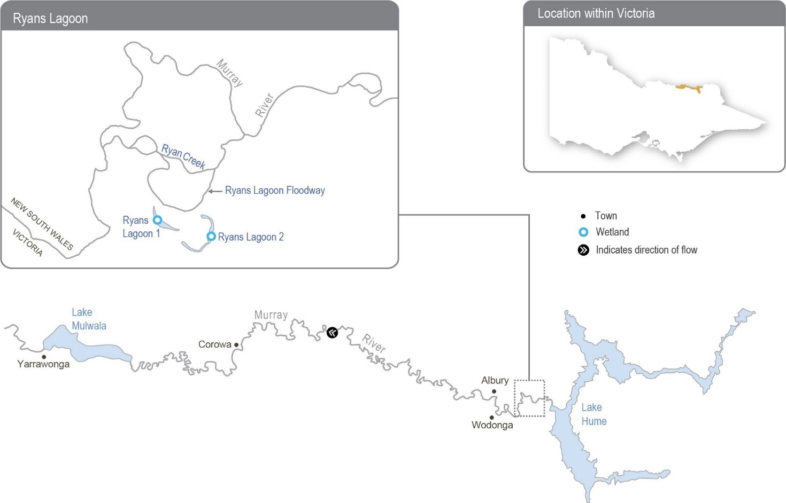
Return to start of section

Environmental values
The North East CMA’s North East Waterway Strategy recognises the Ryans Lagoon wetland complex as a high-value wetland system, and it is listed as a nationally significant wetland in the Directory of Important Wetlands in Australia. The complex provides habitat for seven bird, three fish and one perennial plant species listed under the Commonwealth Environmental Protection and Biodiversity Conservation Act 1999 and/or the Victorian Flora and Fauna Guarantee Act 1988. Ecological surveys conducted at the site since 1975 have recorded 250 species of waterbugs and 29 species of waterbirds, including
the Australian white ibis, great egret and rufous night heron. The complex also supports native wetland vegetation types, the conditions of which are expected to improve once a seasonally aligned, more variable watering regime is reinstated.

Environmental objectives in the upper Murray wetlands
Increase habitat for native fish and increase their populations
Restore carbon and nutrient cycling within the wetlands to increase ecosystem productivity
Increase the extent of fringing and aquatic vegetation
Provide feeding habitat for a range of waterbird species
Increase the abundance and diversity of waterbugs to support aquatic food webs
Traditional Owner cultural values and uses
Traditional Owners have lived on the upper Murray floodplain for tens of thousands of years. Wetlands in the region have immense cultural value to Traditional Owners, including those represented by the Dhudhuroa Nations, the Dalka Warra Mittung Aboriginal Corporation and the Duduroa Dhargal Aboriginal Corporation.
The North East CMA is building relationships with each corporation and aims to support Traditional Owner input to planned environmental flows at the Ryans Lagoon wetland complex in the coming years. In the long term, the North East CMA aims to support the defined objectives of Traditional Owners for the complex and Traditional Owners’ obligations to Country more broadly.
Traditional Owners from Duduroa Dhargal Aboriginal Corporation (DDAC) recently received funding to assist in managing Ryans Lagoon Nature Conservation Reserve for three years (2023-26) alongside Parklands Albury Wodonga Ltd. The funding will employ a DDAC Elder as a part-time ranger to undertake management activities, including ecological thinning, weed management and pest control. The ranger will also train First Nations people in cultural burning, cultural harvesting and cultural education activities.
Increasing the involvement of Traditional Owners in environmental water management and progressing opportunities for
self-determination in the environmental watering program is a core commitment of the VEWH and its agency partners. This is reinforced by legislation and policy commitments, including the Water Act 1989, the Victorian Aboriginal Affairs Framework, the 2016 Water for Victoria, the Water is Life: Traditional Owner Access to Water Roadmap 2022, and in some cases, agreements under the Traditional Owner Settlement Act 2010.
Where Traditional Owners are more deeply involved in the planning and/or delivery of environmental flows for a particular site, their contribution is acknowledged in Table 5.2.1 with an icon. The use of this icon is not intended to indicate that these activities are meeting all the needs of Traditional Owners, but is incorporated in the spirit of valuing that contribution.
Watering planned and/or delivered in partnership with Traditional Owners to support cultural values and uses
The North East CMA and DDAC met on Country at Ryans Lagoon in late 2022 and early 2023. These meetings provided an opportunity for DDAC to explain important cultural values at Ryans Lagoon and some of their objectives for managing Country, including water.
As explained above, the recent increase in the DDAC’s capacity will enable DDAC to engage in the planning and delivery of environmental water to Ryans Lagoon in 2023-24 and beyond.
Return to start of section

The North East CMA will work with DDAC to develop arrangements for delivering environmental water to Ryans Lagoon, including the timing and methods of delivering water and plans for monitoring in 2023-24. DDAC supports and will assist with pumping water to Ryans Lagoon if required.

Social, recreational and economic values and uses
In planning the potential environmental watering actions in Table 5.2.1, the North East CMA considered how environmental flows could support values and uses, including:
- recreation and amenity (such as birdwatching)
- community events (such as visitation by schools, Landcare groups and other community groups)
- socioeconomic benefits (such as incidental visitation to local towns and businesses).

Scope of environmental watering
The term ‘environmental watering’ refers to the active delivery of held environmental water to support specific environmental objectives by altering the flow in a river or the water level in a wetland. While other terms are sometimes used to describe the delivery of environmental water, ‘environmental watering’ is deliberately used here and in seasonal watering statements to ensure consistency in the legal instruments that authorise the use of water for the environment in Victoria.
Table 5.2.1 describes the potential environmental watering actions in 2023-24, their expected watering effect (that is, the intended physical or biological effects of the watering action) and the longer-term environmental objectives they support. Each environmental objective relies on one or more potential environmental watering actions and their associated physical or biological effects.
Table 5.2.1 Potential environmental watering actions, expected watering effects and associated environmental objectives for the upper Murray wetlands

Potential environmental watering action | Expected watering effects | Environmental objectives
Ryans Lagoon 1 and Ryans Lagoon 2 (fill in winter/spring) | - Mobilise carbon and nutrients within the wetlands to support wetland processes  - Maintain permanent, deep, open-water habitat that supports food resources for waterbirds and native fish  - Inundate wetland margins to provide refuge and feeding habitat for small- and large-bodied native fish  - Increase soil moisture to promote the growth of fringing vegetation and the surrounding river red gum community  - Inundate beds of aquatic and semi-aquatic vegetation to stimulate growth and increase their extent  - Prevent the encroachment of river red gum saplings into deep areas of the wetland  - Inundate wetland margins to provide habitat for waterbugs and foraging opportunities for waterbirds

Scenario planning
Table 5.2.2 outlines potential environmental watering and expected water use in a range of planning scenarios.

2022-23 was the first year the upper Murray wetlands were included in the VEWH’s seasonal watering plan, and the first time water for the environment was planned to be delivered to the Ryans Lagoon wetland complex. However, active pumping was not required because natural floods, which peaked at 100,000 ML per day at Doctors Point, naturally filled both lagoons and all other wetlands across the upper Murray floodplain.
Ryans Lagoon 1 and Ryans Lagoon 2 would have naturally filled every year before the river was regulated, and they require frequent watering to maintain permanent water that can support native fish and provide a reliable foraging site for waterbirds. For these reasons, the planned winter/spring watering is a high priority in all planning scenarios in 2023-24. Water for the environment, delivered via temporary pumps, will likely be needed to fill both lagoons under drought, dry and planning scenarios. A high, unregulated flow and natural floods are likely to inundate the wetlands in the wet planning scenario, and water for the environment will only be used in the wet scenario to top up water levels in each lagoon if they do not fill naturally.
Return to start of section

Table 5.2.2 Potential environmental watering for the upper Murray wetlands in a range of planning scenarios

Planning scenario | Drought | Dry | Average | Wet
Expected conditions | - No unregulated flow below Hume Dam  - Regulated flow from Hume Dam is likely to connect the Ryans Lagoon Floodway to allow pumping into Ryans Lagoon 1  and 2 | - Unregulated flow unlikely below Hume Dam  - Regulated flow from Hume Dam will connect the Ryans Lagoon Floodway to allow pumping into Ryans Lagoon 1  and 2  - Possible spring pulse could deliver water to Ryans Lagoon 1 and partially fill Ryans Lagoon 2 | - Unregulated flow is possible below Hume Dam if storages are near capacity and from the Kiewa River  - Unregulated flow may achieve partial or complete inundation of Ryans Lagoon 1  and 2  - Regulated flow from Hume Dam and potential flow from the Kiewa catchment will connect the Ryans Lagoon Floodway to allow pumping into Ryans Lagoon 1 and 2  - Possible spring pulse could deliver water to Ryans Lagoon 1 and partially fill Ryans Lagoon 2 | - Periods of unregulated flow below Hume Dam and from the Kiewa River are likely  and may provide partial or complete inundation to Ryans Lagoon 1  and 2  - Pumping into Ryans Lagoon 1 and 2 if a complete fill is not achieved could be considered, depending on water levels in the lagoons
Potential environmental watering – tier 1 (high priorities) | - Ryans Lagoon 1 and 2 (fill in winter/spring)
Possible volume of water for the  environment required to achieve objectives | - 170 ML (tier 1) |  | - 0-170 ML (tier 1)

Barmah Forest subsystem

System overview
The Barmah Forest is located within Yorta Yorta’s traditional boundaries. The Barmah-Millewa Forest covers 66,000 ha and spans the New South Wales – Victoria border between Tocumwal, Deniliquin and Echuca (Figure 5.2.1). The Barmah-Millewa Forest is listed under the Convention on Wetlands of International Importance (the Ramsar Convention) as well as the Directory of Important Wetlands in Australia, and it is one of six Living Murray icon sites. The forest’s Victorian components are the Barmah National Park and part of the River Murray Reserve, covering 29,305 ha of forest and wetlands that support a vast range of significant plant and animal species and culturally significant sites to the Yorta Yorta.
The wetlands throughout the forest provide a constant source of nutritional foods and significant fibres for the Yorta Yorta People. Resources in the landscape were also used to manufacture canoes, shields and carrying devices.
Flooding in the Barmah-Millewa Forest depends on the flow in the Murray River. A natural narrowing of the river (commonly referred to as the Barmah Choke) restricts the flow and causes overbank flooding when the flow below Yarrawonga Weir exceeds the channel’s capacity. This restriction influences both the operation of Yarrawonga Weir and the magnitude of environmental flows that can be delivered to the forests. The Yorta Yorta People see this narrow part of Dhungulla (Murray River) as a culturally significant creation story, and it provides ecosystem services both from a culturally and environmentally significant viewpoint. The name ‘Barmah Choke’ is culturally inappropriate for the Yorta Yorta, and it is seen as a negative way to view their traditional lands and waters. Yorta Yorta People refer to this as the ‘Pama Narrows’, or more simply ‘The Narrows’.
Return to start of section

Before the river was regulated, Barmah-Millewa Forest was regularly flooded with high flows from rainfall and snowmelt in winter and spring. These regular floods shaped a rich, productive forest environment. The construction and operation of Hume Dam and Dartmouth Dam have greatly reduced the size and frequency of natural winter/spring floods in Barmah-Millewa Forest.
Operational deliveries that supply water to users downstream of The Narrows can cause unseasonal, low-level floods, which can damage the forest and banks of the river, depending on the timing and volume of the flow. Country for the Yorta Yorta People continues to change, but the changes have been rapid post-settlement due to the installation of infrastructure and river regulation. This has changed Country culturally and environmentally for the Yorta Yorta People.
The delivery of irrigation water during summer/autumn is now managed to minimise the unseasonal flooding of the forest. Regulators along the banks of the Murray River that control flow between the river and the forest remain closed during summer and autumn to restrict flow through low-lying flood runners to simulate natural conditions. The delivery of water to Barmah- Millewa Forest is also limited by a flow constraint below Yarrawonga Weir that aims to minimise impacts to adjacent farming operations in NSW. The current constraint limits the regulated flow to a maximum river level of 3.3 m at the Tocumwal gauge (about 18,000 ML per day downstream of Yarrawonga Weir), subject to various conditions. A regulated flow up to a river level of 3.0 m on the Tocumwal gauge (about 15,000 ML per day downstream of Yarrawonga Weir) can be delivered at any time during the year and is not subject to conditions. To overcome this constraint, most environmental flows are shared between Barmah and Millewa forests to deliver water to low-lying wetlands in each forest at least every second year. It is currently
not possible to achieve the desired flood depth and duration for floodplain marsh vegetation in both forests at the same time without larger natural flooding.
Water management at Barmah-Millewa Forest seeks to build on natural flow and the delivery of consumptive and operational water en route to optimise environmental outcomes when possible. As Barmah-Millewa Forest is located towards the upper reaches of the regulated portion of the Murray River, water for the environment that passes through the forest and returns to the river can often be used at sites further downstream as part of multi-site watering events.
Figure 5.2.2 Barmah Forest

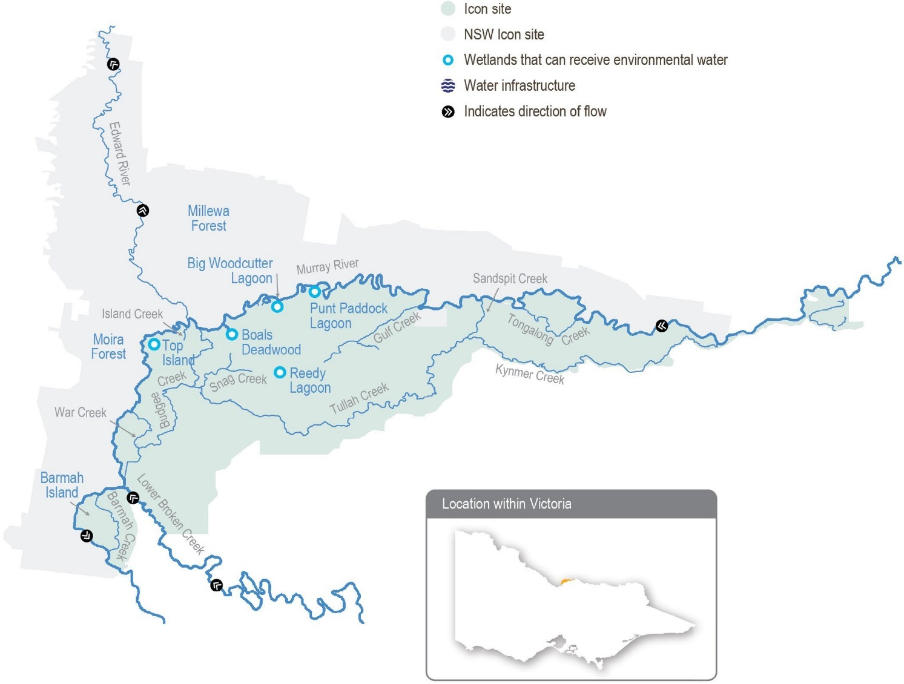

Return to start of section

Environmental values
The Barmah-Millewa Forest is the largest river red gum forest in Australia and the most intact freshwater floodplain system along the Murray River. The forest supports important floodplain vegetation communities, including the threatened Moira grass plains, and is a significant feeding and breeding site for waterbirds, including bitterns, ibis, egrets, spoonbills and night herons. Significant populations of native fish, frogs and turtles also live in the forest’s waterways. Barmah Forest is known to support 74 plant and animal species protected under state and national legislation.

Environmental objectives in the Barmah Forest
Increase habitat for native fish and increase their populations
Maintain frog populations
Protect forest waterways from increased erosion
Maintain turtle populations, including the broad-shelled turtle
Enable carbon and nutrient cycling between the floodplain and river through connectivity
Enhance the health of river red gum communities and aquatic vegetation in the wetlands and watercourses and on the floodplain
Promote the growth of floodplain marsh vegetation communities, with a particular focus on increasing the extent of Moira grass
Provide feeding and nesting habitat for the successful recruitment of colonial nesting waterbirds
Reduce the risk of low-oxygen events in summer

Traditional Owner cultural values and uses
“We are the First People of this place. We were here even before the Murray River flowed through Barmah.” – Uncle Des Morgan, Yorta Yorta Elder, Joint Management Plan for Barmah National Park
The Yorta Yorta Nation Aboriginal Corporation manages Barmah National Park with Parks Victoria under a Traditional Owner Land Management Agreement with the State of Victoria. The Joint Management Plan for Barmah National Park and the Yorta Yorta Whole-Of-Country Plan 2021-2030 inform environmental water management in Barmah National Park. Ongoing interaction on land and water management at Barmah also occurs with Yorta Yorta through the Living Murray Indigenous Partnerships Program.
The Goulburn Broken CMA met with the Yorta Yorta Nation Aboriginal Corporation in early 2023 to discuss Barmah Forest and have a general discussion about environmental water planning. Due to capacity constraints, Yorta Yorta did not provide specific feedback on planned watering for Barmah Forest in 2023-24.
The Yorta Yorta Nation Aboriginal Corporation continues to pursue the Yorta Yorta People’s inherent rights to water for Country. Rights to water will address their spiritual, cultural, environmental, social and economic needs, in line with the Yorta Yorta Whole-Of-Country Plan 2021-2030.
Yorta Yorta values are more than ‘stones and bones’. They encompass an inherent and living connection to land (woka), water (wala) and caring for Country.
Return to start of section

Examples of Yorta Yorta cultural values and uses in Barmah Forest that are supported through deliveries of water for the environment include:
- maintaining refuges that protect turtles, an important totemic species for the Yorta Yorta People
- watering to support floodplain marsh vegetation, which includes important food, fibre and medicinal plants (such as sneezeweed and weaving sedge)
- improving the health of river red gums, which has benefits for important Yorta Yorta sites and significant markings (such as a scarred tree) and furthers connections to Country
- broader restoration to achieving healthy Country.

Social, recreational and economic values and uses
In planning the potential environmental watering actions in Table 5.2.3, the Goulburn Broken CMA considered how environmental flows could support values and uses, including:
- water-based recreation (such as boating, fishing, kayaking and canoeing)
- riverside recreation and amenity (such as birdwatching, picnicking, photography, camping and the general physical, mental and social benefits of communing with nature)
- community events and tourism (such as boat tours)
- socioeconomic benefits (such as for apiarists and irrigation diverters).

Scope of environmental watering
The term ‘environmental watering’ refers to the active delivery of held environmental water to support particular environmental objectives by altering the flow in a river or the water level in a wetland. While other terms are sometimes used to describe the delivery of environmental water, ‘environmental watering’ is deliberately used here and in seasonal watering statements to ensure consistency in the legal instruments that authorise the use of water for the environment in Victoria.
Table 5.2.3 describes the potential environmental watering actions in 2023-24, their expected watering effect (that is, the intended physical or biological effects of the watering action) and the longer-term environmental objectives they support. Each environmental objective relies on one or more potential environmental watering actions and their associated physical or biological effects.
Table 5.2.3 Potential environmental watering actions, expected watering effects and associated environmental objectives for the Barmah Forest

Potential environmental watering action | Expected watering effects | Environmental objectives
Winter/spring forest low flow to various waterways in Barmah Forest (variable flow  rates and duration during July to December and  June) | - Provide a gradual connection of waterways with the Murray River to minimise erosion within those waterways  - Provide flow in forest waterways to ensure adequate refuge pools persist for native fish and turtles  - Provide adequate depth and connection between floodplain waterways and the river to facilitate the movement of native fish
 | - Remove accumulated organic matter from waterways to cycle carbon to the river system and minimise the risk of hypoxic blackwater by ensuring throughflow
Winter/spring/summer | - Maintain a sufficient water level in the Murray River main channel to prevent Murray cod from abandoning their nests, increase juvenile survival and improve dispersal opportunities
low flow (greater than
8,500 ML/day below
Yarrawonga Weir during
August to December)
Spring/summer fresh(es) in the Murray River channel (one to three freshes that increase flow by at least 500 ML/ day and maintain it for two to eight days during November to December) | - Provide variable water levels once water temperatures exceed 22°C to trigger the spawning of native fish species, primarily silver perch

Potential environmental watering action | Expected watering effects | Environmental objectives
Spring/summer/autumn freshes to Gulf and Boals creeks (100 ML/ day for three to five days as required during November to April) | - Maintain critical refuge pools to provide habitat for native fish and turtles  - Flush refuge pools to maintain water quality
Spring/summer/autumn low flow to floodplain waterways, including Sandspit, Gulf, Big Woodcutter, Boals  and Island creeks and Punt Paddock Lagoon (200 ML/day for 30 to 60 days during November to April) | - Replenish refuge pools in permanent waterways to maintain water quality, fish and turtle populations  - Maintain connectivity between the forest and the river  - Remove accumulated organic matter, cycle carbon to the river system and minimise the risk of hypoxic blackwater
Fill or top-up of Boals Deadwood, Harbours Lake, Reedy Lagoon and Top Island wetlands (200-400 ML/day for four and a half months during September to February) | - Provide a cue to initiate waterbird breeding and maintain a depth of at least  0.5 m beneath reed bed nesting breeding colonies  - Maintain wetting duration and depth to grow the wetland vegetation
Spring wetting of floodplain marshes (variable flow rates of greater than 9,500-  18,0001 ML/day below Yarrawonga Weir for three months during September to December) | - Inundate open plains to a sufficient depth and for a sufficient duration to allow the growth of floodplain marsh vegetation  - Inundate forest wetlands and low-lying floodplain areas to create foraging opportunities for waterbirds and increase available habitat for turtles, frogs and small-bodied native fish
Autumn/winter low flow in the Murray River (4,000-5,000 ML/  day downstream of Yarrawonga during May to June) | - Increase water depth in the Murray River channel to provide habitat for large-bodied native fish in the Murray River and unregulated anabranches in Barmah-Millewa Forest

1 The maximum flow constraint is a level of 3.3 m at the Tocumwal gauge in the Murray River, estimated at 18,000 ML/day downstream of Yarrawonga Weir. The maximum flow rate actually delivered may vary for these actions.

Scenario planning
Table 5.2.4 outlines potential environmental watering and expected water use in a range of planning scenarios.

Widespread flooding in 2022-23 fully inundated Barmah-Millewa Forest, a much greater area than the quarter of the floodplain that can be inundated by environmental flows under current delivery constraints. The potential watering actions in this plan are required in most or all years to support the identified environmental values and objectives. For these reasons, the proposed watering actions under each planning scenario tend to be the same each year, and the proposed actions in this seasonal watering plan are similar to those in previous plans.
The ecological objectives for Barmah-Millewa Forest require a sustained flow in the Murray River through winter and spring. Flow-control structures are used to direct water from the Murray River channel into the forest and to facilitate the later return of most of that water back to the river, transporting carbon and nutrients for use downstream. Current flow constraints mean environmental watering will primarily target Millewa Forest in 2023-24, aiming to meet the depth and duration targets for wetlands. Barmah Forest will still receive a flow, but depth and duration targets for some forest wetlands may not be fully met. These arrangements alternate between Barmah and Millewa forests each year.
Return to start of section

Demands for water for the environment in Barmah Forest vary significantly in response to seasonal conditions. A variable winter/spring forest low flow and spring/summer freshes are required in all planning scenarios. The variable winter/spring forest low flow aims to connect waterways within Barmah Forest to the Murray River to maintain habitat and provide movement opportunities for aquatic animals (such as native fish). This watering action will be achieved by keeping regulating structures open between June and December to allow water to move in and out of the forest in response to variations in the normal flow of the Murray River. The spring/summer freshes specifically aim to trigger silver perch spawning when the water temperature exceeds 22°C and are achieved by varying the flow in the Murray River below Yarrawonga Weir.
Under drought and dry conditions, potential environmental flows primarily aim to maintain water levels and water quality in refuge habitats within the forest to sustain fish and turtle populations. To achieve these objectives, relatively small volumes of water need to be directed into the forest and are unlikely to return much water to the Murray River for downstream use. Given high storage levels and forecast high water availability for 2023-24, these flows may be delivered at greater-than-normal rates. For example, the size of a multi-site environmental watering action supporting whole-of-Murray-River and/or downstream environmental objectives during winter and spring is likely to increase the flow through Barmah Forest, or water for the environment may be used to ‘piggyback’ operational transfers from Hume Dam. In 2023-24, the forecast high water availability is expected to also allow spring wetting of floodplain marshes and the delivery of an autumn-winter low flow to minimise environmental stress throughout the forest under drought and dry planning scenarios.
The winter/spring/summer low flow in the Murray River channel aims to maintain sufficient water levels for successful Murray cod nesting and recruitment under the dry-to-wet planning scenarios to increase local Murray cod populations and assist the recovery of the species across the broader region. The volume needed to achieve this low flow depends on the contribution of the natural flow and the delivery of operational water downstream through The Narrows. This action will provide an environmental return flow downstream for use at other sites along the Murray River.
In the average or wet planning scenarios, the focus shifts to building resilience in the system by enhancing ecological responses to unregulated floods. Actions in the average and wet planning scenarios may include extending the duration of unregulated floods (within flow constraints) to increase the vigour and resilience of wetland communities (such as Moira
grass plains) in floodplain marshes or extending watering in river red gum forests to maintain the health of the trees. These actions may require large volumes of water to be directed into the forest, with water for the environment provided as a directed release from Hume Dam targeting specific flow rates downstream of Yarrawonga Weir and managed using forest regulators. Most of the water used for these actions is eventually returned to the Murray River through the natural shedding action of the floodplain.
A prolonged, low-level spring wetting of floodplain marshes in 2023-24 is desirable to help floodplain vegetation flower, set seed and recruit. Some floodplain inundation will occur when the flow downstream of Yarrawonga exceeds about 9,500 ML per day. A larger flow (of up to 3.3. m at the Tocumwal gauge) will inundate more of the floodplain to a greater depth, which will provide better outcomes for floodplain vegetation, native fish, frogs, turtles and waterbirds.
Regulators may be used to divert water to selected wetlands under various planning scenarios to support any significant waterbird breeding that is triggered by a spring inundation.
Table 5.2.4 Potential environmental watering for the Barmah Forest in a range of planning scenarios

Planning scenario | Drought | Dry | Average | Wet
Expected conditions | - Unregulated flow periods are unlikely  - Flow in the Murray River will remain within the channel all year | - Some small, unregulated flow in late winter/spring  - Low chance of overbank flow in late winter/spring | - Likely chance of small-to-medium unregulated flow in winter/spring  - Likely chance of overbank flow in winter/spring | - High probability of moderate to large unregulated flow in winter/spring  - Expected large overbank flow

Planning scenario | Drought | Dry | Average | Wet
Potential environmental watering – tier 1 (high priorities)1 | - Winter/spring forest low flow  - Spring/summer fresh(es) (one to three freshes)  - Spring/summer/ autumn freshes (to Gulf and Boals creeks) | - Winter/spring forest low flow  - Winter/spring/ summer low flow  - Spring/summer fresh(es) (one to three freshes)  - Spring/summer/ autumn low flow  - Fill or top up Boals Deadwood, Harbours Lake, Reedy Lagoon and Top Island wetlands | - Winter/spring forest low flow  - Winter/spring/ summer low flow  - Spring/summer fresh(es) (one to three freshes)  - Spring/summer/ autumn low flow  - Fill or top up Boals Deadwood, Harbours Lake, Reedy Lagoon and Top Island wetlands  - Spring wetting of floodplain marshes  - Autumn/winter low flow (in Murray River) | - Winter/spring forest low flow  - Winter/spring/ summer low flow  - Spring/summer fresh(es) (one to three freshes)  - Spring/summer/ autumn low flow  - Fill or top up Boals Deadwood, Harbours Lake, Reedy Lagoon and Top Island wetlands  - Spring wetting of floodplain marshes  - Autumn/winter low flow (in Murray River)
Potential environmental watering – tier 2 (additional priorities)2 | - Spring wetting of floodplain marshes  - Autumn/winter low flow (in Murray River) | - Spring wetting of floodplain marshes  - Autumn/winter low flow (in Murray River) | - N/A | - N/A
Possible volume of water for the  environment required to achieve objectives3 | - 8,500 ML (tier 1) | - 550,000 ML (tier 1) | - 200,000 ML (tier 1) | - 130,000 ML (tier 1)
- Tier 1 potential environmental watering at Barmah Forest is not classified as tier 1a or 1b because the water available for use is shared across various systems, and it is not possible to reliably determine the supply specifically available for Barmah Forest.
- The volume of water for the environment required to deliver the spring wetting of floodplain marshes and autumn/winter low-flow watering actions in the drought planning scenario will depend on demands for multi-site environmental events or operational transfers and is therefore not estimated in Table 5.2.4.
- The possible volumes of water for the environment required in Barmah Forest are estimates and highly variable, depending on factors such as seasonal conditions and the contributions of operational and/or unregulated flows. Much of the water for the environment delivered to Barmah Forest is returned to the Murray River – around 80 percent in the dry-to-wet planning scenarios – and can be re-used at downstream sites.

Gunbower Creek and Forest
System overview
Gunbower Forest is a large, flood-dependent forest situated on the Murray River floodplain in northern Victoria between Torrumbarry and Koondrook (Figure 5.2.3).
Gunbower Forest, which covers 19,450 ha, is bounded by the Murray River to the north and Gunbower Creek to the south. It is an internationally significant site under the Ramsar Convention and forms part of the Living Murray Gunbower-Koondrook- Perricoota forests icon site. River regulation and water extraction from the Murray River and Gunbower Creek have reduced the frequency, duration and magnitude of flood events in Gunbower Forest. This has affected the extent and condition of floodplain habitats and the health of plant and animal communities (such as river red gum and black box communities, native fish, birds, platypus, frogs and turtles) that depend on those habitats.
Gunbower Creek is a natural creek that has been modified to supply irrigation water from the Murray River to the Torrumbarry Irrigation Area. There are 12 lagoons, largely located in the upper reaches of the creek system, that are permanently or seasonally connected to Gunbower Creek. Water for the environment is used in Gunbower Creek to improve habitat for native fish, especially Murray cod.
The Living Murray environmental works program in the middle and lower forest was completed in 2013. The works allow up to 4,500 ha of the wetlands and floodplain to be watered with considerably less water than would be required if the watering infrastructure was not in place. The works enable efficient watering through Gunbower Creek and the forest to maintain the
wetland and floodplain condition and provide connectivity between the creek, forest floodplain and the Murray River. Frequent connections between the river and floodplain habitats allow animals to move between habitats and support critical ecosystem functions (such as carbon exchange).
Return to start of section

Figure 5.2.3 Gunbower Creek and Forest

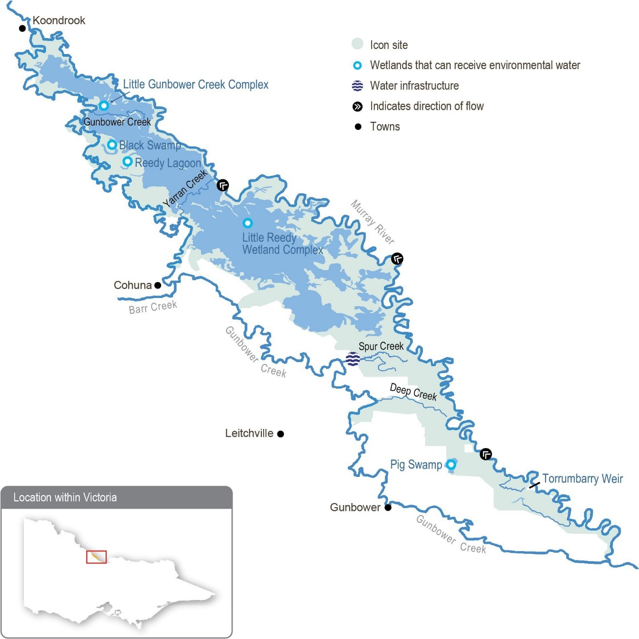

Environmental values
Gunbower Forest contains many important environmental values. It includes rare and diverse wetland habitats and large areas of remnant vegetation communities (such as river red gum forest and woodlands). It is home to vulnerable and endangered plants and animals, including river swamp wallaby grass, wavy marshwort, Murray-Darling rainbowfish and eastern great and intermediate egrets. Gunbower Forest also supports internationally recognised migratory waterbird species.
Return to start of section

Gunbower Creek provides important habitat for native fish (such as Murray cod, golden perch and freshwater catfish). It is a valuable refuge for native fish and provides a source of fish to recolonise surrounding waterways.

Environmental objectives in Gunbower Creek and Forest
Provide feeding, breeding and refuge habitat for small-bodied native fish (such as Murray-Darling rainbow fish) in forest wetlands
Improve populations of large-bodied native fish (such as Murray cod) in Gunbower Creek
Increase the diversity and abundance of native frog species within the forest
Maintain the population of freshwater turtles by providing suitable feeding, breeding and refuge habitat
Support carbon and nutrient cycles in the forest and wetlands and periodically deliver carbon and nutrients from the forest to adjacent waterways to support food webs
Improve the health and increase the abundance of native vegetation in permanent and semi-permanent wetlands Improve the health of river red gums and black box communities
Provide feeding, breeding and refuge habitat for waterbirds, including colonial nesting species (such as egrets, cormorants and herons)
Maintain water quality in Gunbower Creek
Traditional Owner cultural values and uses
The Barapa Barapa are the Traditional Owners in the middle and lower area of Gunbower Forest, and the Yorta Yorta are the Traditional Owners in the upper Gunbower Forest.
The North Central CMA seeks engagement and input from both Traditional Owner groups when undertaking annual environmental water planning and throughout the year as part of the Living Murray Indigenous Partnerships Program.
Yorta Yorta custodians and Barapa Barapa custodians have clearly expressed their aspirations for an active role in the management of land and water to fulfil custodianship obligations and contribute to improvements in the health of Country.
Barapa Barapa custodians and North Central CMA staff spent two days in Gunbower Forest in early 2023 to reflect on the condition of the forest and creek, share knowledge and discuss environmental watering plans for 2023-24 and other
opportunities to improve the health of the forest and creek. Barapa Barapa custodians released several Murray cod and golden perch that were salvaged during the low-oxygen blackwater event in 2022 back into Gunbower Creek. Concerns were raised about the potential for future low-oxygen blackwater events.
Increasing the involvement of Traditional Owners in environmental water management and progressing opportunities towards self-determination in the environmental watering program is a core commitment of the VEWH and its agency partners. This is reinforced by a range of legislation and policy commitments, including the Water Act 1989, the Victorian Aboriginal Affairs Framework, the 2016 Water for Victoria, the Water is Life: Traditional Owner Access to Water Roadmap 2022, and in some cases, agreements under the Traditional Owner Settlement Act 2010.
Where Traditional Owners are more deeply involved in the planning and/or delivery of environmental flows for a particular site, their contribution is acknowledged in Table 5.2.7 with an icon. The use of this icon is not intended to indicate that these activities are meeting all the needs of Traditional Owners, but is incorporated in the spirit of valuing that contribution.
Watering planned and/or delivered in partnership with Traditional Owners to support cultural values and uses
Barapa Barapa custodians have been working in partnership with the North Central CMA to deliver the Water for Country project in Gunbower Forest since 2015. The Water for Country project builds on the work of the previous Barapa Barapa Cultural Heritage Mapping of Lower Gunbower Forest project, delivered in 2013-14, to map a catalogue of cultural heritage assets in the forest. The Water for Country project aims to investigate how Traditional Owners’ cultural and spiritual values can be better represented in water management. In 2018, the Water for Country group expanded to also include Wamba Wemba custodians; the group continues to focus on Gunbower Forest.
Return to start of section

Table 5.2.5 identifies opportunities to support cultural values with water for the environment. These have been informed by the Barapa Barapa Watering Objectives Framework (see Table 5.2.6) and North Central CMA engagement with Barapa Barapa custodians in early 2023.
Table 5.2.5 Cultural values and uses at Gunbower Forest as identified by the Barapa Barapa Wamba Wemba Water for Country project

Value/use | How the value/use will be considered by environmental flows in 2023-24
Cultural plants, cultural practices | - Water in wetlands and on the floodplain from deliveries of water for the environment and natural flooding supports culturally important plants throughout Gunbower Forest and allows the continuation of cultural practices, including harvesting of food, medicine and weaving plants.  - The watering actions via the Hipwell channel in 2023-24 will support cultural plants that Barapa Barapa custodians value and provide opportunities for cultural practices to continue.  - The abundance of cultural resources available is linked to the scale of watering that can be achieved. Floodplain watering via the Hipwell channel provides a greater amount of resources and enables resourceful harvests with less travel and effort.  - Barapa Barapa custodians recognise the value of resources that occur on the drawdown after the inundation of the forest floodplain, providing food for animals and cultural plants (such as old man weed). This can be supported by allowing wetlands to draw down naturally prior to the floodplain watering in winter 2023 and through summer and autumn 2024.  - Having a diversity of habitat and vegetation responses is a priority for Barapa Barapa custodians. They consider it important to have a range of water depths, which creates a more diverse vegetation response and results in a variety of resources becoming available over a longer period.
Healthy Country | - Providing drought refugia and maintaining areas with healthy habitat is a high priority for Barapa Barapa custodians.  - Deliveries of water for the environment will ensure water is present on the floodplain and in high-priority wetlands regardless of whether there is unregulated flooding. This will provide refuge habitat for forest fauna, and the delivery of water across most of the Gunbower Forest wetlands will ensure that high-quality habitat is available.
Cultural heritage | - Barapa Barapa custodians value having water in natural creeks and billabongs off main wetlands, which can contain cultural heritage sites, including earth mounds and a large canoe tree on the edge of a large flood runner.  - Delivering water to the floodplain supports this with water flowing through natural creeks and flood runners on the floodplain. Deliveries of water for the environment result in lower levels than natural flooding, which can ensure that earth mounds or other cultural heritage are not overtopped and harmed.  - Barapa Barapa custodians have noted that areas of black box and river red gum have cultural heritage values, but the changed watering regime since regulation and climate change is causing the encroachment of black box into areas previously dominated by river red gum. Barapa Barapa custodians expressed the desire to preserve the tree community that was historically present, which is supported by the delivery of water to the floodplain. The lower landscape regulators can target small areas of river red gum, and the Hipwell channel watering planned in 2023-24 will inundate large areas of river red gum and potentially suppress black box encroachment within the flood footprint.
Cultural practices | - Barapa Barapa custodians have aspirations to reintroduce traditional fish traps into natural creeks within Gunbower Forest. The flood runners around the Little Gunbower Creek complex have been identified as potential trial sites, and opportunities may be provided to pursue this in 2023-24.  - Traditional Owners have indicated that a smoking ceremony should be a regular activity each year when water is delivered, as it is something that their ancestors would have done when the floodwaters arrived and would represent a restoration of an important cultural practice. The timing of deliveries of water for the environment will be communicated to Traditional Owners so cultural opportunities can be realised.
Cultural resources | - Barapa Barapa custodians have expressed that the ongoing survival of fish populations is important, as the fish are a food resource. In 2023, Barapa Barapa custodians are placing a high priority on protecting native fish populations in Gunbower Creek and avoiding any further fish deaths due to low-oxygen blackwater.  - Native wetland fish populations persisting in the Gunbower Forest wetlands following the 2022 floods will be supported by the planned floodplain watering, ensuring a resident fish population persists across multiple years. Watering the wetlands will also provide habitat for freshwater mussels in the wetlands.
Return to start of section

The Barapa Barapa Wamba Wemba Water for Country project has led to the creation of the Barapa Barapa Cultural Watering Objectives Framework, which is a guiding document to ensure cultural priorities and outcomes are considered and incorporated in the planning for and management of water for the environment. The framework considers cultural objectives matched with hydrological considerations, indicators and measures for monitoring success, which Table 5.2.6 shows. These objectives are considered in conjunction with the environmental objectives and expected effects of the potential watering actions shown in Table 5.2.7.
Applying the framework during seasonal watering proposal engagement with the Barapa Barapa Wamba Wemba Water for Country project members ensures that planned environmental flows incorporate Barapa Barapa custodians’ cultural aspirations and that water managers are culturally informed when delivering water for the environment.
All the potential environmental watering actions in Table 5.2.7 provide the opportunity to support Barapa Barapa cultural values and objectives. Achieving them will depend on climatic conditions.
Table 5.2.6 Barapa Barapa cultural objectives for environmental flows in Gunbower Forest 2023-24 (from the Barapa Barapa Cultural Watering Objectives Framework)

Cultural objective | Hydrological aim | Indicator | Measure | Watering action
Promote and maintain healthy and abundant native fish communities in  Gunbower Creek and  Gunbower Forest | - Presence of water in wetlands before spring to  support native fish spawning events | - Presence of native fish spawning  - Native fish populations show a range of ages | - Fish surveys, larval sampling | - Floodplain watering  - Wetland top-ups  - Yarran throughflow
 | - Presence of water in deep wetlands so that fish can survive for longer | - Presence of native fish following watering event
 |  |  | - Fish surveys
 | - Connectivity between wetlands, Gunbower Creek and the Murray River | - Presence of native fish following watering event | - Fish surveys
Promote the natural flow of water | - Water flows via natural flow  paths to culturally important sites | - Presence of water at culturally significant sites (e.g. fishponds) | - Photo points, site surveys
 | - Presence of healthy-looking and healthy-smelling forest | - Presence of healthy canopies and good ground cover on the forest floodplain | - Plant surveys
Promote and maintain healthy cultural plants and resources | - Presence of water on the floodplain, in small wetlands and in depressions to provide resources across the forest, particularly in dry years | - Presence of food and fibre resources distributed across the forest | - Cultural harvests, plant surveys, seed collection
 | - Presence of water in wetlands which are healthy | - A diverse range of plants, animals  and insects living in harmony | - Results of monitoring activities (e.g. macroinvertebrate surveys, flora and fauna surveys)
Promote healthy waterbird populations | - Presence of water in wetlands that support waterbird breeding | - Presence of waterbird breeding | - Waterbird surveys, spring/summer surveys for eggs
Return to start of section

Social, recreational and economic values and uses
In planning the potential environmental watering actions in Table 5.2.7, the North Central CMA considered how environmental flows could support values and uses, including:
- water-based recreation (such as boating, canoeing, duck hunting, fishing, stand-up paddle boarding and water skiing)
- riverside recreation and amenity (such as birdwatching, camping, photography and walking)
- community events and tourism (such as park visitation, tour and activity operators)
- socioeconomic benefits (such as consumptive water users, including irrigation and domestic use, timber harvesting and education).
Where possible, releases will be timed to minimise disruption to community uses.
Scope of environmental watering
The term ‘environmental watering’ refers to the active delivery of held environmental water to support particular environmental objectives by altering the flow in a river or the water level in a wetland. While other terms are sometimes used to describe the delivery of environmental water, ‘environmental watering’ is deliberately used here and in seasonal watering statements to ensure consistency in the legal instruments that authorise the use of water for the environment in Victoria.
Table 5.2.7 describes the potential environmental watering actions in 2023-24, their expected watering effect (that is, the intended physical or biological effects of the watering action) and the longer-term environmental objectives they support. Each environmental objective relies on one or more potential environmental watering actions and their associated physical or biological effects.
Table 5.2.7 Potential environmental watering actions, expected watering effects and associated environmental objectives for Gunbower Creek and Forest

Potential environmental watering action |  | Expected watering effects | Environmental objectives
Gunbower Forest
Gunbower Forest floodplain, floodrunners and wetlands inundation (with variable flow rates during winter/ spring 2023) | Part B: July- November 20231 | - Continue floodplain watering commenced in June 2023 to inundate for a second consecutive year river red gums, which are still recovering from the Millennium Drought  - Inundate flood-dependent understorey vegetation across the floodplain to support further its establishment and recolonisation to supplement recruitment during the 2022-23 floods  - Provide a variety of water depths throughout the forest to provide feeding, foraging and refuge habitat for frogs, turtles and waterbirds, including juveniles from colonial nesting species, and access to breeding habitat for small-bodied native fish
Extend natural flooding in Gunbower Forest floodplain, flood runners and wetlands (with variable flow rates to maintain an appropriate wetted extent during winter/spring 2023) |  | - Where possible, extend the duration and/or extent of natural floodplain and wetland inundation over the optimal growing season for aquatic vegetation; the objectives are as per the previous action, with a greater area of floodplain inundated
Winter/spring fresh in Yarran Creek (variable flow rates and duration based on water levels in Gunbower Forest and flows in the Murray River and Gunbower Creek) |  | - Connect Gunbower Creek, Gunbower Forest and the Murray River through the Yarran Creek and/or Shillinglaws regulators to increase flowing habitat for the lateral movement of native fish, turtles, carbon and nutrients

Potential environmental watering action | Expected watering effects | Environmental objectives
Black Swamp, Reedy Lagoon, Little Gunbower Creek complex, Little Reedy wetland complex (top-up, variable flow rates during spring/ summer as required  in response to bird breeding) | - Maintain adequate water levels in breeding and feeding habitats to allow breeding waterbirds to successfully fledge their chicks
Black Swamp, Reedy Lagoon, Little Gunbower Creek complex, Little Reedy wetland complex (top-up, variable flow rates during autumn/ winter 2024 as required) | - Maintain a variety of water depths across the floodplain wetlands to provide feeding, foraging and refuge habitat for frogs, fish, turtles and waterbirds, including juvenile colonial nesting species
Gunbower Creek (targeting Cohuna Weir)
Spring/summer/autumn flow (300-400 ML/day during September to March) | - Maintain habitat and food resources for native fish and support breeding and larval survival (such as Murray cod) by minimising large variations in the water level during the irrigation season and achieving about 1.5 m depth in deeper pools and 30 cm depth in the shallow connecting littoral zone to maintain habitat  - A greater area of habitat will be inundated at the upper magnitude
Summer/autumn/winter opportunistic fresh(es) (200-500 ML/day for one to four weeks during July to August 2023 or January to June 2024) | - Increase flowing habitat in Gunbower Creek to provide preferred hydraulic conditions for native fish  - Lower the Koondrook Weir pool during this event to create a hydraulic head difference and increase the amount of flowing habitat for native fish in Gunbower Creek
Autumn/winter low flow (200 ML/day during July to August and March to June) | - Maintain connectivity through the length of Gunbower Creek and between lagoons and fishways during the off-irrigation period and prevent sections from drawing down to isolated pools  - Provide access to food resources over the cooler months, and reduce predation pressure on juvenile fish
Gunbower Creek (targeting Koondrook Weir)
Year-round opportunistic fresh(es) (300-500 ML/day for one to four weeks, as required) | - Deliver in response to high flow in the Murray River (if conditions allow) to:  - promote the exchange of carbon between Gunbower Creek and the Murray River  - provide a natural cue to attract native fish (such as Murray cod if delivered in spring and golden perch and silver perch if delivered in autumn) to migrate into or to the upstream reaches of Gunbower Creek, maximising the effects of the fishways at Koondrook and Cohuna weirs
Trigger-based spring/ summer low flow (50- 300 ML/day as required during September to February) | - Dilute carbon-rich water exiting Gunbower Forest at Three Corner Hole to improve water quality (oxygen concentrations) in lower Gunbower Creek if required

1 This potential watering action is Part B of a watering action that commenced in 2022-23.
Return to start of section

Scenario planning
Table 5.2.8 outlines potential environmental watering and expected water use in a range of planning scenarios.

Gunbower Forest
Wet conditions in winter and spring 2022 triggered the largest flood in Gunbower Forest since 1993. The event re-flooded parts of the floodplain that received water for the environment in 2018 as well as a large portion of the floodplain that cannot be inundated with water for the environment. The conditions of the river red gums and the associated understorey vegetation are still recovering from the Millennium Drought, and vegetation ecologists have recommended using water for the environment
to inundate parts of the floodplain again in 2023-24 to consolidate and enhance the vegetation condition and recruitment outcomes of the 2022 flood. Environmental watering is also needed to provide food for juvenile waterbirds that fledged after the 2022 flood to help them reach maturity over the next few years and breed during the next flood. High mortality among juvenile waterbirds over the past 10 to 20 years is considered one of the main reasons why waterbird populations continue to decline across the Murray-Darling Basin, and actions to increase juvenile survival are being implemented across the basin. For these reasons, a floodplain watering event targeting about 23 percent of the forest (or 4,500 ha) is a high priority in all planning scenarios. The watering action will be delivered via the Hipwell Channel. It was due to start in June 2023, as described in the Seasonal Watering Plan 2022-23, and continue until late spring 2023. Deliveries may be modified to extend the duration or extent of any natural floods during the planned watering period.
If river and operational conditions allow (such as with a moderately high flow in the Murray River for at least two weeks when water temperatures are below 16ºC), the Yarran Creek regulator may be opened to transfer carbon, nutrients and propagules between Gunbower Creek, Gunbower Forest and the Murray River (via Yarran Creek) and encourage native fish to move into Gunbower Creek.
Water for the environment may be delivered to selected wetlands in lower Gunbower Forest during late spring and/or summer, if watering of the forest triggers a significant waterbird breeding event, to prevent water levels in the forest from dropping too quickly and risking nest abandonment. The wetlands are likely to draw down over summer, and additional top-ups may be provided in autumn and winter 2024 to provide overwintering habitat for waterbirds and other aquatic animals and prime the wetlands to help optimise the vegetation response ahead of likely top-ups in spring 2024. This is not essential in the drought planning scenario, as deeper pools in some of the wetlands that are expected to be filled in winter/spring 2023 will retain adequate water levels over winter 2024.
Following the 2022 floods, large increases in European carp populations are expected to have occurred throughout the Murray-Darling Basin, and there are carp in residual pools in Gunbower Forest. This has been an important consideration in the planning for environmental flows in 2023-24 and has been carefully balanced alongside the needs of other ecological
values (such as waterbird recruitment and water-dependant floodplain vegetation requirements). Environmental flows in 2023- 24 are expected to benefit native and non-native fish, and a high priority is minimising carp impacts and population growth
as much as possible. Carp management strategies include avoiding increases in flow by maintaining constant flow rates into the forest once water temperatures reach 16ºC (which is the temperature threshold for carp spawning) and consulting fish ecologists to operate the Hipwell Channel fish lock in a manner that supports native fish objectives while minimising the export of carp to Gunbower Creek.
Gunbower Creek
The flow in Gunbower Creek is highly influenced by irrigation demands, which can cause significant fluctuations in the creek’s water level during the irrigation season and provide little or no flow from late autumn to the end of winter. Water for the environment is primarily used to smooth out these flow fluctuations to provide suitable habitat, breeding and dispersal opportunities for native fish. A low flow is therefore prioritised in all planning scenarios.
The recommended autumn/winter low flow of 200 ML per day is considered the minimum flow required to maintain fish habitat within the main channel of Gunbower Creek and the connections between the main channel and the upper lagoons, which support freshwater catfish. It is planned to deliver a low flow during the main irrigation season at a rate of 300-400 ML per day to provide stable flow conditions in littoral habitats at the margins of the channel, which are important nursery habitats
for Murray cod. The Murray cod breeding season extends from around September to December, depending on the weather and water temperature, and the aim will be to maintain the flow close to 400 ML per day during this period. The flow will
be gradually reduced from 300 ML per day from mid-March to provide a smooth transition between the irrigation and non- irrigation seasons. All low-flow targets will be subject to the environment’s share of channel capacity and the potential need to prioritise inflows to Gunbower Forest via the Hipwell Channel.
The recommended autumn/winter low flow is smaller than the flow that would naturally occur at that time of year and is smaller than the recommended low flow during the irrigation season for two reasons. First, it is considered sufficient to maintain viable habitat and ecological function and can be met with the available supply of environmental water. Second, providing a lower flow during the non-irrigation season relieves some of the stress imposed on the channel form and its banks by a prolonged near-capacity flow during spring, summer and autumn.
Return to start of section

Other opportunistic or trigger-based watering actions may be delivered in Gunbower Creek during 2023-24. A trigger-based flow of 50-300 ML per day may be delivered to Koondrook Weir in response to low oxygen levels in all planning scenarios. The magnitude of this flow will depend on the flow in the creek at the time a low oxygen level is detected and the rate of dilution required to prevent fish deaths. Freshes targeting Cohuna Weir or Koondrook Weir may also be delivered in the average or wet planning scenarios where opportunities allow. These freshes aim to temporarily increase the amount of flowing habitat, which some fish prefer, and encourage fish to move into the system from the Murray River. These freshes are more likely to be
delivered during spring and autumn when fish commonly disperse, but they can only be delivered if the flow in the Murray River is compatible, there is low irrigation demand, Hipwell Channel is not being used and sufficient environmental water is available.
The channel capacity of Gunbower Creek has declined in recent years, and the magnitude of planned environmental flows has dropped accordingly to achieve the target physical and ecological responses without inundating private land. The relationship between the flow over Cohuna Weir and the downstream water level will continue to be monitored and reviewed in 2023-24 and beyond so that environmental flow targets in Gunbower Creek can meet ecological objectives while also adapting to changes in the channel’s capacity.
A carryover target of 4,000 ML has been identified in all planning scenarios as guaranteeing sufficient supply to maintain a low flow in Gunbower Creek during the 2024-25 irrigation shutdown season. About 18,000 ML of carryover is required to enable top-ups to the wetlands at Gunbower Forest during winter and spring 2024.
Table 5.2.8 Potential environmental watering for Gunbower Creek and Forest in a range of planning scenarios

Planning scenario | Drought | Dry | Average | Wet
Expected conditions | - No natural inflow into Gunbower Forest | - No natural inflow into Gunbower Forest | - Minor natural inflow into Gunbower Forest may occur in winter/spring | - Overbank flow is likely in winter/ spring
Gunbower Forest
Potential environmental watering – tier 1 (high priorities)1 | - Gunbower Forest partial floodplain, floodrunners  and wetlands inundation (Part B) in winter/spring  - Winter/spring fresh in Yarran Creek  - Black Swamp, Reedy Lagoon, Little Gunbower Creek complex, Little Reedy wetland complex top-up in spring/ summer, if required in response to bird breeding | - Gunbower Forest partial floodplain, floodrunners and wetlands inundation (Part B) in winter/spring 2023  - Winter/spring fresh in Yarran Creek  - Black Swamp, Reedy Lagoon, Little Gunbower Creek complex, Little Reedy wetland complex top-up in spring/summer, if required in response to bird breeding  - Black Swamp, Reedy Lagoon, Little Gunbower Creek complex, Little Reedy wetland complex top-up during autumn/ winter 2024 |  | - Gunbower Forest partial floodplain, floodrunners  and wetlands inundation (Part B) in winter/spring 2023  - Extend natural flooding in Gunbower Forest floodplain, floodrunners and  wetlands in winter/ spring 2023  - Winter/spring fresh in Yarran Creek  - Black Swamp, Reedy Lagoon, Little Gunbower Creek complex, Little Reedy wetland complex top-up in spring/ summer, if required in response to bird breeding  - Black Swamp, Reedy Lagoon, Little Gunbower Creek complex, Little Reedy wetland complex top-up during autumn/winter 2024

Planning scenario | Drought | Dry | Average | Wet
Potential environmental watering – tier 2 (additional priorities) | - Black Swamp, Reedy Lagoon, Little Gunbower Creek complex, Little Reedy wetland complex top-up during autumn/winter 2024 | - N/A
Gunbower Creek (targeting Cohuna Weir)
Potential environmental watering – tier 1 (high priorities)1 | - Spring/summer/autumn low flow  - Autumn/winter low flow
Potential environmental watering – tier 2 (additional priorities) | - N/A |  | - Summer/autumn/winter opportunistic fresh(es)
Gunbower Creek (targeting Koondrook Weir)
Potential environmental watering – tier 1 (high priorities)1 | - Trigger-based spring/summer low flow |  | - Trigger-based spring/summer low flow  - Year-round opportunistic fresh(es)
Potential environmental watering – tier 2 (additional priorities) | - N/A
Possible volume of water for the  environment required to achieve objectives | - 94,700 ML (tier 1)  - 9,000 ML (tier 2) | - 103,700 ML (tier 1) | - Up to 105,700 ML (tier 1)  - 2,000 ML (tier 2)
Priority carryover requirements for 2024-25 | - 22,150 ML

1 Tier 1 potential environmental watering at Gunbower Creek and Forest is not classified into tier 1a and 1b because the water available for use is shared across various systems, and it is not possible to reliably estimate supply.

Central Murray wetlands
System overview
The central Murray wetlands are located on the lower Loddon River and Murray River floodplains (Figure 5.2.4). The wetland system includes Guttrum and Benwell state forests, Hird Swamp, Johnson Swamp, Kunat Kunat (Round Lake), Lake Cullen, Lake Elizabeth, Lake Murphy, McDonalds Swamp, Muringa wetlands, Richardson’s Lagoon, Third Reedy Lake and the Wirra-Lo wetlands.
The central Murray wetlands are almost wholly contained within the Torrumbarry Irrigation Area and are all wetlands of regional or international significance. The area has experienced dramatic changes since European settlement with the construction of levees, roads and channels. Most of the wetlands are now cut off from natural flow paths and are rarely filled, except by large natural floods. They rely on water for the environment to maintain their ecological character and health.
Eleven of the central Murray wetlands can receive water for the environment from permanent infrastructure: Hird Swamp, Johnson Swamp, Kunat Kunat, Lake Cullen, Lake Elizabeth, Lake Murphy, McDonalds Swamp, Muringa wetlands, Richardson’s Lagoon, Third Reedy Lake and the Wirra-Lo wetlands. Temporary pumps are currently used to deliver water for the environment from the Murray River to some semi-permanent wetlands in the Guttrum and Benwell forests when required. More permanent water delivery infrastructure for Guttrum and Benwell forests is proposed as part of the Victorian Murray Floodplain Restoration Project.
Return to start of section

Figure 5.2.4 The Central Murray wetlands

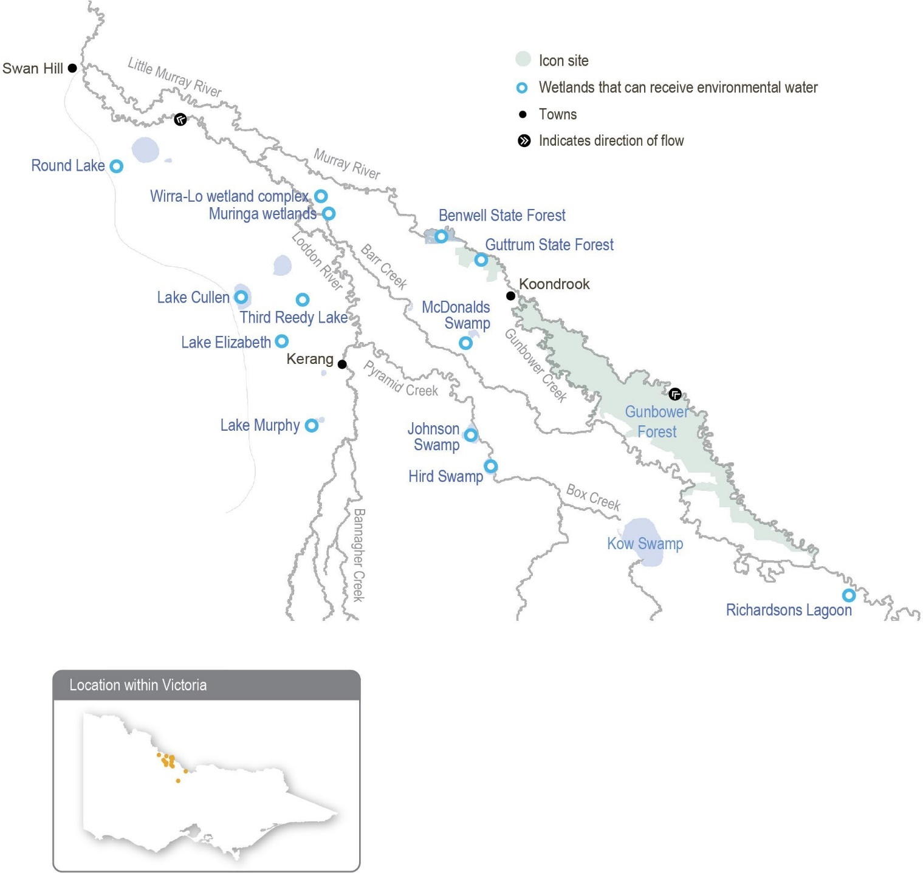

Environmental values
The central Murray wetlands support numerous listed threatened species ranging from vulnerable to critically endangered, including the Australasian bittern, Murray hardyhead, Australian painted snipe, growling grass frog and the southern purple spotted gudgeon, which was presumed extinct in Victoria until it was found at Third Reedy Lake in spring 2019. When the wetlands receive environmental water, they can attract prolific birdlife and provide feeding and breeding habitat for many threatened and endangered bird species (including the eastern great egret and white-bellied sea eagle) listed under legislation and international agreements. Lake Cullen, Hird Swamp, Third Reedy Lake and Johnson Swamp are internationally recognised under the Ramsar Convention, while the other wetlands in the central Murray system have bioregional significance.
Return to start of section

Environmental objectives in the Central Murray wetlands
Maintain populations of small-bodied native fish, including listed threatened (species such as Murray hardyhead)
Maintain populations of the endangered growling grass frog
Maintain populations of common native frogs (such as barking marsh frog, Peron’s tree frog and spotted grass frog)
Maintain populations of native turtles (such as the Murray River turtle and the common long-necked turtle)
Restore and then maintain the health of streamside trees (such as river red gum and black box)
Restore and then maintain mudflat vegetation communities (such as tall marsh, herblands, rushes and sedges)
Restore and then maintain native aquatic vegetation species (such as tassel, foxtail stonewort, milfoil and pondweed)
Reduce the extent and density of invasive plant species
Support a mosaic of wetland plant communities across the region
Provide resting, feeding and breeding habitat for a variety of waterbird feeding guilds, including threatened species (such as Caspian tern, Australasian bittern, little bittern and brolga)
Increase the diversity and biomass of waterbugs

Traditional Owner cultural values and uses
The wetlands and surrounding land in the central Murray region hold great significance for the Traditional Owners: the Barapa Barapa, Wamba Wemba and Yorta Yorta peoples. Their traditional knowledge is a living culture evident throughout the landscape in tree markings, significant cultural sites and cultural tools for cultural practices. The rivers and floodplains are a food and fibre source and contain many sites of significance (such as campsites and meeting places).
Environmental watering supports values including native fish, waterbirds and turtles, and it promotes the growth of culturally important plants that provide food, medicine and weaving materials for Traditional Owner groups. The presence of water itself can be a cultural value, as well as the quality of the water: healthy water promotes a healthy Country.
In early 2023, Barapa Barapa and Wamba Wemba Traditional Owners joined North Central CMA staff on Country to reflect on environmental water management in the central Murray wetlands, including plans for 2023-24. This included a day in Guttrum Forest and another day visiting Johnson Swamp, McDonalds Swamp, Third Reedy Lake and Lake Cullen. Topics of discussion included:
- the impacts of the 2022-23 floods on the wetlands, both positive (such as healthy fringing trees and lignum) and negative (such as carp and hypoxic blackwater)
- the proposed schedule for wetland watering and wetland drying in 2023-24; Barapa Barapa and Wamba Wemba Traditional Owners supported the plans for 2023-24 and noted that floods had provided an important ecological reset for many of the wetlands, and the proposed watering schedule will build on this
- Aboriginal Waterways Assessments (AWAs) and the aspiration for Barapa Barapa and Wamba Wemba Traditional Owners to undertake AWAs at several of the central Murray wetlands in the future during wet and dry phases
- the benefits that water for the environment has delivered to the wetlands over the years. Traditional Owners said that water delivery to Johnson Swamp, combined with tall marsh and lignum slashing, has created a more open-water environment that has attracted waterbirds. Similarly, Traditional Owners involved in tree planting at McDonalds Swamp in 2018 were impressed by the growth of the river red gums and the expansion of lignum and cane grass due to environmental watering
- concerns about the impact of duck hunting on waterbird numbers at several central Murray wetlands and concerns about rabbits harming culturally significant locations at Lake Cullen
- Guttrum Forest (particularly Reed Bed Swamp) and the need to dry it out in the coming months to control carp and allow the removal of protective nets that have helped new vegetation establish. The plan is to deliver environmental water to Reed Bed Swamp in 2023-24 to build on the positive outcomes from previous years (such as the growth of aquatic vegetation and tree canopies).
Return to start of section

Increasing the involvement of Traditional Owners in environmental water management and progressing opportunities towards self-determination in the environmental watering program is a core commitment of the VEWH and its agency partners. This is reinforced by a range of legislation and policy commitments, including the Water Act 1989, the Victorian Aboriginal Affairs Framework, the 2016 Water for Victoria, the Water is Life: Traditional Owner Access to Water Roadmap 2022, and in some cases, agreements under the Traditional Owner Settlement Act 2010.
Where Traditional Owners are more deeply involved in the planning and/or delivery of environmental flows for a particular site, their contribution is acknowledged in Table 5.2.10 with an icon. The use of this icon is not intended to indicate that these activities are meeting all the needs of Traditional Owners, but is incorporated in the spirit of valuing that contribution.

Watering planned and/or delivered in partnership with Traditional Owners to support cultural values and uses
Barapa Barapa and Wamba Wemba input to watering actions for Guttrum Forest in 2023-24
Delivery of water for the environment to Guttrum Forest during 2023-24 has been planned in conjunction with the Barapa Barapa and Wamba Wemba peoples, for whom the wetlands and surrounding forest are places of high cultural significance. Traditional Owners are an important part of Guttrum Forest planning and management and have been directly involved in the delivery of environmental flows to Reed Bed Swamp in 2019-20 and 2021-22. In 2022-23, no environmental water was delivered to Reed Bed Swamp due to large-scale natural flooding.
Barapa Barapa and Wamba Wemba collaborate with waterway managers to ensure that during watering events, their cultural heritage is protected and that the hydrological needs of important cultural values (such as food and medicinal plant species, scar trees and ring trees) are supported through the timing and duration of planned watering actions to the forest.
Table 5.2.9 outlines the values and uses considered in the planning for and management of water for the environment at Guttrum Forest in 2023-24.
Table 5.2.9 Barapa Barapa and Wamba Wemba cultural values and uses at Guttrum Forest

Value/use | Considerations
Food, fibre and medicinal plants | - A winter/spring fill followed by top-ups, as required, will ensure that the duration of wetting will be long enough to support aquatic vegetation during its optimal growth period. Allowing the wetland to draw down before summer will also promote cultural plants on the mudflats in these areas. With annual watering in recent years and natural events like the October 2022 flood, harvesting cultural plants is likely to be possible within a matter of years.
Cultural heritage | - Watering of Reed Bed Swamp supports fringing large old trees, including a couple of ring trees and scar trees. The condition of these trees was seen to improve following previous watering.
Spiritual wellbeing | - The improvement in the condition of the wetland and the presence of water and moisture contribute to a sense of spiritual wellbeing.
Sharing cultural knowledge | - The Traditional Owners provide support and advice about what ecological values to target: that is, they provide information about what the wetland used to look like and what values it previously supported.  - Traditional Owners have been present during the set-up of infrastructure and have been able to advise about avoiding impacts on their cultural heritage.
Employment opportunities | - Traditional Owners want to become more involved in the management of their Country through increased employment opportunities (such as ecological and cultural monitoring). This has occurred as part of previous watering of Reed Bed Swamp.
Cultural landscape | - Maintaining the open-water habitat and mudflats underneath will be difficult if the river red gum saplings that germinated in recent floods are not removed. This is important for maintaining the cultural landscape and access to food and medicinal resources.
Cultural practice | - In 2019-20 when water for the environment was first delivered in Guttrum Forest, a smoking ceremony and celebration were held to welcome the water back to the wetland. The Traditional Owners have indicated that this should be a regular activity each year when water is delivered, as it is something that their ancestors would have done when the floodwaters arrived and would represent a restoration of an important cultural practice.  - Another priority in 2023-24 is to provide more opportunities for women to return to Country and undertake cultural practices such as weaving, emu egg carving and discussion of the wetlands’ health as it relates to women’s business.
Return to start of section

Social, recreational and economic values and uses
In planning the potential environmental watering actions in Table 5.2.10, the North Central CMA considered how environmental flows could support values and uses, including:
- waterway recreation (such as canoeing, fishing, kayaking, swimming and water sports)
- waterway recreation and amenity (such as birdwatching, duck hunting, camping, cycling, running and walking)
- community events and tourism (such as visitation during the hunting and fishing seasons, Breakfast with the Birds events [hosted annually by the North Central CMA] and supporting Aboriginal cultural heritage and history-based tours)
- socioeconomic benefits (such as ecosystem services like groundwater recharge, flood mitigation, nutrient treatment, carbon storage and stock and domestic uses).

Scope of environmental watering
The term ‘environmental watering’ refers to the active delivery of held environmental water to support particular environmental objectives by altering the flow in a river or the water level in a wetland. While other terms are sometimes used to describe the delivery of environmental water, ‘environmental watering’ is deliberately used here and in seasonal watering statements to ensure consistency in the legal instruments that authorise the use of water for the environment in Victoria.
Table 5.2.10 describes the potential environmental watering actions in 2023-24, their expected watering effect (that is, the intended physical or biological effects of the watering action) and the longer-term environmental objectives they support. Each environmental objective relies on one or more potential environmental watering actions and their associated physical or biological effects.
Table 5.2.10 Potential environmental watering actions, expected watering effects and associated environmental objectives for the central Murray wetlands

Potential environmental watering action | Expected watering effects | Environmental objectives
Guttrum Forest (fill in winter/spring, top-ups as required in spring/ summer) | - Wet the fringing adult river red gums to support their growth and drown river red gum saplings within the wetland bed to maintain open-water habitat  - Promote the growth and re-establishment of aquatic vegetation and tall marsh vegetation at the fringe of the wetland  - Maintain the depth of the wetland to support frogs and waterbird feeding and breeding
Guttrum Forest (partial fill in autumn/winter 2024) | - Inundate existing adult river red gums to support their growth, and drown river red gum saplings in the open-water habitat  - Increase the water depth and extent to trigger wetland plants to germinate in late winter and when follow-up watering is provided in early spring 2024  - Provide feeding and refuge habitat for waterbirds and frogs
Hird Swamp (partial fill in autumn) | - Drown terrestrial weeds to limit their growth and reduce their extent  - Promote the germination and establishment of aquatic vegetation  - Inundate the wetland fringe to provide habitat for waterbirds, frogs and turtles and provide conditions suitable for macroinvertebrates that are food for waterbirds
Kunat Kunat (fill in spring, top-ups as required) | - Maintain salinity within 15,000-80,000 EC and water depth to support suitable habitat and breeding conditions for Murray hardyhead  - Restore and maintain submerged aquatic plants  - Maintain the water depth to provide permanent feeding, foraging and refuge habitat for waterbirds
Lake Cullen (top-ups as required) | - Provide feeding, breeding and refuge habitat for waterbirds  - Inundate the wetland to provide suitable conditions for submerged plants  - Provide suitable conditions for macroinvertebrates to grow and complete their life cycles

Potential environmental watering action | Expected watering effects | Environmental objectives
Lake Elizabeth (fill in spring, top-ups as required) | - Maintain salinity within 15,000-80,000 EC and water depth to support suitable habitat and breeding conditions for Murray hardyhead  - Restore and maintain submerged aquatic plants  - Maintain the water depth to provide permanent feeding, foraging and refuge habitat for waterbirds
McDonalds Swamp (partial fill in autumn) | - Drown terrestrial weeds to limit their growth and reduce their extent  - Promote the germination and establishment of aquatic vegetation  - Inundate the wetland body and fringe to provide habitat for waterbirds, frogs and turtles and provide conditions suitable for macroinvertebrates that are food for waterbirds, frogs and turtles  - Support the growth of planted river red gums and other aquatic and herbland vegetation
Muringa wetlands  (fill in spring or autumn, top-ups as required) | - Support the growth of aquatic and semi-aquatic plants  - Increase the area of habitat and grow zooplankton and waterbug communities to provide food resources for frogs and waterbirds
Wirra-Lo wetlands1: Brolga Swamp (fill in winter/spring, top-ups as required) | - Inundate established aquatic vegetation and maintain the large population of growling grass frogs
Wirra-Lo wetlands: Bunyip Swamp East (fill in winter/spring, top-ups as required) | - Inundate established reed beds to stimulate their growth to create feeding and nesting habitat for Australasian bittern
Wirra-Lo wetlands: Cattleyard Creek (fill in winter/spring, top-ups as required) | - Inundate river red gum woodland trees to promote their growth and improve their condition  - Promote the germination and establishment of aquatic vegetation
Wirra-Lo wetlands: Duck Creek North (fill in winter/spring, top-ups as required) | - Inundate river red gum woodland trees to promote their growth and improve their condition  - Inundate the aquatic and herbland vegetation to promote its growth and increase its extent  - Maintain open-water and associated mudflat habitats for waterbirds to feed and breed
Wirra-Lo wetlands: Emu Creek (fill in winter/ spring, top-ups as required) | - Inundate black box and lignum along the creekline to improve their condition  - Promote the germination and growth of aquatic vegetation in the deeper sections of the wetland to support frogs and freshwater turtles
Wirra-Lo wetlands:  Red Gum Swamp (fill in winter/spring, top-ups as required) | - Inundate established river red gum trees to promote their growth and maintain their condition  - Inundate habitat to provide feeding and breeding opportunities for frogs, waterbirds and turtles

1 Watering of the various wetlands within the Wirra-lo complex occurs via Raniformis Creek, which is likely to benefit the small-bodied native fish that live in the creek.
Return to start of section

Scenario planning
Table 5.2.11 outlines potential environmental watering and expected water use in a range of planning scenarios.

The widespread floods in spring 2022 filled most wetlands across the central Murray floodplain, triggering widespread waterbird, frog and fish (including carp) breeding. The floods also improved the condition of established black box, river red gum and lignum communities, but the combination of prolonged deep inundation, the high abundance of carp and poor water quality – water with high turbidity and low oxygen – contributed to poorer-than-expected responses by submerged aquatic vegetation at some sites.
Environmental watering across the central Murray wetlands in 2023-24 will primarily aim to maintain habitat for endangered species, provide foraging habitat for juvenile and subadult waterbirds, reduce the biomass of carp where possible and improve submerged aquatic vegetation communities at sites that had poorer-than-expected responses to the 2022 floods. Providing foraging and resting habitat for waterbirds near recent breeding sites is particularly important because the high mortality of juvenile and subadult waterbirds is the likely reason why large breeding events during other large floods have not significantly grown waterbird populations across the Murray-Darling Basin. Potential watering actions across the central Murray wetlands in 2023-24 aim to create a mosaic of available habitats across the region, with some wetlands drawing down to provide shallow foraging habitat, and then dry-phase ecological processes and others being topped up to maintain deep-water habitat in the landscape. The proposed watering actions are consistent across all potential planning scenarios in 2023-24 to support this strategy, although the volume required to achieve them will be greater in the drier planning scenarios than in the average and wet scenarios.
Watering actions proposed for Kunat Kunat and Lake Elizabeth are needed every year to maintain permanent habitat for the endangered Murray hardyhead. Some wetlands within the Wirra-Lo wetlands complex also require water every year to support endangered species (such as Australasian bittern and growling grass frog) and to maintain red gum and improve aquatic vegetation communities.
Lake Cullen is a large, internationally significant wetland that is known to support very large numbers of waterbirds. Top- ups of water for the environment will be delivered to maintain habitat around the tall marsh at the northern end of the lake to encourage further bird breeding.
Many wetlands across the landscape are expected to dry out over the next 12 to 24 months. These wetlands will provide important foraging habitat for waterbirds during their drawdown phase, and drying for any duration will eliminate carp.
However, extended drying for six to 24 months is needed in some wetlands to allow native vegetation (such as lake-bed herbland communities) to germinate and set seed and to support soil health as well as carbon and nutrient cycles. Wetlands that have previously received water for the environment and that will be allowed to partially or fully draw down during 2023-24 include Lake Murphy, Third Reedy Lake, Johnson Swamp and Richardson’s Lagoon. Many other highly productive wetlands in the region that filled in spring 2022 and are not within the environmental watering program (such as Bael Bael, Koorangie Marshes and Lake Tutchewop) will also begin to dry.
Muringa wetlands, Hird Swamp and McDonalds Swamp are planned to have a drying phase in 2023, ahead of partial or complete fills. Muringa wetlands need to be watered in spring or autumn to help establish the native vegetation that was planted in recent years, but the wetland will be allowed to draw down first to eliminate carp. Hird Swamp will also be allowed to dry to reduce carp and then partially filled in autumn to improve the condition of aquatic vegetation that suffered during the 2022 floods. A partial fill is also planned for McDonalds Swamp in autumn 2024 under drought to average planning scenarios to provide fresh foraging habitat for waterbirds. Watering McDonalds Swamp is a lower priority in the wet planning
scenario because other wetlands in the region, including Bael Bael, Koorangie Marshes and Lake Tutchewop, although highly productive wetlands, are outside the environmental watering program and are likely to retain enough water to provide sufficient waterbird habitat across the region.
In Guttrum Forest, Reed Bed Swamp needs to dry out to reduce carp biomass and allow native mudflat vegetation communities to germinate. The swamp is relatively shallow and dries relatively quickly. If the swamp dries early enough in the year, it will be filled in winter-spring to improve the condition of aquatic vegetation that suffered during the 2022 floods. It will be allowed to dry again over summer 2023-24 and then partially filled in autumn-winter 2024 as part of a longer (six-month) watering action. The Traditional Owners prefer a longer watering action, and it will aim to improve outcomes for large old river red gums by replenishing soil moisture around the wetland fringe and preventing river red gums from becoming established in the open wetland.
Priority carryover for 2024-25 of 7,500 ML is essential to maintain water at sites for endangered fish and frogs and to provide a mosaic of refuge wetlands across the region.
Return to start of section

Table 5.2.11 Potential environmental watering for the Central Murray wetlands in a range of planning scenarios

Planning scenario | Drought | Dry | Average | Wet
Expected conditions | - Catchment run-off and natural flow into the wetlands are highly unlikely | - Catchment run-off and natural flow into the wetlands are unlikely | - Catchment run-off and natural flow into the wetlands are possible, particularly in winter/spring | - Catchment run-off and natural flow into the wetlands are likely, with potential flooding in some wetlands, particularly in winter/spring
Potential environmental watering – tier 1 (high priorities) | - Guttrum Forest (winter/spring fill and top-ups)  - Guttrum Forest (autumn/winter partial fill)  - Hird Swamp  - Kunat Kunat  - Lake Cullen  - Lake Elizabeth  - McDonalds Swamp  - Muringa wetlands  - Wirra-lo wetlands | - Guttrum Forest (winter/spring fill and top-ups)  - Guttrum Forest (autumn/winter partial fill)  - Hird Swamp  - Kunat Kunat  - Lake Cullen  - Lake Elizabeth  - McDonalds Swamp  - Muringa wetlands  - Wirra-lo wetlands | - Guttrum Forest (winter/spring fill and top-ups)  - Guttrum Forest (autumn/winter partial fill)  - Hird Swamp  - Kunat Kunat  - Lake Cullen  - Lake Elizabeth  - McDonalds Swamp  - Muringa wetlands  - Wirra-lo wetlands | - Guttrum Forest (winter/spring fill and top-ups)  - Guttrum Forest (autumn/winter partial fill)  - Hird Swamp  - Kunat Kunat  - Lake Cullen  - Lake Elizabeth  - Muringa wetlands  - Wirra-lo wetlands
Potential environmental watering – tier 2 (additional priorities) | - N/A | - N/A | - N/A | - McDonalds Swamp
Possible volume of water for the  environment required to achieve objectives | - 12,370 ML | - 10,510 ML | - 10,210 ML | - 8,410 ML  - 400 ML (tier 2)
Priority carryover requirements for 2024-25 | - 7,400 ML

Hattah Lakes
System overview
The Hattah-Kulkyne National Park is situated in north-west Victoria, adjacent to the Murray River (Figure 5.2.4). The national park contains a complex of more than 20 semi-permanent freshwater lakes known collectively as the Hattah Lakes.
The ecology of the Hattah Lakes and the surrounding floodplain is strongly influenced by the flooding regimes of the Murray River. The system fills when there is high flow in the Murray River, and some lakes hold water for several years after floods recede. Regulation of the Murray River has significantly reduced the frequency and duration of small to medium-sized natural floods in the Hattah Lakes system. Over time, this has degraded vegetation communities and reduced the diversity and abundance of animals that use the vegetation and wetlands for habitat and food.
The Hattah Lakes complex can be broadly divided into the southern Hattah Lakes, which contain permanent to semi- permanent wetlands, and the higher-elevation northern Hattah Lakes, which are mostly episodic wetlands.
The Messenger, Oateys and Cantala regulators allow water to flow between the Murray River and the Hattah Lakes. When the flow in the Murray River is about 26,000 ML per day, water begins to flow through Messengers regulator into Chalka Creek and through the Hattah Lakes complex. A permanent pump station can deliver up to 1,000 ML per day to the southern Hattah Lakes through Chalka Creek. The regulators and pump station are used in combination with several small constructed levees to deliver a pattern of flooding to the lakes system that is recommended to improve environmental outcomes. Lake Kramen is in the south-east area of Hattah-Kulkyne National Park and is disconnected from the main Hattah Lakes complex. The Hattah
Lakes pump station can deliver up to 145 ML per day to Lake Kramen. New infrastructure proposed under the Victorian Murray Floodplain Restoration Project will allow water to reach additional wetlands and floodplain areas in the northern Hattah Lakes.
Return to start of section

Figure 5.2.5 Hattah Lakes
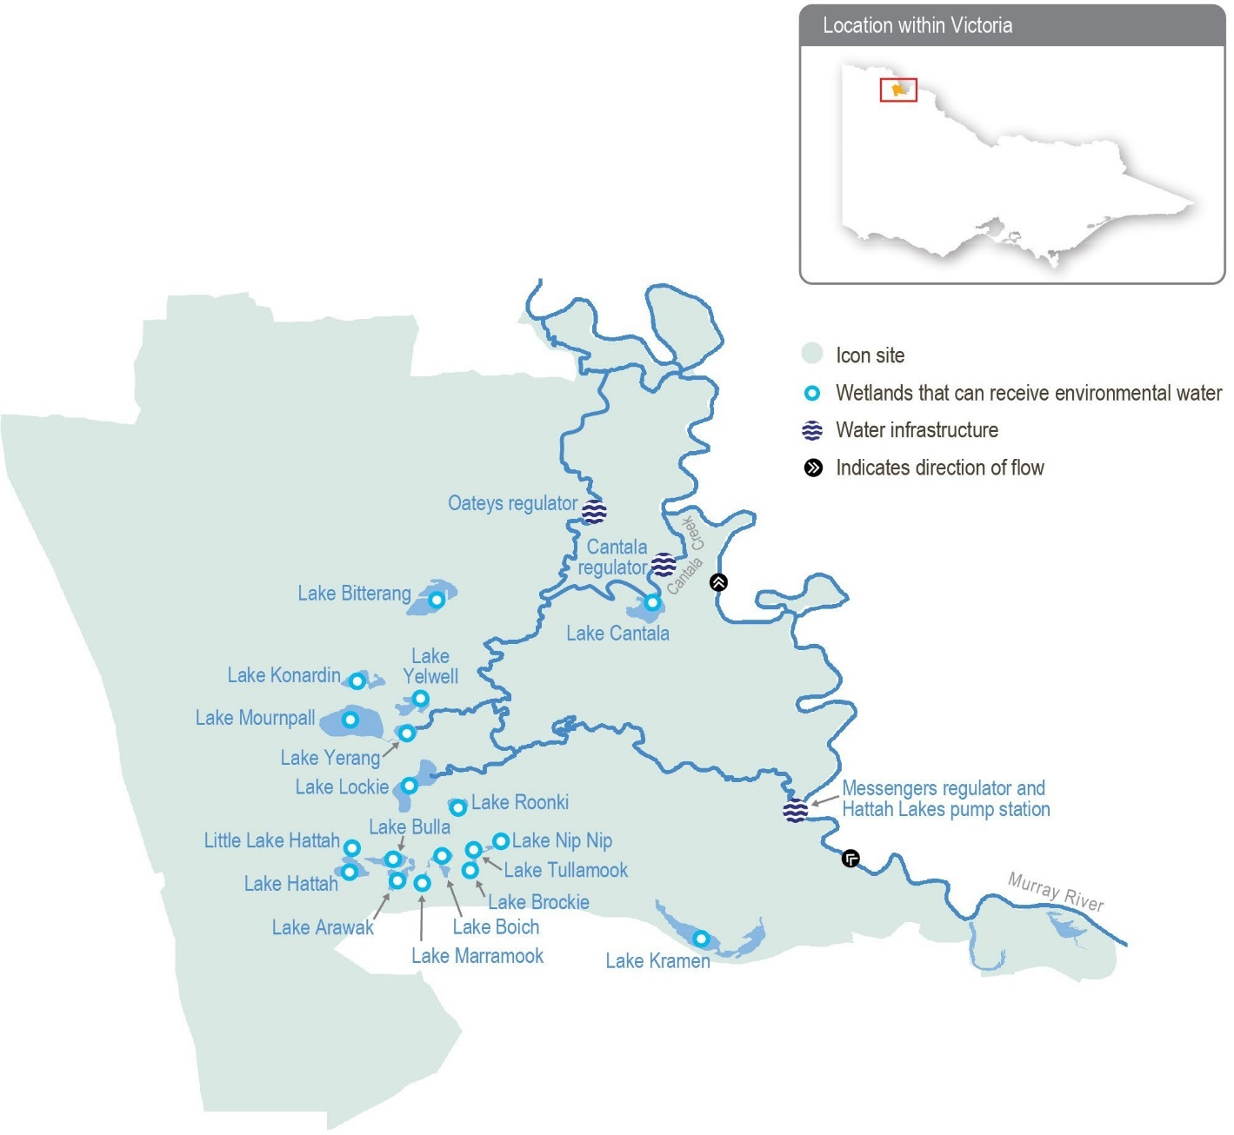

Return to start of section

Environmental values
Hattah Lakes is home to a diverse range of flood-dependent vegetation that changes with the topography of the landscape. Vegetation types range from wetland communities in low-lying areas that require almost annual flooding to lignum and black box communities situated higher on the floodplain that only need flooding once every four to five years (on average).
A combination of natural flooding and the delivery of environmental flows since 2010 has improved tree canopy health and recruitment of black box and river red gum communities throughout the Hattah Lakes. Woodland birds, including the endangered regent parrot, have benefitted from improved tree health.
Hattah Lakes provides important waterbird breeding sites in an arid landscape. A total of 34 species of waterbirds are known to breed at the lakes when conditions are suitable. Another six species of waterbirds breed in the surrounding floodplain.
Wetland drought refuge sites are limited in the region, making the Hattah Lakes critically important for water-dependent flora, waterbirds and terrestrial animals during dry periods.
The Hattah Lakes support large-bodied native fish species (such as golden perch) and small-bodied wetland species (such as carp gudgeon). Fish move between the lakes and the Murray River when the flow is suitable. They also persist in wetlands that retain water in the Hattah Lakes during dry years before re-dispersing during floods.

Environmental objectives in the Hattah Lakes
Maintain populations of small-bodied and large-bodied native fish at the Hattah Lakes
By 2030, improve the function of water-dependent ecosystems by improving productivity linkages between the river and floodplain/wetland habitats
By 2030, improve the richness of species and the abundance of native water-dependent floodplain and wetland aquatic vegetation
By 2030, maintain the extent and improve the condition of river red gum, black box and lignum, compared to 2006 baseline levels
Maintain the regional waterbird population by providing conditions for breeding and fledging at least three times every 10 years
Maintain the regional waterbird population by providing refuge during droughts
Maintain a variety of freshwater ecosystem types within the Hattah Lakes icon site, including semi-permanent lakes, persistent temporary wetlands, floodplain woodlands, shrublands and episodic wetlands

Traditional Owner cultural values and uses
The Hattah Lakes system is part of a highly sensitive region for Aboriginal cultural values and lies on the border of two documented language groups, the Latji Latji and the Jari Jari. Groups with an interest in Hattah Lakes include Latji Latji, Latji Latji Mumthelang, Tati Tati Kaiejin, Tati Tati Land and Water, Wadi Wadi Land and Water, Murray Valley Aboriginal Corporation, Gilby, Dadi Dadi Weki Weki, Culpra Millee, Nyeri Nyeri and Munatunga Elders.
More than 1,000 Aboriginal archaeological sites at the Hattah Lakes are registered on the Aboriginal Cultural Heritage Register and Information System, with the freshwater lakes and wetlands providing focal points for trade and cultural exchanges among the region’s Traditional Owners. Local Aboriginal communities maintain strong connections to the land and its resources, such as native species used for food and medicine.
In early 2023, the Mallee CMA met with representatives of Latji Latji, Nyeri Nyeri, Dadi Dadi Weki Weki, Wadi Wadi Land and Water, Culpra Millee, Munatunga and Murray Valley Aboriginal Corporation to discuss the history of inundations and delivery to the lakes, as well as environmental water planning for 2023-24 and beyond. Groups invited to discussions included Latji Latji Mumthelang, Tati Tati Kaiejin, Tati Tati Land and Water and Gilby.
Return to start of section

Discussions covered the planning of water for the environment and Traditional Owners’ interests and aspirations for the Hattah Lakes region, including:
- the history of inundation and deliveries, including the environmental outcomes of previous deliveries and recent natural flooding
- the impacts of recent natural flooding on environmental and cultural values and ways that Traditional Owners can be involved in viewing and assessing these impacts
- areas where environmental flows are planned for 2023-24, the quantity of water to be delivered and the planned environmental outcomes from it
- projects planned or underway, including the northern Hattah Lakes Victorian Murray Floodplain Restoration Project and ecological monitoring being undertaken across Hattah Lakes through the Living Murray program
- the spiritual importance of water in the landscape: water connects people to the landscape and culture.

Social, recreational and economic values and uses
In planning the potential environmental watering actions in Table 5.2.12, the Mallee CMA considered how environmental flows could support values and uses, including:
- water-based recreation (such as fishing, kayaking and swimming)
- riverside recreation and amenity (such as birdwatching, camping, photography and walking)
- community events and tourism (educational opportunities, including bushwalking, birdwatching and bug hunting; local school education programs; Melbourne-based schools’ educational excursions; and tours involving kayaking, bike riding and camping)
- socioeconomic benefits (such as commercial beekeepers who rest bees away from horticultural orchards in native flowering trees around the lake, multiple ecotourism operators who benefit directly when the lakes contain water, social wellbeing from connecting with nature, and social gatherings).

Scope of environmental watering
The term ‘environmental watering’ refers to the active delivery of held environmental water to support specific environmental objectives by altering the flow in a river or the water level in a wetland. While other terms are sometimes used to describe the delivery of environmental water, ‘environmental watering’ is deliberately used here and in seasonal watering statements to ensure consistency in the legal instruments that authorise the use of water for the environment in Victoria.
Table 5.2.12 describes the potential environmental watering actions in 2023-24, their expected watering effect (that is, the intended physical or biological effects of the watering action) and the longer-term environmental objectives they support. Each environmental objective relies on one or more potential environmental watering actions and their associated physical or biological effects.
Table 5.2.12 Potential environmental watering actions, expected watering effects and associated environmental objectives for the Hattah Lakes

Potential environmental watering action1 | Expected watering effects | Environmental objectives
Southern Hattah Lakes (top-ups of selected wetlands to 42.5 m AHD during autumn) | - Stimulate the growth and improve the condition of river red gums fringing wetlands.  - Provide feeding habitat for waterbirds  - Stimulate new growth of aquatic vegetation  - Inundate dry areas of wetlands to release carbon and nutrients to increase food web productivity  - Provide spawning and recruitment habitat for small-bodied native fish and nursery habitat for large-bodied native fish (such as golden perch)  - Inundate a variety of wetland types at different elevations across the Hattah Lakes to increase habitat diversity
1 In consultation with the VEWH, the Mallee CMA and Parks Victoria, the Hattah Lakes pump station may be operated at any time of year by Goulburn-Murray Water for testing, following pump maintenance and repairs. Water held by the Living Murray Program will be used if testing is required.
Return to start of section

Scenario planning
Table 5.2.13 outlines potential environmental watering and expected water use in a range of planning scenarios.

The floods in spring 2022 were the largest in the Mallee since 1956, and they inundated the entire Hattah Lakes and surrounding floodplain. A drawdown period of 12 to 18 months across the Hattah Lakes system will allow native plants within lake-bed herbland communities to grow on exposed soils as water recedes and provide foraging habitat for wading shorebirds.
The northern Hattah Lakes Victorian Murray Floodplain Restoration Project is currently going through an environmental approvals process. If approved, the new infrastructure will likely be commissioned in 2024-25. During commissioning, about 100 GL of environmental water will be pumped from the Hattah pump station over a three-to-four-month period.
It is operationally important to retain water in the semipermanent wetlands of southern Hattah Lakes in the lead-up to commissioning, so deliveries in 2024-25 can efficiently pass through the southern system and fill the northern Hattah Lakes. This requirement has influenced planned watering actions at Hattah Lakes for 2023-24.
No deliveries of water for the environment are planned at Hattah Lakes in the first half of 2023-24. About 10,000 ML of water for the environment may be used in autumn 2024 in the dry and average planning scenarios to top up the semi-permanent wetlands within the southern Hattah Lakes system to 42.5 m AHD. These top-ups will be timed to occur at the end of the recommended drawdown period to release carbon and nutrients to stimulate food production for fish and birds and to prime the system ahead of larger deliveries planned for 2024-25.
In the wet planning scenario, large-scale natural floods are expected to inundate large parts of the Hattah Lakes and floodplain. This may happen at any time of year but is most likely during winter or spring.
No active watering is proposed in the drought planning scenario. Water from the 2022 floods is likely to persist in some of the Hattah Lakes throughout 2023-24 without additional top-ups, and will provide regional refuge habitat for waterbirds and for some fish that moved into the Hattah Lakes during the floods. There is little value in trying to deliver extra water in the drought planning scenario to trigger plant and animal growth and reproduction because there may not be sufficient resources within the landscape to sustain new life.
Table 5.2.13 Potential environmental watering for the Hattah Lakes system in a range of planning scenarios

Planning scenario | Drought | Dry | Average | Wet
Expected river conditions | - Year-round low flow in the Murray River and no natural inflow to the Hattah Lakes; substantial wetland drying will occur | - Rare high-flow events in the Murray River and no natural inflow to the Hattah Lakes | - Short periods of high flow in the Murray River with minor spills from storages, most likely in late winter/ spring, providing minor natural inflow to the Hattah Lakes | - Lengthy periods of high flow in the Murray River with major spills from storages resulting in widespread inundation of the Hattah Lakes and floodplain
Potential environmental watering – tier 1 (high priorities) | - N/A | - Southern Hattah Lakes autumn top-up to  42.5 m AHD targeting semi-permanent wetlands |  | - All structures will be opened to allow natural flow to fill Hattah Lakes and floodplain
Possible volume of water for the  environment required to achieve objectives | - N/A | - 10,000 ML |  | - 0 ML
Priority carryover requirements for 2024-25 | - 100 GL for extensive floodplain watering of southern and northern Hattah Lakes
Return to start of section

Lower Murray wetlands
System overview
The lower Murray wetlands are dispersed across the Murray River floodplain between Swan Hill and the South Australian border. The system includes a myriad of interconnected creeks, wetlands and floodplains that are ecologically important and reflect the natural character and attributes of the floodplain. While there are hundreds of wetlands across the lower Murray region, only 54 of them have received water for the environment to date.
Regulation and diversion of the Murray River flow have substantially reduced the frequency and duration of the high river flow that would naturally water the lower Murray wetlands. This change to the water regime has been exacerbated by climate change and has reduced the variety and condition of environmental values associated with billabongs and other floodplain habitats.
Water for the environment can be delivered to some wetlands in the region through direct pumping from the Murray River and/ or the use of irrigation supply infrastructure. Most wetlands that receive environmental flows can be managed independently of each other.
Figure 5.2.6 The lower Murray wetlands system

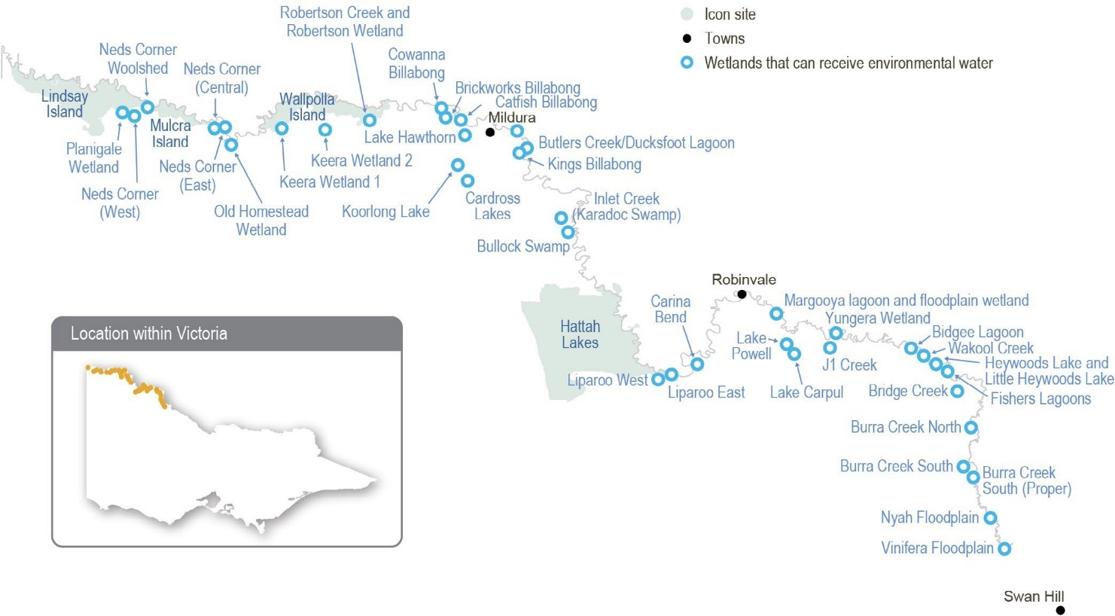

Return to start of section

Environmental values

Environmental objectives in the lower Murray wetlands
Increase the populations of Murray hardyhead in permanent wetlands where they are known to persist Maintain populations of other native fish in permanent wetlands
Maintain populations of native frogs, including the endangered growling grass frog
Promote carbon and nutrient cycling to enable wetland processes for food webs
Increase the diversity, extent and abundance of wetland plants
Improve the condition of river red gums, black box and lignum communities
Provide feeding and breeding habitat for a range of waterbird species, including threatened and migratory species and colonial nesting species (such as egrets)

Traditional Owner cultural values and uses
Watering of the lower Murray wetlands supports cultural values such as traditional food sources and medicines and important species, and it provides opportunities for teaching, learning and storytelling.
The Mallee CMA discussed the proposed 2023-24 watering of the lower Murray wetlands with the First People of the Millewa- Mallee Aboriginal Corporation, Latji Latji Mumthelang, Tati Tati Land and Water, Wadi Wadi Land and Water, Murray Valley Aboriginal Corporation, Gilby, Dadi Dadi Weki Weki, Culpra Millee and Munatunga Elders. Tati Tati Kaiejin was invited to discussions.
Discussions covered a range of options for the delivery of environmental flows in 2023-2024 and what the traditional ecological needs are in the current climate. Feedback was positive, with groups in discussions agreeing to the needs and reasoning behind environmental watering. Drawdown and drying were strongly supported in many cases. Understanding the environmental responses to the recent flooding and identifying and protecting cultural heritage were key topics for discussion. A common foundation of all groups was the importance of water in wetlands for their cultural spirituality and connection to Country.

Social, recreational and economic values and uses
In planning the potential environmental watering actions in Table 5.2.14, the Mallee CMA considered how environmental flows could support values and uses, including:
- water-based recreation (such as canoeing, fishing and kayaking)
- riverside recreation and amenity (such as bike riding, birdwatching, bushwalking, camping, geocaching, photography and running)
- community events and tourism (such as day trips and sightseeing; education programs for school, TAFE and university students; citizen science projects about birds, frogs and bats; and sporting events)
- socioeconomic benefits (such as economic benefits for businesses in the accommodation, beekeeping, food and beverage, ecotourism, hospitality and retail sectors; creating a focal point for socialising; and providing natural, green spaces for the local community).

Scope of environmental watering
The term ‘environmental watering’ refers to the active delivery of held environmental water to support particular environmental objectives by altering the flow in a river or the water level in a wetland. While other terms are sometimes used to describe the delivery of environmental water, ‘environmental watering’ is deliberately used here and in seasonal watering statements to ensure consistency in the legal instruments that authorise the use of water for the environment in Victoria.
Table 5.2.14 describes the potential environmental watering actions in 2023-24, their expected watering effect (that is, the intended physical or biological effects of the watering action) and the longer-term environmental objectives they support. Each environmental objective relies on one or more potential environmental watering actions and their associated physical or biological effects.
Return to start of section

Table 5.2.14 Potential environmental watering actions, expected watering effects and associated environmental objectives for the lower Murray wetlands

Potential environmental watering action | Expected watering effects | Environmental objectives
Brickworks Billabong (fill in spring/summer,  top-ups as required over summer/autumn) | - Maintain water levels (the target water level is between 30.8 m AHD and 31.6 m AHD) to inundate ruppia beds, provide nursery habitat for Murray hardyhead and provide high levels of aquatic productivity  - Maintain water quality suitable for Murray hardyhead  - Provide shallow-water habitat and exposed mudflats to support foraging and resting waterbirds, including migratory waterbirds
Catfish Billabong (fill in winter/spring) | - Fill to 33.5 m AHD to inundate fringing woodland vegetation to improve condition and recruitment  - Allow water level to draw down over summer and autumn to:  - promote the growth of a range of aquatic macrophytes that favour different water depth and inundation patterns  - provide suitable foraging conditions for wading shorebirds  - Maintain water levels above 30.8 m AHD to maintain permanent habitat for large-bodied and small-bodied native fish
Koorlong Lake (top-up in spring, then as required) | - Increase and maintain the water level (the target water level is between 36.7 m AHD and 38.0 m AHD) to support the growth of saline aquatic vegetation, including ruppia, to provide nursery habitat for Murray hardyhead and provide high levels of aquatic productivity  - Maintain water levels within a 1.3 m range to provide feeding resources for shorebirds and to maintain the Murray hardyhead population
Lake Hawthorn (top- ups in spring, then as required over summer/ autumn) | - Maintain water level between 33 m AHD and 33.3 m AHD to encourage the germination and growth of saline aquatic vegetation, including ruppia, and provide mudflat and shallow-water feeding habitat for shorebirds
Robertson Wetland (fill in spring) | - Wet fringing river red gum, black box, lignum and vegetation communities (the target water level is 28.4-28.8 m AHD) to improve their condition  - Inundate cane grass beds to improve their condition and resilience  - Provide a range of open-water, shallow-water and inundated lignum habitat to provide waterbird feeding opportunities
Wakool Creek (fill in spring) | - Inundate and wet outer fringing lignum and vegetation communities (the target water level is 55.4 m AHD) to improve their condition  - Inundate habitat to provide feeding and breeding opportunities for frogs and waterbirds
Scenario planning
Table 5.2.15 outlines potential environmental watering and expected water use in a range of planning scenarios.
Brickworks Billabong, Catfish Billabong, Koorlong Lake and Lake Hawthorn are priorities for watering in 2023-24 in all planning scenarios. Koorlong Lake supports an endangered population of Murray hardyhead, and it requires top-ups each year to ensure salinity levels are maintained within an acceptable range to support submerged vegetation that provides habitat for
the fish. Brickworks Billabong is being managed with a view of returning Murray hardyhead to it in the future. A population of Murray hardyhead that was translocated to Lake Hawthorn in 2018 has not persisted, but the site is prioritised to receive water in all planning scenarios because it provides saline habitat and feeding resources for shorebirds. Catfish Billabong is a new site that supports populations of native fish and wading shorebirds. Construction of a new regulator at Catfish Billabong was delayed in 2022-23 due to floods in the Murray River. Watering is prioritised at this site in all planning scenarios to test the capacity of the new infrastructure to achieve the recommended watering regime.
Wakool Creek and Robertson Wetland are included in the lower Murray wetlands program under dry, average and wet planning scenarios. Both sites were naturally filled during floods in 2022, and the condition of vegetation surrounding the wetlands has improved. However, water drains and evaporates quickly from each site, and a second consecutive year of watering is recommended to enhance the regeneration of black box trees so they can sustain future dry periods. Temporary pumps will be used to deliver water and achieve the objectives in the dry and average planning scenarios. If conditions are wet, it is likely that a high flow in the Murray River will naturally fill both sites.
Return to start of section

All other sites in the lower Murray wetlands will be allowed to draw down during 2023-24, unless they are naturally flooded, to support dry-phase ecosystem processes in accordance with recommendations in their management plans.
It is a high priority to carry over 1,900 ML into 2024-25 for Brickworks Billabong and Koorlong Lake. These sites need top- ups each year to sustain threatened fish populations, as does Lake Hawthorn, which requires top-ups each year to maintain suitable conditions for waterbirds and aquatic vegetation.
Table 5.2.15 Potential environmental watering for the lower Murray wetlands in a range of planning scenarios

Planning scenario | Drought | Dry | Average | Wet
Expected conditions | - Natural flow in the Murray River is too low to connect to wetlands  - Very low rainfall year-round and extremely hot and dry conditions in summer/autumn cause substantial wetland drying  - Wetlands rely on the delivery of water for the environment | - Short periods of high flow in the Murray River are possible, but overbank flow  to wetlands is unlikely; low rainfall and very warm summer/autumn  - Wetlands rely on the delivery of water for the environment | - Sustained periods of high flow in the Murray River in late winter and early spring may wet some low-lying wetlands, but most wetlands will rely on water for the environment  - Local rainfall may be high and provide run-off to some wetlands | - Lengthy periods of high flow  and floods with major spills from storages, resulting in widespread wetting of the floodplain and most wetlands  - Some reliance on water for the environment to achieve target water levels  - Local rainfall may be high and will provide run-off to most wetlands
Potential environmental watering – tier 1 (high priorities)1 | - Brickworks Billabong  - Catfish Billabong  - Koorlong Lake  - Lake Hawthorn | - Brickworks Billabong  - Catfish Billabong  - Koorlong Lake  - Lake Hawthorn  - Robertson Wetland  - Wakool Creek | - Brickworks Billabong  - Catfish Billabong  - Koorlong Lake  - Lake Hawthorn  - Robertson Wetland  - Wakool Creek | - Brickworks Billabong  - Catfish Billabong  - Koorlong Lake  - Lake Hawthorn  - Robertson Wetland  - Wakool Creek
Possible volume of water for the  environment required to achieve objectives1 | - 2,800 ML (tier 1) | - 3,700 ML (tier 1) | - 3,700 ML (tier 1) | - 2,800 ML (tier 1)
Priority carryover requirements for 2024-25 | - 1,900 ML
1 Tier 1 potential environmental watering at the lower Murray wetlands is not classified as tier 1a or 1b because the water available for use is shared across various systems, and it is not possible to reliably determine the supply specifically available for the lower Murray wetlands.
Return to start of section

Lindsay, Mulcra and Wallpolla islands
System overview
Lindsay, Mulcra and Wallpolla islands cover over 26,100 ha of Victorian floodplain in the Murray-Sunset National Park (see Figure 5.2.6). They form part of the Chowilla Floodplain and Lindsay-Wallpolla islands icon site that straddles the Victoria–South Australia-New South Wales border in the mid-Murray River system.
The Lindsay, Mulcra and Wallpolla islands floodplain is characterised by a network of permanent waterways, small creeks and wetlands. The Lindsay River, Potterwalkagee Creek and Wallpolla Creek form the southern boundaries of the site and create large floodplain islands with the Murray River to the north.
In their natural state, these waterways and wetlands would regularly flow and fill in response to high water levels in the Murray River. Large floods still occur, but major storages in the upper reaches of the Murray River system and extraction for consumptive use have reduced the frequency of small to moderate-sized floods.
Flows in the mid-Murray River system are regulated through a series of weir pools. The weir pools are colloquially called locks in reference to structures at the weirs that allow vessels to navigate from one weir pool to the next. The weir pools are primarily managed as small water storages to ensure adequate water levels for off-stream diversion via pumps and regulated channels.
Water is diverted from weir pool 9 in the Murray River to Lake Victoria, where it is stored for later use to meet South Australian water demands. The diversion causes water to bypass Murray River weir pools 7 and 8, and at times it can significantly impact flow in those reaches.
In recent years, water levels in weir pools 7 and 8 have been managed to achieve ecological benefits in the Murray River channel. For example, weir pool levels have been raised during winter and spring and then lowered during summer and autumn to mimic the seasonal river flow. The raising and lowering provide greater environmental benefits than a stable weir pool because it wets and dries off-channel habitats and creates more variable flow patterns in the Murray River and connected floodplain streams. Changes in water levels during appropriate seasons help establish fringing vegetation in shallow margins of the river channel and promote the cycling of nutrients and carbon as conditions fluctuate between wet and dry.
Static weir pool levels and reduced flow in the Murray River have a big effect on the flows in the Lindsay River and Potterwalkagee Creek. When the natural flow increases and/or when water levels in weir pools 7 and 8 are raised above the full supply level, the upper Lindsay River starts flowing (Lock 7) and flow to Potterwalkagee Creek increases (Lock 8). When weir pools are lowered, flow to both the Lindsay River and Potterwalkagee Creek ceases. Mullaroo Creek on Lindsay Island is less affected by weir pool levels, and flow is controlled independently through the Mullaroo Creek regulator, which connects
the creek and the Murray River. Moderate lowering of the lock 7 weir pool level has little effect on Mullaroo Creek, but lowering more than 0.5 m below full supply level makes it difficult to deliver the recommended minimum flow of 600 ML per day that is required to maintain fast-flowing habitat for native fish, especially Murray cod.
Fluctuation of weir pool levels is a major consideration for jurisdictions managing flow in the Murray River and the anabranch waterways of Lindsay, Mulcra and Wallpolla islands. Environmental objectives and associated water regimes for the Murray River sometimes conflict with those for the Lindsay, Mulcra and Wallpolla anabranch systems. Responsible agencies in Victoria and NSW and the Murray-Darling Basin Authority collaboratively plan how to effectively manage weir pools and flows to floodplain habitats.
Return to start of section

Figure 5.2.7 The Lindsay, Mulcra and Wallpolla islands

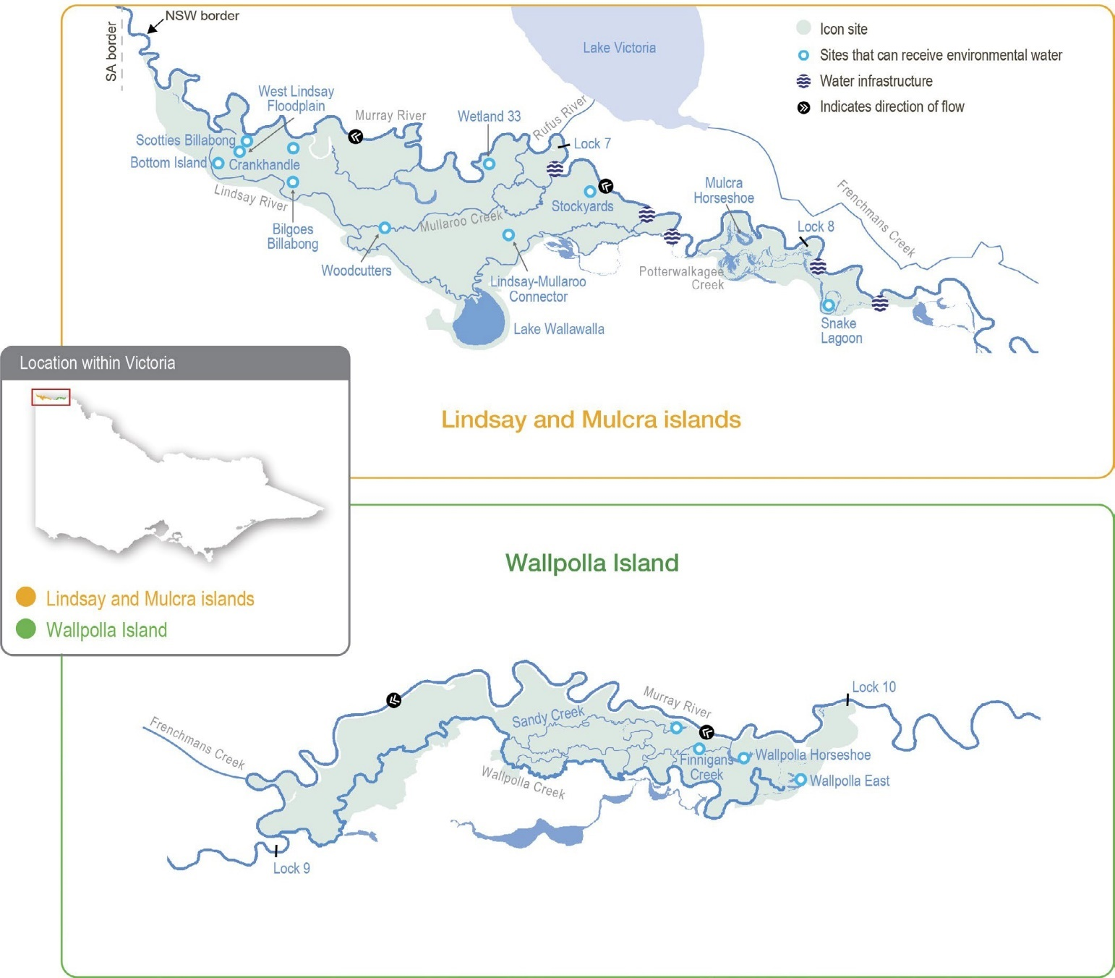

Environmental values
The Lindsay, Mulcra and Wallpolla islands represent three separate anabranch systems that contain various streams, billabongs, large wetlands and swamps. When flooded, waterways and wetlands within these systems provide habitat for native fish, frogs, turtles, waterbirds and water-dependent plants. Terrestrial animals (such as woodland birds) also benefit from improved productivity and food resources when anabranch systems are inundated. Large floodplain wetlands (such as Lake Wallawalla) can retain water for several years after receiving inflows; they provide important refuges for wetland-dependent species and support terrestrial animals (such as small mammals and reptiles).
Mullaroo Creek supports one of the most significant populations of Murray cod in the mid-Murray River system. Mullaroo Creek provides fast-flowing habitat that Murray cod favour, which contrasts with the artificially slow-flowing and still habitats in the nearby Murray River weir pools. Fish in Mullaroo Creek breed and produce juveniles that contribute to populations in adjacent parts of the Murray system (such as in the Darling River in NSW and the lower Murray River in South Australia). Waterways and wetlands throughout the icon site support several other fish species, including freshwater catfish, golden perch, silver perch, Murray-Darling rainbowfish and unspecked hardyhead.
The reduced frequency and duration of floods in the Murray River have degraded the water-dependent vegetation communities throughout the Lindsay, Mulcra and Wallpolla island system, which has, in turn, reduced the diversity and abundance of animals that rely on healthy vegetation for habitat.
Return to start of section

Environmental objectives in Lindsay, Mulcra and Wallpolla islands
By 2030, increase the abundance of small-bodied native fish and the spread of age classes for long-lived native fish, compared to 2006 baseline levels
Maintain populations of frogs
By 2030, improve the function of water-dependent ecosystems by improving productivity linkages between river and floodplain habitats
Improve populations of flow-dependent threatened flora
By 2030, maintain the extent and improve the condition of river red gum, black box and lignum compared to 2006 baseline levels
By 2030, improve the species richness and abundance of native wetland and floodplain aquatic vegetation functional groups
Maintain communities and the species diversity of colonial nesting waterbirds, waterfowl and waders that feed on fish
By 2030, increase populations of colonial nesting waterbirds at Lake Wallawalla and non-colonial waterbirds at Mulcra Horseshoe and Wallpolla Horseshoe

Traditional Owner cultural values and uses
Aboriginal ancestral occupation across the Lindsay-Mulcra-Wallpolla floodplain dates back tens of thousands of years, sustained by the rich productivity of the floodplain woodland and wetland systems. Historically, the islands would have been an abundant source of food and water for these communities. For Aboriginal communities, the floodplain is a vital part of community health and wellbeing.
The First People of the Millewa-Mallee Aboriginal Corporation (FPMMAC) are Latji Latji and Ngintait peoples. The corporation is the recognised Traditional Owner of Country in the north-west of Victoria that runs south of the Murray River to the Mallee Highway and west from the Calder Highway to the South Australian border, including the Murray-Sunset National Park. It is also a Registered Aboriginal Party.
There are many sites of cultural significance across the floodplain, including ceremonial grounds, earth oven remains, scar trees, birthing trees, shell middens, song lines, ancestral resting places and story places.
The FPMMAC has maintained associations with the Murray River for thousands of generations. Indeed, the river and its surrounds are one of the richest sources of Aboriginal archaeological and heritage material in Australia. The floodplain provides vital resources, including food, water, shelter, medicine and tools. The Traditional Owners still use the landscape for these purposes.
The Mallee CMA has a strong working relationship with the FPMMAC, which involves regular two-way communication, including planning, sharing of knowledge and discussions. Water in the landscape is critical to the spirituality of the people of the FPMMAC, strengthening their connection to Country. The Mallee CMA and the FPMMAC have frequent discussions about water, including planning and delivery of environmental water. The Mallee CMA and the FPMMAC discussed plans for the use of environmental water in 2023-24 on the Lindsay-Mulcra-Wallpolla floodplain.
Increasing the involvement of Traditional Owners in environmental water management and progressing opportunities towards self-determination in the environmental watering program is a core commitment of the Victorian Murray Floodplain Restoration Project and its agency partners. This is reinforced by a range of legislation and policy commitments, including the Water Act 1989, the Victorian Aboriginal Affairs Framework, the 2016 Water for Victoria, the Water is Life: Traditional Owner Access to Water Roadmap 2022, and in some cases, agreements under the Traditional Owner Settlement Act 2010.
Where Traditional Owners are more deeply involved in the planning and/or delivery of environmental flows for a particular site, their contribution is acknowledged in Table 5.2.16 with an icon. The use of this icon is not intended to indicate that these activities are meeting all the needs of Traditional Owners, but is incorporated in the spirit of valuing that contribution.

Watering planned and/or delivered in partnership with Traditional Owners to support cultural values and uses
Return to start of section

The Mallee CMA is partnering with the FPMMAC on planning for the delivery of water to Bottom Island and the West Lindsay Island floodplain. A key reason for watering both sites is to support black box condition and germination after the floods
in 2022-23, as explained in Table 5.2.16, which the FPMMAC supports. Another key benefit is to strengthen ground cover vegetation, which increases protection against wind erosion and pest animal activity on the adjacent culturally significant sand dunes. During the 2023-24 watering, the Mallee CMA will partner with the FPMMAC to monitor the delivery of and response to watering.

Social, recreational and economic values and uses
In planning the potential environmental watering actions in Table 5.2.16, the Mallee CMA has also considered how environmental flows could support other values and uses, including:
- water-based recreation (such as canoeing, kayaking, fishing and yabbying)
- riverside recreation and amenity (such as bushwalking, camping, bird and wildlife watching, four-wheel driving and photography)
- community events and tourism (such as increased and longstanding repeat visitation, ecotourism and educational programs for school, TAFE and university students)
- socioeconomic benefits (such as for commercial beekeepers who rest bees around the floodplain away from crops and pesticides ready for the next season, local businesses providing accommodation and hospitality to tourists, researchers and local water delivery contractors).

Scope of environmental watering
The term ‘environmental watering’ refers to the active delivery of held environmental water to support particular environmental objectives by altering the flow in a river or the water level in a wetland. While other terms are sometimes used to describe the delivery of environmental water, ‘environmental watering’ is deliberately used here and in seasonal watering statements to ensure consistency in the legal instruments that authorise the use of water for the environment in Victoria.
Table 5.2.16 describes the potential environmental watering actions in 2023-24, their expected watering effect (that is, the intended physical or biological effects of the watering action) and the longer-term environmental objectives they support. Each environmental objective relies on one or more potential environmental watering actions and their associated physical or biological effects.
Table 5.2.16 Potential environmental watering actions, expected watering effects and associated environmental objectives for the Lindsay, Mulcra and Wallpolla islands

Potential environmental watering action | Expected watering effects | Environmental objectives
Lindsay Island – Mullaroo Creek
Year-round low flow (minimum of 600 ML/ day)1 | - Maintain fast-flowing habitat for native fish (such as Murray cod, silver perch and golden perch)  - Maintain habitat for aquatic vegetation and soil moisture to maintain the condition of streamside vegetation
Elevated spring flow (1,200 ML/day for three months during  September to November) | - Increase the extent and velocity of fast-flowing habitat to cue the movement and spawning and improve recruitment opportunities for native fish  - Increase fish passage between Mullaroo Creek and the Murray River via the Mullaroo Creek regulator fishway
Lindsay Island – Lindsay River
Winter/spring/summer low flow via the northern regulator (45 ML/day  for three months during August to December) | - Provide temporary flowing water to connect pools and support the dispersal and recruitment of small- and large-bodied native fish and the spawning of small-bodied native fish  - Stimulate the release of carbon and nutrients from the sediment to increase the productivity of the floodplain food web  - Maintain bank soil moisture to support the growth of streamside vegetation
Winter/spring/summer low flow via the southern regulator (5 ML/day for three months during August to December)

Potential environmental watering action | Expected watering effects | Environmental objectives
Lindsay Island wetlands
Bilgoes Billabong (fill in spring) | - Provide shallow and open-water habitat to create foraging and breeding opportunities for waterbirds and frogs  - Stimulate the growth of aquatic vegetation  - Increase soil moisture to maintain and improve the condition of streamside and floodplain vegetation, specifically river red gum, black box and lignum  - Provide conditions for lake-bed herbaceous plants to grow as the wetland draws down during summer and autumn
Bottom Island (fill in spring) | - Provide shallow and open-water habitat to create foraging and breeding opportunities for waterbirds and frogs  - Stimulate the growth of aquatic vegetation  - Increase soil moisture to maintain and improve the condition of streamside and floodplain vegetation, specifically river red gum, black box and lignum  - Increase soil moisture to stimulate germination of black box seed
Stockyards (fill in spring or autumn) | - Provide shallow and open-water habitat to create foraging and breeding opportunities for waterbirds and frogs  - Stimulate the growth of aquatic vegetation  - Increase soil moisture to maintain and improve the condition of black box  - Increase soil moisture to stimulate germination of black box seed
West Lindsay Floodplain (fill in spring) | - Provide shallow and open-water habitat to create foraging and breeding opportunities for waterbirds and frogs  - Stimulate the growth of aquatic vegetation  - Increase soil moisture to maintain and improve the condition black box  - Increase soil moisture to stimulate germination of black box seed  - Help protect the highly culturally significant site in the adjacent landscape
Woodcutters (fill in spring) | - Provide shallow and open-water habitat to create foraging and breeding opportunities for waterbirds and frogs  - Increase soil moisture to maintain and improve the condition of river red gums
Mulcra Island – Potterwalkagee Creek
Spring low flow via the Stony Crossing regulator (35-115 ML/day for  three months during September to December) | - Provide temporary flowing water to connect pools and support the dispersal and recruitment of small- and large-bodied native fish, and the spawning of small-bodied native fish  - Stimulate the release of carbon and nutrients from the sediment to increase the productivity of the floodplain food web  - Maintain soil moisture to maintain the condition of streamside
Spring low flow via the upper Potterwalkagee Creek regulator (15 ML/ day for three months during September to December)
Mulcra Island wetlands
Mulcra Horseshoe (fill in spring) | - Provide shallow and open-water habitat to create foraging and breeding opportunities for waterbirds  - Provide shallow-water refuge habitat, if conditions are dry in the next 2-3 years, and feeding habitat for frogs  - Stimulate the growth of emergent, aquatic and streamside vegetation  - Provide conditions for lake-bed herbaceous plants to grow as the wetland draws down during summer and autumn

Potential environmental watering action | Expected watering effects | Environmental objectives
Snake Lagoon extension (fill in spring) | - Provide shallow and open-water habitat to create foraging and breeding opportunities for frogs and waterbirds  - Increase soil moisture to maintain and improve the condition of streamside and floodplain vegetation, specifically river red gum, black box and lignum  - Provide conditions for lake-bed herbaceous plants to grow as the wetland draws down during summer and autumn
Wallpolla Island
- No watering activities are planned for Wallpolla Island in 2023-24
1 There may be a requirement to reduce the baseflow down to 400 ML per day to assist with construction activities as part of the Victorian Murray Floodplain Restoration Project from early 2024, but this is not expected to affect the quality of habitat provided by the flow.
Scenario planning
Table 5.2.17 outlines potential environmental watering and expected water use in a range of planning scenarios.
The two categories of opportunities to deliver water for the environment at Lindsay and Mulcra islands in 2023-24 are:
- deliveries of water for the environment to anabranch waterways (Mullaroo Creek, Lindsay River and Potterwalkagee Creek) in coordination with weir pool operation
- a program of environmental deliveries via temporary pumps to individual wetlands at Lindsay and Mulcra islands.
Anabranch watering
All of the waterways connected to the weir pools – Mullaroo Creek, Lindsay River and Potterwalkagee Creek – are proposed to receive water for the environment in all planning scenarios.
Deliveries to the Lindsay River, Potterwalkagee Creek and Mulcra Horseshoe may be disrupted during 2023-24 due to maintenance and river operation work. The impact on environmental objectives is expected to be minor because natural flooding across Lindsay and Mulcra islands in 2022-23 and managed floodplain watering at Mulcra Island in 2021-22 have improved the condition of these systems, enabling them to withstand drying in 2023-24.
Permanent flowing water with a modest increase in spring is essential for Mullaroo Creek in all planning scenarios because there is strong evidence this watering regime promotes fish movement and breeding, particularly for Murray cod.
Lindsay River and Potterwalkagee Creek require a short-duration low flow in most years to maintain soil moisture for streamside vegetation. Proposed construction activities associated with the Lindsay Island Victorian Murray Floodplain Restoration Project will limit watering opportunities in 2024-25, so deliveries to Lindsay River in 2023-24 will build ecosystem resilience. In 2023-24, the operation of lock 7 and 8 weir pools is expected to allow low flows to be delivered to the Lindsay River and Potterwalkagee Creek via multiple regulators under dry, average and wet planning scenarios, which will provide good flow and habitat during spring. In the drought planning scenario, the lock 7 and 8 weir pools are likely to be held at a lower level, which will mean deliveries to Lindsay River and Potterwalkagee Creek are restricted to the northern and Stony Crossing regulators, respectively. Flows in all waterways will cease through most of summer, autumn and winter in all planning scenarios unless there is widespread natural flooding.
Floodplain inundation at Mulcra Island cannot be achieved under the proposed operation of weir pool 8 under the drought to average planning scenarios in 2023-24. However, natural flooding in the wet planning scenario could inundate large parts of both Lindsay and Mulcra islands and provide a near-continuous year-round flow through anabranch waterways, but most likely in winter and spring. Natural flooding of Lindsay and Mulcra islands in 2022-23 and managed floodplain watering at Mulcra Island in 2021-22 have improved the condition of floodplain ecosystems. Therefore, active floodplain watering is not required in 2023-24.
Deliveries via temporary pumps
Seven wetlands across Lindsay and Mulcra islands are identified for environmental flows using temporary pumps in spring 2023. By that time, floodwaters in all seven wetlands will have drawn down substantially or completely. Re-wetting for a second consecutive year is considered important to consolidate the growth of new plants that recruited in the 2022 floods and further improve the condition of established vegetation, to increase its resilience if conditions turn drier in the coming years.
Return to start of section

Watering the Snake Lagoon extension and Mulcra Horseshoe on Mulcra Island, Bottom Island and the West Lindsay Floodplain on Lindsay Island are high priorities in all planning scenarios. Snake Lagoon, Bottom Island and West Lindsay Floodplain have only been inundated twice in the last 10 years, and they require another fill in 2023-24 to consolidate the vegetation recruitment that occurred in response to the 2022 floods and further improve the condition of the river red gums, black box and lignum surrounding the wetlands. Mulcra Horseshoe has filled five times in the last 10 years and only twice in the last six years. The vegetation community at Mulcra Horseshoe requires open water nine out of 10 years on average, so another fill is proposed in 2023-24 to help re-establish water-dependent vegetation and improve the condition of the surrounding river red gums.
Bilgoes Billabong and Woodcutters are planned to receive water in the dry, average and wet planning scenarios to build on the positive effects of recent flooding. Both sites were filled by floods in 2016 and 2022 and will benefit from another inundation
in spring 2023 to enhance the growth of streamside vegetation and consolidate an aquatic vegetation community. Filling these sites in the drought planning scenario is a lower priority because floods in 2022 improved the condition of the wetland vegetation enough to allow them to tolerate the next dry period.
Stockyards has benefitted from natural inflows in 2016, 2021 and 2022. Watering is planned in the average and wet planning scenarios to promote the abundance and diversity of the understorey vegetation community. The delivery is preferred in spring, but it may need to be deferred until autumn if planned weir-pool-raising operations affect access to the site.
In the wet planning scenario, Mulcra Horseshoe, Stockyards and Woodcutters are expected to fill from natural flooding, but Snake Lagoon extension, Bilgoes Billabong and Bottom Island to only fill if floods are very large. Bilgoes and Bottom Island become inaccessible during floods and cannot be watered via pumping in the wet planning scenario, but it may be possible to transport pumping equipment to Snake Lagoon extension to fill it in the wet planning scenario if required.
Crankhandle, Finnigans Creek, Lake Wallawalla, Lindsay-Mullaroo Connector, Sandy Creek and Lilyponds, Scotties Billabong, Wallpolla Horseshoe, Wallpolla Creek East and Wetland 33 were filled during 2021-22 by natural flows or deliveries of water for the environment, and they were flooded in 2022. Water will not be actively delivered to these sites during 2023-24 to allow them to draw down to support dry-phase ecological processes (such as providing foraging habitat for wading waterbirds and allowing the growth of lake-bed herbland communities). Offsetting wetting and drying phases in different wetlands across Lindsay, Mulcra and Wallpolla islands in non-flood years provides a variety of habitat types and resources for waterbirds, terrestrial birds and other animals.
Table 5.2.17 Potential environmental watering for the Lindsay, Mulcra and Wallpolla islands in a range of planning scenarios

Planning scenario | Drought | Dry | Average | Wet
Expected conditions | - Year-round low flow in the Murray River and no natural floodplain wetting  - Weir pools will be maintained at  full supply level in spring and drawn down below full supply level during summer, autumn and winter  - Substantial wetland drying will occur | - Rare high-flow events in the Murray River and no natural  floodplain wetting  - Weir pools will be raised in spring and drawn down below full supply level in summer, autumn and winter  - Substantial wetland drying will occur | - Short periods of high flow, most likely in spring/ summer, providing minor wetting of the floodplain  - Weir pool levels will be maintained at full supply level or raised in winter/ spring and summer and drawn down in summer, autumn and winter | - Long periods of high flow, with major spills from storages resulting in widespread wetting of the floodplain and wetting of most wetlands  - Weirs would be removed to allow the passage of natural flow

Planning scenario | Drought | Dry | Average | Wet
Lindsay Island
Potential environmental watering – tier 1 (high priorities)1 | - Year-round low flow (Mullaroo Creek)  - Spring high-low flow (Mullaroo Creek)  - Winter/spring/ summer low flow (Lindsay River via the north regulator)  - Bottom Island (fill in spring)  - West Lindsay Floodplain (fill in spring) | - Year-round low flow (Mullaroo Creek)  - Spring high-low flow (Mullaroo Creek)  - Winter/spring/ summer low flow (Lindsay River via the north and south regulator)  - Bilgoes Billabong (fill in spring)  - Bottom Island Billabong (fill in spring)  - West Lindsay Floodplain (fill in spring)  - Woodcutters (fill in spring) | - Year-round low flow (Mullaroo Creek)  - Spring high-low flow (Mullaroo Creek)  - Winter/spring/ summer low flow (Lindsay River via the north and south regulator)  - Bilgoes Billabong (fill in spring)  - Bottom Island Billabong (fill in spring)  - Stockyards (fill in spring or autumn)  - West Lindsay Floodplain (fill in spring)  - Woodcutters (fill in spring) | - Year-round low flow (Mullaroo Creek)  - Spring high-low flow (Mullaroo Creek)  - Winter/spring/ summer low flow (Lindsay River via the north and south regulator)  - Bilgoes Billabong (fill in spring)1  - Bottom Island Billabong (fill in spring)2  - Stockyards (fill in spring or autumn)  - West Lindsay Floodplain (fill in spring)2  - Woodcutters (fill in spring)
Mulcra Island
Potential environmental watering – tier 1 (high priorities)2 | - Spring low flow (Potterwalkagee Creek via Stony Crossing regulator)  - Mulcra Horseshoe (fill in spring)  - Snake Lagoon extension (fill in spring) | - Spring low flow (Potterwalkagee Creek via Stony Crossing and upper Potterwalkagee regulators)  - Mulcra Horseshoe (fill in spring)  - Snake Lagoon extension (fill in spring) | - Spring low flow (Potterwalkagee Creek via Stony Crossing and upper Potterwalkagee regulators)  - Mulcra Horseshoe (fill in spring)  - Snake Lagoon extension (fill in spring) | - Spring low flow (Potterwalkagee Creek via Stony Crossing and upper Potterwalkagee regulators)  - Mulcra Horseshoe (fill in spring)  - Snake Lagoon extension (fill in spring)
Possible volume of water for the  environment required to achieve objectives3 | - 1,690 ML | - 1,860 ML | - 2,660 ML | - 110 ML
- Bilgoes Billabong, Bottom Island and West Lindsay Floodplain each have a high commence-to-flow rate and may not be naturally inundated in the wet planning scenario. Water cannot be delivered in the wet planning scenario due to site inaccessibility.
- Tier 1 environmental watering at Lindsay, Mulcra and Wallpolla islands is not classified as tier 1a or tier 1b because the water available to use is shared across various systems and it is not possible to reliably determine supply specifically available for the islands.
- These estimates include the use of water for the environment at sites across Lindsay, Mulcra and Wallpolla islands and Murray River weir pools. Water for the environment used at these sites may be accounted for in Victoria and New South Wales.
Return to start of section

Ovens system
Waterway manager – North East Catchment Management Authority
Storage manager – Goulburn-Murray Water
Environmental water holder – Commonwealth Environmental Water Holder
Proportions of water entitlements in the Ovens basin held by private users, water corporations and environmental water holders on 30 June 2020

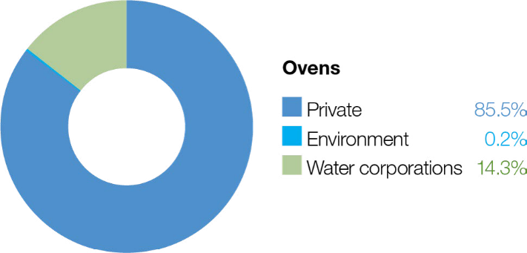

System overview
The Ovens River rises in the steep, forested mountains of the Great Dividing Range near Mount Hotham and flows about 150 km to join the Murray River in the backwaters of Lake Mulwala (Figure 5.3.1). The system has two small water storages: Lake Buffalo on the Buffalo River and Lake William Hovell on the King River. The regulated reaches of the Ovens system include the Buffalo and King rivers below these storages and the Ovens River from its confluence with the Buffalo River to the Murray River.
As its storages are quite small and spill regularly, the Ovens system maintains a large proportion of its natural flow regime, particularly in winter/spring. However, the storages and licensed water extractions throughout the system can restrict flow in drier years, and parts of the system can become flow-stressed during summer and autumn.
The Ovens River flows into Lake Mulwala on the Murray River; the lake is the largest weir pool on the Murray regulated system. The Ovens River flow contributes to the reliability and variability of the flow in the Murray River and supports many downstream uses, including irrigation, urban supply and watering of iconic floodplain sites (such as Barmah Forest).
Water for the environment is held in Lake Buffalo and Lake William Hovell and can be released when the storages are not spilling. Five reaches in the Ovens system can benefit from releases of water for the environment. While all are important, there is a relatively small volume (123 ML) of water available, and it is insufficient to meet most of the environmental flow objectives. In recent years, private landowners have donated some of their annual water allocations to the VEWH to use in the King River. The Taungurung Land and Waters Council has also transferred some of their annual allocation to the VEWH to be delivered to the King River to heal Country.
The water transfers are used selectively to deliver the greatest possible environmental benefit. Water for the environment is most commonly used in the Ovens system to deliver critical flow events in reaches immediately below the two main storages, or it is used in conjunction with operational water releases to influence the flows of the Buffalo River and the lower Ovens River. It is also used to top up Mullinmur Wetland in Wangaratta.
Return to start of section

Figure 5.3.1 The Ovens system

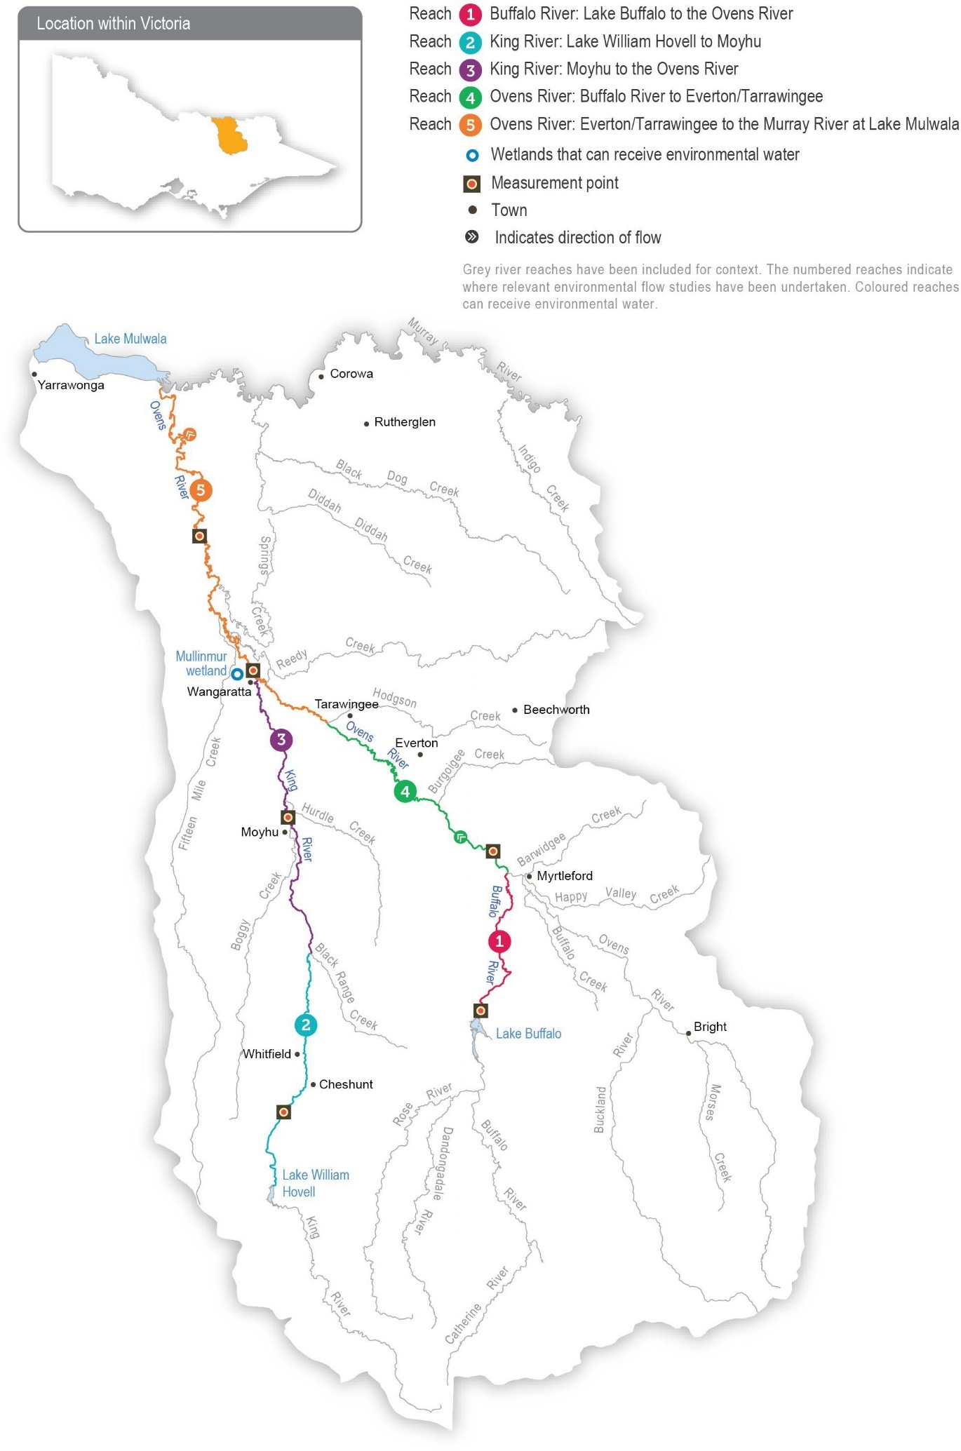
Return to start of section

Environmental values
The diverse aquatic habitat and abundant food resources associated with the Ovens system support a wide range of native fish species, including Murray cod, trout cod, golden perch and unspecked hardyhead. The Buffalo River provides valuable habitat for large-bodied fish species during part of their breeding cycle, while trout cod have a large range within the system and are found as far up the King River as Whitfield. A project to recover trout cod populations in the Ovens system has been successful, and efforts to reintroduce Macquarie perch are continuing.
Frogs (such as the giant banjo frog and growling grass frog) are abundant in the lower reaches and associated wetlands of the Ovens River and the King River above Cheshunt. The lower Ovens wetland complex contains over 1,800 wetlands, is listed as nationally significant and is home to a variety of waterbirds, including egrets, herons, cormorants and bitterns. The streamside zones of river channels throughout the Ovens system support some of Victoria’s healthiest river red gum forests and woodlands, while the wetlands support a variety of aquatic and semi-aquatic vegetation communities.
Water for the environment was delivered to Mullinmur Wetland at Wangaratta for the first time in 2019-20. This site has been the focus of several environmental improvement projects in recent years. Specific management actions include carp removal, a revegetation program and the re-introduction of native fish.

Environmental objectives in the Ovens system
Maintain the size and distribution of native fish populations
Maintain the condition and extent of wetland vegetation communities
Maintain an adequate abundance and diversity of waterbugs to support river food webs and associated ecosystem processes
Maintain water quality for all river life
Traditional Owner cultural values and uses
The North East CMA consulted the Taungurung Land and Waters Council and the Yorta Yorta Nation Aboriginal Corporation in planning for potential 2023-24 environmental flows in the Ovens system.
The Taungurung Land and Waters Council water knowledge group Baan Ganalina (Guardians of Water) supports increasing Taungurung influence in water management, building internal capacity and advancing Taungurung water rights.
The Taungurung Country Plan’s water chapter Baan Dhumba-Dji-Ngan Mundak Gunga (We must speak to protect water) lists several water objectives. These include increasing and strengthening Taungurung voices, increasing water literacy and capacity, and returning water to disconnected wetlands. The future delivery of water for the environment by the Taungurung Land and Waters Council on Taungurung Country would contribute to achieving some of these objectives.
The Yorta Yorta Nation Aboriginal Corporation developed the Yorta Yorta Whole-Of-Country Plan 2021-2030. The plan outlines objectives for Yorta Yorta Country, including for the Ovens River, and it identifies the lower Ovens River as a very high priority for management actions. The plan’s objectives aim to support more culturally informed planning for water in the lower Ovens River in the future.
The Taungurung Land and Waters Council and the Yorta Yorta Nation Aboriginal Corporation are collaborating with the North East CMA on a 2022-24 project to update environmental flow recommendations for the Ovens system. The project aims to progress Taungurung and Yorta Yorta objectives. In 2023, Yorta Yorta Elders and people will conduct on-Country assessments along reach 5 of the Ovens River as part of this project.
The North East CMA has started conversations with the Bangerang Aboriginal Corporation, which has a representative on the Mullinmur Wetland Management Committee. In 2022, the corporation undertook cultural heritage assessments along the Ovens River at Wangaratta and at Mullinmur Wetland. These assessments identified many culturally significant features, including trees modified for cultural purposes and intact populations of plant species used in traditional practices (such as
rope-making and medicine). The corporation has also been involved in management activities at Mullinmur Wetland, including cool weather cultural burning to suppress weed species and promote the growth of native vegetation.
Increasing the involvement of Traditional Owners in environmental water management and progressing opportunities towards self-determination in the environmental watering program is a core commitment of the VEWH and its agency partners. This is reinforced by a range of legislation and policy commitments, including the Water Act 1989, the Victorian Aboriginal Affairs Framework, the 2016 Water for Victoria, the Water is Life: Traditional Owner Access to Water Roadmap 2022, and in some cases, agreements under the Traditional Owner Settlement Act 2010.
Return to start of section

Where Traditional Owners are more deeply involved in the planning and/or delivery of environmental flows for a particular site, their contribution is acknowledged in Table 5.3.1 with an icon. The use of this icon is not intended to indicate that these activities are meeting all the needs of Traditional Owners, but is incorporated in the spirit of valuing that contribution.

Watering planned and/or delivered in partnership with Traditional Owners to support cultural values and uses
The Taungurung Land and Waters Council may consider using its 39 ML entitlement in the King River system to support environmental objectives as part of its goal of healing and caring for Country. The council’s allocation has been released from Lake William Hovell five times as an environmental flow in partnership with the North East CMA, Goulburn-Murray Water and the VEWH to provide additional water to the King River and assist in healing Country.
Social, recreational and economic values and uses
In planning the potential environmental watering actions in Table 5.3.1, the North East CMA considered how environmental flows could support values and uses, including:
- water-based recreation (such as boating and fishing)
- riverside recreation and amenity (such as camping, visitation for mental/physical health and wellbeing)
- community events and tourism (such as providing a setting for community gatherings, outdoor school learning, sporting events and citizen science projects)
- socioeconomic benefits (such as businesses used by anglers and stock and domestic uses that rely on water quality, supported by deliveries of water for the environment when the natural flow is at its lowest from November to March).
Environmental flows are planned for Mullinmur Wetland in summer to re-establish submerged aquatic vegetation and support native fish at the site. The water is expected to sustain other benefits to the local community (such as recreation and amenity). The Mullinmur Wetland site is managed by the Catholic Education Department, supported by Wangaratta Landcare and Sustainability Incorporated. An education hub provides a space for environmental education for students from Galen Catholic College, young people attending the Borinya Wangaratta Community Partnership and other people from the local community, including a team of Waterwatch citizen scientists. These volunteers have been involved in monitoring changes in conditions for plant and fish species after deliveries of water for the environment.
Scope of environmental watering
The term ‘environmental watering’ refers to the active delivery of held environmental water to support particular environmental objectives by altering the flow in a river or the water level in a wetland. While other terms are sometimes used to describe the delivery of environmental water, ‘environmental watering’ is deliberately used here and in seasonal watering statements to ensure consistency in the legal instruments that authorise the use of water for the environment in Victoria.
Table 5.3.1 describes the potential environmental watering actions in 2023-24, their expected watering effect (that is, the intended physical or biological effects of the watering action) and the longer-term environmental objectives they support. Each environmental objective relies on one or more potential environmental watering actions and their associated physical or biological effects.
Table 5.3.1 Potential environmental watering actions, expected watering effects and associated environmental objectives for the Ovens system

Potential environmental watering action | Expected watering effects | Environmental objectives
Buffalo River (targeting reach 1)
Summer/autumn low flow variability (greater than 70 ML/day for two days during February to April) | - Increase connectivity between pools for fish movement  - Maintain waterbug habitat  - Maintain adequate oxygen levels in pools
Autumn low flow fresh (430 ML/day for three days during March to April) | - Provide flow cues to stimulate the movement of native fish  - Increase connectivity between pools for fish movement  - Mix pools to improve the water quality  - Provide small variations in river levels and velocity  - Maintain waterbug habitat  - Scour biofilm from the river bed

Potential environmental watering action | Expected watering effects | Environmental objectives
King River (targeting reaches 2 and 3)
Summer/autumn low flow variability (greater than 60 ML/day for two to four days during February to April) | - Increase connectivity between pools for fish movement  - Maintain waterbug habitat  - Maintain adequate oxygen levels in pools
Mullinmur Wetland
Mullinmur Wetland  (top-up during November to March) | - Maintain the water level within the wetland to support the growth and recruitment of aquatic vegetation  - Maintain habitat and water quality for native fish

Scenario planning
Table 5.3.2 outlines potential environmental watering and expected water use in a range of planning scenarios.
The weather and inflows into storages have a large effect on how water for the environment is likely to be used in the Ovens system. In the drought and dry planning scenarios, the highest priority will be to use available water for the environment to introduce some variability to the summer/autumn low flow to limit the duration of extremely low-flow or cease-to-flow events that can stress native fish and waterbugs. In the average and wet planning scenarios, the objective is to provide a greater flow to support fish movement and breeding and increase the abundance and diversity of waterbugs. There is not enough water for the environment to deliver the recommended autumn fresh in full, so releases would need to coincide with and add to
operational water releases. All the potential environmental watering actions for the Ovens River system are expected to be met naturally in the wet planning scenario.
Due to the limited volume of water for the environment available, there is limited opportunity to vary the potential environmental watering actions each year for each planning scenario. However, water allocation donations (such as those by the Taungurung Land and Waters Council and a private donor in the King River) help to increase the effectiveness of some potential watering actions.
All wetlands on the Ovens floodplain, including Mullinmur Wetland, filled naturally during the 2022 floods. Mullinmur Wetland was still holding water at the end of 2022-23, and the main priority in 2023-24 is to top up water levels throughout the warmer months to offset seepage and evaporation and thereby maintain wetland vegetation, habitat and water quality for native fish. These top-ups will need to be actively delivered in the drought and dry planning scenarios, but Mullinmur Wetland is likely to be topped up or flooded naturally in the average and wet planning scenarios.
All available water for the environment is expected to be used in 2023-24. No carryover targets have been set for 2024-25.
Table 5.3.2 Potential environmental watering for the Ovens system in a range of planning scenarios

Planning scenario | Drought | Dry | Average | Wet
Expected conditions | - Possible winter/ early spring natural fresh  - Very low flow through summer and autumn  - No bulk water release | - Possible winter/ early spring natural fresh  - Very low flow through summer and autumn  - Bulk water release is unlikely | - High winter/spring natural freshes  - Moderate flow in summer and autumn with  occasional natural freshes  - Bulk water release is likely | - High natural freshes and low flow throughout most of the year  - Bulk water release is likely  - All flow objectives are achieved naturally
Expected availability of water for the environment | - 123 ML (73 ML held in Lake Buffalo and 50 ML held in Lake William Hovell)

Planning scenario | Drought | Dry | Average | Wet
Buffalo River (targeting reach 1)
Potential environmental watering – tier 1 (high priorities) | Tier 1a (can be achieved with predicted supply)
 | - Summer/autumn low flow variability | - Summer/autumn low flow variability | - Summer/autumn low flow variability  - Autumn low flow fresh | - Summer/autumn low flow variability  - Autumn low flow fresh
King River (targeting reaches 2 and 3)
Potential environmental watering – tier 1 (high priorities) | Tier 1a (can be achieved with predicted supply)
 | - Summer/autumn low flow variability | - Summer/autumn low flow variability | - Summer/autumn low flow variability | - Summer/autumn low flow variability
Mullinmur Wetland
Potential environmental watering – tier 1 (high priorities) | Tier 1a (can be achieved with predicted supply)
 | - Mullinmur Wetland top-up | - Mullinmur Wetland top-up | - Mullinmur Wetland top-up | - Mullinmur Wetland top-up
Possible volume of water for the  environment required to achieve objectives | - 123 ML (tier 1a) | - 123 ML (tier 1a) | - 123 ML (tier 1a) | - 0-123 ML (tier 1a)
Return to start of section

Goulburn system
Waterway manager – Goulburn Broken Catchment Management Authority
Storage manager – Goulburn-Murray Water
Environmental water holders – Victorian Environmental Water Holder (including the Living Murray program) and Commonwealth Environmental Water Holder
Proportions of water entitlements in the Goulburn basin held by private users, water corporations and environmental water holders on 30 June 2020
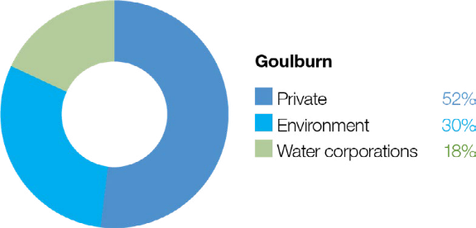

The Goulburn system includes the Goulburn River and Goulburn wetlands

Goulburn River
System overview
The Goulburn is Victoria’s largest river basin, covering over 1.6 million ha or 7.1 percent of the state (Figure 5.4.1). The Goulburn River flows for 570 km from the Great Dividing Range upstream of Woods Point to the Murray River east of Echuca. It is an ancient, iconic river rich with environmental, cultural and recreational values.
There are several environmental water holders in the Goulburn system. The Commonwealth Environmental Water Holder (CEWH) holds the largest volume, and the use of Commonwealth Water Holdings is essential for achieving outcomes in the Goulburn River and priority environmental sites further downstream. Water for the environment held on behalf of the Living Murray program may assist in meeting objectives in the Goulburn system en route to icon sites in the Murray system (see subsection 4.4.2). Water held by the VEWH in the Goulburn system is primarily used to meet environmental objectives in the Goulburn River and the Goulburn wetlands, but it can also be used to support ecological objectives at downstream sites along the Murray River and in South Australia.
The construction and operation of Lake Eildon and Goulburn Weir have significantly altered the natural flow regime of the Goulburn River. Water harvesting during wet periods, and releases to meet irrigation and other consumptive demands during dry periods, mean that flow below these structures is typically low in winter/spring and high in summer/autumn. This is the reverse of the natural seasonal flow pattern. Land use changes and the construction of small dams and drainage schemes have further modified the Goulburn River’s flow regime. Levees and other structures prevent water from inundating the floodplain and filling many of the natural wetlands and billabongs. Several tributaries, including the Acheron, Yea and Broken rivers, join the Goulburn River downstream of Lake Eildon and can add some flow variation on top of the river’s regulated flow. Large floods that cause the Goulburn River’s storages to fill and spill are also important for the overall flow regime and its associated environmental values.
The priority environmental flow reaches in the Goulburn River are downstream of Goulburn Weir (reaches 4 and 5), which are collectively referred to as the lower Goulburn River. The mid-Goulburn River extends from Lake Eildon to Goulburn Weir (reaches 1 to 3). From early spring to late autumn, large volumes of water are delivered from Lake Eildon to Goulburn Weir to supply the irrigation system. During that period, flow in the mid-Goulburn River is usually well above the recommended
environmental flow targets. Deliveries of water for the environment have the most benefit in the mid-Goulburn River (especially in reach 1 immediately downstream of Lake Eildon) outside the irrigation season when the flow is much lower than natural.
Environmental flow targets can sometimes be met by the coordinated delivery of operational water being transferred from Lake Eildon to the Murray River. These inter-valley transfers (IVTs) occur during the irrigation season between spring and autumn and may meet environmental flow objectives without the need to release water for the environment. IVTs in the Goulburn
River can significantly exceed the environmental flow recommendations for summer and early autumn and can damage bank vegetation and erode the riverbanks. A new Goulburn to Murray trade rule and operating plan were introduced in 2022-23 to try to prevent further damage to the lower Goulburn River from prolonged high flow over summer and autumn. Wet conditions in 2021-22 and 2022-23 have meant only small volumes of IVTs have been delivered from the Goulburn system. The impacts of the new trade rule and operating plan on environmental assets are yet to be fully assessed.
Return to start of section

Figure 5.4.1 The Goulburn system

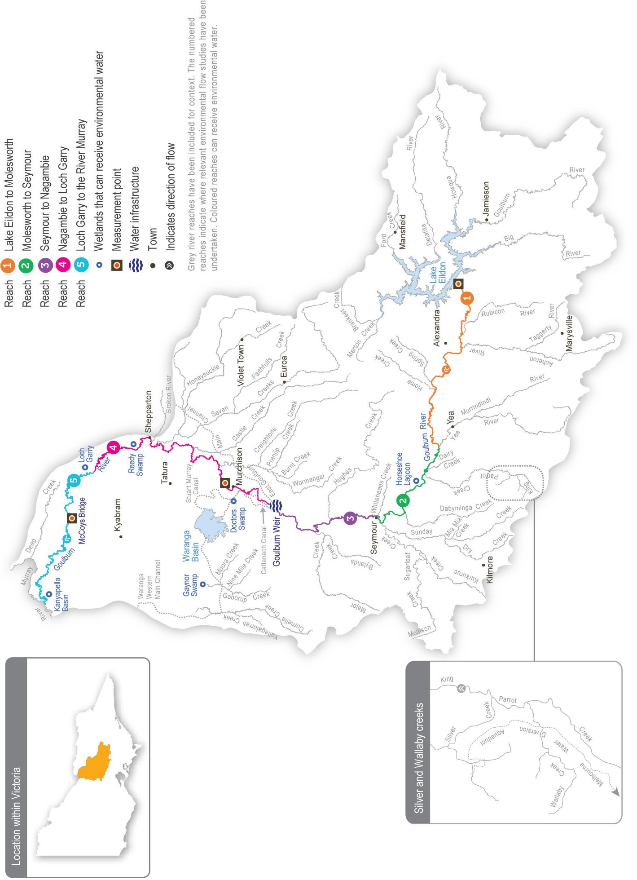

Return to start of section

Environmental values
The Goulburn River and its tributaries support a range of native fish (including golden perch, silver perch, Murray cod, trout cod, Macquarie perch, freshwater catfish), turtles, platypus and rakali (water rats). Aquatic vegetation, scour holes and woody debris within the channel provide high-quality habitat for adult and juvenile fish. River red gums are a dominant feature of the streamside zone along the length of the Goulburn River. These trees shade the river and provide habitat for many species, including the squirrel glider. Leaves that fall from the river red gums provide carbon that supports riverine food webs, and dead trees that fall into the river provide a surface for biofilms and waterbugs and habitat for fish. Birds (such as egrets, herons and cormorants) use trees along the river to roost and feed, while frogs benefit from shallow vegetated habitats at the edge of the river channel and in adjacent wetlands.
The Goulburn River system is an important conservation area for threatened species. Several wetlands in the Goulburn catchment are formally recognised for their conservation significance. Tributaries of the mid-Goulburn River between Lake Eildon and Goulburn Weir host some of the last remaining Macquarie perch populations in the Murray-Darling Basin, while freshwater catfish occur in lagoons connected to reach 3 of the Goulburn River. Citizen science monitoring programs indicate the mid-Goulburn River supports a strong population of platypus, which are now classified as vulnerable under Victoria’s Fauna and Flora Guarantee Act 1988. Monitoring in recent years shows that environmental flows in the lower Goulburn River trigger golden perch and silver perch to spawn. However, the extent to which these spawning events contribute to populations locally and in the wider southern basin is unknown. Self-sustaining populations of Murray cod have been confirmed, and trout cod are extending their range in the lower Goulburn River.

Environmental objectives in the Goulburn River
Protect and increase populations of native fish
Maintain the form of the riverbank and channel and a high diversity of river bed surfaces to support all stream life
Increase populations of platypus
Maintain populations of turtles
Provide sufficient rates of carbon and nutrient production and processing to support native fish and waterbug communities
Increase the abundance of aquatic and flood-tolerant plants in the river channel and on the lower banks to provide shelter and food for animals and stabilise the riverbank
Maintain abundant and diverse waterbug communities to support riverine food webs
Minimise the risk of low-oxygen blackwater
Traditional Owner cultural values and uses
The Goulburn River system flows through Taungurung and Yorta Yorta Country.
Each year, the Goulburn Broken CMA consults with the Taungurung Land and Waters Council and the Yorta Yorta Nation Aboriginal Corporation about plans for environmental watering in the Goulburn River.
In late 2022 and early 2023, the Goulburn Broken CMA met with the Taungurung water knowledge group Baan Ganalina (Guardians of Water) to discuss recently updated environmental flow recommendations for Waring (Goulburn River reaches 1 to 3) as well as the 2023-24 Goulburn River watering priorities.
Baan Ganalina indicated the flows would help to reinstate a more-natural water regime that better reflects the size, timing and variability of natural inflows to this part of the river, including off-channel areas. It said:
“These flow recommendations will help support Waring (Goulburn River), which is such an important part of Taungurung identity. It’s good to see how GBCMA have used peer-reviewed articles to show the effects on important animals like platypus and shared this knowledge. The river is a work in progress, but together with GBCMA, we will continue to seek ways to heal Country despite the harm it has suffered. Baan Ganalina hopes to see the proposed higher winter flows and looks forward to taking an ongoing role in monitoring their effects.”
Return to start of section

The Taungurung Land and Waters Council communicated that the planned reach 1 to 3 baseflows and freshes for 2023- 24 would have positive outcomes for Waring (Goulburn River reaches 1 to 3) that align with Taungurung objectives and responsibilities to heal and care for Country. These flows will connect wetlands that support valued species at appropriate times. They will help to protect intangible and tangible cultural heritage and values, including traditional food and medicine plants. The flows will also support ongoing efforts by Taungurung and partner organisations to care for the river and its floodplain, including investigations into rehabilitating degraded significant sites.
In early 2023, the Goulburn Broken CMA met with the Yorta Yorta Nation Aboriginal Corporation to discuss 2023-24 environmental watering priorities in the Goulburn River. The Yorta Yorta Nation Aboriginal Corporation indicated there is alignment between planned watering actions for Kaiela (Goulburn River reaches 4 and 5) and the cultural and ecological values of the Yorta Yorta people. The planned flows will encourage native fish to spawn, alleviate the slumping of culturally important sites (such as middens and scar trees) and revive streamside vegetation, which is important for food, fibre and medicine.
A Yorta Yorta representative contributed to the 2020 Kaiela (Lower Goulburn River) Environmental Flows Study, which has influenced environmental flows in the lower Goulburn River since 2021-22.
Increasing the involvement of Traditional Owners in environmental water management and progressing opportunities towards self-determination in the environmental watering program is a core commitment of the VEWH and its agency partners. This is reinforced by a range of legislation and policy commitments, including the Water Act 1989, the Victorian Aboriginal Affairs Framework, the 2016 Water for Victoria, the Water is Life: Traditional Owner Access to Water Roadmap 2022, and in some cases, agreements under the Traditional Owner Settlement Act 2010.
Where Traditional Owners are more deeply involved in the planning and/or delivery of environmental flows for a particular site, their contribution is acknowledged in Table 5.4.1 with an icon. The use of this icon is not intended to indicate that these activities are meeting all the needs of Traditional Owners, but is incorporated in the spirit of valuing that contribution.
Watering planned and/or delivered in partnership with Traditional Owners to support cultural values and uses
In 2022, the Taungurung Land and Waters Council joined the Goulburn and Broken Operational Advisory Group, which shares technical and operational information to support environmental water management and decision-making in the Goulburn River and lower Broken Creek.
Social, recreational and economic values and uses
In planning the potential environmental watering actions in Table 5.4.1, the Goulburn Broken CMA considered how environmental flows could support values and uses such as:
- water-based recreation (such as boating, canoeing, fishing, gaming, hunting and kayaking)
- riverside recreation and amenity (for landholders and visitors)
- community events and tourism (such as paddling and boating businesses)
- socioeconomic benefits (such as improving water quality for stock and domestic uses, irrigation diverters and water supply for settlements on the Goulburn River).
If the timing or management of planned environmental flows may be modified to align with a community benefit, this is acknowledged in Table 5.4.1 with the following icon.

Watering planned to support angling activities
The Goulburn River provides numerous recreational and economic benefits. Environmental flows support native fish populations by providing fish passage and habitat and by encouraging fish migration and spawning, which in turn provide benefits for recreational anglers. Following community feedback, the timing of a targeted environmental flow in November/ December is planned to reduce impacts on river access around peak fishing periods, benefitting anglers and local businesses.
Scope of environmental watering
The term ‘environmental watering’ refers to the active delivery of held environmental water to support particular environmental objectives by altering the flow in a river or the water level in a wetland. While other terms are sometimes used to describe the delivery of environmental water, ‘environmental watering’ is deliberately used here and in seasonal watering statements to ensure consistency in the legal instruments that authorise the use of water for the environment in Victoria.
Table 5.4.1 describes the potential environmental watering actions in 2023-24, their expected watering effect (that is, the intended physical or biological effects of the watering action) and the longer-term environmental objectives they support. Each environmental objective relies on one or more potential environmental watering actions and their associated physical or biological effects.
Return to start of section

Table 5.4.1 Potential environmental watering actions, expected watering effects and associated environmental objectives for the Goulburn River

Potential environmental watering action | Expected watering effects | Environmental objectives
Goulburn River reach 1
Year-round low flow (400-2,000 ML/day in  reach 1) | - Maintain habitat for small-bodied native fish  - Maintain adequate foraging habitat for platypus and reduce the risk of predation  - Provide habitat and food for turtles  - Wet and maintain riffles to provide habitat for biofilms and waterbugs  - Additional benefits to reach 1 of the Goulburn River when the flow delivered is above 800 ML/day:  - scour fine sediment from the gravel bed and riffle substrate  - maintain existing beds of in-channel vegetation  - provide connection to off-stream wetland habitats, which increase food resources (waterbugs) available for fish and native animals
Winter fresh (one fresh of more than 8,000 ML/ day for five to 10 days during July to August in reach 1) | - Encourage female platypus to select a nesting burrow higher up the bank to reduce the risk of greater flow later in the year flooding the burrow when juveniles are present  - Scour fine sediment from the gravel bed and riffle substrate  - Maintain existing beds of in-channel vegetation  - Connect lower Goulburn River wetlands and anabranches to the river channel
Winter/spring fresh(es) (one to three freshes of more than 5,000 ML/day for five to 10 days during May to November in reach 1) | - Scour fine sediment from the gravel bed and riffle substrate  - Maintain existing beds of in-channel vegetation  - Maximise the period of time off-stream wetland habitats are available for small-bodied native fish and platypus
Spring fresh (one fresh of more than 8,000 ML/ day for five to 10 days during September to November in reach 1) | - Maintain off-stream habitat for small-bodied native fish and platypus  - Scour fine sediment from the gravel bed and riffle substrate  - Maintain existing beds of in-channel vegetation  - Connect lower Goulburn River wetlands and anabranches to the river channel
Goulburn River reach 4 and 5
Year-round low flow (600-1,000 ML/day in  reach 4 and 5) | - Provide slow, shallow habitat required for the recruitment of larvae/juvenile fish and habitat for adult small-bodied fish  - Provide deep-water habitat for large-bodied fish  - Submerge snags and littoral vegetation to provide habitat for fish and waterbugs and a substrate for biofilms to grow  - Provide habitat and food for turtles  - Maintain habitat for aquatic vegetation and water the root zone of low-bank vegetation  - Vary flow within a specified range to encourage plankton production for food, disrupt biofilms and maintain water quality  - Low, variable flow to enable vegetation to establish to protect against notching and bank erosion

Potential environmental watering action | Expected watering effects | Environmental objectives
Winter/autumn fresh (one fresh of more than 7,300 ML/day for four to five days in reaches 4 and 5 during July to  August and May to June) | - Wash organic matter and carbon (e.g. leaf litter) into the channel  - Provide connectivity to off-channel habitats and through the river for fish dispersal and greater food resources  - Scour bed sediments to maintain pools and change in-channel complexity to improve habitat  - Provide cues for platypus to nest higher up the bank  - Provide sediment and plant propagules from tributary inflows after large rain events to encourage the establishment of new plants  - Drown terrestrial vegetation on low banks and trigger the recruitment of native, flood-tolerant streamside vegetation  - Improve waterbug habitat and food availability by scouring fine sediments
Pass a portion of the flow in the mid-Goulburn to reaches 4 and 5 when flow in reach 3 is above 4,000 ML/day (1,000-  6,000 ML/day in reaches 4 and 5 during May to October) | - Wash organic matter and carbon (e.g. leaf litter) into the channel  - Transport and deposit seed, sediment and plant propagules on the riverbank
Early spring fresh (one fresh of up to 10,500 ML/ day with more than seven days above  7,300 ML/day during September to October in reaches 4 and 5) | - Wash organic matter and carbon (e.g. leaf litter) into the channel  - Provide connectivity to off-channel habitats and through the river for fish dispersal and greater food resources  - Scour bed sediments to maintain pools and change in-channel complexity for improved habitat  - Increase soil moisture in banks to improve the condition of existing native vegetation  - Provide sediment and plant propagules from tributary inflows after large rain events to encourage the establishment of new plants  - Drown terrestrial vegetation on low banks and trigger the recruitment of native flood-tolerant streamside vegetation  - Improve waterbug habitat and food availability by scouring fine sediments and biofilms from hard substrates
Late spring fresh (one fresh of more than 6,000 ML/day for two days during October to December in reaches 4 and 5) | - Stimulate spawning of golden and silver perch  - Scour bed sediments to maintain pools and change in-channel complexity for improved habitat  - Improve waterbug habitat and food availability by scouring fine sediments and biofilms from hard substrates
Autumn fresh (one fresh of more than 5,700 ML/ day for two to five days during March to May in reaches 4 and 5) | - Cue fish to move into and through the system to increase their abundance and dispersal  - Scour bed sediments to maintain pools, and change in-channel complexity for improved habitat  - Increase soil moisture in banks to maintain existing vegetation  - Scour old biofilm from hard substrates to allow new biofilm growth to improve food and habitat for macroinvertebrates
Slow the recession of unregulated flow or releases from Goulburn Weir (6,000 ML/day in reaches 4 and 5) | - Minimise the risk of bank erosion associated with a rapid reduction in the water level  - Transport and deposit seed, plant propagules and sediment on the riverbank  - Minimise the risk of low-oxygen blackwater after natural events
Return to start of section

Scenario planning
Table 5.4.2 outlines potential environmental watering and expected water use in a range of planning scenarios.
The environmental flows study for the Goulburn River recommends a range of watering actions that are needed in most years to achieve the target environmental outcomes. High water availability in the Goulburn system at the end of 2022-23 and a strong resource outlook for 2023-24 mean all the recommended watering actions can potentially be met, even if dry conditions return. Therefore, the proposed actions are the same for all planning scenarios in 2023-24.
Environmental watering actions in the lower Goulburn River in 2023-24 will continue to focus on vegetation recovery after prolonged flooding across the system in spring 2022 and multiple years of artificially high flow during summer and autumn. The spring floods temporarily reduced vegetation cover, but they also deposited sediments and seeds that facilitated the growth
of new vegetation in summer and autumn. Very low demand for IVTs over summer and autumn 2023 allowed for the further recovery of lower-bank vegetation. Ongoing flow management is required to help the vegetation fully recover and reduce the risk of future bank failure.
The most important flows for bank vegetation in the Goulburn River are a year-round low flow and freshes during winter and spring. The target range for the low flow aims to inundate enough of the channel to support in-stream vegetation, while exposing the lower parts of the bank for sustained periods during the warmer growing season to avoid drowning streamside vegetation. Water for the environment will be particularly important for maintaining a minimum flow in reach 1 – immediately downstream of Lake Eildon – during winter, when there are no irrigation releases. Winter and spring freshes are needed to periodically wet higher parts of the bank to enhance the growth and recruitment of native streamside vegetation and deter the growth of terrestrial species. Where possible, these freshes will be delivered by passing tributary inflows from the mid- Goulburn River to the lower Goulburn reaches so that seeds, sediments and nutrients that are carried from natural tributary flows are transported and deposited along banks throughout the whole system.
A year-round low flow and freshes may be fully or partially achieved with natural flows in the wetter planning scenarios, and operational releases (such as IVTs) may help meet environmental flow targets under the drier planning scenarios. Goulburn- Murray Water generally diverts a proportion of the natural high flow from Goulburn Weir into the Waranga Basin. These operational transfers can cause the flow rate in the lower Goulburn River to drop rapidly after a natural high-flow event, and water for the environment may be used as required to slow the recession of natural spills at Goulburn Weir to reduce the risk of bank slumping.
The next-highest priority for environmental watering in 2023-24 will be to support native fish objectives. Wet conditions in 2021-22 and the floods in spring 2022 have significantly increased the number of carp in the Murray River and its tributaries, including the Goulburn River, but recent surveys suggest there was relatively low recruitment of golden and silver perch in
2022-23. Golden and silver perch do not need to spawn every year to maintain good populations, but actions to improve native fish populations will be taken where possible. Late spring freshes are known to trigger spawning in the lower Goulburn River, and water for the environment may be used to deliver freshes in spring 2023 as long as their timing does not compromise the re-establishment of bank vegetation.
The final focus for environmental watering in the Goulburn River in 2023-24 will be to deliver multiple freshes in winter and spring in reach 1 to reinstate some natural flow variation and connect floodplain wetlands between reach 1 and reach 3. This will allow fish and platypus to access off-channel habitats for feeding and breeding. A flow that aimed to connect off-channel habitats in the mid-Goulburn River was trialled successfully in 2022 and will be delivered annually where possible.
Carrying over water to meet minimum low-flow objectives from July 2024 to September 2025 is an important consideration in the drought and dry planning scenarios. It is less important in the average and wet planning scenarios due to likely high early- season allocations.
Table 5.4.2 Potential environmental watering for the Goulburn River in a range of planning scenarios

Planning scenario | Drought | Dry | Average | Wet
Expected conditions | - Very few or no large natural-flow events  - Blackwater could be an issue if there is a large rain event in the warmer months | - One to two short- duration, large, natural-flow events are likely to provide small winter/spring freshes  - Blackwater could be an issue if there is a large rain event in the warmer months | - Large natural-flow events will provide low flow for most of the year and will likely provide winter/spring freshes  - Blackwater could be an issue if there is a large rain event in the warmer months | - Large natural-flow events will provide low flow and multiple freshes and/or overbank flow events in winter/spring
Expected availability of water for the environment | - 742 GL | - 754 GL | - 754 GL | - 754 GL

Planning scenario | Drought | Dry | Average | Wet
Goulburn River (targeting reach 1)
Potential environmental watering – tier 1 (high priorities) | Tier 1a (can be achieved with predicted supply)
- Year-round low flow
- Winter fresh
- Winter/spring freshes
- Spring fresh
Goulburn River (targeting reaches 4 and 5)
Potential environmental watering – tier 1 (high priorities) | Tier 1a (can be achieved with predicted supply)
- Year-round low flow
- Winter/autumn fresh
- Pass mid-Goulburn tributary flows
- Early spring fresh
- Autumn fresh
- Recession flow management
- Late spring fresh
Possible volume of water for the  environment required to achieve objectives | - 576,000 ML  (tier 1a) | - 542,000 ML  (tier 1a) | - 555,000 ML  (tier 1a) | - 555,000 ML  (tier 1a)
Priority carryover requirements for 2024-25 | - 50,000 ML |  | - N/A

Goulburn wetlands
System overview
Within the Goulburn Broken catchment, there are about 2,000 natural wetlands identified, but only six – Doctors Swamp, Gaynor Swamp, Horseshoe Lagoon, Kanyapella Basin, Loch Garry and Reedy Swamp – have received water for the environment through VEWH or CEWH entitlements. Several other small wetlands in the Goulburn catchment have been watered under a separate arrangement through the Murray-Darling Wetlands Working Group.
Doctors Swamp, Gaynor Swamp, Kanyapella Basin, Loch Garry and Reedy Swamp can receive water for the environment through irrigation supply infrastructure. The volume of water that can be delivered to each wetland depends on the physical capacity of the infrastructure and the seasonal allocation. Water for the environment can be delivered from the Goulburn River to Horseshoe Lagoon via a temporary pump.
Environmental values
Many natural wetlands across the Goulburn catchment, including Doctors Swamp, Gaynor Swamp, Kanyapella Basin, Loch Garry and Reedy Swamp, are formally recognised for their conservation significance. The Goulburn wetlands support a variety of plant communities ranging from river red gum swamps to cane grass wetlands.
Doctors Swamp is considered one of the most intact red gum swamps in Victoria, supporting over 80 wetland plant species.
Gaynor Swamp is a cane grass wetland situated on paleosaline soils: soils formed from historic oceans. The wetland supports thousands of waterbirds, including brolga and intermediate egrets, when wet. Gaynor Swamp has a greater salt concentration than other wetlands in the region when water levels are low, and it attracts a different suite of feeding waterbirds as it draws down. One of the most significant species that feed on exposed mudflats at Gaynor Swamp is the red-necked avocet.
Horseshoe Lagoon is a paleochannel of the Goulburn River that has tall marsh, floodway pond herbland and floodplain streamside woodland vegetation communities. The lagoon supports numerous waterbird species and is home to three species of turtle, including the Broad-shelled Turtle.
Kanyapella Basin is a shallow freshwater marsh that provides habitat for numerous plant and animal species, including the threatened intermediate egret. Historically, it has been a popular breeding site for ibis, herons and cormorants.
Return to start of section

Loch Garry is a paleochannel of the Goulburn River that provides deep, open-water habitat. The channel is surrounded by shallow, vegetated wetland depressions, red gum forest and sand ridges. It is an important site for waterbird feeding and roosting, and it is a drought refuge for eastern great egrets, musk ducks, nankeen night herons and royal spoonbills.
Reedy Swamp contains a mosaic of vegetation types, including tall marsh, floodway pond herbland and rushy riverine swamp. It is an important drought refuge, nesting site for colonial waterbirds and stopover feeding site for migratory birds (such as sharp-tailed sandpiper and marsh sandpiper).

Environmental objectives in the Goulburn wetlands
Maintain existing frog populations
Maintain freshwater turtle populations
Restore carbon and nutrient cycling within the wetlands to increase ecosystem productivity
Increase the diversity and cover of native wetland plant species consistent with ecological vegetation class benchmarks
Reduce the cover and diversity of exotic plants
Provide breeding habitat for waterbirds
Provide feeding and roosting habitat for waterbirds

Traditional Owner cultural values and uses
Of the six Goulburn wetlands currently managed with water for the environment, Doctors Swamp, Kanyapella Basin, Loch Garry and Reedy Swamp are on Yorta Yorta Country. The Yorta Yorta Nation Aboriginal Corporation has been involved in planning for environmental flows at these wetlands for several years, including by participating in the development of environmental water management plans.
Gaynor Swamp and Horseshoe Lagoon are on Taungurung Country. The Taungurung Land and Waters Council has been involved in environmental water planning for both wetlands for several years and in delivering water for the environment at Horseshoe Lagoon since 2021. Taungurung Land and Waters Council has also been working with Parks Victoria to reintroduce aquatic plant species that are either missing or in low numbers at Horseshoe Lagoon to boost their diversity and abundance.
In early 2023, the Goulburn Broken CMA met with the Taungurung Land and Waters Council and the Yorta Yorta Nation Aboriginal Corporation to discuss 2023-24 priorities for water for the environment in the Goulburn wetlands. Both groups indicated they support the priorities for the year ahead.
For Yorta Yorta, water for the environment supports many cultural values. At Doctors Swamp, it supports nardoo (a food source), native grasses, old man weed (which has medicinal uses), sedges and rushes (for basket weaving), as well as a wide range of bird and animal species. At Loch Garry, water for the environment supports culturally important food, fibre and
medicinal plants. A flow delivered to Loch Garry in April 2020 initiated a resurgence of these plants as well as giant rush, which provided nesting opportunities for important bird species. Loch Garry is rich in cultural values: stone scatters, marked trees and significant sand hills in the higher elevations.
Kanyapella Basin is important for the Yorta Yorta People’s cultural and spiritual connections. It supports the health of cultural values in the landscape (such as the Creation Story and traditional food and medicine plants). Before the delivery of environmental flows in winter 2020, Yorta Yorta People conducted a cultural burn at the site, helping to enable direct delivery of the water and help the growth of old man weed.
Return to start of section

The Taungurung Land and Waters Council (TLaWC) has identified that water for the environment supports cultural values by protecting intangible cultural heritage and valued species, traditional food and medicine plants. Participation in environmental water planning by TLaWC and the Taungurung water knowledge group Baan Ganalina (guardians of water) also makes an important contribution to enabling Taungurung Traditional Owners to fulfil their obligations to care for Country. This includes working to restore a more natural watering regime to degraded significant sites and rehabilitating habitat for native species. This in turn contributes to reconnecting the Taungurung community to Country through supporting and securing access for Taungurung contemporary cultural practices and uses, teaching places, camping sites and other places of cultural importance.
The Taungurung people have a special interest in the rehabilitation of floodplain wetlands associated with Waring (Goulburn River reaches 1 to 3), which are now largely disconnected from the main river channel due to the impacts of river flow regulation. The council is currently monitoring biocultural values and habitat conditions at six of the disconnected wetlands as part of the ongoing Reading Country program. This process and its findings will inform future seasonal watering proposals and planning for water for the environment. The council is working with partners to enhance habitat conditions for native species in the area, and healthy Country assessments will provide important information about cultural objectives and indicators.
Increasing the involvement of Traditional Owners in environmental water management and progressing opportunities towards self-determination in the environmental watering program is a core commitment of the VEWH and its agency partners. This is reinforced by a range of legislation and policy commitments, including the Water Act 1989, the Victorian Aboriginal Affairs Framework, the 2016 Water for Victoria, the Water is Life: Traditional Owner Access to Water Roadmap 2022, and in some cases, agreements under the Traditional Owner Settlement Act 2010.
Where Traditional Owners are more deeply involved in the planning and/or delivery of environmental flows for a particular site, their contribution is acknowledged in Table 5.4.3 with an icon. The use of this icon is not intended to indicate that these activities are meeting all the needs of Traditional Owners, but is incorporated in the spirit of valuing that contribution.

Watering planned and/or delivered in partnership with Traditional Owners to support cultural values and uses
Horseshoe Lagoon is of high cultural significance for Taungurung people and, in particular Taungurung women, as it is central to their Creation Story. In 2017, the Taungurung Land and Waters Council undertook an Aboriginal Waterways Assessment at Horseshoe Lagoon. In 2019, the council participated in the development of the environmental water management plan before the first delivery of water for the environment to Horseshoe Lagoon in winter 2019. In 2021 and 2022, council staff and the Taungurung water knowledge group Baan Ganalina (Guardians of Water) coordinated the delivery of environmental flows to Horseshoe Lagoon by managing the pumping and delivery. This is planned again for autumn 2024.

Social, recreational and economic values and uses
In planning the potential environmental watering actions in Table 5.4.3, the Goulburn Broken CMA considered how environmental flows could support values and uses, including:
- water-based recreation (such as canoeing)
- riverside recreation and amenity (such as birdwatching, camping, cycling, hiking, photography and walking)
- community events and tourism (such as community birdwatching events, the Nature Scripts Initiative and outdoor classroom learning).

Scope of environmental watering
The term ‘environmental watering’ refers to the active delivery of held environmental water to support particular environmental objectives by altering the flow in a river or the water level in a wetland. While other terms are sometimes used to describe the delivery of environmental water, ‘environmental watering’ is deliberately used here and in seasonal watering statements to ensure consistency in the legal instruments that authorise the use of water for the environment in Victoria.
Table 5.4.3 describes the potential environmental watering actions in 2023-24, their expected watering effect (that is, the intended physical or biological effects of the watering action) and the longer-term environmental objectives they support. Each environmental objective relies on one or more potential environmental watering actions and their associated physical or biological effects.
Return to start of section

Table 5.4.3 Potential environmental watering actions, expected watering effects and associated environmental objectives for the Goulburn wetlands

Potential environmental watering action | Expected watering effects | Environmental objectives
Doctors Swamp (partial fill in autumn if the wetland has been dry for at least six months). | - Inundate 70 percent of the swamp, including deep sections and some shallower margins, to maintain the condition of Red Gum Swamp and Plains Grassy Wetland ecological vegetation classes  - Provide habitat and suitable breeding conditions for frogs  - Support plant species used for Yorta Yorta traditional medicines and weaving
Horseshoe Lagoon (fill in autumn if the wetland has been dry for at least six months). | - Inundate the deeper section and wetland margins to maintain naturally occurring wetland vegetation communities and help recently planted vegetation become established  - Suppress the growth of weeds  - Provide food and breeding habitat for turtle populations

Scenario planning
Table 5.4.4 outlines potential environmental watering and expected water use in a range of planning scenarios.

Record flooding in spring 2022 filled all of the Goulburn wetlands. This triggered widespread bird and frog breeding, the growth and recruitment of wetland vegetation communities and carbon, nutrient and sediment exchange between the Goulburn River and its floodplain. It also facilitated the active and passive dispersal of aquatic plants and animals. By autumn 2023, most
of the Goulburn wetlands that normally receive water for the environment were still full or partially full. The only exception was Doctors Swamp, which was partially drained in December 2022 to reduce the risk that summer storms would cause the wetland to overflow and inundate adjacent properties. Doctors Swamp completely dried in March 2023.
All the Goulburn wetlands included in the environmental watering program require periodic wetting and drying to support the growth and recruitment of native vegetation communities and carbon and nutrient cycling. When they hold water, this increases productivity and provides food for frogs, turtles and waterbirds.
All the actively managed wetlands in the Goulburn system will be allowed to draw down and, in some cases, dry throughout the rest of 2023 to help meet the drying regime requirements for their vegetation communities and support dry-phase ecological processes (such as carbon and nutrient cycling). As they draw down, the wetlands will also provide foraging habitat for wading waterbirds. The recommended watering actions for each wetland vary depending on the plant and animal communities they support, the maximum and minimum dry phases they require and the wetland size, which determines how long they hold water. For example, Horseshoe Lagoon is smaller than the other Goulburn wetlands. Without further inflows, it is likely to dry by winter or early spring 2023.
If there are no significant natural inflows, Doctors Swamp and Horseshoe Lagoon are likely to reach the end of their recommended dry phase by late summer or early autumn 2024, and environmental watering is proposed at both sites in autumn 2024 in all planning scenarios. The other Goulburn wetlands are not expected to reach the end of their recommended dry phases during 2023-24, so they are unlikely to need deliberate watering. Proposed watering actions at Doctors Swamp and Horseshoe Lagoon will only proceed if each wetland has been dry for at least six months. They not be required in the average and wet planning scenarios.
The proposed watering actions for the Goulburn wetlands in 2023-24 will stagger the timing of wetting and drying phases across the six managed wetlands. This will help provide a mix of food and habitat resources for birds, frogs and turtles until the next large flood. Such diversity is necessary to ensure that some habitat and food resources are always available. It will be particularly important if we enter a prolonged sequence of dry years.
Return to start of section

Table 5.4.4 Potential environmental watering for the Goulburn wetlands in a range of planning scenarios

Planning scenario | Very dry | Dry | Average | Wet
Expected conditions | - Catchment run-off and natural flow into the wetlands are highly unlikely | - Catchment run-off and natural flow into the wetlands are highly unlikely | - Some catchment run-off and natural flow into some of the wetlands are likely, particularly in winter/spring | - Catchment run-off and natural flow into the wetlands are likely to fill  or partially fill the wetlands, particularly in winter/spring
Potential environmental watering – tier 1 (high priorities) | - Doctors Swamp  - Horseshoe Lagoon | - Doctors Swamp  - Horseshoe Lagoon | - Doctors Swamp  - Horseshoe Lagoon | - Doctors Swamp  - Horseshoe Lagoon
Potential environmental watering – tier 2 (additional priorities) | - N/A
Possible volume of water for the  environment required to achieve objectives | - 720 ML (tier 1) | - 720 ML (tier 1) | - 720 ML (tier 1) | - 360 ML (tier 1)
Return to start of section

Broken system
Waterway manager – Goulburn Broken Catchment Management Authority
Storage manager – Goulburn-Murray Water
Environmental water holders – Victorian Environmental Water Holder and Commonwealth Environmental Water Holder
Proportions of water entitlements in the Broken basin held by private users, water corporations and environmental water holders on 30 June 2020
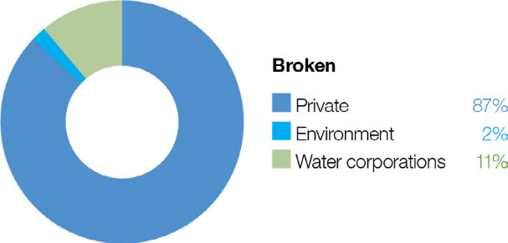
The Broken system includes the Broken River, upper Broken Creek, lower Broken Creek and the Broken wetlands.

Broken River and upper Broken Creek
System overview
The Broken River is a tributary of the Goulburn River, rising in the Wellington-Tolmie highlands and flowing northwest to Benalla and then west for a total distance of 190 km before it joins the Goulburn River near Shepparton (Figure 5.5.1). Lake Nillahcootie is the main storage on the Broken River. It is about 36 km upstream of Benalla and harvests water from the river to support stock and domestic supply and irrigated agriculture. The main tributaries of the Broken River are Hollands Creek, Ryans Creek and Lima East Creek.
Lake Nillahcootie has a storage capacity that is about half the mean annual flow of its upstream catchment, so it fills in most years. The operation of Lake Nillahcootie has modified the river’s natural flow pattern: winter/spring flow is less than natural because a large proportion of inflow is harvested, while summer/autumn flow is greater than natural because water is released to meet downstream irrigation demands. These impacts are most pronounced in the reach between Lake Nillahcootie and Hollands Creek. Below Hollands Creek, the river retains a more-natural flow pattern due to flows from unregulated tributaries, although the total annual flow is considerably less than natural. The catchment has been extensively cleared for agriculture, including dryland farming (such as livestock grazing and cereal cropping) and irrigated agriculture (such as dairy, fruit and livestock).
Water is released from Lake Nillahcootie to meet downstream demand and minimum-flow requirements specified under the bulk entitlement for the Broken River system. Releases from storage may be less than 30 ML per day as tributary inflows immediately below the storage (such as from Back Creek) can supply much of the minimum-flow requirements specified in the bulk entitlement.
Upper Broken Creek is defined as the 89-km stretch of creek from the Broken River (at Caseys Weir) to the confluence with Boosey Creek near Katamatite. Upper Broken Creek flows across a flat riverine plain and has naturally low run-off from its local catchment. It receives flood flows from the Broken River, although the frequency of these floods has been reduced by river regulation, earthworks and road construction.
Upper Broken Creek has been regulated for more than a century. Before 2007, water was diverted into upper Broken Creek at Caseys Weir to meet local demand, but recent water savings projects have reduced the demand on the creek. There is now
a low flow throughout the year between Caseys Weir and Waggarandall Weir. The flow below Waggarandall Weir is mainly influenced by rainfall and catchment run-off. These changes have reduced the amount of permanent aquatic habitat.
Delivery of water for the environment to the Broken River is primarily constrained by the small volume of water holdings in the Broken system. Environmental water holders can trade water into the Broken system from other trading zones subject to relevant limits and conditions to meet environmental needs.
The bulk entitlement for the Broken system held by Goulburn-Murray Water stipulates that a minimum environmental flow – also known as passing flow – is to be maintained in the Broken River when there are natural flows into the system. The bulk entitlement also allows Goulburn-Murray Water and the Goulburn Broken CMA to agree to reduce the minimum passing flow and accumulate unused volumes for later releases that will provide a greater environmental benefit. In recent years, the
passing flow has been reduced, accumulated and delivered to maintain a low flow (on days when there is no passing flow due to no natural flow into the system) and freshes in the Broken River. Accumulated passing flow is the first volume lost when the storage spills. Environmental flows in upper Broken Creek are restricted by the volume of available supply, channel capacity and the need to avoid flooding low-lying, adjacent land.
Return to start of section
Figure 5.5.1 The Broken system
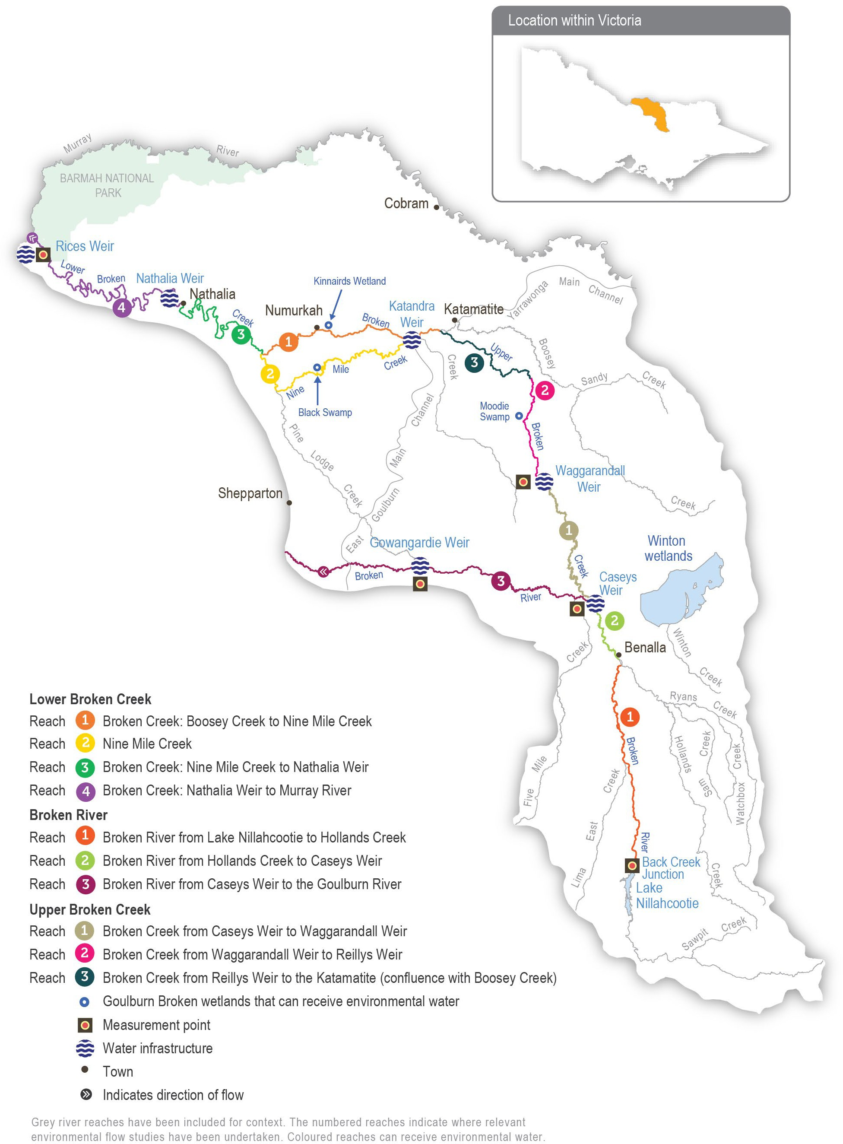

Return to start of section

Environmental values
The Broken River retains one of the best examples of healthy in-stream vegetation in a lowland river in the region. A range of native submerged and emergent plant species, including eelgrass, common reed and water ribbons, populate the bed and
margins of the river. These plants provide habitat for a range of animals, including small- and large-bodied native fish. Murray cod, Macquarie perch, golden perch, silver perch, river blackfish, mountain galaxias, southern pygmy perch and Murray- Darling rainbowfish all occur in the Broken River. The river also supports a large platypus population.
Upper Broken Creek is dominated by unique box streamside vegetation and remnant plains grassy woodland. The creek and its streamside zone support numerous threatened species, including brolga, Australasian bittern, buloke and ridged water- milfoil. Much of the high-quality native vegetation in the region is set aside as a natural features reserve. Upper Broken Creek supports a variety of native fish species, including carp gudgeon, Murray cod, golden perch and Murray-Darling rainbowfish, as well as platypus and common long-necked turtle.
The Broken River and upper Broken Creek are listed in the Directory of Important Wetlands in Australia.

Environmental objectives in the Broken River and upper Broken Creek
Maintain native fish populations
Turn over bed sediments and scour around large wood to maintain in-channel habitat diversity
Maintain platypus populations
Maintain in-stream vegetation
Maintain a wide range and high biomass of waterbugs to break down dead organic matter and support the river’s food web
Maintain water quality

Traditional Owner cultural values and uses
The Broken River system flows through Taungurung and Yorta Yorta Country. The Broken Creek is on Yorta Yorta Country.

The Taungurung Land and Waters Council and the Yorta Yorta Nation Aboriginal Corporation are members of the Broken Environmental Water Advisory Group. Water for the environment in the Broken system supports the health of cultural values and landscapes, including intangible cultural heritage, valued species and traditional food and medicine plants.
Each year, the Goulburn Broken CMA meets with the Taungurung Land and Waters Council and the Yorta Yorta Nation Aboriginal Corporation to discuss plans for environmental watering in the Broken River and upper Broken Creek. Meetings were held in early 2023 to discuss 2023-24 environmental watering priorities. Both groups support the proposed watering actions.
The Taungurung Land and Waters Council plans to assess cultural values and objectives for the Broken River through healthy Country assessments like Aboriginal Waterway Assessments. These will help the council develop more-specific cultural objectives for the Broken River system in future as well as culturally informed recommendations for water for the environment.
In 2021, the Yorta Yorta Nation Aboriginal Corporation provided the following statement about the cultural values of the Broken River system, including Broken Creek:
“The Broken River (and Broken Creek) holds many cultural values. Common reed contained within the slack water provides important material for tools while also providing refuge for culturally important fish species (large- and small-bodied). The river also has significant stands of old-growth river red gum containing important habitat and exhibiting scars made from carving out canoes and coolamons.”
Return to start of section

Social, recreational and economic values and uses
In planning the potential environmental watering actions in Table 5.5.1, the Goulburn Broken CMA considered how environmental flows could support values and uses, including:
- water-based recreation (such as canoeing, fishing, kayaking and swimming)
- riverside recreation (such as birdwatching, bushwalking, camping, duck hunting and picnicking)
- green and blue spaces important to the community for wellbeing and mental health due to the otherwise dry environment
- community events and tourism (such as markets around Benalla Lake)
- socioeconomic benefits (such as maintaining the volume of water in the lower sections to optimise the efficiency of deliveries of consumptive water, maintain water quality for irrigation, stock and domestic use and support terrestrial birds that help control agricultural pests).
Scope of environmental watering
The term ‘environmental watering’ refers to the active delivery of held environmental water to support particular environmental objectives by altering the flow in a river or the water level in a wetland. While other terms are sometimes used to describe the delivery of environmental water, ‘environmental watering’ is deliberately used here and in seasonal watering statements to ensure consistency in the legal instruments that authorise the use of water for the environment in Victoria.
Table 5.5.1 describes the potential environmental watering actions in 2023-24, their expected watering effect (that is, the intended physical or biological effects of the watering action) and the longer-term environmental objectives they support. Each environmental objective relies on one or more potential environmental watering actions and their associated physical or biological effects.
Table 5.5.1 Potential environmental watering actions, expected watering effects and associated environmental objectives for the Broken River and upper Broken Creek

Potential environmental watering action | Expected watering effects | Environmental objectives
Upper Broken Creek1
Winter low flow (5-10 ML/ day during June to August) | - Maintain aquatic habitat and connections between weir pools for native fish and platypus  - Inundate benthic surfaces and large wood located at the bottom of the channel, which serves as habitat for waterbugs  - Maintain water quality and oxygen levels for native fish, platypus and waterbugs
Spring low flow (5-10 ML/ day during September to November)
Summer low flow
(5-10 ML/day during December to February)
Autumn low flow (5-
10 ML/day during March to May)
Summer/autumn fresh (one fresh of 50-100 ML/ day for 10 days during December to May) | - Flush pools to improve their water quality and increase oxygen levels
Broken River (reaches 1, 2 and 3)2
Winter low flow (15-100 ML/day during June to August) | - Maintain habitat for in-stream and fringing vegetation, and prevent terrestrial vegetation from colonising the stream bed  - Maintain riffles, pools and slackwater to provide diverse hydraulic habitat for native fish, aquatic plants, platypus and waterbugs  - Maintain water quality and oxygen levels for native fish, platypus and waterbugs
Spring low flow (15- 100 ML/day during
September to November)
Summer low flow (15- 100 ML/day during December to May)
Autumn low flow (15-100 ML/day during March to May)

Potential environmental watering action | Expected watering effects | Environmental objectives
Summer/autumn fresh (one fresh of 400-500 ML/day for two to five days during December to May) | - Scour sediments around large wood, turn over bed sediments, replenish biofilms and maintain macrophyte habitat  - Provide flow cues to stimulate native fish to breed and migrate  - Maintain longitudinal connectivity for native fish passage
- Potential watering actions in upper Broken Creek will be delivered at a lower magnitude if insufficient water is available to achieve the target magnitude.
- 30-100 ML/day is the recommended flow required to ensure optimal habitat and water quality is achieved in the Broken River. When water availability is low, a flow may need to be delivered at 15 ML per day to provide the minimum habitat and water-quality requirements to sustain populations of fish, platypus and vegetation while conserving enough water to deliver throughout the year.

Scenario planning
Table 5.5.2 outlines potential environmental watering and expected water use in a range of planning scenarios.

The small environmental water entitlement restricts the scope of watering actions that can be delivered in the Broken River system. Therefore, there is little scope to change the proposed watering actions from year to year to enhance outcomes associated with events such as the 2022 floods. The proposed actions presented in Table 5.5.2 are similar to those that have been delivered in previous years.
There are two sets of watering actions: one for upper Broken Creek and another for the Broken River. Delivering flow to upper Broken Creek is a higher priority because upper Broken Creek has no inflows from tributaries and relies more on operational water deliveries and water for the environment. The potential watering actions for upper Broken Creek require less water than those for the Broken River. Any environmental flows delivered to upper Broken Creek will pass through reaches 1 and 2 of the Broken River, where they will provide some environmental benefit.
All potential watering actions in the Broken River and upper Broken Creek are required across all planning scenarios. There is expected to be insufficient water for the environment to meet any of them in the drought planning scenario, or most of them under the dry, average and wet planning scenarios. The VEWH and CEWH may elect to trade water into the system to deliver high-priority actions if a trade opportunity is available.
The main objective of environmental flows in upper Broken Creek is to maintain a low flow throughout the year, to maintain water quality and habitat for native fish, platypus and waterbugs. Maintaining an adequate flow and connectivity is particularly important during spring and summer when native fish, platypus, waterbugs and aquatic vegetation are most active and productive. Water for the environment will likely be prioritised for a spring and summer low flow in the dry, average and
wet planning scenarios. This flow will be delivered at the lower end of its recommended ranges under the drier planning scenarios, due to limited supply. It may be delivered at larger magnitudes and longer durations in average and wet conditions to meet more environmental objectives if water allocations allow. Routine summer/autumn freshes are not planned but may be delivered in any planning scenario to help prevent low-oxygen blackwater events. The Goulburn Broken CMA will monitor water-quality conditions in upper Broken Creek and seasonal forecasts, and it may limit the use of water for the environment for low flows during low-risk periods to conserve water for emergency freshes, if needed.
A year-round low flow (in all planning scenarios) and a summer/autumn fresh (under the dry, average and wet planning scenarios) are needed to support Broken River environmental objectives. However, there is little capacity to influence these with environmental water, especially in the drought and dry planning scenarios. Any environmental water allocations in the drought or dry planning scenarios will be prioritised to deliver a flow to upper Broken Creek, and water will need to be traded into the system if a decision is made to supplement low operational deliveries and natural tributary inflows in the Broken River in these planning scenarios. In the average and wet planning scenarios, increased operational deliveries and tributary inflows will help meet the recommended year-round low flow in the Broken River. Water for the environment may be used to
supplement any of the recommended low flows in these planning scenarios, but additional water will be required through trade to deliver a summer/autumn fresh.
Carryover requirements have not been identified for the upper Broken Creek and Broken River. The preferred course is to use available water in 2023-24 and seek extra supply through trade in 2024-25, if needed, to meet essential environmental demands.
Return to start of section

Table 5.5.2 Potential environmental watering for Broken River and upper Broken Creek in a range of planning scenarios

Planning scenario | Drought | Dry | Average | Wet
Expected conditions | - No unregulated flow in Broken River or upper Broken Creek  - Low releases of operational water in Broken River  - Likely low and cease-to-flow events throughout the year in all reaches | - Low, unregulated flow in Broken River and none in upper Broken Creek  - Low releases of operational water in Broken River  - Possible low and cease-to-flow events throughout the year in all reaches | - High winter/spring flow in Broken River  - Increased releases of operational water in Broken River  - Periods of unregulated flow in upper Broken Creek | - High winter/spring flow in Broken River  - Increased releases of operational water in Broken River  - Periods of unregulated flow in upper Broken Creek with some winter/spring freshes
Expected availability of water for the environment | - 0 ML | - 407 ML | - 647 ML | - 647 ML
Upper Broken Creek
Potential environmental watering – tier 1 (high priorities) | Tier 1a (can be achieved with predicted supply)
 | - Nil | - Spring low flow (partially delivered)  - Summer low flow (partially delivered) | - Spring low flow  - Summer low flow
 | Tier 1b (supply deficit)
 | - Winter low flow  - Spring low flow  - Summer low flow  - Autumn low flow  - Summer/autumn fresh | - Winter low flow  - Spring low flow  - Summer low flow  - Autumn low flow  - Summer/autumn fresh | - Winter low flow  - Autumn low flow  - Summer/autumn fresh
Broken River (targeting reaches 1, 2 and 3)
Potential environmental watering – tier 1 (high priorities) | Tier 1a (can be achieved with predicted supply)
 | - Nil |  | - Winter low flow  - Spring low flow  - Summer low flow  - Autumn low flow
 | Tier 1b (supply deficit)
 | - Winter low flow  - Spring low flow  - Summer low flow  - Autumn low flow | - Winter low flow  - Spring low flow  - Summer low flow  - Autumn low flow  - Summer/autumn fresh | - Summer/autumn fresh
Possible volume of water for the  environment required to achieve objectives | - 0 ML (tier 1a)  - 4,076 ML (tier 1b) | - 407 ML (tier 1a)  - 5,579 ML (tier 1b) | - 647 ML (tier 1a)  - 3,401 ML (tier 1b)
Priority carryover requirements for 2024-25 | - N/A
Return to start of section

Lower Broken Creek
System overview
The lower Broken Creek system is within Yorta Yorta Country, and their cultural connection is evident throughout the landscape. The lower Broken Creek system includes the section of Broken Creek that flows from the confluence of Boosey Creek near Katamatite to the Murray River; and Nine Mile Creek, which is an anabranch of lower Broken Creek that flows from the East Goulburn Main Channel to below Numurkah.
Lower Broken and Nine Mile creeks have been regulated for over a century. Before regulation, the creeks would have had most of their flow in winter/spring and contracted to isolated pools or dried out during summer/autumn. The adjacent floodplain would have also flooded regularly. The creeks now have numerous weirs that maintain a relatively constant water level from mid-August until mid-May to support irrigated agriculture and little flow during the non-irrigation season. These modifications have changed the way native species use the creek and favour invasive species (such as arrowhead). Previously, native
fish would have moved into the creek when it was flowing and returned to the Murray River as it dried. Both creeks now provide year-round habitat for native fish, and fish passage structures allow fish to move between weir pools. Water for the environment is used to support these permanent fish habitats by providing flows to trigger fish movement and support fish passage, encourage the growth of native plants, promote in-stream productivity, control water quality and flush the water fern azolla as necessary.
Regulated water is delivered to lower Broken Creek from the Goulburn and Murray systems via the irrigation channel network. Lower Broken Creek is operated separately from upper Broken Creek and Broken River, which are both supplied from Lake Nillahcootie on upper Broken River.
Water for the environment can be provided to lower Broken Creek from the Goulburn system through the East Goulburn Main Channel and from the Murray system through the Yarrawonga Main Channel. Water is released into lower Broken Creek from several irrigation regulators along the length of lower Broken Creek. The main priority for environmental flows in the lower Broken Creek system is to maintain a minimum flow throughout the year to maintain suitable habitat for native fish. Particular attention is given to reaches 1 and 2 during the non-irrigation season when the flow can stop. The next priority is to deliver freshes in winter/spring to trigger fish movement and spawning, maintain water quality and manage azolla accumulations in reaches 3 and 4. Rices Weir is the measurement point for environmental flows in lower Broken Creek.
Some of the environmental flow targets for lower Broken Creek are partly or wholly met by operational water releases: inter- valley transfers (IVTs) from the Goulburn to the Murray or Barmah Choke bypass that are delivered to meet downstream demands. These operational deliveries mainly occur during peak irrigation demand periods between spring and autumn. Water for the environment may be used to supplement these operational releases and to deliver recommended flow components that are not met by operational releases.
Environmental values
Lower Broken Creek and Nine Mile Creek support a diverse and abundant native fish community, including the threatened Murray cod, golden perch, silver perch, unspecked hardyhead and Murray-Darling rainbowfish.
Sections of lower Broken and Nine Mile creeks have been reserved as state park and natural feature reserves. The associated floodplain and wetland habitats support box-dominated grassy woodland communities and numerous species of state and national conservation significance, including river swamp wallaby grass and the Australasian bittern.

Environmental objectives in lower Broken Creek
Protect and increase native fish populations, including the threatened Murray cod, golden perch and silver perch
Protect platypus populations, particularly outside the irrigation season Protect rakali (water rat) populations, particularly outside the irrigation season
Protect turtle populations, particularly outside the irrigation season
Avoid the excessive build-up of azolla
Increase the cover and condition of native in-stream and littoral vegetation communities
Increase the diversity and abundance of waterbug populations
Maintain oxygen levels suitable for aquatic animals
Return to start of section

Traditional Owner cultural values and uses
Lower Broken Creek flows on Yorta Yorta Country.
Each year, the Goulburn Broken CMA meets with the Yorta Yorta Nation Aboriginal Corporation to discuss water for the environment in lower Broken Creek. A meeting was held in early 2023 to discuss 2023-24 environmental watering priorities.
The planned environmental flows for 2023-24 in the lower Broken Creek are supported by the Yorta Yorta Nation Aboriginal Corporation. The flows will support in-stream vegetation and native fish, along with other aquatic plants and animals.
The Goulburn Broken CMA will continue to work with Yorta Yorta People to identify how the management of water for the environment can better support cultural values.
In 2021, the Yorta Yorta Nation Aboriginal Corporation provided the following statement about the cultural values of the Broken River system including lower Broken Creek:
“The Broken River and Broken Creek hold many cultural values. Common reed contained within the slack water provides important material for tools while also providing refuge for culturally important fish species (large and small-bodied). The creek also has significant stands of old-growth river red gum containing important habitat and exhibiting scars made from carving out canoes and coolamons.”
The Yorta Yorta Nation Aboriginal Corporation has raised concerns about flow regulation in all their waterways, which is affecting their Country and cultural knowledge.
The Yorta Yorta Nation Aboriginal Corporation continues to pursue the Yorta Yorta People’s inherent rights to water for Country. Rights to water will improve their spiritual, cultural, environmental, social and economic needs, in line with the Yorta Yorta Whole-Of-Country Plan 2021-2030.
Social, recreational and economic values and uses
In planning the potential environmental watering actions in Table 5.5.3, the Goulburn Broken CMA considered how environmental flows could support values and uses, including:
- water-based recreation (such as canoeing, fishing, game hunting and kayaking)
- riverside recreation and amenity (such as aesthetic and amenity values that are particularly important for the community’s mental health and wellbeing during dry periods and for passive recreation)
- community events and tourism
- socioeconomic benefits (such as consumptive water users, Goulburn-Murray Water irrigators and diverters and Goulburn Valley Water customers).
Scope of environmental watering
The term ‘environmental watering’ refers to the active delivery of held environmental water to support particular environmental objectives by altering the flow in a river or the water level in a wetland. While other terms are sometimes used to describe the delivery of environmental water, ‘environmental watering’ is deliberately used here and in seasonal watering statements to ensure consistency in the legal instruments that authorise the use of water for the environment in Victoria.
Table 5.5.3 describes the potential environmental watering actions in 2023-24, their expected watering effect (that is, the intended physical or biological effects of the watering action) and the longer-term environmental objectives they support. Each environmental objective relies on one or more potential environmental watering actions and their associated physical or biological effects.
Table 5.5.3 Potential environmental watering actions, expected watering effects and associated environmental objectives for the lower Broken Creek

Potential environmental watering action | Expected watering effects | Environmental objectives
Winter low flow  (20-40 ML/day during May to August)1 | - Provide native fish with passage through fish ladders  - Provide suitable foraging habitat for platypus and rakali (water rats), and support the conditioning of females in preparation for the breeding season  - Provide habitat for turtles, including protection from exposure during their winter dormancy  - Provide flowing-water habitat and avoid winter drying of weir pools for fish, vegetation, waterbugs, platypus and turtles  - Maintain water over submerged aquatic plants so they are protected from drying and frost  - Reduce the stagnation of weir pools

Potential environmental watering action | Expected watering effects | Environmental objectives
Spring/summer/autumn low flow (70-250 ML/ day in reaches 1 and 2 and 200-450 ML/day in reaches 3 and 4 during August to May) | - Provide habitat for native fish, platypus, rakali (water rats), turtles and waterbugs  - Support the movement and recruitment of fish  - Maintain oxygen levels in summer  - Additional benefits when delivered from December to February (at 250- 450 ML/day):  - mobilise azolla and increase oxygen levels during high-risk periods
Winter/spring fresh(es) (one to three freshes of 300-450 ML/day for one to two weeks during July to November) | - Flush and mobilise azolla if it has accumulated to maintain water quality  - Trigger the movement and spawning of fish  - Encourage the germination and growth of littoral and in-stream vegetation  - Reduce the stagnation of weir pools
1 This flow may be difficult to achieve when channel maintenance work is being completed. If maintenance work is required, waterway managers will work with the storage manager to minimise impacts where possible. Possible mitigation actions include closing fishways to maintain water in weir pools and scheduling works to minimise the duration of impacts on flow.

Scenario planning
Table 5.5.4 outlines potential environmental watering and expected water use in a range of planning scenarios.
The high degree of regulation in the lower Broken Creek system means flow patterns in the lower Broken and Nine Mile creeks are the same in all planning scenarios. Water for the environment in the lower Broken Creek system is primarily used to guard against reduced flow during the non-irrigation season.
Potential watering actions in all planning scenarios include maintaining the flow above 40 ML per day outside the irrigation season, ameliorating sudden fluctuations in irrigation demand during the irrigation season and delivering spring freshes to trigger fish movement or flush excessive accumulations of azolla. Delivering spring freshes in 2024-25 in all planning scenarios will be of particular importance to trigger the movement and spawning of native fish in the system after the record flooding and subsequent low-oxygen blackwater event in 2022. These events caused widespread fish deaths in the lower Broken Creek and many parts of the southern connected basin.
The Goulburn Broken CMA will monitor water quality throughout the year, and it may increase the flow to the upper end of the recommended range in Table 5.5.3 if oxygen levels drop below 4.0 mg/L. The total volume of water for the environment that will be needed to achieve planned watering actions in 2023-24 will vary depending on operational deliveries (including IVTs) and the sizes and durations of any unregulated flow events. A carryover target of 5,000 ML applies in all planning scenarios to ensure a minimum low flow and a small fresh can be delivered early in 2024-25.
Return to start of section

Table 5.5.4 Potential environmental watering for lower Broken Creek in a range of planning scenarios

Planning scenario | Drought | Dry | Average | Wet
Expected conditions | - No unregulated flow | - Some unregulated flow in winter  - No unregulated flow throughout the irrigation season (mid-August to May)  - No diversion of unregulated Murray River flow is available | - Unregulated flow in winter/spring  - Unregulated flow is unlikely from October to May  - Diversion of unregulated Murray River flow is available from mid- August to October | - Unregulated flow is likely in winter/ spring  - Unregulated flow is possible from November to May  - Diversion of unregulated Murray River flow available from mid-August to November
Potential environmental watering – tier 1 (high priorities)1 | - Winter low flow  - Spring/summer/autumn low flow  - Winter/spring freshes
Possible volume of water for the  environment required to achieve objectives | - 80,000 ML
Priority carryover requirements for 2024-25 | - 5,000 ML
1 Tier 1 potential environmental watering for lower Broken Creek is not classified as tier 1a or 1b because the water available for use is shared across various systems and it is not possible to reliably determine the supply specifically available for lower Broken Creek.
Return to start of section

Broken wetlands
System overview
Of some 2,000 natural wetlands in the Goulburn Broken area, only three in the Broken catchment have infrastructure that allows them to receive environmental water: Black Swamp, Kinnairds Wetland and Moodie Swamp.
These wetlands are on the Country of the Yorta Yorta People, whose knowledge and practice are evident throughout the landscape; for example, Black Swamp has evidence of old cooking mounds around its perimeter. Kinnairds Wetland and Black Swamp are red gum swamps near Numurkah. Moodie Swamp is a cane grass wetland adjacent to upper Broken Creek at Waggarandall that provides excellent breeding habitat for brolga.
The water regimes of these wetlands are influenced by their position in the landscape. The development and operation of the Shepparton and Murray Valley irrigation districts have changed the natural flow paths and the timing, frequency, volume and duration of natural flooding to these and other wetlands in the region. The existing irrigation system infrastructure enables water for the environment to be delivered to the three nominated wetlands, but under existing agreements, irrigation deliveries have priority within the channel system. This limits the volume of water that can be delivered to the wetlands. The VEWH, waterway managers and storage managers adjust the timing and rate of environmental deliveries where possible to optimise environmental outcomes within the current system constraints.
Environmental values
Moodie Swamp, Kinnairds Wetland and Black Swamp support a great diversity of vegetation communities ranging from river red gum to cane grass. The wetlands contain state- and nationally-threatened vegetation communities and species, including ridged water-milfoil and river swamp wallaby grass. The wetlands also provide food resources and breeding habitat for bird species of high conservation significance, including eastern great egret, Latham’s snipe, white-bellied sea eagle, Australasian bittern, brolga, royal spoonbill, yellow-billed spoonbill, Australasian shoveler and glossy ibis. Many of these species are listed in international agreements and conventions.

Environmental objectives in the Broken wetlands
Provide breeding habitat for frogs
Improve the cover, diversity, recruitment/regeneration and growth of native wetland plant species, consistent with ecological vegetation class benchmarks
Reduce the cover and diversity of exotic plant species Maintain populations of ridged water-milfoil
Provide breeding habitat for waterbirds
Provide feeding and roosting habitat for waterbirds
In 2023-24, no active deliveries of water for the environment are planned for the Broken wetlands. The environmental objectives are considered long-term aspirational goals for the system, based on the achievement of multi-year water regimes that involve wetting and drying cycles. Wetland drawdown and drying contribute to important ecosystem processes (such
as nutrient cycling and ecosystem productivity). These, in turn, support the achievement of the long-term environmental objectives.
Traditional Owner cultural values and uses
Moodie Swamp, Kinnairds Wetland and Black Swamp support various native plants and animals that provide many cultural values and uses for the Yorta Yorta People. Black Swamp and Kinnairds Wetland support multiple varieties of nardoo (a food source), native grasses (such as old man weed and sneezeweed, which have medicinal uses) and sedges and rushes (used for basket weaving). Basket weaving sedges also grow at Moodie Swamp.
Each year, the Goulburn Broken CMA meets with the Yorta Yorta Nation Aboriginal Corporation about the management of water for the environment in the Broken system, including the Broken wetlands. The Yorta Yorta Nation Aboriginal Corporation is also a member of the Broken Environmental Water Advisory Group, which meets with the CMA two or three times a year.
The Yorta Yorta Nation Aboriginal Corporation supports the planned drying of Moodie Swamp, Kinnairds Wetland and Black Swamp in 2023-24.
Return to start of section

Social, recreational and economic values and uses
In planning the potential environmental watering actions in Table 5.5.5, the Goulburn Broken CMA considered how environmental flows could support values and uses, including:
- water-based recreation (such as canoeing)
- riverside recreation and amenity (such as birdwatching, camping, picnicking, photography, walking and hunting)
- community events and tourism (such as community gatherings at Kinnairds Wetland and the Walk and Squawk event)
- socioeconomic benefits (such as tourism, which is a large contributor to the local economy).
Scope of environmental watering
The term ‘environmental watering’ refers to the active delivery of held environmental water to support particular environmental objectives by altering the flow in a river or the water level in a wetland. While other terms are sometimes used to describe the delivery of environmental water, ‘environmental watering’ is deliberately used here and in seasonal watering statements to ensure consistency in the legal instruments that authorise the use of water for the environment in Victoria.
Table 5.5.5 describes the potential environmental watering actions in 2023-24, their expected watering effect (that is, the intended physical or biological effects of the watering action) and the longer-term environmental objectives they support. Each environmental objective relies on one or more potential environmental watering actions and their associated physical or biological effects.
Table 5.5.5 Potential environmental watering actions, expected watering effects and associated environmental objectives for the Broken wetlands

Potential environmental watering action | Expected watering effects | Environmental objectives
- No deliveries of water for the environment are planned in 2023-24

Scenario planning
Table 5.5.6 outlines potential environmental watering and expected water use in a range of planning scenarios.

In September and October 2022, there was widespread flooding in the Broken system, which filled all the floodplain wetlands, including Black Swamp, Kinnairds Wetland and Moodie Swamp. Black Swamp and Kinnairds Wetland reached their optimum fill period of six to eight months during 2022-23. Moodie Swamp received natural inflows from Broken Creek in January, February and October 2022. It was still holding a significant volume during autumn 2023, and aquatic plant diversity may be beginning to decline because of this prolonged inundation.
All three wetlands will be allowed to complete a full natural drawdown during 2023-24 to support dry-phase ecological processes and help eradicate the large number of carp that entered the wetlands during the 2022 floods. Each wetland has a recommended dry phase of at least six months, and staged watering will likely resume at these wetlands from 2024-25.
Table 5.5.6 Potential environmental watering for the Broken wetlands in a range of planning scenarios

Planning scenario | Drought | Dry | Average | Wet
Expected conditions | - Catchment run-off and natural flow into the wetlands are highly unlikely | - Catchment run-off and natural flow into the wetlands are unlikely | - Some catchment run-off and natural flow into some of the wetlands are likely, particularly in winter/spring | - Catchment run-off and natural flow into the wetlands may significantly contribute to water levels in  the wetlands, particularly in winter/spring
Potential environmental watering – tier 1 (high priorities) | - N/A: No deliveries of water for the environment are planned in 2023-24
Potential environmental watering – tier 2 (additional priorities) | - N/A

Planning scenario | Drought | Dry | Average | Wet
Possible volume of water for the  environment required to achieve objectives | - N/A
Priority carryover requirements for 2024-25 | - N/A
Return to start of section

Campaspe system
Waterway manager – North Central Catchment Management Authority
Storage manager – Goulburn-Murray Water
Environmental water holders – Victorian Environmental Water Holder (including the Living Murray program) and Commonwealth Environmental Water Holder
Proportions of water entitlements in the Campaspe basin held by private users, water corporations and environmental water holders on 30 June 2020
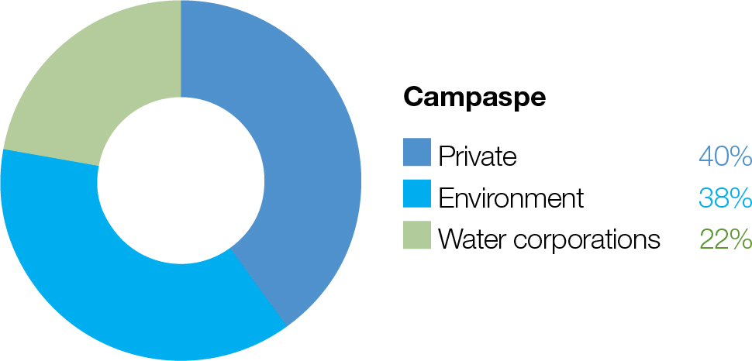
The Campaspe system includes the Campaspe and Coliban rivers.

Campaspe River
System overview
Natural inflows in the upper Campaspe River catchment are harvested into Lake Eppalock, which is located near the townships of Axedale and Heathcote. The main tributaries of the Campaspe River are the Coliban River, McIvor and Wild Duck creeks above Lake Eppalock and Mount Pleasant, Forest and Axe creeks below Lake Eppalock (Figure 5.6.1).
Below Lake Eppalock, the major in-stream structure is the Campaspe Weir, which was built to divert water to the Campaspe Irrigation District. It is no longer used for water diversion but is a barrier to fish migration. Gates on the weir provide some degree of control over the flow, but greater flow spills over the weir. The Campaspe Siphon, just below Rochester, is part of the Waranga Western Channel, which carries water from the Goulburn system to western Victoria. Water can be released from the Waranga Western Channel into the lower reaches of the Campaspe River, but the siphon is another barrier to fish migration when there is low-to-moderate flow.
The flow below Lake Eppalock is largely influenced by releases from storage and the operation of the Campaspe Weir and the Campaspe Siphon. The Campaspe’s major tributary (the Coliban River) flows through the three Coliban Water storages (the Upper Coliban, Lauriston and Malmsbury reservoirs) before reaching Lake Eppalock. Water for the environment is held and released from Lake Eppalock, with some limited ability to regulate flow further downstream at the Campaspe Weir.
Water for the environment is released from Lake Eppalock to support aquatic plants and animals in and along the Campaspe River. It can be supplemented by water for the environment delivered via the Waranga Western Channel at the Campaspe Siphon, which provides important flexibility to meet environmental demands in reach 4. Water for the environment is primarily used in the Campaspe River to improve the magnitude and variability of flow during winter and spring, but it is also used to deliver critical flow in summer and autumn that is not met or exceeded by operational deliveries. Primary flow measurement points are at Barnadown (reach 2) and below the Campaspe Siphon (reach 4).
Goulburn-Murray Water transfers operational water from Lake Eppalock or through Waranga Western Channel to customers in the Murray River and to downstream storages (such as Lake Victoria). These inter-valley transfers (IVTs) usually occur in summer and autumn and, depending on the rate of delivery, can either support or compromise environmental flow objectives. High IVT flows delivered at a time when the Campaspe River would naturally have low flow may reduce the amount of suitable habitat for juvenile fish, which rely on protected, shallow areas of water near the edge of the river channel. Sustained high IVT flows in summer can also drown recruiting streamside vegetation. Storage managers and the North Central CMA have been working cooperatively to enhance the positive effects and limit the negative effects of IVTs on native plants and animals in the
Campaspe River. For example, IVTs are sometimes delivered in a pattern that meets summer low-flow and fresh requirements, thereby reducing demand for the environmental entitlement. IVTs have also been released in a pattern to support native fish migration from the Murray River into reach 4 of the Campaspe River without affecting delivery to downstream users.
Return to start of section

Figure 5.6.1 The Campaspe system
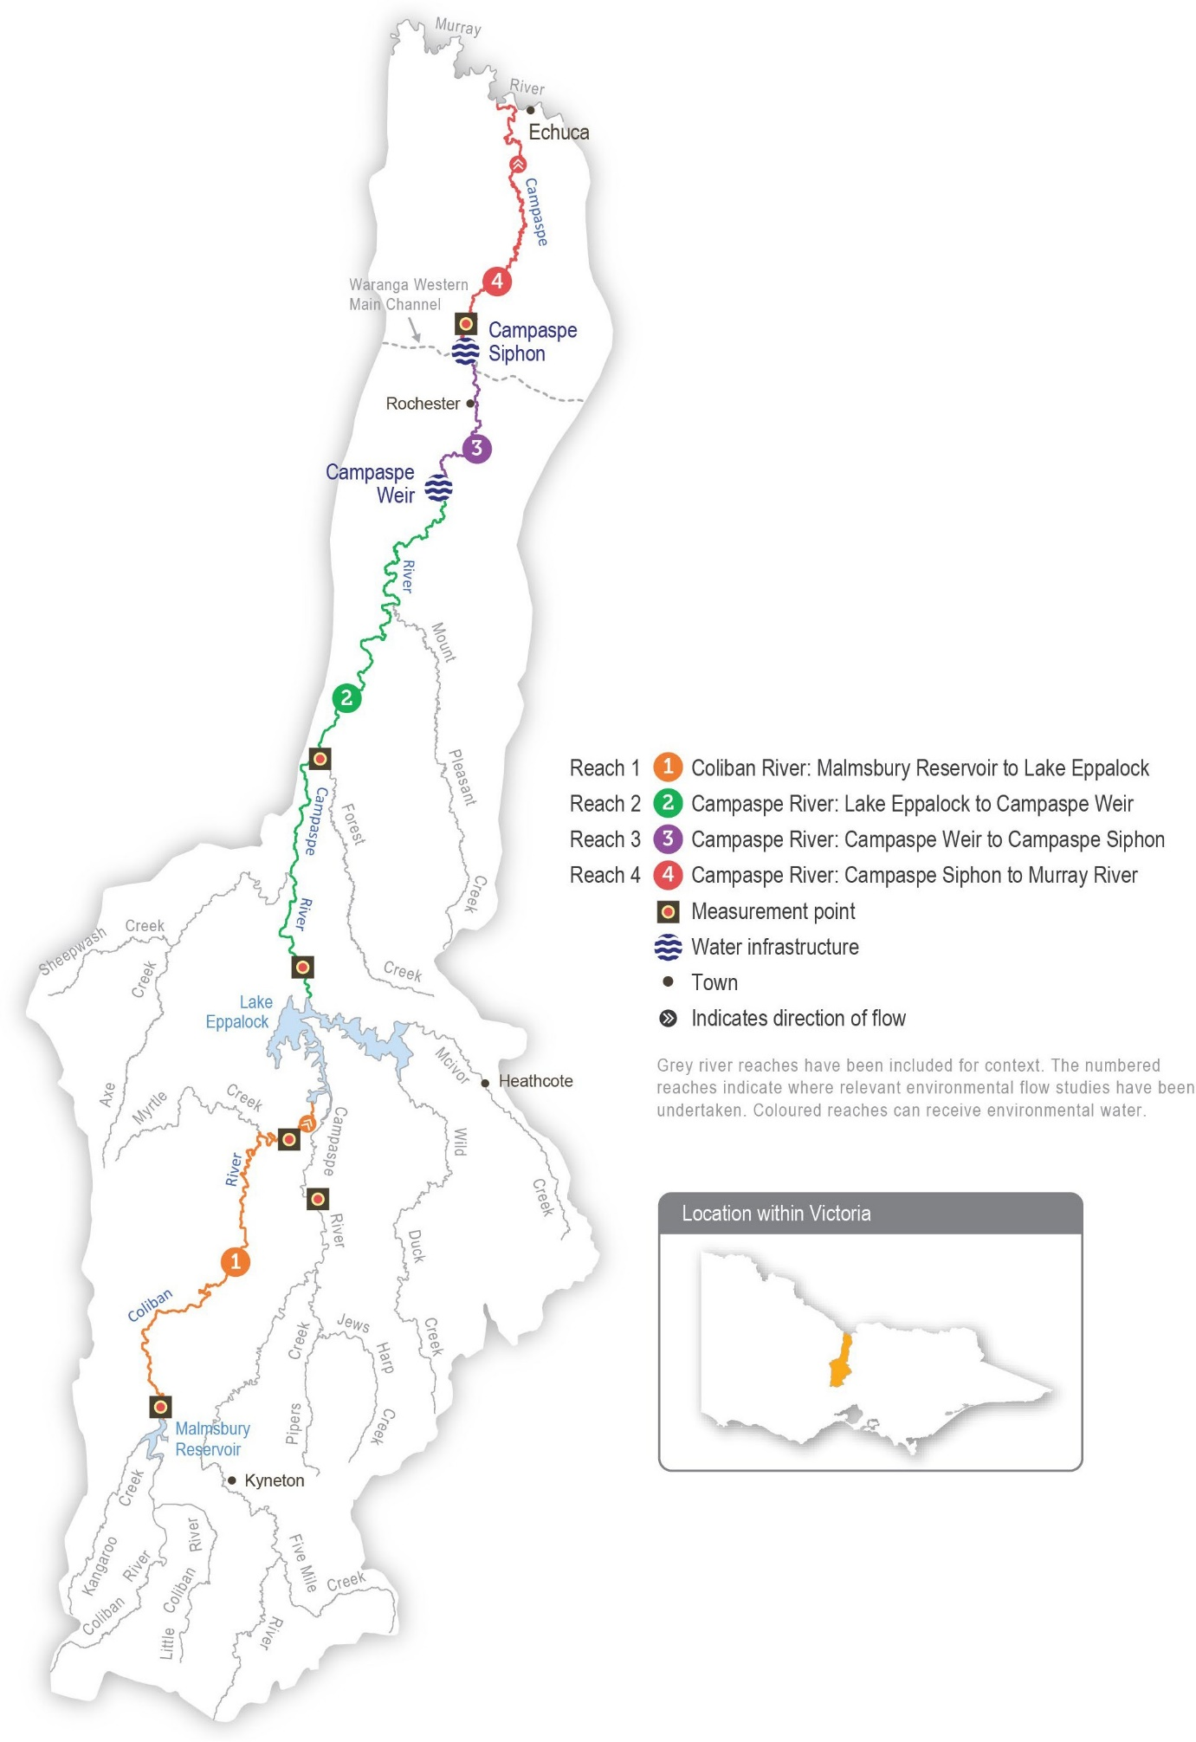
Return to start of section

Environmental values
The Campaspe River below Lake Eppalock provides important habitat for several native fish species, including Murray cod, silver perch, golden perch, Murray-Darling rainbowfish and flat-headed gudgeon. Murray-Darling rainbowfish were presumed lost from the system during the Millennium Drought, but since 2011, they have been recorded at many sites on the Campaspe River and are now abundant below Elmore. Environmental flows help native fish migrate and disperse throughout the Campaspe system.
Platypus, rakali (water rats), turtles and frogs are also present along the length of the Campaspe River. The streamside vegetation zone is narrow and dominated by large, mature river red gum trees that support wildlife (such as the swift parrot and squirrel glider).

Environmental objectives in the Campaspe system
Protect and increase populations of native fish
Facilitate recolonisation by native fish species (including trout, cod and blackfish) that have been presumed lost
Enhance the channel form and features, including deep pools and benches
Maintain the condition of suitable substrate to maintain ecosystem processes Engage floodrunners, distributary channels, anabranches and backwaters
Protect the resident platypus population
Maintain adult river red gums and increase the recruitment of immature trees Maintain the extent and increase the diversity of streamside vegetation
Increase the extent of in-stream aquatic plants
Increase the diversity and biomass of waterbugs
Maintain water quality in deep pools and prevent stratification in summer Reduce the risk of low-oxygen blackwater events in summer

Traditional Owner cultural values and uses
The Campaspe River flows through Dja Dja Wurrung, Taungurung and Yorta Yorta Country.
In planning for environmental flows in the Campaspe River in 2023-24, the North Central CMA met with Dja Dja Wurrung Clans Aboriginal Corporation (trading as Djaara), the Taungurung Land and Waters Council and the Yorta Yorta Nation Aboriginal Corporation (YYNAC) to discuss how cultural objectives can be supported by water for the environment and the importance of Traditional Owner involvement in the management of water on Country.
The following meetings were held in early 2023:
- the North Central CMA met with Djaara to discuss environmental water management in the Campaspe River in 2023-24. Discussions covered reflections on the previous water year, current conditions in the Campaspe River and how Djaara would like to input to planning in 2023-24 and beyond
- the North Central CMA attended a YYNAC meeting to discuss potential watering in the Campaspe in 2023-24, potential cultural heritage impacts and how YYNAC would like to be involved in environmental water planning and management for the upcoming year
- the North Central CMA attended a Taungurung Land and Waters Council Baan Ganalina meeting to discuss the 2022-23 floods and plans for environmental watering in 2023-24. Baan Ganalina members discussed with North Central CMA the Taungurung Reading Water Country program, including recent monitoring and collection of biocultural knowledge at seven sites on the Campaspe River.
Through the Taungurung Reading Water Country program, Baan Ganalina has developed Taungurung cultural objectives for the Campaspe River. These cultural objectives recognise the interconnectedness of people and Country and the central role of Traditional Owners in speaking for Country.
Regarding water management, Baan Ganalina emphasises the principle of ‘right way water: right time, right place, right amount’. ‘Right way water’ includes flows at varying and seasonally appropriate levels that reconnect backwaters, that maintain water quality and that do not damage cultural sites.
Return to start of section

Social, recreational and economic values and uses
In planning the potential environmental watering actions in Table 5.6.1, the North Central CMA considered how environmental flows could support values and uses, including:
- water-based recreation (such as canoeing, kayaking, fishing and water sports)
- riverside recreation and amenity (such as birdwatching, bushwalking, camping, cycling, duck hunting and picnicking)
- community events and tourism (such as visitors travelling to canoe and kayak on the river)
- socioeconomic benefits (such as diversions for irrigation, domestic and stock uses; local and regional economic benefits from increased visitation; ecosystem services [such as carbon storage, groundwater recharge and water-quality regulation]; lower salinity management costs, lower blackwater and blue-green algae risks for landholders; and contributions to community enjoyment, health and recuperation).
If the timing or management of planned environmental flows may be modified to align with a community benefit, this is acknowledged in Table 5.6.1 with the following icon.

Watering planned to support peaks in visitation (e.g. camping or other public activities on long weekends or school holidays)
There are many places along the Campaspe River where visitors like to camp. Aysons Reserve is a popular camping site near Elmore, and it draws hundreds of campers during school holiday periods. Where possible, freshes are delivered outside of peak visitation periods (such as the March and April long weekends) to ensure the flow is not too high for campers and water- related activities.

Scope of environmental watering
The term ‘environmental watering’ refers to the active delivery of held environmental water to support particular environmental objectives by altering the flow in a river or the water level in a wetland. While other terms are sometimes used to describe the delivery of environmental water, ‘environmental watering’ is deliberately used here and in seasonal watering statements to ensure consistency in the legal instruments that authorise the use of water for the environment in Victoria.
Table 5.6.1 describes the potential environmental watering actions in 2023-24, their expected watering effect (that is, the intended physical or biological effects of the watering action) and the longer-term environmental objectives they support. Each environmental objective relies on one or more potential environmental watering actions and their associated physical or biological effects.
Table 5.6.1 Potential environmental watering actions, expected watering effects and associated environmental objectives for the Campaspe River

Potential environmental watering action | Expected watering effects | Environmental objectives
Campaspe River (targeting reach 4)
Winter/spring low flow (40-200 ML/day during June to November) | - Maintain longitudinal connectivity to allow native fish to disperse within reaches  - Provide foraging opportunities across a wide range of habitats for female platypus to develop fat reserves before breeding  - Maintain water quality by preventing pools from stratifying  - Discourage terrestrial plants from colonising the lower sections of the riverbank and low benches in the channel  - Maintain soil moisture in the riverbank to water established river red gums and woody shrubs  - Help establish littoral vegetation1  - Provide a variety and large abundance of habitats for high macroinvertebrate productivity supporting food webs  - Greater-magnitude flows will facilitate:  - long-distance movement by male platypus, especially in the August to October breeding season  - greater movement of large-bodied native fish

Potential environmental watering action | Expected watering effects | Environmental objectives
Winter/spring fresh(es) (one to two2 freshes 1,000-1,600 ML/day for two to five days during June to November) | - Flush accumulated leaf litter from the banks and low benches to reduce the risk of blackwater events during high river flow in summer  - Maintain soil moisture for established river red gum and woody shrubs (such as bottlebrush and tea tree)  - Provide sufficient velocity to scour accumulated sediment from pools and scour biofilms  - Maintain connectivity to allow native fish to move and access new habitat  - Encourage female platypus to select nesting burrows higher up the bank to reduce the risk of a high flow later in the year flooding burrows when juveniles are present
Summer/autumn low flow (40-50 ML/day3 at the Campaspe Siphon during December to May) | - Maintain slackwater habitats for zooplankton and nursery habitats for native fish  - Maintain the water depth and prevent stratification in deep pools in summer to maintain habitat for native fish and platypus  - Inundate a variety of habitats to facilitate the growth of biofilms and support waterbug productivity
- Allow platypus to safely move between pools while foraging, and ensure there is adequate food for lactating females
Reducing flow to 20 ML/day in reaches 2 and 3 in autumn will expose mudflats and encourage the recruitment of some fringing vegetation
Summer/autumn freshes (three freshes of 100- 200 ML/day for two  to three days during December to May) | - Promote the germination, growth and survival of fringing emergent macrophytes, including phragmites, reeds and sedges, by inundating the lower banks and low benches to wet the soil  - Promote the local movement of adult fish to access alternative habitats and trigger migration from the Murray River  - Increase longitudinal connectivity to allow native fish to access new habitats  - Wet submerged wood and flush fine silt and old biofilms to promote new biofilm growth and increase waterbug productivity for native fish and platypus  - Facilitate the downstream dispersal of juvenile platypus in April/May to colonise other habitat areas
Year-round fresh (trigger- based, 50-200 ML/day as required) | - Destratify pools and improve water quality (increase oxygen levels) along the river in reach 4, ensuring there is adequate oxygen to support aquatic animals (such as native fish and platypus)
Triggers:
- oxygen level is below 5 mg/L
- low or cease-to-flow river conditions
- high water temperatures

- A greater-magnitude flow rate will wet a larger perimeter of the riverbank, supporting increased littoral vegetation.
- A second winter/spring fresh may be delivered in the average and wet planning scenarios to further enhance the river conditions if required.
- The reach 4 flow will target 40-50 ML/day. However, a reduction in the flow to 20-30 ML/day at reaches 2 and 3 may be considered in autumn to expose the river’s mudflats and promote native vegetation recruitment. To achieve these two flow rate targets, water for the environment from the Goulburn River flow will need to be delivered to reach 4 at the Campaspe Siphon.
Return to start of section

Scenario planning
Table 5.6.2 outlines potential environmental watering and expected water use in a range of planning scenarios.
Following consecutive years of high seasonal determinations, frequent unregulated flows and floods and storages close to capacity, the supply outlook for 2023-24 is expected to be strong in all planning scenarios. It is expected all planned environmental watering actions will be achieved at magnitudes consistent with seasonal tolerances.
Initial post-flood surveys along the Campaspe River in January and February 2023 indicated the 2022 floods provided a net benefit to the river’s native vegetation. Although there has been a loss of aquatic (in-stream) vegetation, their root masses remain in place within the bed of the river and are expected to recover quickly. The flood also removed exotic weeds and terrestrial species from the riverbanks. It is important that all potential environmental watering actions are delivered in 2023-24 to consolidate the environmental benefits of the 2022 floods, including maximising the opportunity to increase the extent and diversity of native streamside and in-stream vegetation in the absence of exotic and terrestrial vegetation species.
Planned watering actions for the Campaspe River aim to meet low-flow targets throughout the year and to deliver a mix of small and medium-sized freshes in all planning scenarios. Under drought and dry planning scenarios, freshes and the winter/ spring low flow will likely be delivered at the lower end of the target magnitude ranges, in line with climate conditions and limited natural and passing flow. In the average and wet planning scenarios, some watering actions will likely be achieved naturally. This means that water for the environment can be used to deliver freshes and a winter-spring low flow at the
higher end of their recommended magnitude to help increase the size and condition of platypus, native fish and native plant populations. A second winter/spring fresh will only be delivered if it can be timed to not interfere with potential Murray cod breeding. The North Central CMA will monitor water levels and water quality throughout the year and deliver trigger-based freshes in any planning scenario, if needed to mitigate poor water quality.
The flow may be lowered to about 20 ML per day in reaches 2 and 3 in autumn in all planning scenarios to encourage the recruitment of fringing plants on exposed mudflats. This would be a joint initiative between the North Central CMA and vegetation ecologists from the Arthur Rylah Institute, and it will be supported by dedicated monitoring if it proceeds. Lowering the flow in reach 4 may pose a risk to water quality, so the watering trial will only proceed if sufficient water can be delivered from the Western Waranga Channel to supplement the flow downstream of the Campaspe Siphon.
The carryover target for 2023-24 is based on the volume required to deliver a priority summer/autumn low flow during 2024-25 if there is a return to dry or drought conditions. No carryover targets are set for the average/wet planning scenario, as early- season allocations are likely to be sufficient to meet summer/autumn low flow environmental flow demands.
Table 5.6.2 Potential environmental watering for the Campaspe River in a range of planning scenarios

Planning scenario | Drought | Dry | Average to wet
Expected conditions | - Little to no natural flow from tributaries and local run-off  - Low passing flow  - Operational water deliveries | - Some natural flow from tributaries and local run-off  - Increased passing flow  - Operational water deliveries | - Moderate-to-high natural flow from tributaries and local run-off  - Increased passing flow  - An expected spill of Eppalock Reservoir
Expected availability of water for the environment | - 34,500 ML | - 34,500 ML | - 27,500 ML
Campaspe River (targeting reach 4)
Potential environmental watering – tier 1 (high priorities) | Tier 1a (can be achieved with predicted supply)
 | - Winter/spring low flow (lower magnitude)  - Winter/spring fresh (one of lower magnitude)  - Summer/autumn low flow1  - Summer/autumn freshes (three of lower magnitude)  - Year-round fresh (if required) | - Winter/spring low flow (lower magnitude)  - Winter/spring fresh (one of lower magnitude)  - Summer/autumn low flow1  - Summer/autumn freshes (three of lower magnitude)  - Year-round fresh (if required) | - Winter/spring low flow  - Winter/spring fresh(es) (one to two freshes2)  - Summer/autumn low flow1  - Summer/autumn freshes (three freshes)  - Year-round fresh (if required)
 | Tier 1b (supply deficit)
 | - N/A | - N/A | - N/A
Potential environmental watering – tier 2 (additional priorities) | - N/A

Planning scenario | Drought | Dry | Average to wet
Possible volume of water for the environment required to achieve objectives | - 28,500 ML (tier 1a)  - 900 ML3 (tier 1a Goulburn) | - 28,500 ML (tier 1a)  - 900 ML3 (tier 1a Goulburn) | - 27,500 ML (tier 1a)  - 900 ML3 (tier 1a Goulburn)
Priority carryover requirements for 2024-25 | - 6,000 ML | - 6,000 ML | - N/A
- This potential watering action may have a period of a lower flow rate in reaches 2 and 3 (20 ML/day) while maintaining the 40-50 ML/day flow in reach 4. To achieve this outcome, water for the environment from the Goulburn will need to be delivered to reach 4 at the Campaspe Siphon.
- A second winter/spring fresh may be delivered in the average and wet planning scenarios to further improve streamside vegetation by wetting riverbanks, support fish movement and clear accumulated leaf litter to reduce the risk of blackwater events during the summer high flow.
- The possible volume of water required from the Goulburn could increase up to 2,200 ML if it is more effective to source water from Waranga Western Channel to deliver a year-round fresh to reach 4 at the Campaspe Siphon.

Coliban River
System overview
The Coliban River is the major tributary of the Campaspe River and flows into Lake Eppalock. It is highly regulated, with three storages harvesting water primarily for urban use.
Flow in the Coliban River below Malmsbury Reservoir is regulated by the operation of the Malmsbury, Lauriston and Upper Coliban reservoirs. An important distinction between the Coliban River and other regulated Victorian systems is the lack of irrigation demand that may be met by managed releases downstream of system storages. Flow in the river is influenced by the passing flow entitlement, which depends on catchment inflows and major flood events in the catchment.
The VEWH does not have any environmental entitlements in the Coliban system, but the passing flow can be managed – for example, it can be accumulated and released when most needed – to help mitigate some risks associated with a critically low summer/autumn flow, including low oxygen levels in the river between Malmsbury Reservoir and Lake Eppalock. A small
volume of Commonwealth water for the environment is held in the system but has a high delivery cost. There is no plan to use the water in 2023-24.
Environmental values
The Coliban River provides important habitat for platypus, rakali (water rats) and small-bodied native fish (such as flat-headed gudgeon and mountain galaxias). The Coliban River also contains a diverse range of waterbugs supported by stands of emergent and submergent aquatic vegetation. It is bordered by remnant patches of streambank shrubland vegetation and woodland containing river red gum, callistemon, woolly tea tree and inland wirilda, which provide habitat for terrestrial animals.

Environmental objectives in the Coliban River
Increase the abundance and diversity of small-bodied native fish
Facilitate recolonisation by native fish species (including river blackfish) that have been presumed lost
Maintain the platypus population
Increase the cover and diversity of aquatic plants
Increase the cover and diversity of fringing vegetation while limiting encroachment into the middle of the channel Maintain streamside woody vegetation and facilitate recruitment
Maintain an adequate diversity and biomass of waterbugs to break down dead organic matter and supply the river’s food chain
Maintain water quality to support aquatic life and ecological processes
Return to start of section

Traditional Owner cultural values and uses
The Coliban River system is on Dja Dja Wurrung Country.

The Djaara (Dja Dja Wurrung people) Nation Statement in the Victorian Government’s Water is Life: Traditional Owner Access to Water Roadmap 2022 and the Dhelkunya Dja (Healing Country) Country Plan 2014-2034 both describe Djaara’s aspirations around the management of water on their Country.
Djaara’s Kapa Gatjin (water advisory) Group and the North Central CMA have been working together to identify sites where water for the environment can support Djaara’s aspirations for the Coliban River. They have also been identifying opportunities for Djaara to be more involved in managing and administering environmental water, with the aim of Djaara ownership and management of environmental water.
In recent years, Djaara has completed several Aboriginal Waterways Assessments in the upper and lower catchments of the Coliban River.

Social, recreational and economic values and uses
In planning the potential environmental watering actions in Table 5.6.3, the North Central CMA considered how environmental flows could support values and uses, including:
- water-based recreation (such as swimming, canoeing and fishing)
- riverside recreation and amenity (such as socialising, relaxing, birdwatching, bushwalking, camping and cycling)
- socioeconomic benefits, including tourism to Malmsbury, diversions for domestic and stock uses, benefits to the local and regional economies from recreational activities, ecosystem services (such as carbon storage, groundwater recharge and water-quality regulation), lower salinity costs and blackwater and blue-green algae risks for landholders and contributions to community enjoyment, health and recuperation.

Scope of environmental watering
The term ‘environmental watering’ refers to the active delivery of held environmental water to support particular environmental objectives by altering the flow in a river or the water level in a wetland. While other terms are sometimes used to describe the delivery of environmental water, ‘environmental watering’ is deliberately used here and in seasonal watering statements to ensure consistency in the legal instruments that authorise the use of water for the environment in Victoria.
Table 5.6.3 describes the potential environmental watering actions in 2023-24, their expected watering effect (that is, the intended physical or biological effects of the watering action) and the longer-term environmental objectives they support. Each environmental objective relies on one or more potential environmental watering actions and their associated physical or biological effects.
Table 5.6.3 Potential environmental watering actions, expected watering effects and associated environmental objectives for the Coliban River

Potential environmental watering action | Expected watering effects | Environmental objectives
Coliban River (targeting reach 1)
Winter/spring low flow (2- 10 ML/day during June to November) | - Maintain up to 6 cm water depth between pools for native fish movement and maintain river pool depth  - Maintain wet areas for native aquatic and streamside plants  - Prevent stagnation and a decline in water quality  - Maintain aquatic habitat that supports waterbugs, native fish and platypus
Winter/spring fresh (one fresh of up to 160 ML/ day for three to five days during June to September) | - Maintain up to 65 cm water depth between pools so native fish can disperse throughout the river and colonise sites  - Encourage female platypus to select a nesting burrow higher up the bank to reduce the risk of a greater flow later in the year flooding the burrow when juveniles are present  - Increase the wetted river perimeter for fringing and edge vegetation  - Increase the wetted river perimeter to increase habitat for waterbugs  - Flush organic matter to reduce the risk of declining water quality in summer

Potential environmental watering action | Expected watering effects | Environmental objectives
Summer/autumn low flow (2-10 ML/day during December to May) | - Maintain up to 6 cm water depth between pools for native fish movement, and maintain river pool depth  - Wet the channel to maintain in-stream aquatic and fringing vegetation  - Maintain aquatic habitat that supports waterbugs, native fish and platypus  - Maintain water quality, including oxygen levels
Summer/autumn fresh(es) (one to two freshes of 25-160 ML/ day for three to five days during December to May) | - Increase the water depth through riffle-run habitats to 8-20 cm for a 25-50 ML/day event to maintain water quality and habitat for waterbugs  - Increase the water depth through riffle-run habitats to 45-60 cm for a 160 ML/day event to:  - facilitate the movement of fish and platypus  - clean sediment and biofilms from river substrates  - wet the benches and low banks to promote the growth and recruitment of fringing vegetation
Pulsed summer/autumn low flow (5-15 ML/day for up to 14 days during December to May, trigger-based)  Triggers:  - oxygen level is below 5 mg/L  - low or cease-to-flow river conditions  - high water temperatures | - Improve water quality, including oxygen levels  - Maintain refuge habitat for aquatic animals, including fish and platypus
Scenario planning
Table 5.6.4 outlines potential environmental watering and expected water use in a range of planning scenarios.
The potential environmental flows required for the Coliban River include a low flow and freshes in all planning scenarios, but the magnitude of particular flows and the number and duration of freshes that can be delivered varies between planning
scenarios, due to available supply and the expected contribution of natural flows in the system. Where supply is limited, a low flow will be delivered at the lower end of the recommended magnitude to maintain some connecting flow for a longer period. Freshes will be delivered where possible to facilitate the dispersal of platypus and fish and clean biofilms from in-stream surfaces.
In all planning scenarios, the highest-potential watering action in the Coliban River is the summer/autumn low flow to maintain sufficient habitat for native fish, platypus and waterbugs. Natural baseflow and tributary inputs help to maintain some flow through the Coliban River during winter and spring each year, but long sections of the river contract to a series of pools or completely dry during late summer and autumn, especially in dry and drought years. Deliveries of water for the environment in summer and autumn help to maintain water quality, especially when oxygen levels are low. They also maintain the depth of pools in the upper reaches to help sustain populations of native fish and platypus.
In August 2022, Malmsbury Reservoir spilled, resulting in the loss of water held in the Passing Flows Account, including water carried over from 2021-22. The accrual of passing flow resumed in December 2022 when the reservoir ceased spilling, and some of that water was used to deliver a summer/autumn fresh in April 2023. As a result, limited water is expected to
be available to carry over into 2023-24. Providing Malmsbury Reservoir does not spill again over winter/spring 2023, any water carried over from 2022-23 will be used to help maintain a continuous low flow in all planning scenarios in 2023-24. If a continuous flow cannot be maintained, shorter, pulsed flows may be delivered to maintain pool habitats for native fish and platypus. These trigger-based pulses will most likely be needed in the dry planning scenario, but may also be needed in the
wetter planning scenarios if there is insufficient supply to deliver a continuous low flow in late summer or early autumn. Where possible, summer and autumn freshes will be delivered to facilitate the movement of fish and platypus and support fringing vegetation. These freshes will aim to be delivered in March or April to support the dispersal of juvenile platypus and reduce predation.
Return to start of section

An aspirational carryover target of 720 ML has been set for all planning scenarios to supply high-priority summer and autumn low flows in 2024-25. This target is unlikely to be achieved in most years due to the limited availability of water for the
environment in the Coliban system and yearly variations in climatic conditions. The carryover target will be revised throughout the year based on climatic forecasts, the risk of spills and the extent to which priority actions for 2023-24 have been met. For example, if forecasts indicate a high likelihood of dry conditions in 2024-25, setting aside supply for carryover might become a higher priority than delivering a second summer/autumn fresh in 2023-24. Alternatively, if Malmsbury Reservoir is predicted to spill, delivering at least one summer/autumn fresh in 2023-24 will be a higher priority than achieving the full 720 ML carryover target.
Table 5.6.4 Potential environmental watering for the Coliban River in a range of planning scenarios

Planning scenario | Drought | Dry | Average/wet
Expected conditions | - Little to no natural flow | - Some natural flow | - Extended periods of natural flow, including some high-flow events and reservoir spills
Expected availability of water for the environment1 | - 1,650 ML | - 1,780 ML | - 1,905 ML
Coliban River (targeting reach 1)
Potential environmental watering – tier 1 (high priorities) | - Tier 1a (can be achieved with predicted supply)
 | - Winter/spring low flow (lower magnitude)  - Summer/autumn low flow (lower magnitude in the range)  - Pulsed summer/autumn low flow (trigger-based) | - Winter/spring low flow  - Summer/autumn low flow  - Summer/autumn fresh (one fresh of lower magnitude)  - Pulsed summer/autumn low flow (trigger-based) | - Winter/spring low flow  - Summer/autumn low flow  - Summer/autumn fresh(es) (one to two freshes of lower magnitude)  - Pulsed summer/autumn low flow (trigger-based)
 | - Tier 1b (supply deficit)
 | - Summer/autumn low flow (greater magnitude)  - Summer/autumn fresh(es) (one to two freshes of lower magnitude) | - Winter/spring fresh (one fresh)  - Summer/autumn freshes (tier 1a partially delivered at increased magnitude) | - Winter/spring fresh (one fresh)  - Summer/autumn freshes (tier 1a freshes at full magnitude)
Potential environmental watering – tier 2 (additional priorities) | - N/A | - N/A | - N/A
Possible volume of water for the environment required to achieve objectives | - 1,650 ML (tier 1a)  - 920 ML (tier 1b) | - 1,780 ML (tier 1a)  - 1,640 ML (tier 1b) | - 1,905 ML (tier 1a)  - 1,620 ML (tier 1b)
Priority carryover requirements for 2024-25 | - 0-720 ML
1 As there is no formal environmental entitlement in the Coliban River, these are estimated volumes of passing flow that may be accumulated for a managed environmental flow.
Return to start of section

Loddon system
Waterway manager – North Central Catchment Management Authority
Storage manager – Goulburn-Murray Water
Environmental water holders – Victorian Environmental Water Holder and Commonwealth Environmental Water Holder
Proportions of water entitlements in the Loddon basin held by private users, water corporations and environmental water holders on 30 June 2020
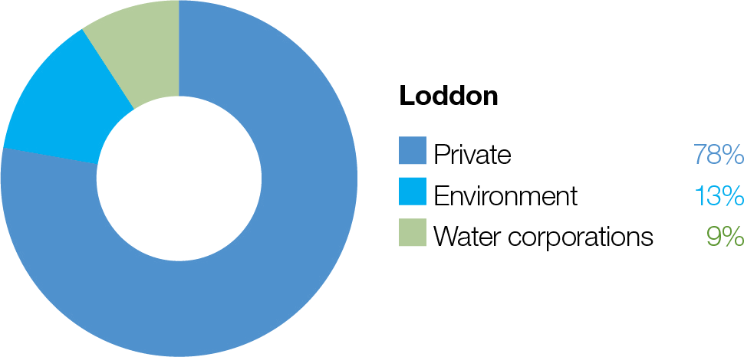

The Loddon system includes the Loddon River system (including Serpentine and Pyramid creeks), the Boort wetlands and Birchs Creek subsystems.

Loddon River system (including Serpentine and Pyramid creeks)
System overview
The Loddon River flows from the Great Dividing Range in the south to the Murray River in the north (Figure 5.7.1). The middle section of the Loddon River is characterised by many distributary streams and anabranches that carry water away from the river onto the floodplain. Pyramid Creek joins the lower Loddon River at Kerang, at which point the Loddon becomes part of the Murray River floodplain.
The two main storages on the Loddon River are Cairn Curran Reservoir and Tullaroop Reservoir. Laanecoorie Reservoir is a smaller storage used to regulate water released from the larger upstream storages. Flow in the Loddon River downstream of Laanecoorie Reservoir is regulated by the operation of the Bridgewater, Serpentine, Loddon and Kerang weirs.
Water for the environment can be delivered to the Loddon River from Cairn Curran or Tullaroop reservoirs or from the Goulburn system via the Waranga Western Channel, which intersects with the Loddon River at Loddon Weir. Water is provided to Pyramid Creek through releases from Kow (Ghow) Swamp, which receives water diverted from the Murray River at Torrumbarry Weir. Water is diverted from the Loddon River to the Loddon Valley Irrigation Area to supply agriculture and to Serpentine Creek to support environmental values and supply agriculture.
The highly regulated nature of the Loddon system provides challenges and opportunities for the effective management of water for the environment. The ability to manipulate the timing of releases at multiple locations can help achieve environmental outcomes at discrete locations. However, coordinating environmental and consumptive flows is difficult through the irrigation season, especially when irrigation demand is high or the flow in the river is highly variable. These issues can constrain the timing and delivery of water for the environment or lead to a flow that exceeds the recommended flow rates above Loddon Weir. The structures used for managing irrigation water also form barriers in the waterway that restrict native fish movement throughout the river and make it difficult to meet ecological objectives.
Return to start of section

Figure 5.7.1 The Loddon system

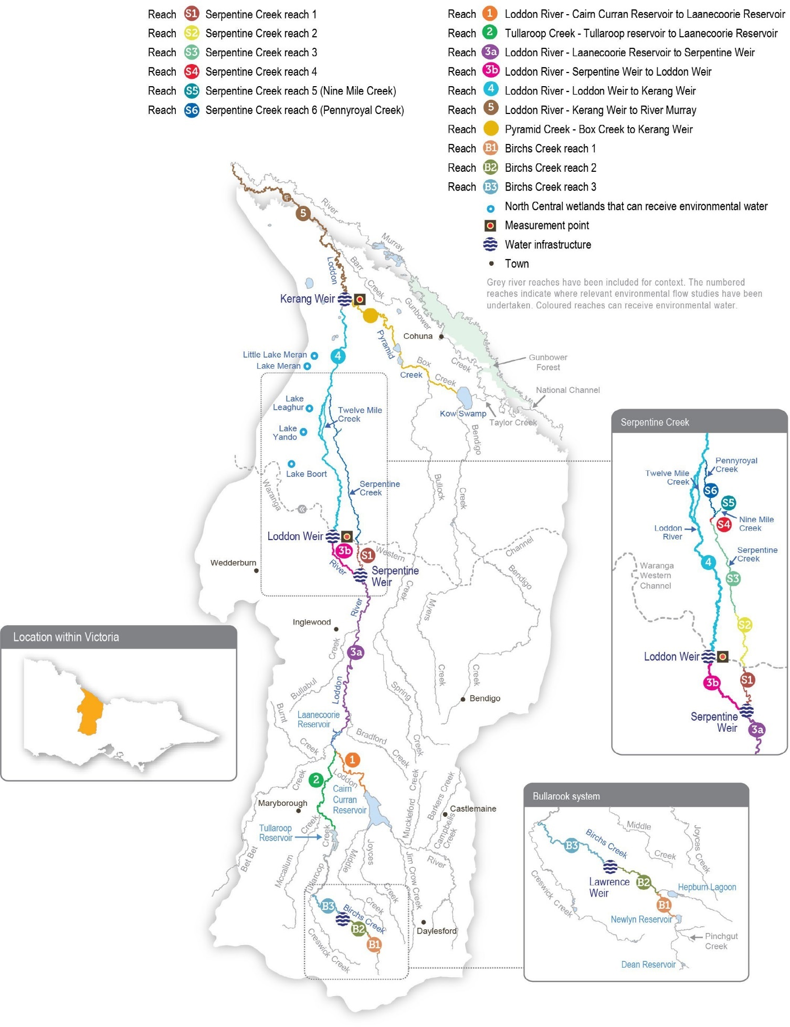
Return to start of section

Environmental values
The Loddon River system supports platypus, rakali (water rats) and several species of native fish (such as Murray cod, golden perch, silver perch, river blackfish and Murray-Darling rainbowfish). Streamside vegetation varies in condition depending on the recent water regime, the extent of clearing and historic and current land management practices. The areas that remain relatively intact support a variety of woodland birds and other native animals. Important plant species across the system include cane grass, tangled lignum, black box and river red gum.
Although fish populations in the Loddon system are affected by the many barriers caused by weirs and reservoirs, a large range of species are still found through the catchment. Native fish are most abundant and diverse in the upper catchment. River blackfish are found in Serpentine Creek, and rare Murray-Darling rainbowfish are found in the middle and lower sections of the Loddon River.
The highest-priority reach for water for the environment is from Loddon Weir to Kerang Weir. The reach does not carry irrigation water, and it relies heavily on environmental flows to maintain its environmental condition. Environmental flows to this reach aim to maintain water quality, increase the abundance and diversity of native fish and improve the condition of streamside vegetation. Environmental flows are delivered to the upper Loddon River and Serpentine Creek to maintain or increase populations of river blackfish and platypus.
Pyramid Creek and the lower Loddon River support large-bodied fish (such as golden perch, Murray cod and silver perch) and are important corridors for fish migration between the Loddon and Murray systems. Engineering works to provide fish passage at the Chute, Box Creek regulator, Kerang Weir, Fish Point Weir and Little Murray Weir on the Little Murray River in recent years have been important in reopening these migration routes. The Arthur Rylah Institute has monitored fish movement and populations in Pyramid Creek and the lower Loddon River since 2017. The monitoring indicates that the combined flows in the lower Loddon River and Pyramid Creek are stimulating native fish movement through the fishways.

Environmental objectives in the Loddon River system
Increase populations of small and large-bodied native fish
Provide habitat for fish to feed and breed and opportunities for movement between habitats
Enhance the channel form and features, including deep pools and benches
Maintain the condition of suitable substrate to maintain ecosystem processes Engage flood runners, distributary channels, anabranches and backwaters
Increase the population and recruitment of resident platypus Maintain a stable rakali (water rat) population in the long term
Maintain productive and dynamic food webs Maintain the diversity and abundance of biofilms
Maintain the condition of streamside and floodplain vegetation Maintain and increase the extent of in-stream vegetation
Maintain the diversity and increase the abundance of waterbugs and waterbug functional feeding groups
Maintain water quality to support aquatic animals and minimise the occurrence of blackwater events

Traditional Owner cultural values and uses
The Dja Dja Wurrung Clans Aboriginal Corporation (trading as Djaara) are recognised as the Traditional Owners in the upper part of the Loddon catchment. The Barapa Barapa and Wamba Wemba people are recognised as Traditional Owners in the lower part of the catchment. There are artefacts of cultural practices throughout the Loddon and Pyramid system and its floodplain.
In planning for environmental flows in the Loddon River system, Djaara, Barapa Barapa, Wamba Wemba and North Central CMA have considered how environmental flows in the Loddon system can be managed to support their respective values, priorities and uses.
In the upper part of the catchment, the Djaara Kapa Gatjin (water advisory) Group and the North Central CMA work together to identify opportunities and sites where water for the environment can support Djaara’s aspirations for the Loddon River. A key aspiration is for Djaara to be more involved in the management and administering of environmental water, with the aim of future ownership and management of environmental water.
Return to start of section

In August 2022, Dja Dja Wurrung Traditional Owners joined North Central CMA staff for a field visit to three sites along the Loddon River. Key points of discussion included the need to maintain a low river level for cultural burning and to support the growth of weaving plants, the need for restoration projects on creeks that flow into the Loddon, the need to inform Traditional Owners about inter-valley transfer trades and when water is leaving one Country and flowing into another, and the need for more water quality and ecological monitoring (including eDNA sampling and yabby surveys).
Dja Dja Wurrung Traditional Owners plan to undertake more field visits to conduct Cultural Values Assessments in the Loddon catchment. Djaara plans to develop a live and comprehensive report based on the assessments that will inform Loddon water management in the future, including seasonal watering proposals.
In early 2023, Barapa Barapa and Wamba Wemba Traditional Owners joined North Central CMA staff on Country to reflect on environmental water management in the Loddon River system in 2022-23 and to discuss aspirations for 2023-24.
Longstanding concerns were raised about constraints and limitations to delivering environmental water and, in the future, cultural water in the Loddon River system. Related to this, Barapa Barapa and Wamba Wemba Traditional Owners raised that private land tenure often creates impediments to floodplain watering and Traditional Owner restoration efforts on Country.
Building on 2021 discussions about the importance of water for the environment supporting native fish populations in summer, Barapa Barapa and Wamba Wemba Traditional Owners said they would like to be involved in projects and monitoring to investigate fish migration out of the lower Loddon River in response to poor water quality.
The impacts of a carp boom after the 2022 flooding in the Loddon River were also discussed. It was agreed that flow and habitat management (rather than manual control efforts) were more likely to reduce carp numbers in the long term in the Loddon River.
Barapa Barapa and Wamba Wemba Traditional Owners noted that the Loddon west arm at Canary Island contains significant cultural heritage, and they would like to see environmental flows continue to target this reach.
Barapa Barapa custodians have communicated their cultural objectives for the Loddon River and other waterways in the Barapa Barapa Healthy Country Plan 2018-2021. Objectives that relate to the Loddon River system include:
- that all wetlands surrounding the Murray River, Gunbower Forest, Loddon River and associated lakes will have good plant life and healthy native fish (cod and yellow belly), mussels and turtle populations by 2033
- by 2033, the Murray, Gunbower and Loddon rivers and associated lakes will have enough water, their water quality is improving, and the water will be clear for most of the year in good years
- Barapa people are actively involved in water management
- there are fewer fish and plant deaths from toxic blackwater events.
Social, recreational and economic values and uses
In planning the potential environmental watering actions in Table 5.7.1, the North Central CMA considered how environmental flows could support values and uses, including:
- water-based recreation (such as fishing, powered and non-powered boating, water skiing and water sports)
- riverside recreation and amenity (such as birdwatching, bushwalking, camping and cycling)
- community events and tourism (such as water skiing competitions at Bridgewater and associated visitation)
- socioeconomic benefits (such as diverters for domestic and stock uses, local and regional economic benefits from increased visitation and ecosystem services, including carbon storage, groundwater recharge and nutrient recycling).
If the timing or management of planned environmental flows may be modified to align with a community benefit, this is acknowledged in Table 5.7.1 with the following icon.

Watering planned to support water sports activities (e.g. water skiing)
The North Central CMA will work with Goulburn-Murray Water to manage the delivery of low flow rates and the timing of freshes over summer/autumn to support optimum conditions for annual water skiing competitions at Bridgewater weir pool, where possible.
Scope of environmental watering
The term ‘environmental watering’ refers to the active delivery of held environmental water to support particular environmental objectives by altering the flow in a river or the water level in a wetland. While other terms are sometimes used to describe the delivery of environmental water, ‘environmental watering’ is deliberately used here and in seasonal watering statements to ensure consistency in the legal instruments that authorise the use of water for the environment in Victoria.
Table 5.7.1 describes the potential environmental watering actions in 2023-24, their expected watering effect (that is, the intended physical or biological effects of the watering action) and the longer-term environmental objectives they support. Each environmental objective relies on one or more potential environmental watering actions and their associated physical or biological effects.
Return to start of section

Table 5.7.1 Potential environmental watering actions, expected watering effects and associated environmental objectives for the Loddon River system

Potential environmental watering action | Expected watering effects | Environmental objectives
Loddon River (targeting reach 4)
Winter/spring low flow (50-100 ML/day during June to November)1 | - At 50 ML/day, a low flow will provide a minimum level of continuous flow through the reach and maintain water quality and adequate depth in pools to provide habitat for aquatic plants, waterbugs, fish and rakali (water rats)  - At 100 ML/day:  - increase the water depth for fish, platypus and rakali (water rat) dispersal (especially for male juvenile platypus) to colonise new breeding territory in winter and provide foraging habitat  - prevent silt and fine sediment from settling on submerged wood and other hard surfaces  - inundate a variety of habitats to increase the growth of biofilms and support waterbug productivity  - inundate native fringing bank vegetation to support seed germination and growth and prevent the encroachment of exotic terrestrial plants in the river channel
Winter/spring low-flow trial (one to three trials of 100-200 ML/day for one to 30 days during June to November, if triggered by an unregulated flow event) | - Increased longitudinal connectivity by drowning out fish barriers to allow fish to access new habitats  - Inform future works to modify or remove fish barriers
Winter/spring high flow (one high flow of  400-450 ML/day for 10 days during August to November) | - Provide sufficient velocity to scour accumulated sediment from pools and scour biofilms, promoting the growth of new biofilms and increasing waterbug productivity  - Flush accumulated organic matter from the bank and benches to increase productivity and reduce the risk of a hypoxic blackwater event in summer  - Wet the banks to promote the recruitment and growth of streamside and emergent vegetation  - Stimulate native fish movement and breeding
Summer/autumn low flow (50 ML/day during December to May)2 | - Maintain an adequate depth in pools for aquatic plants and to provide habitat for waterbugs, fish and rakali (water rats)  - Provide a continuous flow through all reaches  - Maintain water quality throughout most of the reach, except the Loddon River west branch, during warm weather  - Wet the banks and shallow riffles to support the growth of in-stream and fringing non-woody vegetation
Summer/autumn low- flow trial (50-100 ML/ day for six weeks during December to May) | - Maintain water quality and mitigate against a hypoxic blackwater event in the Loddon River west branch  - Prevent the emigration of native fish species due to poor water quality
Summer/autumn freshes (three freshes of 100 ML/ day for three days during December to May) | - Increase the water level to promote seed germination and the growth of fringing emergent macrophytes  - Increase connectivity between deep pools to promote the local movement of fish and prompt the dispersal of juvenile platypus in autumn  - Generate sufficient force to flush fine sediment and old biofilms from submerged wood and other hard surfaces, promoting the growth of new biofilms and increasing waterbug productivity  - Freshen water quality and reoxygenate pools

Potential environmental watering action | Expected watering effects | Environmental objectives
Autumn high flow (one high flow of 400 ML/ day for six days3 during March to May) | - Trigger and facilitate the upstream movement of golden perch, silver perch and Murray cod older than one year  - Facilitate the dispersal of juvenile platypus  - Generate sufficient force to flush fine sediment and old biofilms from submerged wood and other hard surfaces, promoting the growth of new biofilms and increasing waterbug productivity
Year-round fresh (trigger- based, 100-200 ML/day as required)  Triggers:  - dissolved oxygen level is below 5 mg/L  - low or cease-to-flow river conditions  - high water temperatures | - Destratify pools and improve water quality (increase oxygen levels) along the river in reach 4, ensuring there is adequate oxygen to support aquatic animals (such as native fish and platypus)
Pyramid Creek and Loddon River (targeting reach 5)
Year-round low flow (90-300 ML/day at Box Creek regulator) | - At 90 ML/day:  - the low flow will maintain connectivity between pools, maintain water quality at a level that can support fish and macroinvertebrates and provide habitat for aquatic animals  - At 200 ML/day:  - increase longitudinal connectivity to allow native fish and platypus to access new habitats  - improve water quality by reducing salinity levels  - increase the wetted area to maintain and promote the growth of fringing emergent (non-woody) vegetation along the lower banks of the channel  - At 300 ML/day:  - facilitate greater movement for large-bodied native fish  - increase hydrodynamic diversity and improve the quality of flowing habitats
Winter/spring high flow (one high flow of 650 ML/ day at Kerang Weir for 10 days during August to November)4 | - Trigger the migration, spawning and recruitment of native fish species, including Murray cod  - Maintain connectivity between habitats and improve water quality  - Provide sufficient energy to flush accumulated sediment from pools and substrates
Autumn high flow (one high flow of 650 ML/day at Kerang Weir for 10 days3 during March to April)4 | - Trigger and facilitate the upstream movement of golden perch, silver perch and Murray cod older than one year  - Maintain connectivity between habitats and improve water quality  - Facilitate platypus dispersal  - Provide sufficient energy to flush accumulated sediment from pools and substrates

Potential environmental watering action | Expected watering effects | Environmental objectives
Serpentine Creek (targeting reach 1)5
Winter/spring low flow (10-30 ML/day6 during June to November) | - At 10 ML/day:  - the low flow will maintain connectivity between pools to allow the dispersal of small to medium-bodied native fish  - provide a sufficient flow to maintain water quality by oxygenating pools  - maintain foraging habitat for platypus  - maintain the wetted area to support in-stream aquatic vegetation (such as water ribbons, eel weed and milfoil)  - At 20-30 ML/day:  - maintain habitat for larger native fish and facilitate movement for aquatic animals  - wet exposed roots, woody debris, emergent vegetation and leaf packs to provide habitat for aquatic animals  - inundates low benches, banks and some secondary channels, supporting increased macroinvertebrate productivity and native fish breeding, including river blackfish breeding  - provide flow variability to maintain the diversity of the fringing vegetation
Winter/spring fresh (one fresh of 40-120 ML/ day6 for two days during August to November) | - Provide connectivity for fish and waterbugs to access different habitat areas  - Transport organic matter that has accumulated in the channel to facilitate its breakdown and incorporation into the foodweb, with a low risk of hypoxic blackwater  - Wet the banks to promote the recruitment and growth of streamside and emergent vegetation  - At 120 ML/day:  - maintain the channel form and scour pools  - encourage female platypus to select nesting burrows higher up the bank to reduce the risk of a greater flow later in the year flooding burrows with juveniles in them  - flush accumulated leaf litter from the banks and low benches to reduce the risk of blackwater events during summer
Summer/autumn low flow (10-20 ML/day6 during December to May) | - At 10 ML/day:  - the low flow will provide connectivity between pools to allow the dispersal of small to medium-bodied native fish  - provide a sufficient flow to maintain water quality by oxygenating pools  - maintain foraging habitat for platypus  - maintain the wetted area to support in-stream aquatic vegetation (such as water ribbons, eel weed and milfoil)  - At 20 ML/day:  - maintain habitat for larger native fish and facilitate movement of aquatic fauna  - wet exposed roots, leaf packs and woody debris to provide habitat for aquatic animals

Potential environmental watering action | Expected watering effects | Environmental objectives
Summer/autumn freshes (three freshes of 40 ML/ day6 for two days during December to May) | - Maintain the channel form by inundating benches  - Generate sufficient force to flush fine sediment and old biofilms from submerged wood and other hard surfaces, promoting the growth of new biofilms, increasing waterbug productivity and replenishing the food supply for aquatic animals  - Increase connectivity between pools to promote the local movement of fish and prompt the dispersal of juvenile platypus in autumn  - Provide flow variability to maintain the diversity of fringing vegetation (such as emergent macrophytes)  - Freshen the water to improve its quality by diluting salt, reoxygenating the water and flushing poor-quality water in pools, transporting accumulated nutrients and carbon downstream
- A winter/spring low flow of 50 ML per day is below the passing flow magnitude and will result in the VEWH banking passing flow savings for use in other potential watering actions.
- In all planning scenarios except extreme drought, a 100 ML/day summer/autumn low flow rate may be trialled to mitigate low-oxygen blackwater and prevent the emigration of native fish species.
- The high flow of this event is planned to be delivered for six days, but there is an extended, 14-day ramp-down period.
- Winter/spring and autumn freshes are planned to occur at the same time in the Loddon River and Pyramid Creek, with the peak timed to meet at Kerang Weir. 650 ML per day is the total combined target at Kerang Weir.
- The flow in Serpentine Creek may be allowed to either return to the Loddon River or continue down Pennyroyal, Bannacher and/or Nine Mile creeks with the agreement of landholders.
- The flow delivered from Serpentine Weir may be restricted to manage end-of-system outfalls to avoid third-party impacts until an alternate solution is determined.
Scenario planning
Table 5.7.2 outlines potential environmental watering and expected water use in a range of planning scenarios.
Loddon River
In the Loddon River, the delivery of a continuous, year-round low flow and three summer/autumn freshes are high priorities in all planning scenarios to maintain habitat for native fish, platypus and native vegetation and prevent poor water quality.
A minimum flow of 50 ML per day is preferred during summer and autumn to minimise the risk of poor water quality during warm weather. A lower-magnitude flow may be delivered during the cooler months, if needed, to conserve supply in the drier planning scenarios. This lower-magnitude flow should prevent critical harm to aquatic plants and animals, but it is unlikely to grow populations or improve their condition. Low-oxygen incidents in recent years have highlighted the need for a fresh that can be delivered at any time to respond to poor water quality. This watering action may be delivered up to a magnitude of 200 ML per day, based on the flow rate needed to improve water quality in 2017 and 2022, and it is considered a high priority in all planning scenarios.
In the drought-to-wet planning scenarios, the winter/spring low flow will be delivered between 50-100 ML per day to create a variable flow across the seasons, although it will likely be delivered towards the upper range for longer if water availability
allows. Delivering the winter/spring low flow at the greater magnitude aims to improve the condition of vegetation higher up the bank, improve water quality and increase the abundance of native fish and platypus populations.
Fish ecologists have recommended trialling different flow rates to improve fish outcomes in the Loddon River if sufficient water is available. The first trial aims to increase the summer/autumn low flow to 100 ML per day during the warmest months – likely in January and February or if hot conditions are forecast at other times – and to reduce the risk of fish emigration. It will also test whether water quality issues in the mid-Loddon River can be mitigated through adaptive flow management. The second trial involves increasing the winter/spring low flow to 200 ML per day after an unregulated event to improve fish passage past low-level barriers. The first trial may occur in any planning scenario if there is sufficient supply. The second trial is proposed
in the average-to-wet planning scenarios in response to unregulated flows or spills at Loddon Weir. Each trial will only be implemented if appropriate monitoring is in place to assess their effect and to inform adaptive management.
Return to start of section

Pyramid Creek
Pyramid Creek is regionally significant for native fish. Fish populations within Pyramid Creek have increased since the Millennium Drought, and the removal of fish barriers means it is now an important dispersal corridor for fish moving between the Murray River, Kow (Ghow) Swamp and Gunbower Creek. Maintaining adequate low flow to allow fish to remain in Pyramid Creek all year (including during the non-irrigation season) and delivering high flow to cue and facilitate fish movement at key times of the year are high priorities in all planning scenarios.
Modelling conducted by the Arthur Rylah Institute indicates that maintaining a low flow of at least 200 ML per day throughout the year in Pyramid Creek is optimal for resident fish populations, but a flow of about 90 ML per day should provide minimum habitat requirements. During the irrigation shutdown period, it may not be operationally possible to maintain a flow of at least 200 ML per day. The North Central CMA and the storage manager will aim to maintain the flow within a range of 90-300 ML per day in Pyramid Creek during this period.
The winter/spring high flow in Pyramid Creek has a target flow rate of 650 ML per day at Kerang Weir to cue and facilitate fish movement, which requires coordinated releases in Pyramid Creek and reach 4 of the Loddon River. A similar-sized event in autumn is recommended for the dry-to-wet planning scenarios when large numbers of juvenile fish are likely to migrate from the Murray River into the Loddon system. However, these flows could potentially allow carp to move throughout the Loddon system. Wet conditions in 2021-22 and large floods in spring 2022 greatly increased the abundance and distribution of carp throughout the Loddon catchment and the broader Murray system. The North Central CMA has evaluated the risks and benefits of the planned environmental watering actions for 2023-24 and has determined that the expected benefits to native fish outweigh the cost of allowing already abundant carp to move throughout the system. The planned environmental flows will also allow platypus to disperse, and they will flush accumulated sediment and organic material through the system. The winter/ spring high flow is the highest-priority in all planning scenarios to cue native fish to move into the system. It will also flush organic material from the banks of the Loddon River to reduce the likelihood that this material could contribute to a hypoxic blackwater event in summer. The autumn high flow is a lower priority: it is not required every year and was partially achieved in 2022-23. It will be delivered where possible in the dry-to-wet planning scenarios to facilitate the movement of native fish and platypus that may have bred in spring, but it is less likely to be delivered in the drought planning scenario.
Serpentine Creek
In Serpentine Creek, the main priority will be to maintain a low flow throughout the year to provide habitat for native fish, waterbugs, rakali (water rats) and platypus and to deliver freshes to improve water quality, allow fish and platypus movement and improve the condition of streamside vegetation. The flow will likely be delivered at the lower end of the recommended range in most planning scenarios to avoid inundating private property at the end of the system. The planned environmental flows are expected to maintain connectivity between habitats, but they would not provide as much habitat complexity for aquatic plants and animals as would environmental flows delivered at the upper end of the recommended range.
Carryover of 3,000 ML is prioritised into 2024-25 in the drought planning scenario. This water will ensure delivery of the priority winter/spring high flow in the Loddon River if conditions become drier. No carryover targets are set in the dry-to-wet planning scenarios, as early-seasonal allocations are likely to be sufficient to meet winter/spring high-flow environmental flow demands.
Table 5.7.2 Potential environmental watering for the Loddon River system in a range of planning scenarios

Planning scenario | Drought | Dry | Average | Wet
Expected conditions | - Negligible contributions from unregulated reaches and tributaries of the Loddon River,  consumptive water deliveries in the irrigation season (and none in reach 4)  - Combined volume in storages above 60 GL | - Small inflows from unregulated reaches and tributaries of the Loddon River contributing to low flow, consumptive water deliveries  in the irrigation season (but not in reach 4) | - The natural flow will provide a low flow and multiple freshes, most likely in winter/spring  - Consumptive water deliveries in the irrigation season (but not in reach 4)  - No spill is likely | - Spills from Loddon system storages will provide an extended-duration high flow, and overbank flow is most likely in late winter/spring
Expected availability of water for the environment1 | - 22,761 ML | - 23,465 ML | - 23,465 ML | - 23,465 ML

Planning scenario | Drought | Dry | Average | Wet
Loddon River (targeting reach 4)
Potential environmental watering – tier 1 (high priorities) | Tier 1a (can be achieved with predicted supply)
 | - Winter/spring low flow (delivered at 50-77 ML/day)  - Winter/spring high flow (one high flow)  - Summer/autumn low flow (delivered at 50 ML/day)  - Summer/autumn low flow trial  - Summer/autumn freshes (three freshes)  - Year-round fresh if triggered | - Winter/spring low flow (delivered at 77 ML/day)  - Winter/spring high flow (one high flow)  - Summer/autumn low flow (delivered at 50 ML/day)  - Summer/autumn low flow trial  - Summer/autumn freshes (three freshes)  - Autumn high flow (one high flow)  - Year-round fresh if triggered | - Winter/spring low flow (delivered at 77-100 ML/day)  - Winter/spring high flow (one high flow)  - Winter/spring low flow trial, if triggered  - Summer/autumn low flow (delivered at 50 ML/day)  - Summer/autumn low-flow trial  - Summer/autumn freshes (three freshes)  - Autumn high flow (one high flow)  - Year-round fresh if triggered
 | Tier 1b (supply deficit)
 | - Winter/spring low flow (tier 1a delivered at 100 ML/day)  - Winter/spring low flow trial, if triggered | - Winter/spring low flow (tier 1a delivered at 100 ML/day)  - Winter/spring low flow trial, if triggered | - N/A
Potential environmental watering – tier 2 (additional priorities) | - Autumn high flow (one high flow) | - N/A
Possible volume of water for the  environment required to achieve objectives | - 17,500 ML (tier 1a)  - 3,200 ML (tier 1b)  - 3,500 ML (tier 2) | - 20,200 ML (tier 1a)  - 3,200 ML (tier 1b) | - 17,900 ML (tier 1a) | - 10,700 ML (tier 1a)
Pyramid Creek and Loddon River (targeting reach 5)
Potential environmental watering – tier 1 (high priorities) | Tier 1 (can be achieved with predicted supply)
 | - Year-round low flow  - Winter/spring high flow (one high flow) | - Year-round low flow  - Winter/spring high flow (one high flow)  - Autumn high flow (one high flow)
Potential environmental watering – tier 2 (additional priorities) | - Autumn high flow (one high flow) | - N/A
Possible volume of water for the  environment required to achieve objectives2 | - 4,000 ML (tier 1a)  - 2,000 ML (tier 2) | - 6,000 ML (tier 1a)

Planning scenario | Drought | Dry | Average | Wet
Serpentine Creek (targeting reach 1)3
Potential environmental watering – tier 1 (high priorities) | Tier 1a (can be achieved with predicted supply)
 | - Winter/spring low flow (delivered at 10 ML/day)  - Winter/spring fresh (one fresh  delivered at 40 ML/ day)  - Summer/autumn low flow (delivered at 10 ML/day)  - Summer/autumn freshes (three freshes) | - Winter/spring low flow (delivered at 10 ML/day)  - Winter/spring fresh (one fresh)  - Summer/autumn low flow (delivered at 10 ML/day)  - Summer/autumn freshes (three freshes) | - Winter/spring low flow (delivered at 10 ML/ day)  - Winter/spring fresh (one fresh)  - Summer/autumn low flow  - Summer/autumn freshes (three freshes)
 | Tier 1b (supply deficit)
 | - Winter/spring low flow (delivered at 10-20 ML/day)  - Winter/spring fresh (tier 1a fresh delivered at 120 ML/day)  - Summer/autumn low flow (delivered at 10-20 ML/day) | - Winter/spring low flow (delivered at 10-20 ML/day)  - Summer/autumn low flow (delivered at 10-20 ML/day) | - Winter/spring low flow (delivered at 10- 30 ML/day)
Potential environmental watering – tier 2 (additional priorities) | - N/A
Possible volume of water for the  environment required to achieve objectives | - 1,300 ML (tier 1a)  - 3,730 ML (tier 1b) | - 1,430 ML (tier 1a)  - 2,500 ML (tier 1b) | - 2,500 ML (tier 1a)  - 2,000 ML (tier 1b) | - 1,160 ML (tier 1a)  - 2,000 ML (tier 1b)
Priority carryover requirements for 2024-25 | - 3,000 ML | - N/A

- Loddon system entitlements are shared between the Loddon River system and the Boort wetlands. Expected water availability is used to meet demands in both systems.
- Each environmental watering event in Pyramid Creek has an estimated demand of 2,000 ML for underwriting losses associated with delivering consumptive water en route to downstream locations via Pyramid Creek. The actual demand for each event is expected to be much less.
- Delivery of a low flow in Serpentine Creek is constrained below recommended flow rates until an approach to deal with end-of-system flow is agreed on.
Return to start of section

Boort wetlands

System overview
The Boort wetlands are on the floodplain west of the Loddon River, below Loddon Weir. They consist of temporary and permanent freshwater lakes and swamps: Lake Boort, Lake Leaghur, Lake Yando, Little Lake Meran and Lake Meran. Together, the Boort wetlands cover over 800 ha. There are numerous other wetlands in the district that are not currently managed with water for the environment.
The natural watering regimes of wetlands throughout the broader Loddon system have been substantially modified by the construction of levees and channels across the floodplain and by the construction and operation of reservoirs and weirs along the Loddon River. Water is delivered to the Boort wetlands through Loddon Valley Irrigation Area infrastructure.
The availability of water for the environment for the Boort wetlands is closely linked to water available for the Loddon River system. The ability to deliver water for the environment to the wetlands is sometimes limited by channel capacity constraints. The VEWH and the North Central CMA work with the storage manager (Goulburn-Murray Water) to best meet environmental objectives within capacity constraints.
Environmental values
The Boort wetlands provide habitat for a range of plant and animal species. At Lake Yando, 12 rare plant species have been recorded, including the jerry-jerry and water nymph. Bird species recorded at Lake Boort, Lake Leaghur and Lake Meran include the white-bellied sea eagle, Latham’s snipe and eastern great egret. Little Lake Meran is a swampy woodland with black box trees on the higher wet margins and river red gums fringing the waterline.

Environmental objectives in the Boort wetlands
Increase the population of large and small-bodied fish species
Increase the diversity and population of native frogs, including by enhancing breeding opportunities
Maintain the population of freshwater turtles and, in particular, of Murray River turtles
Rehabilitate and increase the extent of emergent and aquatic vegetation (aquatic herblands, tall marsh), intermittent swampy woodland and riverine chenopod woodland
Maintain the health and restore the distribution of river red gums and associated understorey species Maintain the extent and restore the health of black box vegetation on the fringes of the wetlands
Support a high diversity of wetland birds by enhancing feeding and breeding conditions

Traditional Owner cultural values and uses
In planning for environmental flows in the Boort wetlands, the North Central CMA works with Barapa Barapa and Wamba Wemba Traditional Owners and the Dja Dja Wurrung Clans Aboriginal Corporation (trading as Djaara). Lake Boort at Boort is in the Dja Dja Wurrung Registered Aboriginal Party boundary. Boort wetlands to the north of Lake Boort are recognised as Barapa Barapa Country.
In late 2022 and early 2023, Barapa Barapa and Wamba Wemba Traditional Owners met with the North Central CMA to reflect on environmental watering in the Boort wetlands in 2022-23 and to discuss aspirations for 2023-24. At the time, most of the Boort wetlands were full, so the discussion centred on the positive and negative impacts of the flooding. Participants supported the proposal to top up Little Lake Meran in 2023-24 while allowing the other wetlands to draw down. As indicated in previous years, they expressed an interest in doing revegetation work at the Boort wetlands and in undertaking Aboriginal Waterways Assessments at the Boort wetlands in both wet and dry phases.
Increasing the involvement of Traditional Owners in environmental water management and progressing opportunities towards self-determination in the environmental watering program is a core commitment of the VEWH and its agency partners. This is reinforced by a range of legislation and policy commitments, including the Water Act 1989, the Victorian Aboriginal Affairs Framework, the 2016 Water for Victoria, the Water is Life: Traditional Owner Access to Water Roadmap 2022, and in some cases, agreements under the Traditional Owner Settlement Act 2010.
Return to start of section

Where Traditional Owners are more deeply involved in the planning and/or delivery of environmental flows for a particular site, their contribution is acknowledged in Table 5.7.3 with an icon. The use of this icon is not intended to indicate that these activities are meeting all the needs of Traditional Owners, but is incorporated in the spirit of valuing that contribution.

Watering planned and/or delivered in partnership with Traditional Owners to support cultural values and uses
In 2022, Djaara joined the newly established Lake Boort Operational Advisory Group, which shares technical and operational information to support environmental water management and decision-making at Lake Boort. This is the first example of Traditional Owner membership of a North Central CMA Operational Advisory Group and the first time Djaara has had an operational role in environmental watering.
The North Central CMA will work with Djaara and the Yung Balug clan in 2023-24 regarding the management of water at Lake Boort, including a possible top-up. The natural drawdown of water from Lake Boort after the 2022 floods will be monitored, and throughout the year, there will be a focus on ensuring that current communities of culturally significant plants are maintained and enhanced if possible.

Social, recreational and economic values and uses
In planning the potential environmental flows in Table 5.7.3, the North Central CMA considered how environmental flows could support values and uses, including:
- water-based recreation (such as fishing and water sports)
- waterway recreation and amenity (such as birdwatching, camping and duck hunting)
- community events and tourism (such as attracting locals and visitors for birdwatching and hunting)
- socioeconomic benefits (such as aesthetic benefits for landholders, groundwater recharge and appropriate water levels and quality for flood mitigation, nutrient treatment and carbon storage).

Scope of environmental watering
The term ‘environmental watering’ refers to the active delivery of held environmental water to support particular environmental objectives by altering the flow in a river or the water level in a wetland. While other terms are sometimes used to describe the delivery of environmental water, ‘environmental watering’ is deliberately used here and in seasonal watering statements to ensure consistency in the legal instruments that authorise the use of water for the environment in Victoria.
Table 5.7.3 describes the potential environmental watering actions in 2023-24, their expected watering effect (that is, the intended physical or biological effects of the watering action) and the longer-term environmental objectives they support. Each environmental objective relies on one or more potential environmental watering actions and their associated physical or biological effects.
Table 5.7.3 Potential environmental watering actions, expected watering effects and associated environmental objectives for the Boort wetlands

Potential environmental watering action | Expected watering effects | Environmental objectives
Lake Boort (top-up in autumn/winter 2024 as required) | - Maintain the water depth around the wetland fringe (the target water level is 89.5-90 m AHD) to promote the germination and recruitment of fringing vegetation, including culturally significant species (such as spiny flat sedge)  - Support the growth of aquatic and semi-aquatic plants within the wetland  - Grow zooplankton and waterbug communities to provide food for waterbirds and frogs
Little Lake Meran (top-up any time as required) | - Wet the wetland fringe to promote the growth and recruitment of river red gums and maintain existing mature trees  - Support the growth of aquatic and semi-aquatic plants  - Grow zooplankton and waterbug communities to provide food for waterbirds and frogs  - Support waterbird breeding by providing habitat and food resources and maintaining an adequate water depth under nests for juveniles to fledge
Return to start of section

Scenario planning
Table 5.7.4 outlines potential environmental watering and expected water use in a range of planning scenarios.

Wet conditions in spring 2022 caused widespread flooding across the Loddon system that filled all of the Boort wetland except Little Lake Meran. Little Lake Meran was filled with environmental water in 2022-23 and is expected to hold this level until spring/summer 2023. Each of the Boort wetlands has different recommended watering regimes based on their size and the environmental values they support. Before the floods, the Boort wetlands were in various stages of their wetting and drying cycles, but the floods have effectively re-set those cycles and will influence the schedule of planned watering actions at the wetlands over the next few years.
The only environmental watering planned in the Boort wetlands during 2023-24 is top-ups at Lake Boort and Little Lake Meran. These will maintain water levels for another year to help recently germinated plants become established and to provide adequate water under nesting habitat and food resources for waterbirds. All other managed wetlands in the Boort system will be allowed to draw down naturally to provide a range of foraging habitats for waterbirds and to support the growth of native vegetation communities around the edges and on the banks of the wetlands. The planned approach to environmental watering the Boort wetlands in 2023-24 will ensure wetlands across the region are in various stages of drawdown, which will provide
a range of habitat and food types for waterbirds, frogs and turtles. This mix of resources is particularly important to meet the needs of different species that bred in the 2022 floods and will rely on a range of different resources to help juveniles survive and thrive.
No carryover targets into 2024-25 have been set for the Boort wetlands. Many of the wetlands will still be in their drawdown or drying phases, and seasonal allocations are likely to be sufficient to meet expected environmental demands next year.
Table 5.7.4 Potential environmental watering for the Boort wetlands in a range of planning scenarios

Planning scenario | Drought | Dry | Average | Wet
Expected conditions | - No natural inflow to wetlands  - Storages above 60 GL | - Minimal natural inflow to wetlands from local catchment run-off is possible | - Moderate inflow from local catchment run- off, but little if any inflow from nearby creeks or flood runners | - Extended durations of high flow and overbank flow from creeks and flood runners, which fill most wetlands
Expected availability of water for the environment1 | - 22,761 ML | - 23,465 ML | - 23,465 ML | - 23,465 ML
Potential environmental watering – tier 1 (high priorities) | Tier 1a (can be achieved with predicted supply)
- Lake Boort (autumn/winter top-ups, as required)
- Little Lake Meran (top-ups as required)
 | Tier 1b (supply deficit)
 | - N/A
Potential environmental watering – tier 2 (additional priorities) | - N/A
Possible volume of water for the  environment required to achieve objectives | - 1,500 ML (tier 1a)
Priority carryover requirements for 2024-25 | - N/A
1 Loddon system entitlements are shared between the Loddon River system and the Boort wetlands.
Return to start of section

Birchs Creek

System overview
Birchs Creek is a tributary of the Loddon River located in the southernmost part of the catchment. The creek rises in the ranges northeast of Ballarat and flows northwest through Newlyn and Smeaton before joining Tullaroop Creek near Clunes. The lower parts of the catchment are extensively cleared, where the creek meanders through an incised basaltic valley. The creek contains a regionally significant platypus community and a vulnerable river blackfish population.
Birchs Creek is part of the broader Bullarook system, which contains two small storages – Newlyn Reservoir and Hepburn Lagoon – that provide water for irrigation and urban supply. The storages fill and spill during winter or spring in years with average or above-average rainfall. The VEWH holds water for the environment in Newlyn Reservoir, but there is no water held in Hepburn Lagoon.
Birchs Creek receives tributary inflows from Rocky Lead, Langdons, Lawrence and Tourello creeks. Groundwater provides reliable baseflows to the downstream reaches of Birchs Creek in most years.
The VEWH is allocated 100 ML in Newlyn Reservoir on 1 December each year, provided that seasonal determinations in the Bullarook system are at least 20 percent. Any unused allocation from 1 December can be carried over until 30 November
of the following water year, but if Newlyn Reservoir spills from 1 July to 30 November, the volume held in carryover is lost. Any water remaining on 30 November is forfeited. When seasonal determinations are below 20 percent, the VEWH does not receive an allocation, and the system’s resources are used to protect essential human needs.

Environmental values
Birchs Creek supports threatened aquatic plants, and its deep pools provide habitat for aquatic animals during dry periods. The creek contains native fish, including regionally significant populations of river blackfish and mountain galaxias, as well as flat-headed gudgeon and Australian smelt. Recent monitoring indicates that platypus are present throughout the entire creek.

Environmental objectives in Birchs Creek
Maintain the abundance and diversity of small- and medium-bodied native fish, including river blackfish, mountain galaxias, flat-headed gudgeon and Australian smelt
Maintain the platypus population and improve its resilience to future droughts and floods
Maintain the diversity and abundance of in-stream aquatic plants
Maintain a diverse variety of fringing and streamside native vegetation communities
Maintain the population of waterbugs and the diversity of functional groups to drive productive and dynamic food webs
Maintain water quality to support aquatic life and ecological processes

Traditional Owner cultural values and uses
Birchs Creek is recognised as Dja Dja Wurrung Country. The Djaara (Dja Dja Wurrung people) Nation Statement in Water is Life and the Dhelkunya Dja (Healing Country) Country Plan 2014-2034 both describe their objectives around the management of water on their Country.
In planning for environmental flows in Birchs Creek, the Dja Dja Wurrung Clans Aboriginal Corporation (trading as Djaara) and the North Central CMA have identified the creek as a potential site for future projects.
The North Central CMA and Djaara continue to work towards increased engagement in planning and delivering environmental water, including identifying opportunities for Dja Dja Wurrung to play a greater role in its management and administration.
Return to start of section

Social, recreational and economic values and uses
In planning the potential environmental watering actions in Table 5.7.5, the North Central CMA considered how environmental flows could support values and uses, including:
- water-based recreation (such as fishing)
- riverside recreation and amenity (such as cycling and walking [particularly in Newlyn, Smeaton and Clunes] and improved amenity at key community spaces like Andersons Mill)
- improved water quality (such as for domestic and stock use)
- socioeconomic benefits (such as increased tourism and visitation to key community spaces).

Scope of environmental watering
The term ‘environmental watering’ refers to the active delivery of held environmental water to support particular environmental objectives by altering the flow in a river or the water level in a wetland. While other terms are sometimes used to describe the delivery of environmental water, ‘environmental watering’ is deliberately used here and in seasonal watering statements to ensure consistency in the legal instruments that authorise the use of water for the environment in Victoria.
Table 5.7.5 describes the potential environmental watering actions in 2023-24, their expected watering effect (that is, the intended physical or biological effects of the watering action) and the longer-term environmental objectives they support. Each environmental objective relies on one or more potential environmental watering actions and their associated physical or biological effects.
Table 5.7.5 Potential environmental watering actions, expected watering effects and associated environmental objectives for Birchs Creek

Potential environmental watering action | Expected watering effects | Environmental objectives
Birchs Creek (targeting reach 2)1
Winter/spring fresh (one fresh of 27 ML/day for three days during June to November) | - Maintain and support the growth and germination of streamside vegetation by increasing soil moisture and depositing sediment on the bank and benches  - Scour old biofilms and organic matter that has accumulated in the channel, and cycle nutrients throughout the creek  - Improve water quality by freshening refuge pools and provide connectivity between pools for fish and platypus movement
Summer/autumn freshes (three freshes of 10-  15 ML/day for three days during December to May) | - Increase the water depth to maintain and support seed germination and the growth of in-stream aquatic vegetation  - Top up pools to refresh water quality (particularly oxygen levels) and enhance connectivity between pools for fish and platypus movement
1 Environmental flows target outcomes in reach 3, but compliance can only be assessed in reach 2.

Scenario planning
Table 5.7.6 outlines potential environmental watering and expected water use in a range of planning scenarios.
Water for the environment in Birchs Creek is primarily used to deliver winter/spring freshes and summer/autumn freshes, where these are not met by the natural flow or consumptive water deliveries. The volume of available water for the environment is not sufficient to deliver any of the other environmental flows recommended for the system.
Regular winter/spring freshes are important to cycle nutrients throughout the system and wet higher channel features to increase connectivity between habitat types for aquatic animals. Summer/autumn freshes are needed to maintain water quality in the warmer months and ensure pools do not dry out. While both watering actions are important, summer/autumn freshes may be prioritised in the drier planning scenarios, if required and where allocation allows, to avoid critical loss of environmental values when the system is likely to be under the greatest stress. Summer/autumn freshes should be delivered at the upper magnitude where possible, either by augmenting natural or consumptive flows or by using water for the environment to deliver greater-magnitude freshes after one fresh has been met naturally. In the drought planning scenario, the environment is unlikely to receive its allocation in December, so carryover from 2022-23 should be used to deliver a winter/spring fresh before the water is forfeited on 30 November. Winter/spring freshes will likely be delivered naturally by reservoir spills in the average and wet planning scenarios.
Return to start of section

Table 5.7.6 Potential environmental watering for Birchs Creek in a range of planning scenarios

Planning scenario | Drought | Dry | Average | Wet
Expected conditions | - Reservoir is unlikely to spill  - Extremely low flow in winter/spring  - Limited irrigation releases due to low allocations | - Reservoir spill is possible  - Low flow in winter/ spring if no spills occur  - Moderate irrigation releases | - Reservoir spills are certain in winter/ spring  - Some natural flow through summer/ autumn  - Groundwater contributes to baseflow  throughout the year | - Reservoir spills are certain in winter/ spring  - Natural flow through summer/ autumn  - Groundwater contributes to baseflow  throughout the year
Expected availability of water for the environment | - 100 ML (2022  carryover) | - 100-200 ML (2022  carryover and likely 2023 allocation) | - 100 ML (2023 allocation)1
Birchs Creek (targeting reach 2)
Potential environmental watering – tier 1 (high priorities) | Tier 1a (can be achieved with predicted supply)
 | - Winter/spring fresh (one fresh for three days) | - Winter/spring fresh (one fresh for three days)  - Summer/autumn freshes (three freshes)
 | Tier 1b (supply deficit)
 | - Summer/autumn freshes (three freshes) | - N/A
Potential environmental watering – tier 2 (additional priorities) | - N/A
Possible volume of water for the  environment required to achieve objectives | - 100 ML (tier 1a)  - 135 ML (tier 1b) | - 200 ML (tier 1a) | - 100 ML (tier 1a) | - 0 ML (tier 1a)
Priority carryover requirements for 2024-25 | - If the 100 ML allocation is received on 1 December 2023 and water for the environment is not required to achieve summer/autumn freshes, carry over 100 ML allocation into 2024-25 for use by 30 November 2024
1 In the average and wet planning scenarios, it is likely that Newlyn Reservoir will spill before 30 November 2023, losing the 100 ML carryover from December 2022.
Return to start of section

Section 6 – Further information

Acronyms and abbreviations
AHD – Australian Height Datum (also see Glossary entry)
BGLC – Barengi Gadjin Land Council Aboriginal Corporation
BLCAC – Bunurong Land Council Aboriginal Corporation
CEWH – Commonwealth Environmental Water Holder
CEWO – Commonwealth Environmental Water Office
CMA – Catchment management authority
DEECA – Department of Energy, Environment and Climate Action
EVC – Ecological vegetation class
FPMMAC – First People of the Millewa-Mallee Aboriginal Corporation
FSL – Full supply level
GL – Gigalitre (also see glossary entry)
GLaWAC – Gunaikurnai Land and Waters Aboriginal Corporation
GMW – Goulburn Murray Water
GWMWater – Grampians Wimmera Mallee Water
IVT – Inter-valley transfer
MDBA – Murray-Darling Basin Authority
MDWWG – Murray Darling Wetlands Working Group
ML – Megalitre (also see glossary entry)
NVIRP – Northern Victoria Irrigation Renewal Project
NVRM – Northern Victoria Resource Manager
RMIF – River Murray Increased Flows
SAC – Snowy Advisory Committee
VEFMAP – Victorian Environmental Flows Monitoring Assessment Program
VEWH – Victorian Environmental Water Holder
VMFRP – Victorian Murray Floodplain Restoration Project
WetMAP – Wetland Monitoring Assessment Program
WMPP – Wimmera-Mallee Pipeline Project
Return to start of section

Glossary
Acid sulphate soils – Naturally occurring soils containing high quantities of iron sulphates. These soils are stable when inundated but can generate sulphuric acid and severe environmental impacts when exposed to air.
Adaptive management – An iterative decision-making process based on continuous learning that aims to improve outcomes over time. Also known as ‘learning by doing’.
Allocation (of water) – The specific volume of water made available against a water entitlement in a given water year.
Australian Height Datum (AHD) – Height above sea level.
Azolla – A native aquatic fern that grows in waterways in dense patches. Its presence usually indicates high levels of nutrients.
Bank erosion – The wearing away of the banks of a stream or river, as distinct from erosion of the bed.
Bank slumping – When a coherent mass of loosely consolidated materials or rock layers that form part of the river bank moves a short distance down a slope. Bank slumping is usually associated with bank erosion.
Bankfull flow – A flow of sufficient size to reach the top of the riverbank, with little flow spilling onto the floodplain.
Biodiversity – The variety of plant and animal species in a particular habitat or environment.
Biofilm – A slimy film of bacteria, other microbes and organic materials that covers underwater surfaces including rocks and snags.
Biota – The plants and animals of a region.
Blackwater – A natural occurrence caused by the breakdown of organic matter in a waterway leading to discolouration. Sometimes the breakdown of organic matter can deplete oxygen in the waterway. When the depletion is severe, it can stress or kill fish and other animals that breathe underwater.
Brackish water – Water that is moderately salty but not as salty as seawater. It may result from the mixing of seawater with freshwater, as in estuaries.
Carryover – Allows entitlement holders to retain ownership of unused water allocated or purchased from the current season into the following season, according to specified rules.
Catchment management authority (CMA) – A Victorian statutory authority responsible for the integrated planning and coordination of land, water and biodiversity management in a designated catchment and land protection region. Victoria’s CMAs are listed in ‘6.3 Contact details’.
Cease-to-flow – The period in which there is no discernible flow in a river and partial or total drying of the river channel.
Cold-water pollution – A phenomenon caused by cold water being released (usually from large storages) into rivers. Such releases have the potential to disrupt ecological processes (such as fish breeding) that are influenced by the water temperature.
Commonwealth Environmental Water Office – The office that manages water entitlements recovered by the Australian Government through a combination of investments in water-saving infrastructure, water purchases and other water-recovery programs. The entitlements are held by the Commonwealth Environmental Water Holder.
Confluence – The point where a tributary joins a larger river (called the main stem) or where two streams meet to become the source of a river of a new name.
Consumptive water – Water owned by water corporations or private entitlement holders held in storages and actively released to meet domestic, stock, town and irrigation needs.
Country – Aboriginal culture revolves around relationships to the land and water. For Traditional Owners, Country is a part of who they are, just as they are a part of it. Country must be respected. Traditional Owners of Country are authorised to speak for Country and its heritage.
Diadromous fish – Fish that migrate between freshwater and saltwater to complete specific parts of their life cycle.
Deficit in supply – The situation when the available volume of water for the environment is insufficient to meet identified requirements to deliver water for the environment.
Drawdown – Water released or allowed to evaporate from a dam, reservoir or wetland to lower the water level. Drawdowns in storages are usually done for operational or maintenance purposes and may be done in wetlands to support specific ecological outcomes.
Ecological vegetation class – A standard unit for classifying vegetation types in Victoria based on floristic, structural and ecological features.
Return to start of section

En route (water) – Water that has been released from a storage and is moving downstream to meet an urban, irrigation or operational need.
Environmental flows study – A scientific study of the flow requirements of a particular river and/or wetland system that is used to inform decisions about the management and allocation of water resources.
Environmental objective – A measurable environmental outcome sought from deliberate management actions (such as the delivery of water for the environment) in a particular system. An environmental objective may take years or even decades to achieve.
Environmental water entitlement – A legal right to take and use water to maintain an Environmental Water Reserve or improve the environmental values and health of a water ecosystem. It covers an environmental entitlement, environmental bulk entitlement, water share, section 51 or take and use licence or supply agreement.
Environmental water management plan – A plan developed by a waterway manager setting long-term environmental objectives and the necessary water regime to support those objectives.
Estuary – A partially enclosed body of water along the coast where freshwater from rivers and streams meets and mixes with saltwater from the sea.
Expected watering effect – A physical, chemical, biological or behavioural effect expected from a potential action to deliver water for the environment. Each potential action will have one or more expected watering effects.
Fishway – A series of pools built like steps to enable fish to travel past an artificial obstruction like a dam or weir.
Fledging – The stage at which a young bird grows feathers, becomes independent and can fly and leave its nest.
Flow component – A component of a river system’s flow regime that can be described by its size, timing, frequency and length, for example, cease-to-flow and overbank flow.
Fresh – A small increase in the size of a flow over a short length of time within a river. A fresh can occur in any season and usually lasts from several days to a few weeks.
Geomorphology – The scientific study of landforms and the processes that shape them.
Gigalitre (GL) – One billion litres of water or a thousand megalitres.
Groundwater – Water held underground in the soil or in pores and crevices in rock.
Headwater – A tributary stream of a river close to or forming part of its source.
Headworks system – A collection of water storage infrastructure such as reservoirs, diversion weirs and channels that supports the harvest and distribution of water within one or more catchment regions.
Heritage river – A river listed under the Heritage Rivers Act 1992 and part of a river and river catchment area in Victoria that has significant nature conservation, recreation, scenic or cultural heritage attributes.
High-reliability entitlement – A legally recognised, secure entitlement to a defined share of water. Water shares are classed by their reliability, which is defined by how often full seasonal allocations are expected to be available. Allocations are made to high-reliability water shares before low-reliability shares.
Hydrology – The study of the properties of water and its movement in relation to land.
Inter-valley transfer – The transfer of water between river systems to meet demands as a result of water trade between river systems.
Irrigation release – The release of water for irrigation purposes.
Juvenile – A stage of life at which an animal or plant is not yet fully mature.
Land manager – An agency or authority responsible for conserving natural and cultural heritage on public land including parks and reserves (such as Parks Victoria and DEECA).
Low flow – A relatively stable, sustained flow in a river, generally being its minimum natural level for that season.
Low-reliability entitlement – A legally recognised, secure entitlement to a defined share of water. Allocations are made to high-reliability water shares before low-reliability shares.
Macroinvertebrate (also called a waterbug) – An aquatic animal without a backbone that can be seen with the naked eye. Worms, snails, mites, bugs, beetles, dragonfly larvae, shrimps and freshwater crayfish are all macroinvertebrates.
Macrophyte – An aquatic plant that is either emergent or growing out of the water (such as phragmites), submergent or growing under the water (such as ribbon weed) or floating (such as floating pondweed).
Return to start of section

Managed release – A deliberate release of stored water for the environment to deliver a potential watering action and associated environmental outcomes.
Megalitre (ML) – One million litres of water.
Midden – A site of cultural significance where Aboriginal people left the remains of their meals and other domestic waste.
Millennium Drought – The Millennium Drought of 1997 to 2009 was the most severe drought experienced in Victoria since European settlement. The drought broke in 2010, the fifth-wettest year on record, and resulted in severe flooding in the summer of 2010-11.
Operational release – A release of water from a storage to support the operation of the water distribution system or make water available to consumptive water users.
Overbank flow – A flow event that exceeds the capacity of the river channel and inundates neighbouring floodplains.
Passing flow – A release of water from a storage to operate a river and distribution system, often to help deliver water for environmental or consumptive uses, and to maintain environmental values and provide other community benefits. The volume of a passing flow is generally determined by inflows to the storage.
Permanent trade – The transfer of ownership of a water share or licence.
Potential action to deliver water for the environment – An environmental flow component that has been identified for a particular system in a particular year.
Program partner – An organisation responsible for delivering part of the environmental watering program. The VEWH’s program partners include Victoria’s waterway managers (catchment management authorities and Melbourne Water), the Department of Energy, Environment and Climate Action (DEECA), other environmental water holders, storage managers and land managers. Traditional Owners also increasingly partner in the environmental watering program.
Pulse – Water released to increase the size of a flow for a short length of time, usually to cue an ecological response like triggering the movement of fish.
Ramsar-listed wetland – A wetland listed as internationally significant under the Convention on Wetlands of International Importance signed in Ramsar, Iran, in 1971.
Reach – A section of a river, generally defined in an environmental flow study.
Recreational values – The objectives and benefits that recreational users and community members associate with the use of waterways for recreational activities. They include wellbeing and enjoyment derived from social interaction, physical activity and relaxation associated with activities like sporting events, fishing, waterskiing, rowing, paddling, camping, walking and gathering with friends and family.
Recruitment – The process where individuals are added to a population, such as when plants and animals mature from their early life stages to breeding ages.
Regional waterway strategy – An eight-year strategy prepared by a waterway manager for the rivers, wetlands and estuaries in its catchment. It is the single regional planning document for waterways in the area.
Remnant vegetation – Patches of native trees, shrubs and grasses remaining after disturbance (such as by land clearing).
Return flow – The part of a delivery of water for the environment that flows back into the river channel or out the end of a river system and is available for use further downstream. Return flows may be captured and stored for later reuse, but they are more commonly used as the water moves downstream.
Riffle – A shallow section of stream where water flows at a higher velocity, turbulence increases and the surface is disturbed.
Riparian vegetation – Plants that grow along the banks of waterways, in the zone between the waterway and the land next to it.
Salt wedge – The transition zone of saltwater and freshwater environments that happens when a freshwater river flows directly into saltwater.
Seasonal watering plan – The VEWH’s annual operational document describing potential actions to deliver water for the environment across Victoria in the coming water year.
Seasonal watering proposal – An annual proposal outlining the regional priorities for using water for the environment in each water year that waterway managers submit to the VEWH to consider for its seasonal watering plan.
Seasonal watering statement – An authorisation from the VEWH to allow a CMA or Melbourne Water to apply water from specific environmental entitlements to deliver the watering actions specified in the seasonal watering plan.
Return to start of section

Self-determination – The United Nations Declaration on the Rights of Indigenous Peoples describes self-determination as the ability for indigenous people to freely determine their political status and pursue their economic, social and cultural equity based on their own values and way of life. This means that Traditional Owners have the right to make choices that best reflect them on their journey to self-determination and self-governance.
Shared benefits – Benefits achieved when water is managed primarily to meet the needs of the entitlement holder, but secondary environmental, Traditional Owner, recreation or social benefits are also provided without requiring additional water.
Shared risk – A risk associated with the environmental watering program that is shared by two or more agencies and that requires coordinated management by more than one agency.
Slackwater habitat – An area of a river or stream with little or no current. The area may be immediately downstream of an obstruction like a rock or at the margins of the channel, and they are often important areas for waterbugs, fish larvae and small-bodied fish.
Spawning – The process of fish releasing eggs and sperm to reproduce.
Stakeholder – An organisation, group or individual with an interest in the environmental watering program. Program partners engage with stakeholders when they are planning or delivering water for the environment or reporting on the outcomes of the watering.
Storage manager – An organisation appointed by the Minister for Water to operate major water storages in a river basin to deliver water to entitlement holders.
System operating water – Water managed by storage managers, held in storages and actively released so that the system can deliver consumptive water and water to meet other needs.
Terrestrial vegetation – Land-based plants.
The Living Murray program – The intergovernmental program that holds an average of 500,000 ML of water for the environment each year to use at six iconic sites along the Murray River.
Tier 1 – Potential actions to deliver water for the environment that are required this year to achieve intended environmental objectives, given current environmental conditions and the planned strategies to deliver water for the environment under each climate scenario.
Tier 1a – The subset of tier 1 watering actions that the waterway manager proposes to deliver with the predicted supply under each climate scenario.
Tier 1b – The subset of tier 1 watering actions that the waterway manager does not expect to be able to deliver if the available supply is exhausted on tier 1a actions.
Tier 2 – Potential watering actions that are generally not required every year to achieve the intended environmental objectives but are needed over the long term. When a seasonal watering plan is being developed, these actions are not considered necessary to deliver in the current year under specific climate scenarios. They are however likely to be necessary in coming years, and they may be delivered in the current year to take advantage of operational circumstances or if environmental conditions change.
Trade – see Water trading
Traditional Owners – People who, through membership of a descent group or clan, are responsible for caring for particular Country. A Traditional Owner is authorised to speak for Country and its heritage.
Translocation – The movement of living organisms from one area to another where they are given free release.
Tributary – A smaller river or creek that flows into a larger river.
Unregulated (entitlement) – An entitlement to water declared during periods of unregulated flow in a river system, usually when high rainfall causes river flow to exceed consumptive and system storage demands.
Unregulated flow – A natural streamflow that cannot be captured in a major reservoir or storage.
Victorian Environmental Water Holder (VEWH) – The independent statutory body responsible for holding and managing Victorian water for the environment entitlements and allocations.
Victorian environmental watering program – The overarching program for planning and delivering water for the environment and involving all program partners.
Water Act 1989 – The legislation that governs water entitlements and establishes how Victoria’s water resources are managed.
Water entitlement – The right to a volume of water that can usually be stored in a reservoir and taken and used under specific conditions, and the right to receive water allocations, depending on resource availability.
Return to start of section

Water allocation – See Allocation (of water).
Water for the environment – Water available for environmental purposes, including entitlements held by the VEWH, passing flows and unregulated flows.
Water trading – The process of buying, selling or exchanging rights to water. A water trade can be a permanent transfer of ownership of a water entitlement or the trade of an annual water allocation. The Minister for Water sets rules for water trading in Victoria. The term ‘trade’ used in the seasonal watering plan refers to the purchase, sale or transfer of annual water allocation.
Water year – The twelve-month period from 1 July to 30 June used for allocating, managing and reporting the use of water entitlements.
Waterway manager – The agency or authority (regional CMAs or Melbourne Water) responsible for the environmental management of a catchment or waterway.
Waterway – A river, wetland, creek, floodplain, estuary or other body of water.
Return to start of section

Contact details

For further information about the Seasonal Watering Plan 2023-24, please contact the VEWH.

Victorian Environmental Water Holder
Ground floor, 8 Nicholson Street, East Melbourne, Victoria 3002 PO Box 500, East Melbourne, Victoria 3002
(03) 9637 8951
general.enquiries@vewh.vic.gov.au www.vewh.vic.gov.au
For specific information about each system and details about specific seasonal watering proposals, please contact the relevant waterway manager.
Corangamite CMA
64 Dennis Street, Colac, Victoria 3250
PO Box 159, Colac, Victoria 3250
1800 002 262
info@ccma.vic.gov.au www.ccma.vic.gov.au
East Gippsland CMA
574 Main Street, Bairnsdale, Victoria 3875
PO Box 1012, Bairnsdale, Victoria 3875
(03) 5152 0600
reception@egcma.com.au www.egcma.com.au
Glenelg Hopkins CMA
79 French Street, Hamilton, Victoria 3300
PO Box 502, Hamilton, Victoria 3300
(03) 5571 2526
ghcma@ghcma.vic.gov.au www.ghcma.vic.gov.au
Goulburn Broken CMA
168 Welsford Street, Shepparton, Victoria 3630
PO Box 1752, Shepparton, Victoria 3630
(03) 5822 7700
reception@gbcma.vic.gov.au www.gbcma.vic.gov.au
Mallee CMA
Agriculture Victoria Centre, Corner Koorlong Avenue and Eleventh Street, Irymple, Victoria 3498 PO Box 5017, Mildura, Victoria 3502
(03) 5051 4377
reception@malleecma.com.au www.malleecma.com.au
Melbourne Water
990 La Trobe Street, Docklands, Victoria 3008 PO Box 4342, Melbourne, Victoria 3001
131 722
enquiry@melbournewater.com.au www.melbournewater.com.au
North Central CMA
628–634 Midland Highway, Huntly, Victoria 3551
PO Box 18, Huntly, Victoria 3551
(03) 5448 7124
info@nccma.vic.gov.au www.nccma.vic.gov.au
North East CMA
Level 1, 104 Hovell Street, Wodonga, Victoria 3690
PO Box 616, Wodonga Victoria 3689
1300 216 513 or (02) 6043 7600
necma@necma.vic.gov.au www.necma.vic.gov.au

West Gippsland CMA
16 Hotham Street, Traralgon, Victoria 3844
PO Box 1374, Traralgon, Victoria 3844
1300 094 262
www.wgcma.vic.gov.au (which includes a contact form)

Wimmera CMA
24 Darlot Street, Horsham, Victoria 3400
PO Box 479, Horsham, Victoria 3402
(03) 5382 1544
wcma@wcma.vic.gov.au www.wcma.vic.gov.au
For specific information about the other environmental water holders in Victoria, please contact one of the following organisations.
Murray-Darling Basin Authority
33 Allara Street, Canberra City, ACT 2601 GPO Box 1801, Canberra City, ACT 2601
(02) 6279 0100 or 1800 630 114
www.mdba.gov.au

Commonwealth Environmental Water Office
John Gorton Building, King Edward Terrace, Parkes, ACT 2600 GPO Box 858, Canberra, ACT 2061
(02) 6274 1111
ewater@environment.gov.au www.awe.gov.au/water/cewo
© Victorian Environmental Water Holder 2023

This work is licensed under a Creative Commons Attribution 4.0 Australia licence. You are free to reuse the work under that licence, on the condition that you credit the Victorian Environmental Water Holder (VEWH) as the author. The licence does not apply to any images, photographs or branding, including the Victorian Government logo and the VEWH logo. To view a copy of this licence, visit http://creativecommons.org/licenses/by/4.0/.
ISSN: 2203-6520 (Online)

Disclaimer
This publication may be of assistance to you, but the VEWH and its employees do not guarantee that the publication is without flaw of any kind or is wholly appropriate for your particular purposes and therefore disclaims all liability for any error, loss or other consequence that may arise from you relying on any information in this publication.
Return to start of section

